Unit-I
Part-A
- What is the difference between primary and backup protection (Nov/Dec 2016)
Primary protection is the essential protection provided for protecting an equivalent machine or a part of the power system. As a precautionary measure, an addition protection is generally provided and is called back-up protection,
If any fault occurs in the protected area, the primary protection fails to act, the backup protection comes into action and removes the faulty part from the healthy system.

- What do you mean by dead spot in zone of protection? (Nov/Dec 2016)
In practice, various protective zones are overlapped. The overlapping of protective zones is done to ensure complete safety of each and every element of the system. The zone which is unprotected is called dead spot.

- What is the difference between a short circuit and an overload?(May/June 2016)
Over load is a situation of the current flowing to the load exceeds the current rating of the conductor. if prolonged , the circuit breaker protecting the circuit will heat up and trip opening the circuit to prevent damage to wiring (or) equipment
Short circuit is a condition where the circuit path is disrupted resulting in high current more than expected / rated value causing the circuit breaker to trip instantly.

- Why earth wire is provided in overhead transmission lines? (May/June 2016-Nov/Dec 2015)
Ground wires are bare conductors supported at the top of transmission towers. They serve to shield the transmission line and intercept lighting stroke before it hits the current carrying conductors below. The ground wires are solidly connected to ground at each tower.

- Define the term pick up value in a protective relay.(Nov/Dec 2014)
The current for which the relay initiates it operation is called pick up current of relay.

- What is the necessity for earthling? (Nov/Dec 2014)
Earthing system (or) grounding system in electrical network is for safety purpose. The main objective of earthing system is to provide alternate path for dangerous current to flow so that the problem of electric shock and damaging of equipments can be avoided.

- What are the different types of fault occurring in the power system(May/June 2014)
Symmetrical Fault
  - Tripple line to ground fault
  - Tripple line fault
Unsymmetrical fault
  - Line to ground fault
  - Line to line fault
  - Double line to ground fault

- Write the effects of power system faults(Apr/May 2017-May/June 2014)
  - Over current flow
  - Danger to operating personnel
  - Loss of equipment
  - Disturbs interconnected active circuits
  - Electric fires

- Enumerate the significance of back-up protection(Apr/May 2017)
The back-up protection is intended to operate when a power system faults is not cleared (or) an abnormal condition is not detected in the required time because of failure (or) inability of other protection to operate (or) failure of the appropriate circuit breaker to trip.

- What is protective zone ? (May/June 2015)
A protective zone is a separate zone which is established around each element of a power system such that any fault occurring within that zone will cause the tripping of relays which causes opening of all the circuit breakers located in that zone so as to disconnect the faulty part as quickly as possible .

- List the essential qualities of protection (or) protective relaying (Nov/Dec 2008)
  - Reliability
  - Selectivity
  - Speed and time
  - Sensitivity
  - Adequateness

- State any four functions of protective relaying (May/June 2013)
  - To sense the abnormal operating part
  - To prevent the subsequent faults arising due to the primary fault
  - To disconnect the faulty part as quickly as possible
  - To improve system performance , reliability and service continuity

- What are the causes of faults in a power system? (Nov/Dec 2013)
The various causes of faults in a power system are failure of insulation of conductor at one or more places, conducting object comes in contact with the live part of the system, mechanical failure, excessive internal and external stresses, over voltages due to switching surges, lighting strokes, heavy winds and storms.
- What are advantages of neutral grounding?
  - The faulty part can be isolated from the remaining system with the help of earth fault relays
  - The transient voltage in the system with grounded neutral is small
  - The arcing grounds are prevented from occurring by using suitable switchgears.

- Define earth resistance.
The resistance of the earthing electrode to the real earth is known as earth resistance.
Earth resistance=voltage across each electrode /current in the earth electrode

- What are various methods of earthing in substations?
  - Solid (or) effective grounding
  - Resistance grounding
  - Reactance grounding
  - Resonant grounding

- How is arcing ground avoided?
Arcing ground is avoided with the use of Peterson coil (or) arc suppression coil connected between neutral and earth along the suitable switchgear.

- Define screening coefficient.
The screening coefficient for n electrodes in parallel is defined as .
R=Resistance of one electrode/(resistances of n electrodes in parallel)xn

- Define the term insulation coordination.
The grading between the insulation level of the equipment, protective level of surge arrestor and insulation levels of other equipment and surge arrestors at the same voltage level, the grading between various voltage levels in the network is called insulation – coordination.

- What is surge absorber? How do they differ from surge diverter?
Surge absorber is a device designed to protect electrical equipment from transient high voltage to limit the duration and amplitude of the following current. Surge diverter discharges the impulse surge to the earth and dissipates energy in the form of heat.

- Give the consequences of short circuit.
Whenever short –circuit occurs, the current flowing through the coil increases to an enormous value. If protective relays are present, a heavy current also flows through the relay coil, causing it to operate by closing its contacts. The trip circuit is then closed, the circuit breaker opens and the fault is isolated from the rest of the system. Also, a low voltage may be created which may damage systems connected to the supply.

- Classify the protective schemes.
  - Overcurrent protection
  - Distance protection
  - Carrier current protection
  - Differential protection

- What is meant by carrier transfer inter tripping?
The carrier signal sent from –one-end to other end of transmission line so as to trip the circuit breaker at other end.

- What is PLCC?
It is power line carrier communication in which high frequency signals are transmitted through the transmission line conductor for the purpose of communication, protection, monitoring and signaling.

- What are symmetrical faults?
These are very severe faults and occur infrequently in the power systems. These are also called as balanced faults and are of two types namely line to line to line to ground (L-L-L-G) and line to line to line (L-L-L).
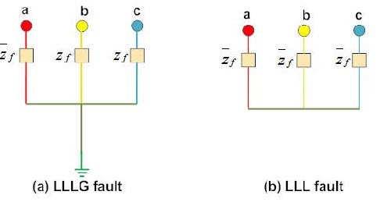
Only 2-5 percent of system faults are symmetrical faults. If these faults occur, system remains balanced but results in severe damage to the electrical power system equipments.

Part-B
- Explain in detail about the need and different types of earthing scheme (Nov/Dec 2016)
To connect the metallic (conductive) Parts of an Electric appliance or installations to the earth (ground) is called Earthing or Grounding.
In other words, to connect the metallic parts of electric machinery and devices to the earth plate or earth electrode (which is buried in the moisture earth) through a thick conductor wire (which has very low resistance) for safety purpose is known as Earthing or grounding.

Need of Earthing or Grounding.
The primary purpose of earthing is to avoid or minimize the danger of electrocution, fire due to earth leakage of current through undesired path and to ensure that the potential of a current carrying conductor does not rise with respect to the earth than its designed insulation.
When the metallic part of electrical appliances (parts that can conduct or allow passage of electric current) comes in contact with a live wire, maybe due to failure of installations or failure in cable insulation, the metal become charged and static charge accumulates on it. If a person touches such a charged metal, the result is a severe shock.
To avoid such instances, the power supply systems and parts of appliances have to be earthed so as to transfer the charge directly to the earth.
Below are the basic needs of Earthing.
- To protect human lives as well as provide safety to electrical devices and appliances from leakage current.
- To keep voltage as constant in the healthy phase (If fault occurs on any one phase).
- To Protect Electric system and buildings form lighting.
- To serve as a return conductor in electric traction system and communication.
- To avoid the risk of fire in electrical installation systems.

Methods of Earthing
Earthing can be done in many ways. The various methods employed in earthing.

Plate Earthing:
In plate earthing system, a plate made up of either copper with dimensions 60cm x 60cm x 3.18mm (i.e. 2ft x 2ft x 1/8 in) or galvanized iron (GI) of dimensions 60cm x 60cm x 6.35 mm (2ft x 2ft x ¼ in) is buried vertical in the earth (earth pit) which should not be less than 3m (10ft) from the ground level.
For proper earthing system, follow the above mentioned steps in the (Earth Plate introduction) to maintain the moisture condition around the earth electrode or earth plate.
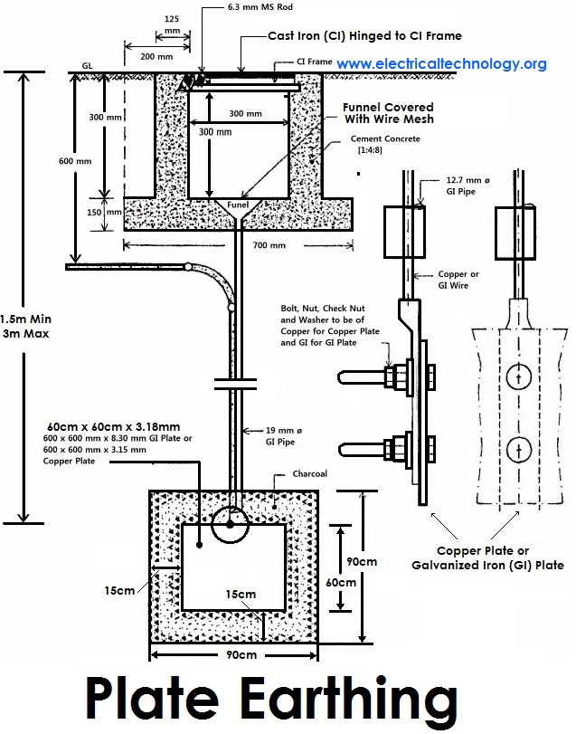

2). Pipe Earthing:
A galvanized steel and a perforated pipe of approved length and diameter is placed vertically in a wet soil in this kind of system of earthing. It is the most common system of earthing.
The size of pipe to use depends on the magnitude of current and the type of soil. The dimension of the pipe is usually 40mm (1.5in) in diameter and 2.75m (9ft) in length for ordinary soil or greater for dry and rocky soil. The moisture of the soil will determine the length of the pipe to be buried but usually it should be 4.75m (15.5ft).
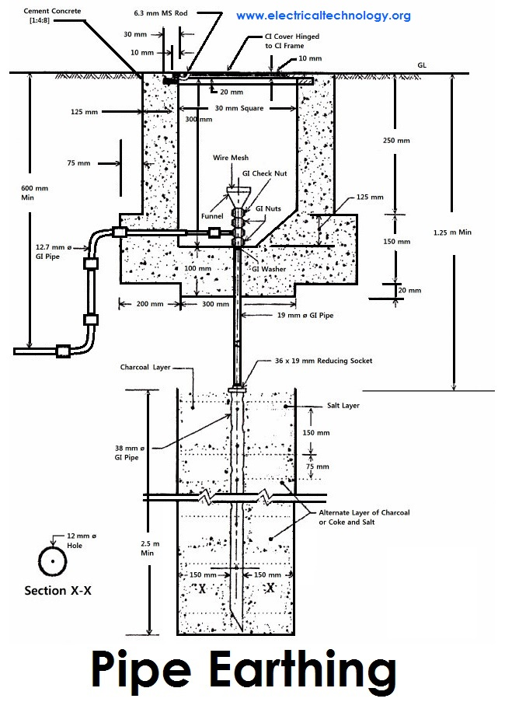

Rod Earthing
it is the same method as pipe earthing. A copper rod of 12.5mm (1/2 inch) diameter or 16mm (0.6in) diameter of galvanized steel or hollow section 25mm (1inch) of GI pipe of length above 2.5m (8.2 ft) are buried upright in the earth manually or with the help of a pneumatic hammer. The length of embedded electrodes in the soil reduces earth resistance to a desired value.
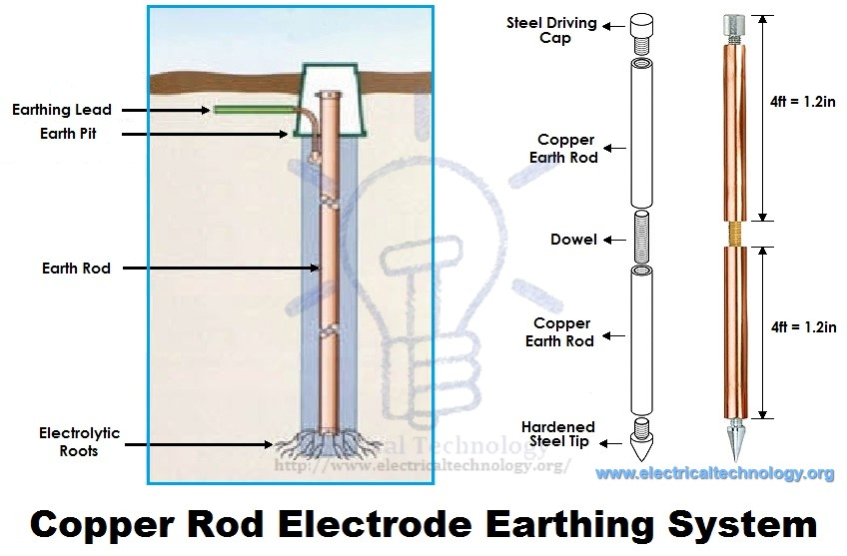Copper Rod Electrode Earthing System
Earthing through the Waterman
In this method of earthing, the waterman (Galvanized GI) pipes are used for earthing purpose. Make sure to check the resistance of GI pipes and use earthing clamps to minimize the resistance for proper earthing connection.
If stranded conductor is used as earth wire, then clean the end of the strands of the wire and make sure it is in the straight and parallel position which is possible then to connect tightly to the waterman pipe.

Strip or Wire Earthing:
In this method of earthing, strip electrodes of cross-section not less than 25mm x 1.6mm (1in x 0.06in) is buried in a horizontal trenches of a minimum depth of 0.5m. If copper with a cross-section of 25mm x 4mm (1in x 0.15in) is used and a dimension of 3.0mm² if it’s a galvanized iron or steel.
If at all round conductors are used, their cross-section area should not be too small, say less than 6.0mm² if it’s a galvanized iron or steel. The length of the conductor buried in the ground would give a sufficient earth resistance and this length should not be less than 15m.

- Explain the essential qualities of protection and explain them in detail. (Nov/Dec 2016)

Speed/Fastness of Operation
When electrical faults or short circuits occur, the damage produced is largely dependent upon the time the fault persists. Therefore, it is desirable that electrical faults be interrupted as quickly as possible.
Since 1965, great strides have been made in this area. High-speed fault detecting relays can now operate in as little time as 10 milliseconds and output relaying in 2 milliseconds. The use of protection zones minimizes the requirement for time-delayed relaying.

Reliability
The protective system must function whenever it is called upon to operate, since the consequences of non-operation can be very severe. This is accomplished by duplicate A and B protections and duplicate power supplies.

Security
Protections must isolate only the faulted equipment, with no over-tripping of unaffected equipment. This is accomplished by the use of over-lapping protection zones.

Sensitivity
The protection must be able to distinguish between healthy and fault conditions, i.e., to detect, operate and initiate tripping before a fault reaches a dangerous condition.
On the other hand, the protection must not be too sensitive and operate unnecessarily.
Some loads take large inrush starting currents, which must be accommodated to prevent unnecessary tripping while still tripping for fault conditions. The ability of relaying to fulfill the sensitivity requirement is improved through the use of protection zones.

- Explain different types of earthing the neutral point of the power system. Derive an expression for the reactance of the Peterson coil in terms of capacitance of the protected line .(May/June 2016)

There are many neutral grounding options available for both Low and Medium voltage power systems. The neutral points of transformers, generators and rotating machinery to the earth ground network provides a reference point of zero volts. This protective measure offers many advantages over an ungrounded system, like
  - Reduced magnitude of transient over voltages
  - Simplified ground fault location
  - Improved system and equipment fault protection
  - Reduced maintenance time and expense
  - Greater safety for personnel
  - Improved lightning protection
  - Reduction in frequency of faults.

There are five methods for Neutral earthing.
  - Unearthed Neutral System
  - Solid Neutral Earthed System.
  - Resistance Neutral Earthing System.
  - Resonant Earthing System.

Solidly Neutral Grounded Systems:
- Solidly grounded systems are usually used in low voltage applications at 600 volts or less.
- In solidly grounded system, the neutral point is connected to earth.
- Solidly Neutral Grounding slightly reduces the problem of transient over voltages found on the ungrounded system and provided path for the ground fault current is in the range of 25 to 100% of the system three phase fault current. However, if the reactance of the generator or transformer is too great, the problem of transient over voltages will not be solved.
- While solidly grounded systems are an improvement over ungrounded systems, and speed up the location of faults, they lack the current limiting ability of resistance grounding and the extra protection this provides.
- To maintain systems health and safe, Transformer neutral is grounded and grounding conductor must be extend from the source to the furthest point of the system within the same raceway or conduit. Its purpose is to maintain very low impedance to ground faults so that a relatively high fault current will flow thus insuring that circuit breakers or fuses will clear the fault quickly and therefore minimize damage. It also greatly reduces the shock hazard to personnel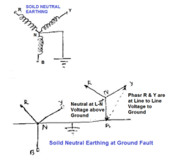
- If the system is not solidly grounded, the neutral point of the system would “float” with respect to ground as a function of load subjecting the line-to-neutral loads to voltage unbalances and instability.
- The single-phase earth fault current in a solidly earthed system may exceed the three phase fault current. The magnitude of the current depends on the fault location and the fault resistance. One way to reduce the earth fault current is to leave some of the transformer neutrals unearthed.

Advantage:
- The main advantage of solidly earthed systems is low over voltages, which makes the earthing design common at high voltage levels (HV).
Disadvantage:
- This system involves all the drawbacks and hazards of high earth fault current: maximum damage and disturbances.
- There is no service continuity on the faulty feeder.
- The danger for personnel is high during the fault since the touch voltages created are high.
Applications:
- Distributed neutral conductor.
- 3-phase + neutral distribution.
- Use of the neutral conductor as a protective conductor with systematic earthing at each transmission pole.
- Used when the short-circuit power of the source is low.

Resistance earthed systems:
- Resistance grounding has been used in three-phase industrial applications for many years and it resolves many of the problems associated with solidly grounded and ungrounded systems.
- Resistance Grounding Systems limits the phase-to-ground fault currents. The reasons for limiting the Phase to ground Fault current by resistance grounding are:
- To reduce burning and melting effects in faulted electrical equipment like switchgear, transformers, cables, and rotating machines.
- To reduce mechanical stresses in circuits/Equipments carrying fault currents.
- To reduce electrical-shock hazards to personnel caused by stray ground fault.
- To reduce the arc blast or flash hazard.
- To reduce the momentary line-voltage dip.
- To secure control of the transient over-voltages while at the same time.
- To improve the detection of the earth fault in a power system.
- Grounding Resistors are generally connected between ground and neutral of transformers, generators and grounding transformers to limit maximum fault current as per Ohms Law to a value which will not damage the equipment in the power system and allow sufficient flow of fault current to detect and operate Earth protective relays to clear the fault. Although it is possible to limit fault currents with high resistance Neutral grounding Resistors, earth short circuit currents can be extremely reduced. As a result of this fact, protection devices may not sense the fault.
- Therefore, it is the most common application to limit single phase fault currents with low resistance Neutral Grounding Resistors to approximately rated current of transformer and / or generator.
- In addition, limiting fault currents to predetermined maximum values permits the designer to selectively coordinate the operation of protective devices, which minimizes system disruption and allows for quick location of the fault.
- There are two categories of resistance grounding:
- Low resistance Grounding.
- High resistance Grounding.
- Ground fault current flowing through either type of resistor when a single phase faults to ground will increase the phase-to-ground voltage of the remaining two phases. As a result, conductor insulation and surge arrestor ratings must be based on line-to-line voltage. This temporary increase in phase-to-ground voltage should also be considered when selecting two and three pole breakers installed on resistance grounded low voltage systems.
- The increase in phase-to-ground voltage associated with ground fault currents also precludes the connection of line-to-neutral loads directly to the system. If line-to neutral loads (such as 277V lighting) are present, they must be served by a solidly grounded system. This can be achieved with an isolation transformer that has a three-phase delta primary and a three-phase,
four-wire, wye secondary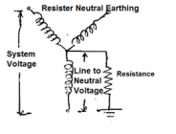
- Neither of these grounding systems (low or high resistance) reduces arc-flash hazards associated with phase-to-phase faults, but both systems significantly reduce or essentially eliminate the arc-flash hazards associated with phase-to-ground faults. Both types of grounding systems limit mechanical stresses and reduce thermal damage to electrical equipment, circuits, and apparatus carrying faulted current.
- The difference between Low Resistance Grounding and High Resistance Grounding is a matter of perception and, therefore, is not well defined. Generally speaking high-resistance grounding refers to a system in which the NGR let-through current is less than 50 to 100 A. Low resistance grounding indicates that NGR current would be above 100 A.
- A better distinction between the two levels might be alarm only and tripping. An alarm-only system continues to operate with a single ground fault on the system for an unspecified amount of time. In a tripping system a ground fault is automatically removed by protective relaying and circuit interrupting devices. Alarm-only systems usually limit NGR current to 10 A or less.
- Rating of The Neutral grounding resistor:
- Voltage: Line-to-neutral voltage of the system to which it is connected.
- Initial Current: The initial current which will flow through the resistor with rated voltage applied.
- Time: The “on time” for which the resistor can operate without exceeding the allowable temperature rise.

Resonant earthed system:
- Adding inductive reactance from the system neutral point to ground is an easy method of limiting the available ground fault from something near the maximum 3 phase short circuit capacity (thousands of amperes) to a relatively low value (200 to 800 amperes).
- To limit the reactive part of the earth fault current in a power system a neutral point reactor can be connected between the transformer neutral and the station earthing system.
- A system in which at least one of the neutrals is connected to earth through an
- Inductive reactance.
- Petersen coil / Arc Suppression Coil / Earth Fault Neutralizer.
- The current generated by the reactance during an earth fault approximately compensates the capacitive component of the single phase earth fault current, is called a resonant earthed system.
- The system is hardly ever exactly tuned, i.e. the reactive current does not exactly equal the capacitive earth fault current of the system.
- A system in which the inductive current is slightly larger than the capacitive earth fault current is over compensated. A system in which the induced earth fault current is slightly smaller than the capacitive earth fault current is under compensated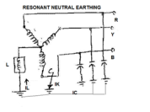
- However, experience indicated that this inductive reactance to ground resonates with the system shunt capacitance to ground under arcing ground fault conditions and creates very high transient over voltages on the system.
- To control the transient over voltages, the design must permit at least 60% of the 3 phase short circuit current to flow underground fault conditions.
- Example. A 6000 amp grounding reactor for a system having 10,000 amps 3 phase short circuit capacity available. Due to the high magnitude of ground fault current required to control transient over voltages, inductance grounding is rarely used within industry.

Petersen Coils
Peterson coils are used to in ungrounded 3-phase grounding systems to limit the arcing currents during ground faults. The coil was first developed by W. Petersen in 1916.
Application:
When a phase to earth fault occurs in ungrounded 3 phase systems, the phase voltage of the faulty phase is reduced to the ground potential. This causes the phase voltage in the other two phases to rise by √3 times. This increase in voltage causes a charging current, Ic between the

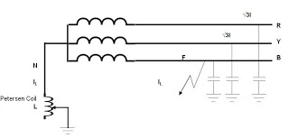
Phase-to-earth capacitances. The current Ic, Which increases to three times the normal capacitive charging current, needs to complete its circuit. This causes a series of restrikes at the fault locations known as arcing grounds. This can also lead to overvoltages in the system.
A Petersen coil consists of an iron-cored reactor connected at the star point of a three phase system. In the event of a fault, the capacitive charging current is neutralized by the current across the reactor which is equal in magnitude but 180 degrees out of phase. This compensates for the leading current drawn by the line

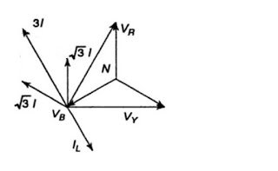
Capacitances. The power factor of the fault moves closer to unity. This facilitates the easy extinguishing of the arc as both the voltage and current have a similar zero-crossing.
I_{C}=3I=3Vp/(1/ωC) =3VpωC

Where IC is the resultant charging current that is three times the charging current of each phase to ground. Consider a Petersen coil connected between the star-point and the ground with inductive reactance ωL, and then the current flowing through it is given by
I_{L} =Vp/ωL
To obtain an effective cancellation of the capacitive charging currents, I_{L} to be equal to I_{C}.
Therefore,
Vp/ωL=3VpωC
From which we get,
L=1/ (3ω²C)
The value of the inductance in the Petersen coil needs to match the value of the line capacitance which may vary as and when modifications in the transmission lines are carried out. Hence, the Petersen coil comes with a provision to vary the inductance.
- Explain the overlapping of protective zones with neat sketch (May/June 2016)

Overlapping Zone of Power System
If there were no overlapping in the protective zone, then the failure occurs in the equipment will not lie in any one of the zones and hence no circuit breaker would be tripped. The fault occurs in the unprotective system will damage the equipment and hence disturb the continuity of the supply.
The figure below shows a certain amount of overlapping between the protective zones.
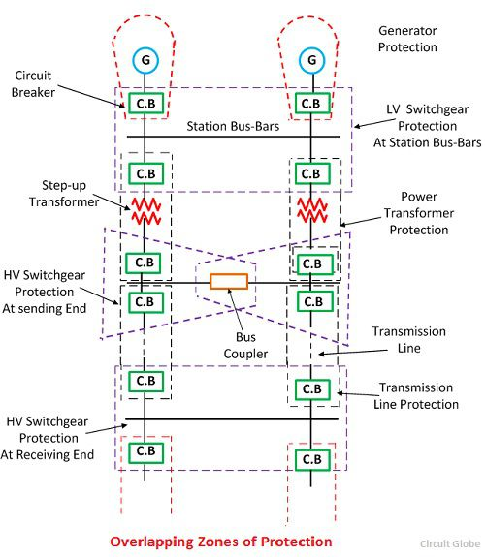
The probability of failure in the overlap region is very small. But the overlap region will cause the tripping of the more circuit breaker than the minimum necessary for the disconnection of the faults region. Because when the fault occurs in any one of the two overlapping regions than the breaker of both the region will be opened, and the systems are isolated.
Consider the two protective zone A and B which will overlap each other. The X is the fault occurs in the zone B, and due to this fault, the circuit breakers of zone B tripped along with the C (circuit breaker). The relay of the zone B will also trip the circuit breaker of zone A for other faults in the zone B which occurs to the right of the C (circuit breaker). Hence the unnecessary tripping of the breaker can be tolerated only in the particular region.
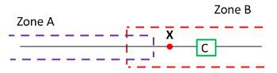
The scheme which senses the fault of any of the certain unit will have a high degree of sensitivity and it also has the adaptability of the fast speed of operation.
- Classify the different faults in power system. Which of these are more frequent?(May/June 2016)
Electrical faults in three-phase power system mainly classified into two types, namely open and short circuit faults. Further, these faults can be symmetrical or unsymmetrical faults. Let us discuss these faults in detail.

Open Circuit Faults
These faults occur due to the failure of one or more conductors. The figure below illustrates the open circuit faults for single, two and three phases (or conductors) open condition.
The most common causes of these faults include joint failures of cables and overhead lines, and failure of one or more phase of circuit breaker and also due to melting of a fuse or conductor in one or more phases.
Open circuit faults are also called as series faults. These are unsymmetrical or unbalanced type of faults except three phase open fault.
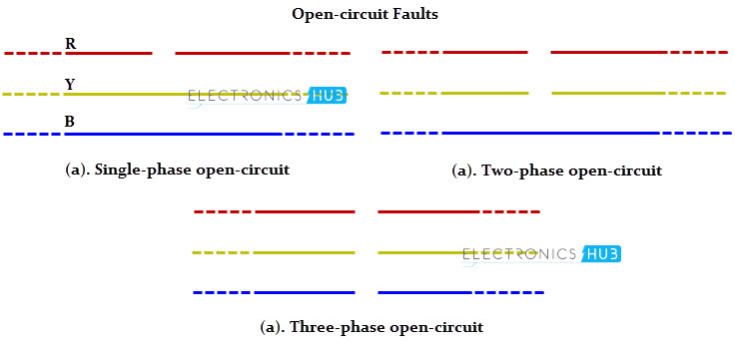
Consider that a transmission line is working with a balanced load before the occurrence of open circuit fault. If one of the phase gets melted, the actual loading of the alternator is reduced and this cause to raise the acceleration of the alternator, thereby it runs at a speed slightly greater than synchronous speed. This over speed causes over voltages in other transmission lines.
Thus, single and two phase open conditions can produce the unbalance of the power system voltages and currents that causes great damage to the equipments.

Causes
Broken conductor and malfunctioning of circuit breaker in one or more phases.

Effects
- Abnormal operation of the system
- Danger to the personnel as well as animals
- Exceeding the voltages beyond normal values in certain parts of the network, which further leads to insulation failures and developing of short circuit faults.
Although open circuit faults can be tolerated for longer periods than short circuit faults, these must be removed as early as possible to reduce the greater damage.

Short Circuit Faults
A short circuit can be defined as an abnormal connection of very low impedance between two points of different potential, whether made intentionally or accidentally. These are the most common and severe kind of faults, resulting in the flow of abnormal high currents through the equipment or transmission lines. If these faults are allowed to persist even for a short period, it leads to the extensive damage to the equipment.Short circuit faults are also called as shunt faults. These faults are caused due to the insulation failure between phase conductors or between earth and phase conductors or both. The various possible short circuit fault conditions include three phase to earth, three phase clear of earth, phase to phase, single phase to earth, two phase to earth and phase to phase plus single phase to earth as shown in figure.The three phase fault clear of earth and three phase fault to earth are balanced or symmetrical short circuit faults while other remaining faults are unsymmetrical faults.
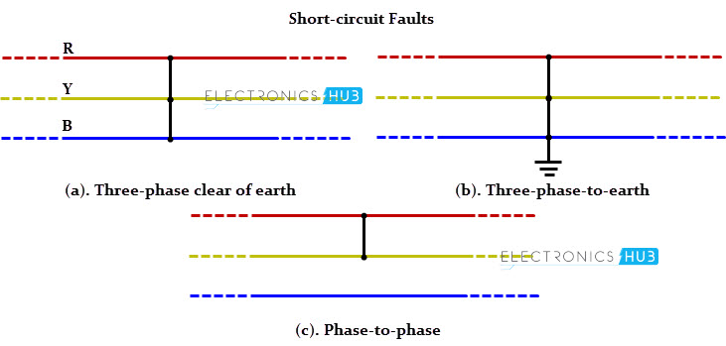

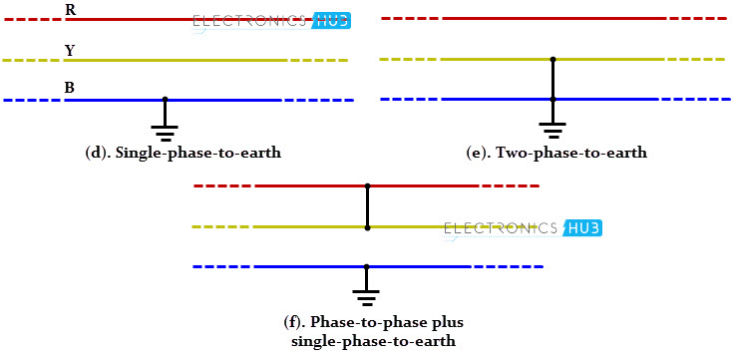

Causes
These may be due to internal or external effects
- Internal effects include breakdown of transmission lines or equipment, aging of insulation, deterioration of insulation in generator, transformer and other electrical equipments, improper installations and inadequate design.
- External effects include overloading of equipments, insulation failure due to lighting surges and mechanical damage by public.

Effects
- Arcing faults can lead to fire and explosion in equipments such as transformers and circuit breakers.
- Abnormal currents cause the equipments to get overheated, which further leads to reduction of life span of their insulation.
- The operating voltages of the system can go below or above their acceptance values that creates harmful effect to the service rendered by the power system.
- The power flow is severely restricted or even completely blocked as long as the short circuit fault persists.

Symmetrical and Unsymmetrical Faults
As discussed above that faults are mainly classified into open and short circuit faults and again these can be symmetrical or unsymmetrical faults.

Symmetrical Faults
A symmetrical fault gives rise to symmetrical fault currents that are displaced with 1200 each other. Symmetrical fault is also called as balanced fault. This fault occurs when all the three phases are simultaneously short circuited.
These faults rarely occur in practice as compared with unsymmetrical faults. Two kinds of symmetrical faults include line to line to line (L-L-L) and line to line to line to ground (L-L-L-G) as shown in figure below.
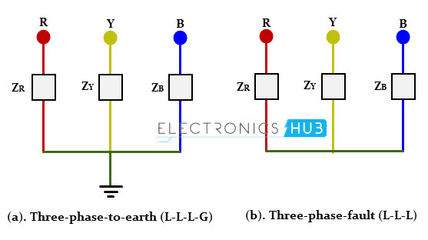
A rough occurrence of symmetrical faults is in the range of 2 to 5% of the total system faults. However, if these faults occur, they cause a very severe damage to the equipments even though the system remains in balanced condition. The analysis of these faults is required for selecting the rupturing capacity of the circuit breakers, choosing set-phase relays and other protective switchgear. These faults are analyzed on per phase basis using bus impedance matrix or Thevenins’s theorem.

Unsymmetrical Faults
The most common faults that occur in the power system network are unsymmetrical faults. This kind of fault gives rise to unsymmetrical fault currents (having different magnitudes with unequal phase displacement). These faults are also called as unbalanced faults as it causes unbalanced currents in the system. Up to the above discussion, unsymmetrical faults include both open circuit faults (single and two phase open condition) and short circuit faults (excluding L-L-L-G and L-L-L). The figure below shows the three types of symmetrical faults occurred due to the short circuit conditions, namely phase or line to ground (L-G) fault, phase to phase (L-L) fault and double line to ground (L-L-G) fault.
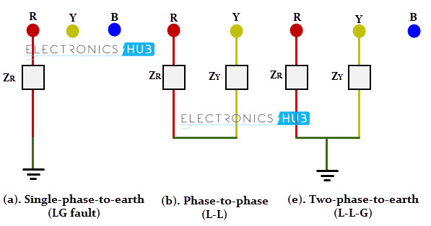
A single line-to-ground (LG) fault is one of the most common faults and experiences show that 70-80 percent of the faults that occur in power system are of this type. This forms a short circuit path between the line and ground. These are very less severe faults compared to other faults.
A line to line fault occur when a live conductor get in contact with other live conductor. Heavy winds are the major cause for this fault during which swinging of overhead conductors may touch together. These are less severe faults and its occurrence range may be between 15-20%.
In double line to ground faults, two lines come into the contact with each other as well as with ground. These are severe faults and the occurrence these faults is about 10% when compared with total system faults.
Unsymmetrical faults are analyzed using methods of unsymmetrical components in order to determine the voltage and currents in all parts of the system. The analysis of these faults is more difficult compared to symmetrical faults.
This analysis is necessary for determining the size of a circuit breaker for largest short circuit current. The greater current usually occurs for either L-G or L-L fault.

- Differentiate between surge diverter and surge absorber. Also explain the characteristics of an ideal surge diverter. (Nov/Dec 2014).
A surge arrester is a device to protect electrical equipment from over-voltage transients caused by external (lightning) or internal (switching) events. you can say more generally that it helps preventing the transient voltages occured by switching. it is connected to conductor just before entering the equipment
A surge diverter is a piece of equipment that diverts excess voltages (caused by spikes in the electrical supply) to earth, thus protecting sensitive electrical and electronic equipment. A surge diverter has to be a non-conductor for operating power frequency voltages. It should behave as a short circuit for transient overvoltages of impulse character, discharge the heavy current, and recover its insulation without allowing the follow-up of the power frequency current.

Condenser or capacitor surge absorber-
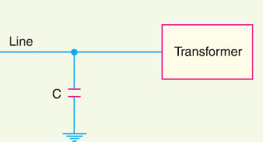

Inductor and resistance surge absorber-
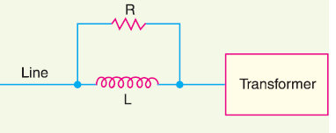

Ferranti surge absorber.
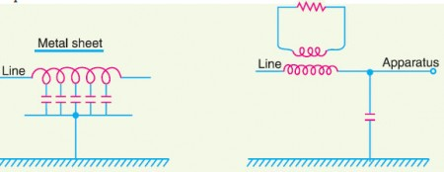

Rod Gap Arrester
It is one of the simplest forms of the arrester. In such type of arrester, there is an air gap between the ends of two rods. The one end of the arrester is connected to the line and the second end of the rod is connected to the ground. The gap setting of the arrester should be such that it should break before the damage. When the high voltage occurs on the line, the gap sparks and the fault current passes to the earth. Hence the equipment is protected from damage.
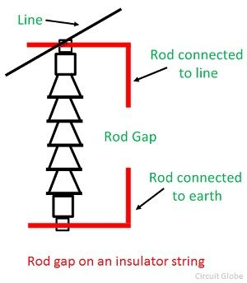

The difficulty with the rod arrester is that once the spark having taken place it may continue for some time even at low voltages. To avoid it a current limiting reactor in series with the rod is used. The resistance limits the current to such an extent that it is sufficient to maintain the arc. Another difficulty with the road gap is that the rod gap is liable to be damaged due to the high temperature of the arc which may cause the rod to melt.

Horn Gap Arrester
It consists of two horns shaded piece of metal separated by a small air gap and connected in shunt between each conductor and earth. The distance between the two electrodes is such that the normal voltage between the line and earth is insufficient to jump the gap. But the abnormal high voltage will break the gap and so find a path to earth.
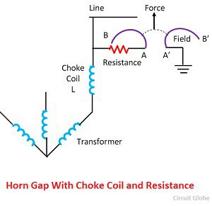
Characteristics of an ideal surge diverter
- It should not pass any current at normal and abnormal power frequency voltage
- It should breakdown as quickly as possible after the abnormal high frequency voltage arrives.
- It should not only protect the equipment for which it is used but should discharge current without damaging itself.
- It should interrupt power frequency follow current after the surge is discharge to ground.
- With a neat diagram explain the operation of any one type of lighting arrestor (Nov/Dec 2014)
Definition: The device which is used for the protection of the equipment at the substations against travelling waves, such type of device is called lightning arrester or surge diverter. In other words, lightning arrester diverts the abnormals high voltage to the ground without affecting the continuity of supply. It is connected between the line and earth, i.e., in parallel with the equipment to be protected at the substation.
The following are the damages that are caused by the travelling wave on the substation equipment.
  - The high peak or crest voltage of the surge may cause flash-over in the internal winding thereby spoil the winding insulation.
  - The steep wave fronts of the surges may cause external flashover between the terminal of the transformer.
  - The highest peak voltage of the surge may cause external flashover, between the terminal of the electrical equipment which may result in damage to the insulator.

Working of Lightning Arrester
When a travelling wave reaches the arrestor, its sparks over at a certain prefixed voltage as shown in the figure below. The arrestor provides a conducting path to the waves of relatively low impedance between the line and the ground. The surge impedance of the line restricts the amplitude of current flowing to ground.
The lightning arrester provides a path of low impedance only when the travelling surge reaches the surge diverter, neither before it nor after it. The insulation of the equipment can be protected if the shape of the voltage and current at the diverter terminal is similar to the shape shown below.
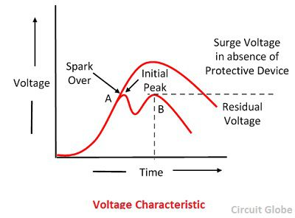
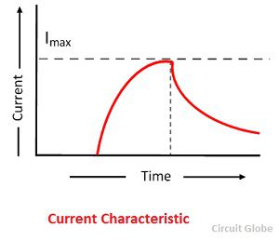
An ideal lightning arrester should have the following characteristics;
- It should not draw any current during normal operating condition, i.e., it sparks-over voltage must be above the normal or abnormal power frequency that may occur in the system.
- Any transient abnormal voltage above the breakdown value must cause it to break down as quickly as possible so that it may provide a conducting path to ground.
- When the breakdown has taken place, it should be capable of carrying the resulting discharge current without getting damaged itself and without the voltage across it exceeding the breakdown value.
- The power frequency current following the breakdown must be interrupted as soon as the transient voltage has fallen below the breakdown value.
There are many types of lightning arrester which are used to protect the power system. The choices of the lightning arrester depend on the factor like, voltage and frequency of the line, cost, weather condition and reliability.

Location of Lightning Arrester
The lightning arrester is located close to the equipment that is to be protected. They are usually connected between phase and ground in an AC system and pole and ground in case of the DC system. In an AC system, separate arrester is provided for each phase.
In an extra-high voltage AC system the surge diverter is used to protect the generators, transformers, bus bars, lines, circuit breakers, etc. In HVDC system the arrester is used to protect the buses, valves converter units reactors, filter, etc.

Sphere Gap Arrester
In such type of devices, the air gap is provided between two different spheres. One of the spheres is connected to the line, and the other sphere is connected to the ground. The spacing between the two spheres is very small. A choking coil is inserted between the phase winding of the transformer and spheres is connected to the line.
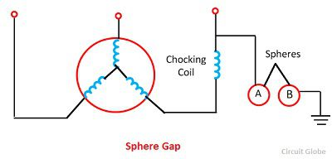
The air gap between the arrester is set in such a way so that the discharge must not take place at normal operating condition.The arc will travel up the sphere as the heated air near the arc tend to rise upward and lengthening till it is interrupted automatically.

Impulse Protective Gap
The protective impulse gap is designed to have a low voltage impulse ratio, even less than one and to extinguish the arc. Their working principle is very simple as shown in the figure below. It consists of two sphere electrode S1 and S2 which are connected respectively to the line and the arrester.
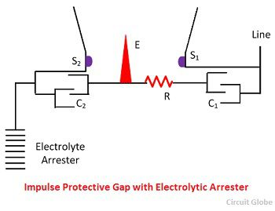
The auxiliary needle is placed between the mid of two sphere S1 and S2. At normal frequency, the impedance of the capacitance C1 is quite large as compared to the impedance of resistor R. If C1 and C2 are equal the potential of the auxiliary electrode will be midway between those of the S1 and S2 and the electrode has no effect on the flash over between them.
When the transient occurs the impedance of capacitor C1 and C2 decrease and the impedance of the resistor now become effective. Due to this, the whole of the voltage is concentrated across the gap between E and S1. The gap at once breakdown, the rest of the length between E and S2 immediately follow.
- What is Peterson coil? Explain the protective function performed by this device with necessary diagram (Nov/Dec 2014)

Petersen Coils
Peterson coils are used to in ungrounded 3-phase grounding systems to limit the arcing currents during ground faults. The coil was first developed by W. Petersen in 1916.
Application:
When a phase to earth fault occurs in ungrounded 3 phase systems, the phase voltage of the faulty phase is reduced to the ground potential. This causes the phase voltage in the other two phases to rise by √3 times. This increase in voltage causes a charging current, Ic between the

Phase-to-earth capacitances. The current Ic, Which increases to three times the normal capacitive charging current, needs to complete its circuit. This causes a series of restrikes at the fault locations known as arcing grounds. This can also lead to overvoltages in the system.
A Petersen coil consists of an iron-cored reactor connected at the star point of a three phase system. In the event of a fault, the capacitive charging current is neutralized by the current across the reactor which is equal in magnitude but 180 degrees out of phase. This compensates for the leading current drawn by the line

Capacitances. The power factor of the fault moves closer to unity. This facilitates the easy extinguishing of the arc as both the voltage and current have a similar zero-crossing.
I_{C}=3I=3Vp/(1/ωC) =3VpωC

Where IC is the resultant charging current that is three times the charging current of each phase to ground. Consider a Petersen coil connected between the star-point and the ground with inductive reactance ωL, and then the current flowing through it is given by
I_{L} =Vp/ωL
To obtain an effective cancellation of the capacitive charging currents, I_{L} to be equal to I_{C}.
Therefore,
Vp/ωL=3VpωC
From which we get,
L=1/ (3ω²C)
The value of the inductance in the Petersen coil needs to match the value of the line capacitance which may vary as and when modifications in the transmission lines are carried out. Hence, the Petersen coil comes with a provision to vary the inductance.
- Enumerate the basic concepts of insulation coordination (May/June 2014)
Insulation Coordination in Power System was introduced to arrange the electrical insulation levels of different components in the electrical power system including transmission network, in such a manner, that the failure of insulator, if occurs,confindes to the place where it would result in the least danmage of the system, easy to repair and replace, and results least disturbance to the power supply. When any over voltage appears in the electrical power system, then there may be a chance of failure of its insulation system. Probability of failure of insulation, is high at the weakest insulation point nearest to the source of over voltage. In power system and transmission networks, insulation is provided to the all equipment and components.
Insulators in some points are easily replaceable and repairable compared to other. Insulation in some points are not so easily replaceable and repairable and the replacement and repairing may be highly expensive and require long interruption of power. Moreover failure of insulator at these points may causes bigger part of electrical network to be out of service. So, it is desirable that in situation of insulator failure, only the easily replaceable and repairable insulator fails. The overall aim of insulation coordination is to reduce to an economically and operationally acceptable level the cost and disturbance caused by insulation failure. In insulation coordination method, the insulation of the various parts of the system must be so graded that flash over if occurs it must be at intended points.

Conventional Method of Insulation Coordination
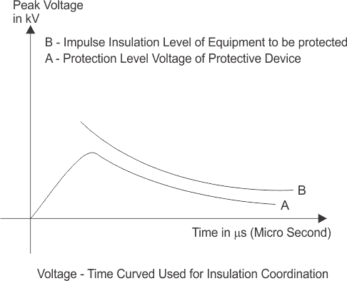
As we discussed above that a component of electrical power system may suffer from different level of transient voltage stresses, switching impulse voltage and lightning impulse voltage. The maximum amplitude of transient over voltages reach the components, can be limited by using protecting device like lightning arrestor in the system. If we maintain the insulation level of all the power system component above the protection level of protective device, then ideally there will be no chance of breakdown of insulation of any component. Since the transient over voltage reaches at the insulation after crossing the surge protective devices will have amplitude equals to protection level voltage and protection level voltage < impulse insulation level of the components.
Generally, the impulse insulation level is established at 15 to 25 % above the protective level voltage of protective devices.

Statistical Methods of Insulation Coordination
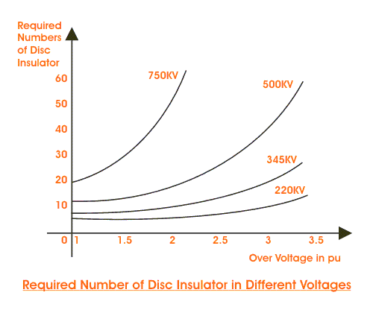
At higher transmission voltages, the length of the insulator strings and the clearance in air do not increase linearly with voltage but approximately to V1.6. The required number of insulator disc in suspension string for different over voltages is shown below. It is seen that increase in the number of disc is only slight for 220 KV system, with the increase in the over voltage factor from 2 to 3.5 but that there is a rapid increase in the 750 kV system. Thus, while it may be economically feasible to protect the lower voltage lines up to an over voltage factor of 3.5(say), it is definitely not economically feasible to have an over voltage factor of more than about 2 to 2.5 on the higher voltage lines. In the higher voltage systems, it is the switching over voltages that is predominant. However, these may be controlled by proper design of switching devices.
- Explain the method of calculating fault current using symmetrical components (Nov/Dec 2016)
For unbalance conditions the calculation of fault currents is more complex. One method of dealing with this is symmetrical components. Using symmetrical components, the unbalance system is broken down into three separate symmetrical systems.
Symmetrical Component Analysis
The above fault calculation is made on assumption of three phase balanced system. The calculation is made for one phase only as the current and voltage conditions are same in all three phases. When actual faults occur in electrical power system, such as phase to earth fault, phase to phase fault and double phase to earth fault, the system becomes unbalanced means, the conditions of voltages and currents in all phases are no longer symmetrical. Such faults are solved by symmetrical component analysis. Generally three phase vector diagram may be replaced by three sets of balanced vectors. One has opposite or negative phase rotation, second has positive phase rotation and last one is co-phasal. That means these vectors sets are described as negative, positive and zero sequence, respectively.
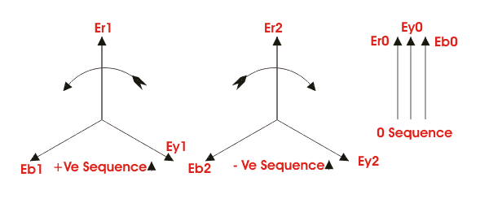The equation between phase and sequence quantities are,
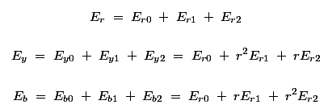
Therefore,
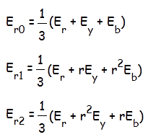

Where all quantities are referred to the reference phase r. Similarly a set of equations can be written for sequence currents also. From, voltage and current equations, one can easily determine the sequence impedance of the system. The development of symmetrical component analysis depends upon the fact that in balanced system of impedance, sequence currents can give rise only to voltage drops of the same sequence. Once the sequence networks are available, these can be converted to single equivalent impedance. Let us consider Z1, Z2 and Z0 are the impedance of the system to the flow of positive, negative and zero sequence current respectively.
For earth fault
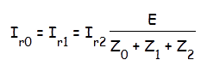
Phase to phase faults
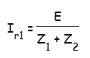
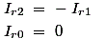
Double phase to earth faults
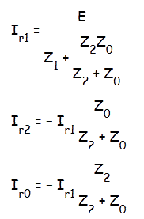

Three phase faults
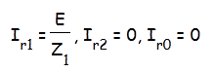
fault current in any particular branch of the network is required, the same can be calculated after combining the sequence components flowing in that branch. This involves the distribution of sequence components currents as determined by solving the above equations, in their respective network according to their relative impedance. Voltages it any point of the network can also be determine once the sequence component currents and sequence impedance of each branch are known.
Sequence Impedance
Positive Sequence Impedance
The impedance offered by the system to the flow of positive sequence current is called positive sequence impedance.
Negative Sequence Impedance
The impedance offered by the system to the flow of negative sequence current is called negative sequence impedance.
Zero Sequence Impedance
The impedance offered by the system to the flow of zero sequence current is known as zero sequence impedance. In previous fault calculation, Z1, Z2 and Z0 are positive, negative and zero sequence impedance respectively. The sequence impedance varies with the type of power system components under consideration:-
In static and balanced power system components like transformer and lines, the sequence impedance offered by the system are the same for positive and negative sequence currents. In other words, the positive sequence impedance and negative sequence impedance are same for transformers and power lines.
But in case of rotating machines the positive and negative sequence impedance are different.
The assignment of zero sequence impedance values is a more complex one. This is because the three zero sequence current at any point in a electrical power system, being in phase, do not sum to zero but must return through the neutral and /or earth. In three phase transformer and machine fluxes due to zero sequence components do not sum to zero in the yoke or field system. The impedance very widely depending upon the physical arrangement of the magnetic circuits and winding.
  - The reactance of transmission lines of zero sequence currents can be about 3 to 5 times the positive sequence current, the lighter value being for lines without earth wires. This is because the spacing between the go and return(i.e. neutral and/or earth) is so much greater than for positive and negative sequence currents which return (balance) within the three phase conductor groups.
  - The zero sequence reactance of a machine is compounded of leakage and winding reactance, and a small component due to winding balance (depends on winding tritch).
  - The zero sequence reactance of transformers depends both on winding connections and upon construction of core.
- Determine the inductance of Peterson coil to be connected between the neutral and ground to neutralize the charging current of overhead line having the line to ground capacitance of 0.15mf. If the supply frequency is 50 Hz and the operating voltage is 132KV, find the KVA Rating of the coil.(Nov/Dec 2016).

