Unit-V
Part-A
- Give the two methods of arc interruption.(Apr/May 2017)
  - High resistance method,
  - Low resistance method or current zero interruption method.

- What is RRRV?(Apr/May 2017)
Rate of Rise of Restriking Voltage (RRRV): It is defined as the ratio of peak value of restriking voltage to time taken to reach to peak value. It is one of the most important parameter as if the rate at which the dielectric strength developed between the contacts is greater than RRRV, and then the arc will be extinguishes.

- What is meant by auto-reclosing (May/June 2016)
In electric power distribution, a recloser, or autorecloser, is a circuit breaker equipped with a mechanism that can automatically close the breaker after it has been opened due to a fault. Reclosers are used on overhead distribution systems to detect and interrupt momentary faults.
- Write the function of isolating switch (May/June 2016)
Isolator is used to break the circuit under off-load whereas on-load circuit breaking is done by Circuit Breaker It is operated after the circuit breaker to completely isolate the circuit.
- What is meant by making capacity of a circuit breaker? (Nov/Dec 2015)
The making capacity is expressed as making current of circuit breaker is expressed in maximum peak value; it is always more than rated short circuit breaking current of circuit breaker. Normally value of short circuit making current is 2.5 times more than short circuit breaking current.
- Mention any two advantages of vacuum circuit breaker (Nov/Dec 2014)
  - Vacuum circuit breakers does not require filling of any gas or oil. They do not need auxiliary air system, oil handling and free from periodic maintenance
  - Rapid recovery of very high dielectric strength on current interruption so that only half cycle or less arcing occurs after proper contact separation
  - No emission of gases, hence pollution free
  - Current interruption occurs at first current zero after contact separation with no re-striking, making it exceptionally good for capacitor and cable switching and long line drooping
- List the different types of circuit breakers (Nov/Dec 2014)
  - Air Circuit Breaker
  - SF6 Circuit Breaker
  - Vacuum Circuit Breaker
  - Oil Circuit Breaker
  - Air Circuit Breaker

- How do you quench an arc in an circuit breaker (May/Jun 2014)
The final arc extinction or arc quenching in circuit breaker is achieved by rapid increase of the dielectric strength in the medium between the contacts so that reestablishment of arc after zero crossing cannot be possible. Arc is quenched in circuit breakers using the following methods
  - High Resistance Method
  - Low Resistance Method
- What are the demerits of resistance switching (May/June 2014)
  - Enormous energy is dissipated in the arc.
  - It is employed only in D.C. circuit breakers and low-capacity a.c. circuit breakers.
- Why current chopping is not common in oil circuit breaker? (Nov/Dec 2015)
In oil circuit breaker, the chance of arc restriking again is less. So transient voltage is not sufficient to maintain the arc. Hence current chopping in not present in oil CB.
- List out the tests performed on SF6 and Vacuum Circuit Breaker.(Apr/May 2017)
  - Dielectric test on auxiliary circuit and control circuit
  - Measurement of resistance of main circuit or contact resistance test
  - Tightness test or SF6 gas leakage test
  - Design and visual checks
- Explain how to arrive at the rating of a circuit breaker (Apr/May 2017)
The rating of a circuit breaker includes,
- Rated short circuit breaking current.
- Rated short circuit making current.
- Rated operating sequence of circuit breaker.
- Rated short time current.
- What is the difference between re-striking voltage and recovery voltage? (Nov/Dec 2016)
At which Voltage level restrike of ARC occurs is called as restriking Voltage. The normal frequency (60 Hz) r.m.s. voltage that appears across the contacts of the circuit breaker after final arc extinction in the steady state is the recovery voltage and is equal to the system voltage.
- State the difference between D.C and A.C Circuit breaking (Nov/Dec 2016)
In AC circuits (regular household circuits), the voltage source changes the polarity of its output regularly. In India, this happens 100 times per second. By contrast, in DC circuits, the current flow is unidirectional due to the fixed polarity of the voltage source. This leads to undisrupted, longer and sustainable arcs in DC circuits (the reason why arc welding machines use DC current and not AC current). See DC arcs in action here While breaking a DC circuit, it is easy to form such arcs, and if they are not extinguished in time they lead to device overheating and ultimately to fire. AC circuit breakers are not equipped well enough to deal with such arcs, whereas DC circuit breakers have special arc chutes to capture arcs and extinguish them safely, hence they are highly recommended. See what happens when AC circuit breakers are used in DC circuits or when safety devices are under-rated.
- Give the difference between isolator and circuit breaker (May/June 2016)
Isolator is an off-load device while, circuit breaker is an on-load device. Isolator is a switch operated manually, which separate the circuit from the power main and discharges the trapped charges in the circuit.

- State the advantages of SF6 circuit breaker (May/June 2016)
  - Excellent insulating, arc extinguishing, physical and chemical properties of SF6 gas is greater advantage of SF6 circuit breakers
  - The gas is non-inflammable and chemically stable. The decomposition products are non-explosive i.e, there is no risk of fire or explosion
  - Electrical clearances are very much reduced because of high dielectric strength of SF6
  - Outdoor EHV SF6 circuit breaker has less number of interrupters per pole in comparison to the air-blast circuit breaker and minimum oil breaker. Outdoor SF6 circuit breaker is simple, comparatively cheaper in cost, maintenance free and compact
- How does a circuit breaker differ from a switch? (Nov/Dec 2015)
Circuit Breaker | Switch
Electrical circuit breaker is a switching device which can be operated manually and automatically for controlling and protection of electrical power system respectively. | switch is a device, which can make or break an electrical circuit or we can say that switch is a controlling device, which interrupt the flow of current or direct the flow of current in another direction

- Define the term breaking capacity in a circuit breaker. (Nov/Dec 2014)
Breaking capacity or interrupting rating is the current that a fuse, circuit breaker, or other electrical apparatus is able to interrupt without being destroyed or causing an electric arc with unacceptable duration.
- What is meant by current chopping? (Nov/Dec 2014)
Current Chopping in circuit breaker is defined as a phenomena in which current is forcibly interrupted before the natural current zero. Current Chopping is mainly observed in Vacuum Circuit Breaker and Air Blast Circuit Breaker. There is no such phenomena in Oil Circuit Breaker. Current chopping is predominant while switching Shunt Reactor or unloaded Transformer.
- Write the difference between the fuse and circuit breaker. (May/June 2014)
A fuse is made up of a piece of metal that melts when overheated; a circuit breaker has an internal switch mechanism that is tripped by an unsafe surge of electricity. Fuses tend to be quicker to interrupt the flow of power, but must be replaced after they melt, while circuit breakers can usually simply be reset.
- Define the operating time of circuit breaker. (May/June 2014)
Generally the operating time of the circuit breakers depends on the designer. The opening time of the breaker should be less than the closing of the breaker. Opening
time should be less than or equal to 20msec (preferable)Closing time depends but preferably less than 90msec
- What are the ratings of a circuit breaker?
  - Breaking Capacity
  - Making Capacity
  - Short-time Capacity
- What are the indirect methods of circuit breaker testing?
  - Unit test
  - Synthetic test
  - Substitution testing
  - Compensation testing
  - Capacitance testing
- What is meant by electro negativity of SF6 gas?
SF6 has high affinity for electrons. When a free electron comes and collides with a neutral gas molecule, the electron is absorbed by the neutral gas molecule and negative ion is formed. This is called as electro negativity of SF6 gas.
- Define composite testing of a circuit breaker.
In this method the breaker is first tested for its rated breaking capacity at a reduced voltage and afterwards for rated voltage at a low current. This method does not give a proper estimate of the breaker performance.

Part-B
- Explain the construction, operating principle and application of minimum oil circuit breakers. (April/May 2017).
The simplified constructional diagram of a Minimum Oil Circuit Breaker (MOCB) is shown in the figure. It consists of two oil filled chambers namely upper chamber and lower chamber, which are separated from each other.
They are extinction process is carried out in the upper chamber. So, it is called as an arc extinction chamber or current interruption chamber of Minimum Oil Circuit Breaker (MOCB).This chamber houses an arc control device, an upper fixed contact and a ring shaped lower fixed contact. The are control device is fitted to the upper to the upper fixed contact. The moving contact slides through the lower fixed contact such that a physical (or electrical) maintained between them. The entire assembly of upper fixed contact. Lower fixed contact and arc control device is enclosed in a glass fiber enclosure which is surrounded by oil
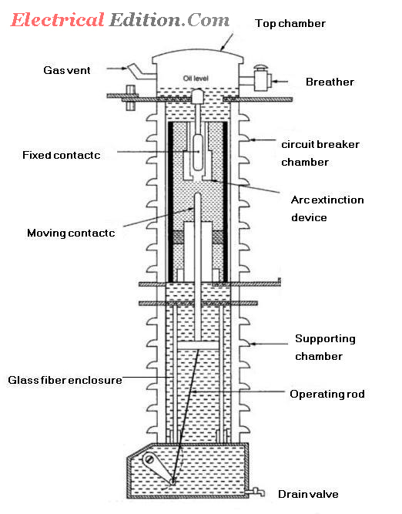
The oil present in the lower chamber does not involve the arc extinction process and instead it is used only for insulation purpose. So, the lower chamber is also known as dielectric supporting chamber. Both the upper and lower chambers are individually enclosed with the cylindrical shaped synthetic resin bonded papers within the porcelain insulators.

The operating rod which is permanently fixed to the moving contact is connected to the operating mechanism which provides vertical motion in order to make and break the circuit.
Whenever the moving contact is drawn out of the. hollow structure of fixed contact, under current carrying conditions, an arc is drawn between them. As the contacts are present in the dielectric oil, the oil surrounding the arc attains a high temperature and thus decomposes the releasing gases. The gases formed will expand and so the pressure inside the chamber rises. Hence ,the gases will move upwards by which the contacts cools down and the arc splits.
The gap between the contacts will be filled with fresh oil. This oil will also be decomposed and the released gases will expand. So. the pressure will be increased again. Hence, the gases will move upwards and again fresh oil will enter.
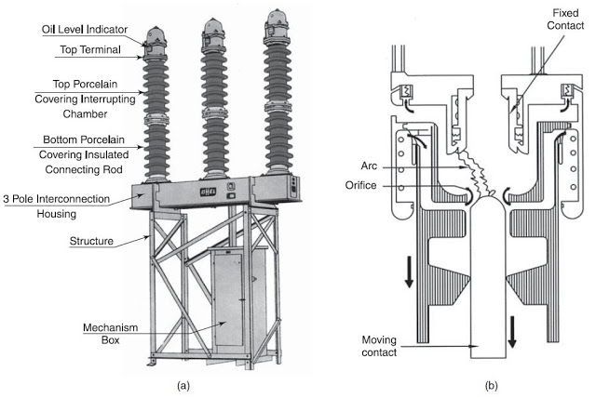
This flow of fresh oil through the gap between the contacts will continue until the final arc extinction which occurs near . current zero instant. In order to achieve sufficiently high dielectric strength immediately after current zero instant. either of the following method is implemented.
(i) Forcing fresh oil into the gap between the contacts with the help of piston action produced by the piston attached to the moving contact.
(ii) Maintaining high pressure on the oil inside the circuit breaker with the help of an inert gas. By this the fresh oil will enter into the gap between the contact from all directions and the gases moves upwards.

Applications of Minimum Oil Circuit Breaker
  - For indoor applications, minimum oil circuit breakers can be used upto 36 kV.
  - For outdoor applications, minimum oil circuit breakers can be employed upto the line voltages of 220 kV.

- Describe the construction, operating principle and application of a SF6 Circuit Breaker. (Apr/May 2017)
A circuit breaker in which SF₆ under pressure gas is used to extinguish the arc is called SF₆ circuit breaker. SF₆ (sulphur hexafluoride) gas has excellent dielectric, arc quenching, chemical and other physical properties which have proved its superiority over other arc quenching mediums such as oil or air. The SF₆ circuit breaker is mainly divided into three types
- Non-puffer piston circuit breaker
- Single- puffer piston circuit breaker.
- Double-puffer piston circuit breaker.
The circuit breaker which used air and oil as an insulating medium, their arc extinguishing force builds up was relatively slow after the movement of contact separation. In the case of high voltage circuit breakers quick arc extinction properties are used which require less time for quick recovery, voltage builds up. SF₆ circuit breakers have good properties in this regards compared to oil or air circuit breakers. So in high voltage up to 760 kV, SF₆ circuit breakers is used.

Properties of Sulphur hexafluoride Circuit Breaker
Sulphur hexafluoride possesses very good insulating and arc quenching properties. These properties are
- It is colourless, odourless, non-toxic, and non-inflammable gas.
- SF₆ gas is extremely stable and inert, and its density is five times that of air.
- It has high thermal conductivity better than that of air and assists in better cooling current carrying parts.
- SF₆ gas is strongly electronegative, which means the free electrons are easily removed from discharge by the formation of negative ions.
- It has a unique property of fast recombination after the source energising spark is removed. It is 100 times more effective as compared to arc quenching medium.
- Its dielectric strength is 2.5 times than that of air and 30% less than that of the dielectric oil. At high pressure the dielectric strength of the gas increases.
- Moisture is very harmful to SF₆ circuit breaker. Due to a combination of humidity and SF₆ gas, hydrogen fluoride is formed (when the arc is interrupted) which can attack the parts of the circuit breakers.

Construction of SF6 Circuit Breakers
SF₆ circuit breakers mainly consist of two parts, namely (a) the interrupter unit and (b) the gas system.
Interrupter Unit – This unit consists of moving and fixed contacts comprising a set of current-carrying parts and an arcing probe. It is connected to the SF₆ gas reservoir. This unit consists slide vents in the moving contacts which permit the high-pressure gas into the main tank.
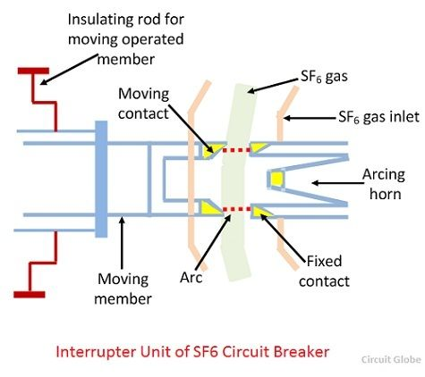
Gas System – The closed circuit gas system is employed in SF₆ circuit breakers. The SF₆ gas is costly, so it is reclaimed after each operation. This unit consists low and high-pressure chambers with a low-pressure alarm along with warning switches. When the pressure of the gas is very low due to which the dielectric strength of gases decrease and an arc quenching ability of the breakers is endangered, then this system gives the warning alarm.

Working Principle of SF6 Circuit Breaker
In the normal operating conditions, the contacts of the breaker are closed. When the fault occurs in the system, the contacts are pulled apart, and an arc is struck between them. The displacement of the moving contacts is synchronised with the valve which enters the high-pressure SF₆ gas in the arc interrupting chamber at a pressure of about 16kg/cm^2.
The SF₆ gas absorbs the free electrons in the arc path and forms ions which do not act as a charge carrier. These ions increase the dielectric strength of the gas and hence the arc is extinguished. This process reduces the pressure of the SF₆ gas up to 3kg/cm^2 thus; it is stored in the low-pressure reservoir. This low-pressure gas is pulled back to the high-pressure reservoir for re-use.
Now a day puffer piston pressure is used for generating arc quenching pressure during an opening operation by mean of a piston attached to the moving contacts.

Advantage of SF6 circuit breaker
SF₆ circuit breakers have the following advantages over conventional breaker
- SF₆ gas has excellent insulating, arc extinguishing and many other properties which are the greatest advantages of SF₆ circuit breakers.
- The gas is non-inflammable and chemically stable. Their decomposition products are non-explosive and hence there is no risk of fire or explosion.
- Electric clearance is very much reduced because of the high dielectric strength of SF₆.
- Its performance is not affected due to variations in atmospheric condition.
- It gives noiseless operation, and there is no over voltage problem because the arc is extinguished at natural current zero.
- There is no reduction in dielectric strength because no carbon particles are formed during arcing.
- It requires less maintenance and no costly compressed air system is required.
- SF₆ performs various duties like clearing short-line faults, switching, opening unloaded transmission lines, and transformer reactor, etc. without any problem.

Disadvantages of SF6 circuit breakers
- SF₆ gas is suffocating to some extent. In the case of leakage in the breaker tank, the SF₆ gas being heavier than air and hence SF₆ are settled in the surroundings and lead to the suffocation of the operating personnel.
- The entrance of moisture in the SF₆ breaker tank is very harmful to the breaker, and it causes several failures.
- The internal parts need cleaning during periodic maintenance under clean and dry environment.
- The special facility requires for transportation and maintenance of quality of gas.

- Derive the expression for restriking voltage and maximum RRRV (Nov/Dec 2016)
When the current across the contact of the circuit breaker is zero, a high-frequency transient voltage develops in the whole breaker contact and is produced by the sudden distribution of energy between the electric and magnetic field. This transient voltage is called restriking voltage. The voltage appears across the breaker contacts at the moment of final current has a serious influence on the arc extinction process. Under the influence of this voltage, the arc tries to restrike and hence it is named as the restriking voltage.
After the zero current, the arc gets extinguished, if the rate of rising of restriking voltage between the contact is less than the rate at which the dielectric strength of the medium between the contact gains. Immediately after the final current interruption, the voltage that appears across the breaker contacts (transient voltage) superimposed on the power frequency system voltage (recovery voltage).
Considered a simple circuit, having a circuit breaker CB, as shown in the figure below. Let L be the inductance per phase of the system up to the fault point; R be the resistance per phase of the system up to the fault point, and C be the capacitance of the circuit.
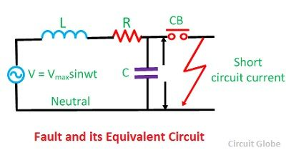
When the fault occurs in the system under fault condition the contacts of the breaker are open, and the capacitance C is short-circuited by the fault, and the short circuit current is limited by the resistance and the inductance.
When the breaker contacts are opened, and the arc certainly quenches at some current zero, a voltage v is suddenly applied across the capacitor and therefore across the circuit breaker contacts. The current i which would flow to the fault is not injected in the capacitor and inductor. Thus
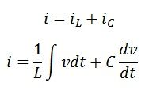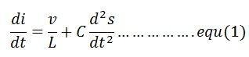
Assuming Zero time at zero currents when t = 0 and the value of current and voltage before opening of circuit breaker is expressed as
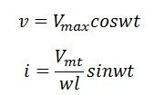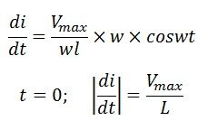
On substituting the above values in equation (1), we get
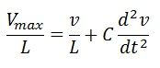
The solution of the standard equation is
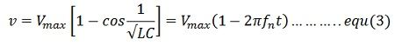
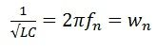
From the equation, The above expression is for restriking voltage where V_{max} is the peak value of recovery voltage (phase -to-neutral) t is time is seconds. L is inductance in Henrys, C is the capacitance in farads and v is the restriking voltage in volts. The maximum value of restriking voltage is 2V_{max} and occurs at

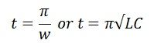

Characteristic of Restriking Voltage
The important characteristic of restriking voltage which affects the performance of the circuit breaker is as follows –
Amplitude Factor – It is defined as the ratio of the peak of transient voltage to the peak system frequency voltage.
The rate of Rising of Restriking Voltage – It is defined as the slope of the steepness tangent of the restriking voltage curve. It is expressed in kV/µs. RRRV is directly proportional to the natural frequency. The expression for the restriking voltage is expressed as
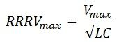
The transient voltage vanishes rapidly due to the damping effect of system resistance, and the normal frequency system voltage is established. This voltage across the breakers contact is called recovery voltage.
The waveforms of recovery and the restricting voltage are shown in the figure above. After the current zero, the voltage appearing across the breaker contacts is composed of transient restriking voltage and power frequency recovery voltage.

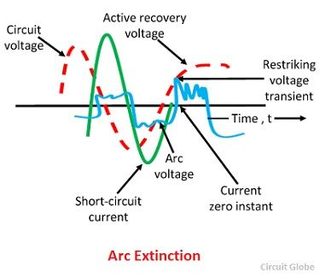

- With a neat sketch explain the principle of vacuum circuit breaker (Nov/Dec 2016)
A breaker which used vacuum as an arc extinction medium is called a vacuum circuit breaker. In this circuit breaker, the fixed and moving contact is enclosed in a permanently sealed vacuum interrupter. The arc is extinct as the contacts are separated in high vacuum. It is mainly used for medium voltage ranging from 11 KV to 33 KV.
Vacuum circuit breaker has a high insulating medium for arc extinction as compared to the other circuit breaker. The pressure inside the vacuum interrupter is approximately 10-4 torrent and at this pressure, very few molecules are present in the interrupter. The vacuum circuit breaker has mainly two phenomenal properties.
  - High insulating strength: In comparison to various other insulating media used in circuit breaker vacuum is a superior dielectric medium. It is better than all other media except air and SF6, which are employed at high pressure.
  - When an arc is opened by moving apart the contacts in a vacuum, an interruption occurs at the first current zero. With the arc interruption, their dielectric strength increases up to a rate of thousands time as compared to other breakers.
The above two properties make the breakers more efficient, less bulky and cheaper in cost. Their service life is also much greater than any other circuit breaker, and almost no maintenance are required.

Construction of Vacuum Circuit Breaker
It is very simple in construction as compared to any other circuit breaker. Their construction is mainly divided into three parts, i.e., fixed contacts, moving contact and arc shield which is placed inside the arc interrupting chamber.
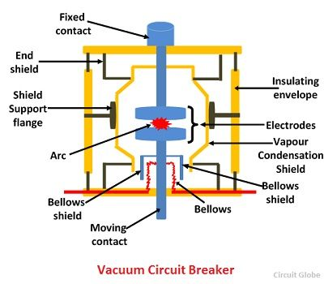
The outer envelope of vacuum circuit breaker is made up of glass because the glass envelope help in the examination of the breaker from outside after the operation. If the glass becomes milky from its original finish of silvery mirror, then it indicates that the breaker is losing vacuum.
The fixed and moving contacts of the breaker are placed inside the arc shield. The pressure in a vacuum interrupter at the time of sealing off is kept at about 10-6 torr. The moving contacts of the circuit breaker are move through a distance of 5 to 10 mm depending upon the operating voltage.
The metallic bellows made of stainless steel is used to move the moving contacts. The design of the metallic bellows is very important because the life of the vacuum circuit breaker depends on the ability of the component to perform repeated operations satisfactorily.

Working Vacuum Circuit Breaker
When the fault occurs in the system, the contacts of the breaker are moved apart and hence the arc is developed between them. When the current carrying contacts are pulled apart, the temperature of their connecting parts is very high due to which ionization occurs. Due to the ionization, the contact space is filled with vapour of positive ions which is discharged from the contact material.
The density of vapour depends on the current in the arcing. Due to the decreasing mode of current wave their rate of release of vapour fall and after the current zero, the medium regains its dielectric strength provided vapour density around the contacts reduced. Hence, the arc does not restrike again because the metal vapour is quickly removed from the contact zone.

Current Chopping in Vacuum Circuit Breaker
Current chopping in vacuum circuit breaker depends on the vapour pressure and the electron emission properties of the contact material. The chopping level is also influenced by the thermal conductivity–lower the thermal conductivity, lower is the chopping level.
It is possible to reduce the current level at which chopping occurs by selecting a contact material which gives out sufficient metal vapour to allow the current to come to a very low value or zero value, but this is rarely done as it affects the dielectric strength adversely.

Vacuum Arc recovery of Vacuum Circuit Breaker
High vacuum possesses extremely high dielectric strength. At zero current the arc is extinguished very quickly, and the dielectric strength is established very quickly. This return of dielectric strength is because of the vaporized metal which is localized between the contacts diffuses rapidly due to the absence of gas molecules. After arc interruption, the recovery strength during the first few microseconds is 1 kV/µs second for an arc current of 100A.
Because of the above-mentioned attribute of vacuum circuit breaker, it is capable of handling the severe recovery transients associated with short-line faults without any difficulty.

Property of contact material
The contact material of the vacuum circuit breaker should have the following property.
  - The material should have high electrical conductivity so as to pass normal load currents without overheating.
  - The contact material should have low resistance and high density.
  - The material should possess high thermal conductivity so as to dissipate rapidly the large heat generated during arcing.
  - The material should have a high arc withstand ability and low current chopping level.

Advantages of Vacuum Circuit Breaker
- Vacuum circuit breaker does not require any additional filling of oil or gas. They do not need periodic refilling.
- Rapid recovery of high dielectric strength on current interruptions that only a half cycle or less arcing occurs after proper contact separation.
- Breaker unit is compact and self-contained. It can be installed in any required orientation.
- Because of the above reasons together with the economic advantage offered, vacuum circuit breaker has high acceptance.

Disadvantage of Vaccum Circuit Breaker
- Requirements of high technology for production of vacuum interrupters.
- It needs additional surge suppressors for the interruption of low magnetizing currents in a certain range.
- Loss of vacuum due to transit damage or failure makes the entire interrupter useless, and it cannot be repaired on site.

Applications of Vacuum Circuit Breaker
- Because of the short gap and excellent recovery of vacuum circuit breaker, they are very useful as very high speed making switches in many industrial applications.
- When the voltage is high and current to be interrupted is low these breakers have definite superiority over the other breakers.
- For low fault interrupting capacities the cost is low in comparison to other interrupting devices.
- Because of the least requirements of maintenance, these breakers are very suitable for the system which requires voltage from 11 to 33 kV

- Briefly describe the testing of circuit breakers (May/Jun 2016-May/June 2014)
Testing of circuit breakers is more difficult as compared to other electrical equipment like transformer or machine because the short circuit current is very large. Testing of the transformer is mainly divided into two groups, type tests, and routine tests.

Type Tests of Circuit Breaker
Type tests are conducted for the purpose of proving the capabilities and confirming the rated characteristic of the circuit breaker. Such tests are conducted in the specially built testing laboratory. Type tests can be broadly classified as the mechanical performance test, thermal test, dielectric or insulating test, short circuit test for checking the making capacity, breaking capacity, short time rating current and operating duty.
Mechanical Test – It is mechanical ability type test involving the repeated opening and closing of the breaker. A circuit breaker must open and close at the correct speed and perform its designated duty and operation without mechanical failure.
Thermal Test – Thermal tests are carried out to check the thermal behavior of the circuit breakers. The breaker under test deal with the steady-state temperature rises due to the flow of its rated current through its pole in a rated condition. The temperature rise for rated current should not exceed 40° for current less than 800A normal current and 50° for normal value of current 800A and above.
Dielectric Test – These tests are performed to check power frequency and impulse voltage withstand capacity. Power frequency tests are kept on a new circuit breaker; the test voltage changes with a circuit breaker rated voltage.
The test voltage with a frequency between 15-100Hz is applied as follows. (1) between poles with circuit breaker closed (2) between pole and earth with circuit breaker open, and (3) across terminals with circuit breaker open.
In impulse tests impulse voltage of specified magnitude is applied to the breaker. For outdoor circuit dry and wet tests are conducted.
Short -Circuit Test – Circuit breakers are subjected to sudden short-circuits in short-circuit test laboratories, and oscillograms are taken to know the behavior of the circuit breakers at the time of switching in, during contact breaking and after the arc extinction.
The oscillograms are studied with particular reference to the making and breaking currents, both symmetrical and asymmetrical restriking voltages, and switchgear is sometimes tested at rated conditions.

Routine Tests of a Circuit Breaker
Various routine tests are performed for ensuring the quality, performance of a circuit breaker and these are
- Power frequency over voltage withstand test
- Dielectric test on auxiliary circuit and control circuit
- Measurement of resistance of main circuit or contact resistance test
- Tightness test or SF6 gas leakage test
- Design and visual checks
- Mechanical operation tests.

Power Frequency Over Voltage Withstand Test
The power system may experience different temporary power over voltage conditions may be due to sudden cut of load from the system, wrong operation of online tap changer, insufficient shunt compensation in the system, etc. Power frequency over voltage withstand test of circuit breaker is performed to verify sufficiency of insulation strength of the main circuit to withstand this kind of abnormal over voltage conditions of the system. The circuit breaker should also be designed to be capable of withstanding over voltages due to lightning and switching impulses. A circuit breaker like other costly engineering equipment, are designed for safely facing all kind of abnormal situations, but at the same time, the designers cannot sacrifice economical aspects. To verify the capability of withstanding all kinds of over voltages conditions without sacrificing the economical aspects of manufacturing, a circuit breaker has to go through and pass different dielectric tests. But only power frequency over voltage withstand test comes under the category of routine test of circuit breakers

One Minute Dry Power Frequency Voltage Withstand Test
It is assumed that over voltage conditions, at power frequency cannot be sustained beyond one minute time moreover it is actually sustained for much less time than one minute duration. This test is carried out to verify whether the insulation provided in the main circuit of breaker is capable of withstanding power frequency over voltages for long one minute duration or not. The test is performed in dry conditions of the breaker. The power frequency voltages, applied to the breaker during the test, are specified in the standard as per the nominal voltage level of the system.
.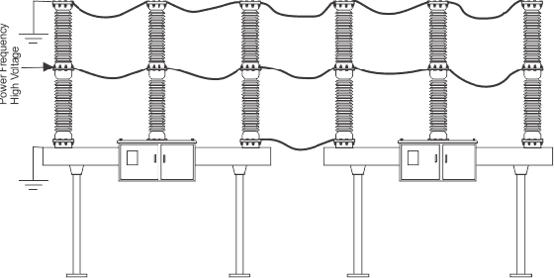
Let us discuss one common example of One Minute Dry Power Frequency Voltage Withstand Test of SF6 Circuit Breaker. Here normally top of all poles of all circuit breakers of same voltage rating to be tested, are connected together preferably by copper conductor. This connection then is earthed properly. Similarly base of all circuit breakers under test is to be properly connected to earth.The buttom of all poles of all circuit breakers under test, are connected together preferably by copper conductor.This connection then is connected to the phase terminal of single phase high voltage cascaded transformer. High voltage transformer used here is a cascaded auto transformer where input voltage can be varied from zero to several hundred volts and corresponding secondary voltage would be zero to several hundred kilo volts. During test the voltage is applied at the button terminal of breakers by high voltage cascaded transformer, and varied from 0 to specified value slowly and gently then stay there for 60 second and then slowly decreased to zero. During test the leakage current to the ground to be measured and the leakage current should not cross the specified maximum allowed limit. Any failure of insulation during test indicates the insufficiency of insulation used in breaker.

Dielectric test on auxiliary and control circuit
There may be abnormal over voltage condition in the auxiliary and control supply circuits, too. Hence, the auxiliary and control circuits of breakers should also be gone through short duration power frequency voltage withstand test. Here test voltage of 2000 V is applied for duration of one minute. The insulation of auxiliary and control circuit should pass this test, and there should not be any destructive discharge during the test.

Measurement of the resistance of main circuit
The resistance of main circuit is measured from DC voltage drop across the circuit. In this test, direct current is injected to the circuit and corresponding voltage drop is measured and from this resistance of the circuit is measured. The injected current would be from 100 A to maximum rated current of the circuit breaker. The maximum measured value can be 1.2 times the value obtained at the temperature rise test.

Tightness Test
This test is carried out on mainly gas insulated switch-gear. In this test, leakage rate is measured. This test ensures the desired lifespan of the switchgear. Here all the jointing points in the gas containing paths are covered air tightly with thin sheets of polythene (preferably transparent) for more than 8 hours and then the gas density inside this covers is measured by inserting gas detecting port of a gas detector through a hole now created on the covers. The measurement is taken in ppm unit and should be within the specified limit.

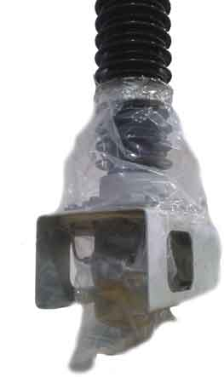
Maximum limit of gas leakage 3 ppm / 8 hours, is taken as standard.

Visual Checks
The circuit breaker should be visually checked for language and data on the templates, proper identification mark of any auxiliary equipment, color and quality of paint and corrosion on metallic surface, etc.

Mechanical Operation Test
The circuit breaker must be smoothly operated at maximum as well as minimum allowable auxiliary and control circuit supply voltage. Closing and tripping operation should be performed at least 5 times for specified maximum allowable control circuit supply voltage as well as specified minimum allowable control circuit supply voltage. The closing and opening operation of circuit breaker are also to be checked for rated supply voltage of control circuit. 110% of control voltage is taken as maximum limit for closing and opening operation of circuit breaker. 85% of control voltage is taken as minimum limit for closing operation of circuit breaker and 70% of control voltage is taken as minimum limit for opening or tripping operation of circuit breaker. During maximum and minimum control voltage operation it would be found that operating times are less and more respectively than that in rated control voltage but all the times should be within specified times limits. If it is applicable, such as in the case of pneumatic circuit breakers, the breaker should also be operated at least 5 times in specified maximum allowable operating pressure, in specified minimum allowable operating pressure and in specified rated operating pressure. A circuit breaker is also intended for rapid auto reclosing; at least 5 open close operating cycles should be checked against specification given on the rating plate. The actual time interval between open and close operations should be tallied with the time interval given in the operating cycle specification. When the circuit breakers are shipped as separate units and reassembled at site, the manufacturer should participate in commissioning test to give confirmation about compatibility of such separate units and components when assembled as a complete circuit breaker. For all required operation sequences, the test should be conducted and all closing and opening operating times along with intervals between two conjugative operations are recorded. Where applicable, the measurements of fluid compression (pressure difference) during circuit breaker operation are also recorded.
No load operating cycle can be performed on the circuit breaker to draw the no-load travel curve. The curve should be within the prescribed envelope of the reference mechanical travel characteristics. NB: The parameters should be measured and recorded during operation test of circuit breaker, are given below
- Closing time of each pole
- Closing time difference between poles or closing mismatch time
- Opening time of each pole
- Opening time difference between poles or opening mismatch time
- Close-Open time of each pole
- Time difference between two conjugative opening operation (O-C-O)
- Maximum bounce of moving contact during closing operation
- Total bounce of moving contact during closing operation
- Over travel of moving contact
- Contact speed for closing in deg/ms (as transducer is of rotary type)
- Contact speed for opening in deg/ms (as transducer is of rotary type)
- Damping time during opening
- Spring charging time
When sub assemblies of circuit breaker are fitted together at site, the mechanical travel characteristics of the breaker should confirm the correctness at the end of the commissioning test on site. If this is done on-site, the manufacturer should prescribe the exact procedure of doing that otherwise the result may be different and the comparison of the instantaneous contact stroke may be impossible to achieve. The mechanical travel characteristics of circuit breaker contacts are produced by using travel transducer or similar device connected to the circuit breaker contacts mechanism.
In addition to this, each connection in the control and auxiliary circuit in the circuit breaker kiosk should be checked. It should also be checked whether control and/or auxiliary switches correctly indicate the open and close position of circuit breaker. All auxiliary equipments should also be operated correctly and smoothly for specified maximum and minimum allowable control voltage supply.

- Discuss in detail the different types of rating of circuit breaker bringing out clearly their physical significance. (Nov/Dec 2015).
The rating of the circuit breaker is given on the duties that are performed by it. For complete specification standard ratings and various tests of switches and circuit breakers may be consulted. Apart from the normal working of circuit breakers, the circuit breaker is required to perform following three major duties under short circuit conditions.
- It is capable of breaking the faulty section of the system. This is described as the breaking capacity of the circuit breaker.
- The circuit breaker must be capable of making the circuit in the greatest asymmetrical current in the current wave. This refers to making the capacity of the circuit breaker.
- It must be capable of carrying fault safely for a short time while the other breaker is clearing the fault. This refers to the short-time capacity of a circuit breaker.
In addition to the above rating, the circuit breakers should be specified in terms of
  - The number of poles
  - Rated voltage
  - Rated current
  - Rated frequency
  - Operating voltage
These terms are explained below in details.
Rated voltage – The rated maximum voltage of the circuit breaker is the highest RMS voltage, above nominal voltage for which the circuit breaker is designed and is the upper limits for operation. The rated voltage is depicted in KVrms and used phase to phase voltage for three phase circuit.
Rated current – The rated normal current of the circuit breaker is the RMS value of the current with which the circuit breaker shall be able to carry at rated frequency and at rated voltage continuously, under specified conditions.
Rated Frequency – The rated frequency of a circuit breaker is the frequency at which it is designed to operate. Standard frequency is 50 Hz
Operating Duty – The operating duty of a circuit breaker consists of the prescribed number of unit operations at stated intervals. The operating sequence refers the opening and closing operation of circuit breaker contacts.
Breaking Contact – The terms expressed the highest number of short-circuit current that the breakers are capable of breaking under specified conditions of transient recovery voltage and power frequency voltage. It is expressed in KA RMS at contact separation. The breaking capacities are divided into two types.
- Symmetrical breaking capacity of a circuit breaker
- Asymmetrical breaking capacity of a circuit breaker.
Making Capacity – There is always the possibility that the circuit breaker is closed under short circuit conditions. The making capacity of the circuit breaker is its ability to withstand under the effect of electromagnetic forces which are directly proportional to the square of the peak value of the making current of a circuit breaker.
The making current of the circuit breaker, when closed on a short circuit, is the peak value of the maximum current wave (including dc component) in the first cycle of the current after the circuit is closed by the circuit breaker.
Short Circuit Current – The short circuit current of a circuit breaker is the RMS value of current that a breaker can carry in a fully closed condition without damage, for the specified time interval under prescribed condition. It is normally expressed regarding terms of KA for 1 second or 4 seconds. These ratings are based on thermal limitation.
Low voltage circuit breaker does not have any such short circuit current because these are normally equipped with straight acting series overload trips.
- Explain the terms: restriking voltage, recovery voltage, RRRV. Derive the expressions for restriking voltage and RRRV in terms of system voltage, inductance and capacitance. (Nov/Dec 2014)
Restriking voltage: It may be defined as the voltage that appears across the breaking contact at the instant of arc extinction.
Recovery voltage: It may be defined as the voltage that appears across the breaker contact after the complete removal of transient oscillations and final extinction of arc has resulted in all the poles.
Rate of Rise of Restriking Voltage (RRRV): It is defined as the ratio of peak value of restriking voltage to time taken to reach to peak value. It is one of the most important parameter as if the rate at which the dielectric strength developed between the contacts is greater than RRRV, and then the arc will be extinguishes.

When the current across the contact of the circuit breaker is zero, a high-frequency transient voltage develops in the whole breaker contact and is produced by the sudden distribution of energy between the electric and magnetic field. This transient voltage is called restriking voltage. The voltage appears across the breaker contacts at the moment of final current has a serious influence on the arc extinction process. Under the influence of this voltage, the arc tries to restrike and hence it is named as the restriking voltage.

After the zero current, the arc gets extinguished, if the rate of rising of restriking voltage between the contact is less than the rate at which the dielectric strength of the medium between the contact gains. Immediately after the final current interruption, the voltage that appears across the breaker contacts (transient voltage) superimposed on the power frequency system voltage (recovery voltage).

Considered a simple circuit, having a circuit breaker CB, as shown in the figure below. Let L be the inductance per phase of the system up to the fault point; R be the resistance per phase of the system up to the fault point, and C be the capacitance of the circuit.
When the fault occurs in the system under fault condition the contacts of the breaker are open, and the capacitance C is short-circuited by the fault, and the short circuit current is limited by the resistance and the inductance.
When the breaker contacts are opened, and the arc certainly quenches at some current zero, a voltage v is suddenly applied across the capacitor and therefore across the circuit breaker contacts. The current i which would flow to the fault is not injected in the capacitor and inductor. Thus
Assuming Zero time at zero currents when t = 0 and the value of current and voltage before opening of circuit breaker is expressed as
On substituting the above values in equation (1), we get
The solution of the standard equation is
From the equation, The above expression is for restriking voltage where V_{max} is the peak value of recovery voltage (phase -to-neutral) t is time is seconds. L is inductance in Henrys, C is the capacitance in farads and v is the restriking voltage in volts. The maximum value of restriking voltage is 2V_{max} and occurs at

Characteristic of Restriking Voltage
The important characteristic of restriking voltage which affects the performance of the circuit breaker is as follows –
Amplitude Factor – It is defined as the ratio of the peak of transient voltage to the peak system frequency voltage.
The rate of Rising of Restriking Voltage – It is defined as the slope of the steepness tangent of the restriking voltage curve. It is expressed in kV/µs. RRRV is directly proportional to the natural frequency. The expression for the restriking voltage is expressed as
The transient voltage vanishes rapidly due to the damping effect of system resistance, and the normal frequency system voltage is established. This voltage across the breakers contact is called recovery voltage.
The waveforms of recovery and the restricting voltage are shown in the figure above. After the current zero, the voltage appearing across the breaker contacts is composed of transient restriking voltage and power frequency recovery voltage.

- With necessary diagrams describe the recovery rate theory and energy balance teory of arc interruption in a circuit breaker. (Nov/Dec 2014)
Energy Balance Theory: When the contact of circuit breaker are about to open, restriking voltage is zero, hence generated heat would be zero and when the contacts are fully open there is infinite resistance this again make no production of heat. We can conclude from this that the maximum generated heat is lying between these two cases and can be approximated, now this theory is based on the fact that the rate of generation of heat between the the contacts of circuit breaker is lower than the rate at which heat between the contact is dissipated. Thus if it is possible to remove the generated heat by cooling, lengthening and splitting the arc at a high rate the generation, arc can be extinguished.
Voltage Race Theory : The arc is due to the ionization of the gap between the contact of the circuit breaker. Thus the resistance at the initial stage is very small i.e. when the contact are closed and as the contact separates the resistance starts increasing. If we remove ions at the initial stage either by recombining them into neutral molecules or inserting insulation at a rate faster than the rate of ionization, the arc can be interrupted. The ionization at zero current depends on the voltage known as restriking voltage.
Let us define an expression for restriking voltage. For loss-less or ideal system we have,
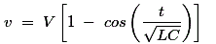
Here, v = restriking voltage. V = value of voltage at the instant of interruption. L and C are series inductor and shunt capacitance up to fault point. Thus from above equation we can see that lower the value of product of L and C, higher the value of restriking voltage. The variation of v versus time is plotted below:
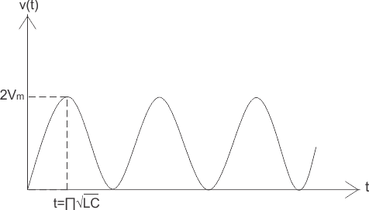
Now let us consider a practical system, or assume there finite loss in the system. As figure shown below, in this case the restriking voltage is damped out due to the presence of some finite resistance. Here it is assumed that the current lags behind the voltage by an angle(measured in degrees) of 90. However in practical situation angle may varies depending upon time in cycle at which the fault is occurred.
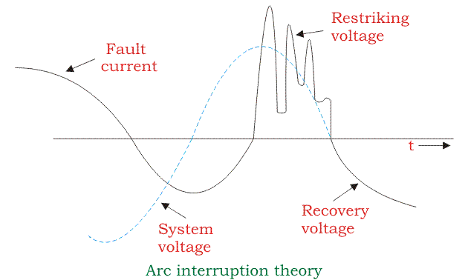Let us consider the effect of arc voltage, if arc voltage is included in the system, there is an increment in the restriking voltage. However this is offset by another effect of an arc voltage which opposes the current flow and making change in the phase of current, thus bringing it more into phase with the applied voltage. Hence the current is not at its peak value when voltage passes through zero value.
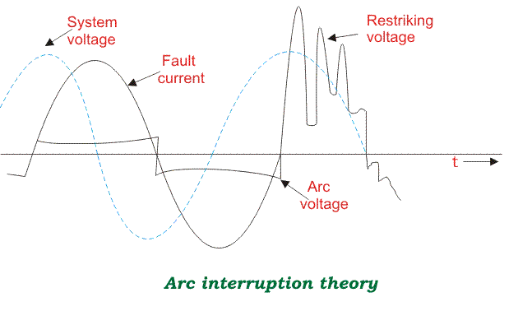

- Explain the phenomenon of current chopping in a circuit breaker. (Apr/May 2017)
Current Chopping in circuit breaker is defined as a phenomena in which current is forcibly interrupted before the natural current zero. Current Chopping is mainly observed in Vacuum Circuit Breaker and Air Blast Circuit Breaker. There is no such phenomena in Oil Circuit Breaker. Current chopping is predominant while switching Shunt Reactor or unloadedTransformer.

Theory of Current Chopping
Generally the arc extinction in a circuit breaker take place at natural current zero. But this is true if the capacity of the breaker to extinguish the arc is varies with the level of fault current. This means that, the arc extinction capability of breaker will always ensure that arc extinction is taking place at natural current zero.
Now, let us assume Air Blast Circuit Breaker. In Air Blast Circuit Breaker or Vacuum Circuit Breaker, the fault clearing capacity is fixed and independent of the fault current level. In this case, when breaker is used to break the circuit of unloaded transformer or shunt reactor, the current will be brought to zero well before the natural current zero. This is because, the breaker is interrupting only the magnetizing current which is very less compared to full load current or fault current. As the capability of breaker arc extinction is high enough, therefore the low magnetizing current will be brought to zero before the natural current zero position. This phenomena is known as Current Chopping. Let us understand current chopping in detail.
Consider a shunt reactor as shown in figure below.
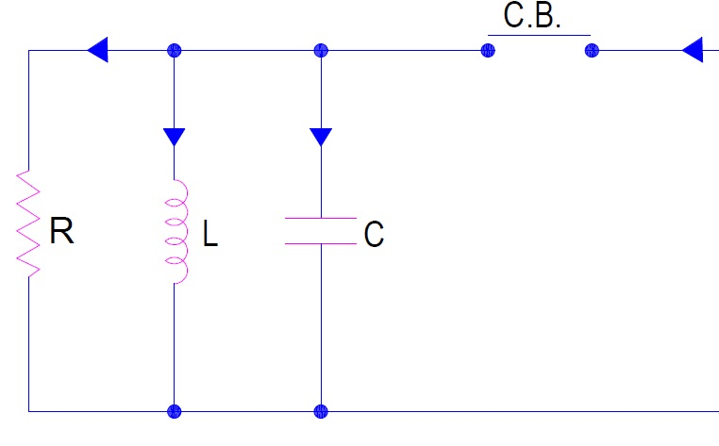
In the figure above, L is the inductance of shunt reactor, C is the capacitance of winding and R is for eddy current loss in the reactor. Breaker in the figure above is Air Blast Circuit Breaker.
We know that shunt reactor always takes magnetizing current. This magnetizing current is, of course, low. Under normal condition, the current flowing through the reactor is I (say) and hence the stored magnetic energy in it is (LI2 / 2). But as soon as the breaker is open, current chopping will take place and the current through the reactor becomes zero. Due to this sudden drop of current through the inductor, a high voltage will be developed across it according to Faraday’s Law. Therefore, the voltage across the capacitor will also rise. Now, the question arises, where did the store energy of reactor go?
The stored energy in the inductance of reactor is basically transferred to the capacitor. Therefore mathematically we can write as
LI2 / 2 = CV2 / 2
Here V = Voltage across the capacitor
Thus, V = 1 I √(L/C)
This is the prospective voltage across the capacitor during current chopping. Notice that this prospective voltage is above the natural voltage of the system. This means that there will be a high voltage stress on the shunt reactor during current chopping. Note that the prospective voltage V is directly proportional to the value of current chopped and the surge impedance of the reactor.
Let us consider a simple example to have an idea of magnitude of prospective voltage. Let the value of L = 64 mH and C = 0.001 uF then the induced voltage for a chopping current of 10 A will be
V = 10x√(64×10-3 / 0.001×10-6 )= 80 kV
Thus we see that, the magnitude of V is quite high. Again, if this voltage V is high enough, then it may lead to the restrike of arc in the breaker and thus current again start to flow through the circuit. Again, there will be chopping of current and but this time the level of current chopped will reduce and therefore the voltage stress on the reactor is less. Thus a number of current chopping will take place till the prospective voltage become low enough torestrike the arc.
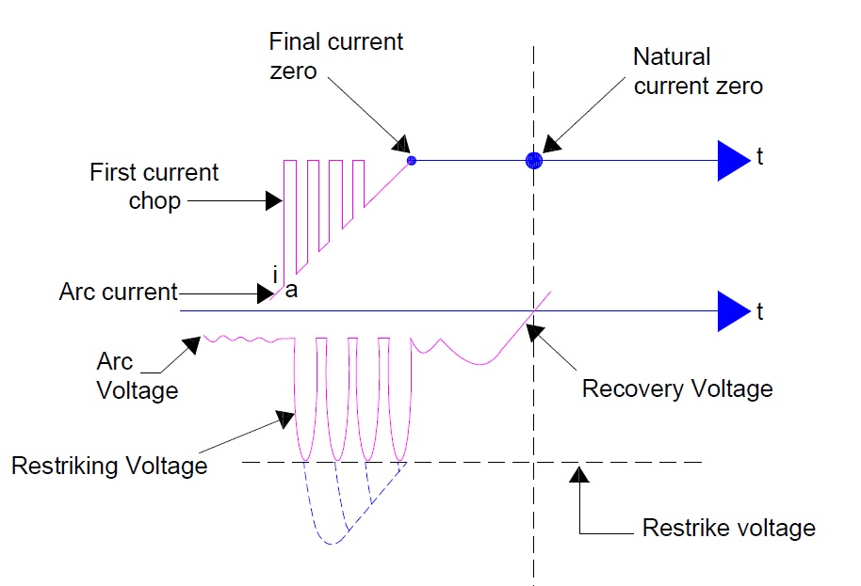
Carefully observe the figure above. In the figure you can see, 4 current chopping. In each current chopping the magnitude of current reduces. This is because of dampening effect of losses in the equipment like eddy current loss and hysteresis loss.
- Briefly Explain the Phenomenon of arc extinction in circuit breaker.
Factors responsible for the maintenance of arc between the contacts. These are :
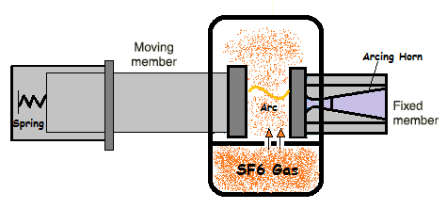

  - potential difference between the contacts.
  - ionised particles between contacts
Taking these in turn, When the contacts have a small separation, the p.d. between them is sufficient to maintain the arc. One way to extinguish the arc is to separate the contacts to such a distance that p.d. becomes inadequate to maintain the arc.
However, this method is impracticable in high voltage system where a separation of many meters may be required.
The ionised particles between the contacts tend to maintain the arc. If the arc path is deionised, the arc extinction will be facilitated. This may be achieved by cooling the arc or by bodily removing the ionised particles from the space between the contacts.

Methods of Arc Extinction in Circuit Breaker
There are two methods of extinguishing the'arc in circuit breakers
- High resistance method
- Low resistance or current zero method.

1. High Resistance Method
In this method, arc resistance is made to increase with time so that current is reduced to a value insufficient to maintain the arc. Consequently, the current is interrupted or the arc is extinguished.
The principal disadvantage of this method is that enormous energy is dissipated in the arc. Therefore, it is employed only in d.c. circuit breakers Land low-capacity a.c. circuit breakers.

The resistance of the arc may be increased by
- Lengthening the arc - The resistance of the arc is directly proportional to its length. The length of the arc can be increased by increasing the gap between contacts.
- Cooling the arc - Cooling helps in medium between the contacts. This increases the arc may be obtained by a gas resistance. Efficient cooling blast directed along the arc.
- Reducing X-section of the arc - If the area of X-section of the arc is reduced, the voltage necessary to maintain the arc is increased. In other words, the resistance of the arc path is increased. The cross-section of the arc can be reduced by letting the arc pass through a narrow opening or by having smaller area of contacts.
- Splitting the arc - The resistance of the arc can be increased by splitting the arc into a number of smaller arcs in series. Each one of these arcs experiences the effect of lengthening and cooling. The arc may be split by introducing some conducting plates between the contacts.

Low Resistance or Current zero Method
This method is employed for arc extinction in AC Circuits only.
In this method, arc resistance is kept low until current zero where the arc extinguishes naturally and is prevented from restriking inspite of the rising voltage across the contacts.
All modern high power AC Circuit Breakers employ this method for arc extinction.
In an a.c. system, current drops to zero after every half-cycle. At every current zero, the arc extinguishes for a brief moment.
Now the medium between the contacts contains ions and electrons so that it has small dielectric strength and can be easily broken down by the rising contact voltage known as restriking voltage.
If such a break-down does occur, the arc will persist for another half-cycle. If immediately after current zero, the dielectric strength of the medium between contacts is built up more rapidly than the voltage across the contacts, the arc fails to restrike and the current will be interrupted. The rapid increase of dielectric strength of the medium near current zero can be achieved by
(a) Causing the ionised particles in the space between contacts to recombine into neutral molecules.
(b) Sweeping the ionised particles away and replacing them by unionized particles.
Therefore, the real problem in AC arc interruption is to rapidly deionise the medium between contacts as soon as the current becomes zero so that the rising contact voltage or restriking voltage cannot breakdown the space between contacts. The de-ionization of the medium can be achieved by :
(i) Lengthening of the gap : The dielectric strength of the medium is proportional to the length of the gap between contacts. Therefore, by opening the contacts rapidly, higher dielectric strength of the medium can be achieved.
(ii) High pressure. If the pressure in the vicinity of the arc, is increased, the density of the particles constituting the' discharge also increases. The increased density of particles causes higher rate of de-ionisation and consequently the dielectric strength of the medium between contacts is increased.
(iii) Cooling: Natural combination of ionised particles takes place more rapidly if they are allowed to cool. Therefore, dielectric strength of the medium between the contacts can be increased by cooling the arc
(iv) Blast effect: If the ionised particles between the contacts are swept away and replaced by un-ionised particles, the dielectric strength of the medium can be increased consider-ably. This may be achieved by a gas blast directed along the discharge or by forcing oil into the contact space.

