**UNIT IV**

**PART-A:**

1. **What is meant by permeance co-efficient? [May/June 2012]**

It is also called the load line, B/H (or) operating slope of a magnet. This is the line on the demagnetization curve where a given magnet operates.

1. **A permanent magnet DC commutator motor has a stalling torque of 1 Nm. The stall current is 5 A. Compute the motor's no-load speed if it is fed with 28 V DC supply. [Nov/Dec 2012]**















1. **What is commutation? [May/June 2013]**

Commutation is the process of turning off the SCR (or) switch. The device which is used to measure the rotation of machine which is placed internally and based on it feedback is taken out.

1. **Compare permanent magnet brushless DC motor with permanent magnet synchronous motor. [May/June 2013]**

|  |  |  |
| --- | --- | --- |
| **S.No** | **PMBLDC** | **PMSM** |
| 1. | Rectangular distribution of magnetic flux in the air gap. | Sinusoidal or quasi-sinusoidal distribution of magnetic flux in the air gap. |
| 2. | Rectangular current waveform. | Sinusoidal or quasi sinusoidal current waveforms. |
| 3. | Concentrated stator winding. | Quasi sinusoidal distribution of stator conductors. |

1. **What is meant by demagnetization in PMBLDC motor? [Nov/Dec 2014 April/May 2015]**

During the normal operation of motor, when the torque and back emf are constant, if the field flux level becomes low, then demagnetisation occurs.

1. **Name the position sensor used that are used for PMBL DC motor.**
2. Optical position sensor
3. Hall effect position sensor
4. **What is hall sensor?**

A sensor which is operated with hall effect principle. It is called hall sensor. It is used to sense the rotor position of the BLPM DC motor.

1. **What is optical sensor?**

A sensor is operated with photo transistor. It is the optical sensor. It is used to sense the rotor position of the BLPM DC motor.

1. **What are the materials used for making Hall IC pallet?**
2. Indium-Antimony
3. Gallium-Arsenide
4. **What is PMDC commutator motor?**

A dc motor consists of PM in the stator and armature winding, commutator in the rotor. This motor is called PMDC commutator motor.

1. **Name the two comparators used in the power controllers of PMBLDC motors?**
2. Speed Comparator
3. Current Comparator
4. **Define magnetic permanence?**

It is defined as the magnetic flux density which persists in the magnetic materials even though the magnetizing forces are removed.

1. **What is coercive forces?**

It is defined as the demagnetizing force which is necessary to neutralize completely the magnetism in an electromagnet after the value of magnetizing force becomes zero. The above demagnetizing force is obtained by an increasing negative field strength, which is called as coercive field.

1. **What are position sensors?**

The position sensors detect the position of the rotating magnets and send logic codes to a commutation decoder which, after processing this code, activates the firing circuits of semiconductor switches feeding power to the stator winding of the drive motor. The reliable position sensing techniques do not involve contact between stationary and moving parts.

1. **What are the ways by which demagnetization can be limited in permanent magnet?**

There are several ways to limit the demagnetization. One way is to keep the current below the maximum value and another way is use of pole shoes to a permanent magnet to collect the flux and then transfer it to the air gap.

1. **Define the energy product and maximum energy product of a permanent magnet.**

The absolute values of the product of the flux density and the field intensity at each points along the demagnetization curve is called energy product. The maximum value of the energy product is called maximum energy product and this quantity is one of the strengths of the permanent magnet.

1. **State the advantages of brushless configuration.**
2. Brush maintenance is no longer required.
3. Sparking associated with brushes are eliminated.
4. The absence of commutator and brush gear reduces the motor length.
5. The brushless magnet motors will have better efficiency and greater output power.
6. **What is PMBLDC machine? [Nov/Dec 2010]**

Permanent Magnet Brushless DC Machine, DC motors with solid state switches performing the function of commutation and that too brushless making those maintenance free motors are known as PMBLDC.

1. **What is electronic commutation? [Nov/Dec 2010]**

Power electronic switching devices used in commutator with the utilisation of position sensor are known as electronic commutation.

1. **How are the directions of rotations reversed in case of PMBLDC motor? [Nov/Dec 2011]**

The directions of rotation of PMBLDC motor can be reversed by changing the signals of the commutator and sensor arrangement.

1. **What is meant by permanence co-efficient? [May/June 2014]**



In the demagnetization characteristics, the line drawn from the origin through the operating point is called the load line and absolute value of its slope normalized to µo is called the permeance co- efficient.

1. **What are the advantages and disadvantages of brushless de motor drives?**

**[Nov/Dec 2012]**

**Advantages**

1. There is no field winding so that field copper loss is neglected.
2. Length of the motor is very small as there is no mechanical commutator, so thatsize becomes very small.
3. Better ventilation because of armature accommodated in the stator.
4. Regenerative braking is possible.
5. Speed can be easily controllable.
6. Motor can be designed for higher voltages subjected to the constraint caused bythe power semi conductor switching circuit.
7. It is possible to have very high speeds.

**Disadvantages**

1. Motor field cannot be controlled
2. Power at1g is restricted because of the maximum available size of permanentMagnets.
3. It requires a rotor position sensor.
4. It requires a power semi conductor switching circuit.
5. **List the various permanent magnet materials. [May/June 2007 May/June 2009]**
6. Alnico
7. Rare-earth magnet
8. Ceramic magnet
9. NdFeB magnet
10. Sm2 CO17 magnet

1. **What is permanent magnet DC commutator motor?[Nov/Dec 2007]**

PMDC motor is the second stage of evolution of conventional DC motor. The main difference in construction of the PMDC motor from conventional DC motor is the stator poles are replaced by suitable permanent magnets. Because of the presence of permanent magnets in PMDC motors there is no need to have field windings.

1. **Give the merits of PMBLDC motor compared to conventional motor.[April/May 2008]**
2. Low Maintenance
3. Motor size is small
4. Rotor has permanent magnets.
5. **Draw the magnetic circuit of 2 pole permanent magnet brushless dc motor**

**[Apr/May 2010 Nov/Dec 2013]**

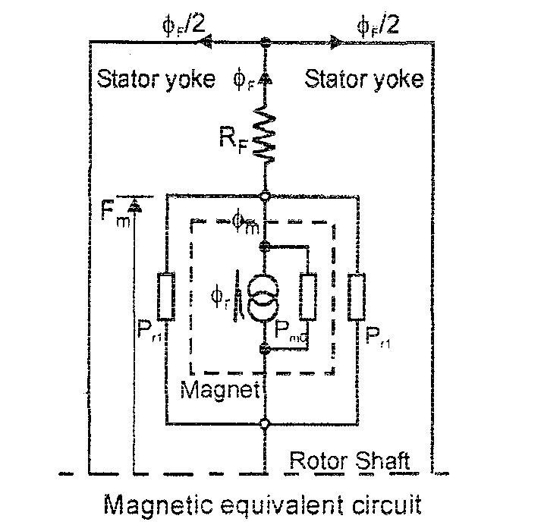

1. **What are the differences between mechanical and electronic commutators?[Nov/Dec 2013 Nov 2016]**

|  |  |
| --- | --- |
| **Mechanical Commutator** | **Electronic Commutator** |
| Commutator is made up of commutator segments and mica insulation. Brushes are made up of carbon or graphite. | Power electronic switching devices are used in the commutator. |
| Commuatator arrangement is located in the rotor. | Commutator arrangement is located in the stator. |
| Shaft position sensing is inherent in the arrangement. | It requires a separate rotor position sensor. |
| Number of commuatator segments are very high. | Number of switching devices is limited to 6. |
| Sliding contact between commutator and brushes. | No sliding contacts. |
| Sparking takes place. | There is no sparking. |
| It requires a regular maintenance. | It is possible to get the feed back from the stored energy in the magnetic field to the mains. It requires less maintenance. |
| Difficult to control the voltage available across tappings. | Voltage available across armature tappings can be controlled by PWM techniques. |
| High reliable. | Reliability can be improved by specially designed devices and protecting circuits. |

1. **Write the torque and emf equation of square wave brushless motor.[April/May 2010 April 2017]**

Emf equation: eph = 4’Bg r l Tphωm volts

Where Bg = flux density in the airgap, r = radius of the airgap,

l = length of the armature, ωm = angular velocity in mech. rad/sec.

Tph = number of turns per phase

Torque equation: T = 4 Bgr l TphI N-m

1. **Mention some applications of PMBLDC motor.[May/June 2007 April/May 2009]**
2. Power alternators
3. Automotive applications
4. Computer and Robotics applications
5. Textile and Glass industries
6. **Compare conventional dc motor and PMBLDC motor. [Nov/Dec 2012]**

|  |  |  |
| --- | --- | --- |
| **Features** | **Conventional DC motor** | **PMBLDC motor** |
| Mechanical structure  Maintenance  Winding connection  Commutation method  Detectingmethod  Reversing method | Field magnets on the stator  Maintenance is high  Ring connection  The simplest: Delta connection  Mechanical contact between brushes and commutator  Automaticallydetectedby brushes  By a reverse of terminal voltage. | Field magnets on the rotor  Low maintenance  The highest grade: Dell or star- connected three phase connection.  Normal: star-connected three phase winding with grounded neutral point or four-phase connection. The simplest: Two-phase connection.  Electronic switching using  power semi conductor devices  ie. transistors, MOSFETS.  Rotor position can be detected by using sensor i.e., Hall sensor; optical encoder.  Rearranging logic sequencer |

1. **Why is the PMBLDC motor called electronically commutated motor?**

The PMBL DC motor is also called electronically commutated motor because thephase windings of PMBLDC motor is energized by using power semiconductorswitching circuits, Here, the power semiconductor switching circuits act as acommutator.

1. **What is the classification of BLPM dc motor? [Apr/May-2011 Apr/May 2015]**
2. BLPM square wave motor
3. BLPM sine wave motor
4. **What are the two types of BLPM SQWDC motor?**
5. 180° polearc BLPM square wave motor
6. 120° polearc BLPM square wave motor
7. **What are the relative merits of the brushless dc motor drives?[Nov 2016]**

**Advantages**

1. There is no field winding so that field copper loss is neglected.
2. Length of the motor is very small as there is no mechanical commutator, so thatsize becomes very small.
3. Better ventilation because of armature accommodated in the stator.
4. Regenerative braking is possible.
5. Speed can be easily controllable.
6. Motor can be designedfor higher voltages subjected to the constraint caused bythe power semi conductor switching circuit.
7. It is possible to have very high
8. **Draw the circuit diagram of electronic commutator. (Apr/May-08)**

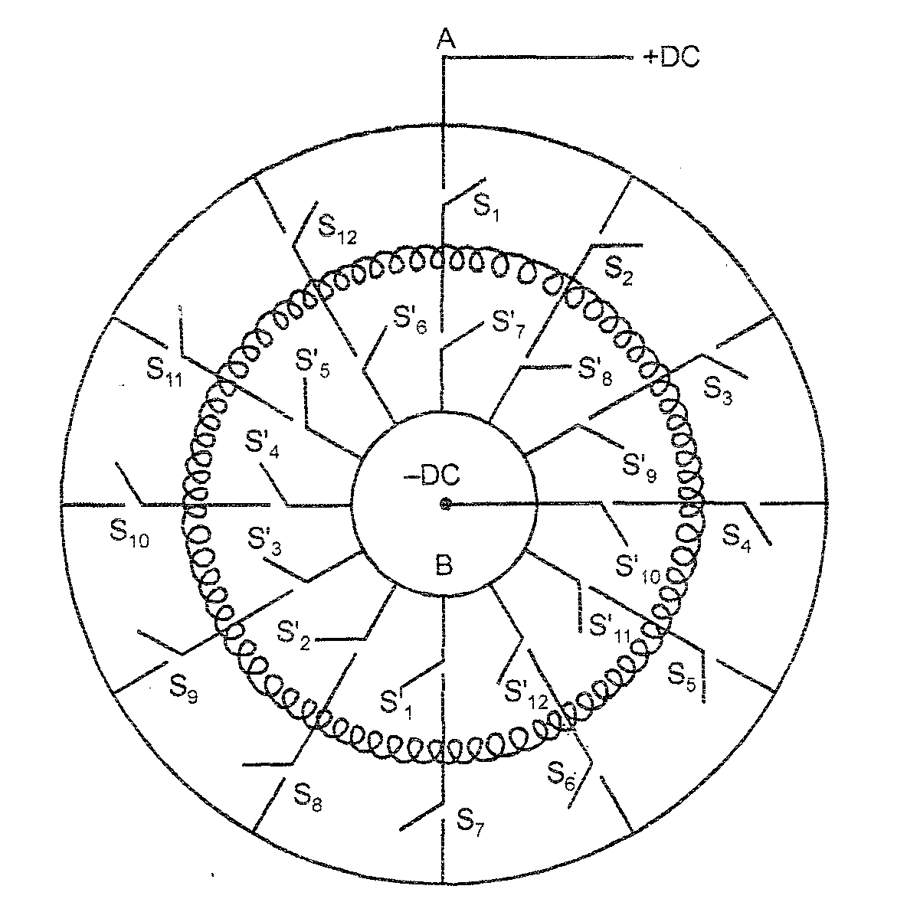

1. **Compare PMBLDC motor and switched reluctance motor.[Apr/May 2010]**

|  |  |  |
| --- | --- | --- |
| **S.No.** | **PMBLDC motor** | **Switched Reluctance Motor** |
| 1. | Rotor is a permanent magnet. | No permanent magnet in the rotor. |
| 2. | High cost. | Cost is less compared with PMBLDC motor. |
| 3. | Torque = 4 BgrlITph |  |
| 4. | More efficient. | Less efficient. |

1. **Write the principle of operation of PM-BLDC motor? [Nov/Dec 2014]**

When Dc supply is switched on to the motor the armature winding draws a current. The current distribution within the stator winding depends upon rotor position and the devices turned on. An emf perpendicular to the permanent magnet field is set up. Then the armature conductors experience a force. The reactive force develops a torque in the rotor.

1. **What is an electronic commutator? [April 2017]**

The electronic commutator is equipment used in PMBLDC motor to transfer the current to the armature. In this, power semiconductor devices are used as switched devices. Usually six switching devices are employed in a normal electronic commutator. Hence, the armature should have three tappings, which can be connected in either star or in delta.

**PART – B**

1. **Describe the construction of a permanent magnet dc motor. What are the advantages and disadvantages of PMDC motors compared with conventional shunt dc motors. [May/June 2007 Nov/Dec 2013 Nov 2016 April 2017].**

**Constructional Features of BLPM Motors**

The BLPMDC motors can be constructed in several different physical configurations. Main two types are,

1. Conventional [Also known as in runner] configuration
2. Out runner configuration

In the conventional in runner configuration, the permanent magnets are mounted on the rotor. The stator armature windings surround the core.

In the out runner configuration, the radial relationship between the coils and magnets is reversed. (i.e.,) the stator coils form the center (core) of the motor, while the permanent magnets spin on an over hanging rotor, which surrounds the core.

Here, let us study about the conventional (in runner) configuration of BLPM motor. The following Fig. shows the arrangement of permanent magnet in the motor. As this is an ‘in runner’ configuration, the stator surrounds the rotor.

**Stator**

The stator of the BLPMDC motor is made up of silicon steel stampings with slots in its interior surface. These slots accommodate either a closed or opened distributed armature winding. Usually it is closed one. This winding is to be wound for a specified (even) number of poles and the winding is suitably connected to a d.c supply through a power electronic switching circuitry [named as electronic commutator].

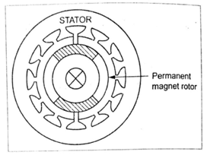

**Fig. Construction of BLPMDC motor**

**Rotor**

The rotor is made of forged steel. The rotor accommodates permanent magnet. The number of poles of the rotor is same as that of the stator. The rotor shaft carries a rotor position sensor. This position sensor provides information about the position of the shaft at any instant to the controller which sends suitable signals to the electronic commutator.

**Armature winding**

For normal electronic commutator, usually six switching devices are employed. Then the winding should have three tappings.

There are also two electrical configurations having to do with how the wires form the windings are connected to each other [not their physical shape or location]. The delta configuration, as already known, connects the three windings to each other [series circuit ] in a triangle-like circuit, and power is applied at each of the connections.

The wye (“Y” – shaped) configuration, called a star winding, connects all of the windings to a central point [parallel circuit] and power is applied to the remaining end of each winding.

The BLDC motor with windings in delta configuration gives low torque at low rpm, but can give higher ranges of rpm. Wye configuration gives high torque at low rpm, but he motor cannot be operated in higher rpm ranges.

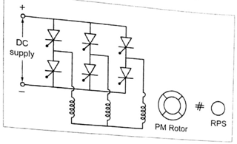

**Fig. Star (WYE-Y) connected stator armature winding**

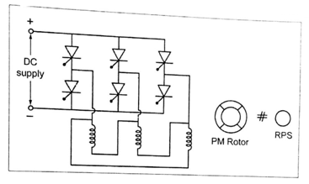

**Fig. Delta (Δ) connected stator armature winding**

Although the efficiency is greatly affected by the motor’s construction, the wye winding is normally more efficient. Delta-connected windings can allow high-frequency parasitic electrical currents to circulate entirely within the motor. A wye-connected winding does not contain a closed loop in which parasitic currents can flow, preventing such losses.

From the controller point of view, the two types of windings are treated exactly the same, although some less expensive controllers are needed to read the voltage from common centre of the wye winding.

The circuits shown in Fig. are same as that of the 3 phase bridge inverter, but the switching of power devices in the two circuits are influenced by rotor position sensor.

Hence like other machines, the BLPMDC motor has stator and rotor. The stator carries the armature and the rotor carries the permanent magnet. So, the permanent magnets rotate and armature remains static. In all BLDC motors, the stator-armature coils are stationary.

**Advantages**

1. There is no field winding so that field copper loss is neglected.
2. Length of the motor is very small as there is no mechanical commutator, so thatsize becomes very small.
3. Better ventilation because of armature accommodated in the stator.
4. Regenerative braking is possible.
5. Speed can be easily controllable.
6. Motor can be designed for higher voltages subjected to the constraint caused bythe power semi conductor switching circuit.
7. It is possible to have very high speeds.

**Disadvantages**

1. Motor field cannot be controlled
2. Power at1g is restricted because of the maximum available size of permanentMagnets.
3. It requires a rotor position sensor.
4. It requires a power semi conductor switching circuit.
5. **Explain the principle of operation of permanent magnet brushless dc motor.[Nov/Dec 2007]**

**Principle of Operation of PMBLDC Motor**

The brushless permanent magnet DC motor is a synchronous electric motor which is powered by DC supply and it has an electronically controlled commutation system, instead of a mechanical commutation system based on brushes. In these motors, the current and torque, voltage and rpm are linearly related.

In order to study the principle of operation of permanent magnet brushless DC motor. Let us analysis, the starting and dynamic equilibrium conditions which will enable to understand the process of electromechanical power transfer in PMBLDC motor.

**Starting**

When d.c. supply is given to the motor, the armature winding draws a current. The current distribution within the stator armature winding depends upon the rotor position and the devices turned on. This current sets up an mmf which is perpendicular to the main mmf set up by the permanent magωωnet field. According to Fleming’s left hand rule, a force is experienced by the armature conductors. As it is in the stator, a reactive force develops a torque in the rotor. If this developed torque is more than the load torque and frictional torque, the motor starts rotating. It is a self-starting motor.

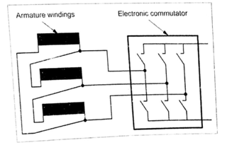

**Fig. Principle of a permanent magnet excited DC motor equivalent circuit**

**Dynamic equilibrium [steady-state]**

As the motor picks up speed, there exists a relative velocity between the stationary armature conductors & the rotating rotor. Therefore, according to Faraday’s law of electromagnetic induction, an emf is dynamically included in the armature conductors. As per Len’z law, this emf opposes the cause [armature current (i.e.,) the current drawn from the mains]. As the supply voltage is maintained constant, the current drawn is reduced. Thus the developed torque is reduced.

When the developed torque is exactly equal to the opposing load torque, the rotor attains a steady state speed. Thus the motor attains a stead state condition.

**Electro mechanical power transfer**

When the torque is increase, the speed tends to fall. Therefore it reduces the back emf induced in the armature. Then the current drawn from the mains increased. Therefore more torque is developed. The motor attains the new equilibrium condition, when the developed torque is equal to the new load torque.

Now the power drawn from the supply (V× I) equals the mechanical power developed and the power loss in the machine and in the switching circuitry. Vice-versa takes place when the load torque (TL) is reduced.

1. **Illustrate in detail the operation of PMBLDC motor with 180o magnetic arcs and 120o square wave phase currents. [Nov/Dec 2012]**

**Types**

The BLMDC motor can be classified on the basis of flux-density distribution in the airgap of the motor. They are,

1. BLPM sqauare wave DC motor
2. BLPM sine wave DC motor
3. **BLPM square wave DC motor**

There are two types of BLPM square wave DC motor, they are,

1. 180° magnetic pole are BLPM square wave DC motor
2. 120° pole are BLPM square wave DC motor

**180° magnetic pole are BLPM square wave DC motor**

The airgap flux density distributin in 180° BLPM square wave motor is shown in the following Fig.

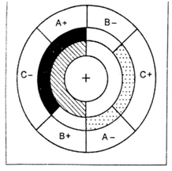

**Fig. (a) BLDC motor with 180° magnet arc and 120° square wave phase currents**

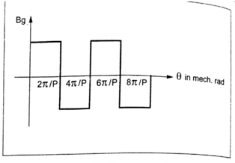

**Fig. (b) Airgap flux density distribution of 180° pole arc BLPM square wave DC motor**

The airgap flux density distribution of BLPMDC square wave motor with 120° pole arc is shown in the following Fig.

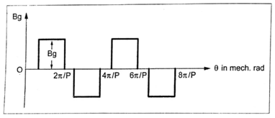

**Fig. Airgap flux density distribution of 120°pole arc BLPM sqaure wave DC motor**

The phase windings are assumed to be star connected as in the Fig.

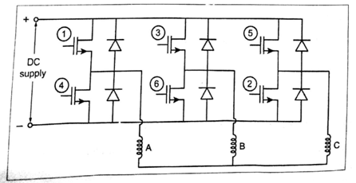

**Fig. Converter for brushless DC motor with star connected phase winding**

The permanent magnet rotor position is shown at ωt = 0° in the Fig.4.14(a). The rotor magnetic poles are shaded to distinguish north and south. The phase belts are shaded as a complete 60° sectors of the stator bore. There are two slots in each of these phase belts. These slots carry identical currents and the condutors in these slots are normally connected in series. In the Fig. (a), in between the rotor ring and the stationary phase belt ring there is a third ring called the ‘mmf ring’. This represents the mmf distribution of the stator currents at a particular instant.

**Case (i): At ωt = 0**

At this position, the phase A is conducting positive current and phase C is conducting negative current. The resulting mmf distribution of stator phase belts has the same shading as that of the N and S poles of the rotor. (i.e.,) the polartiy of mmf distribution is the same as that of the flux density distribution of the rotor. Thus a positive torque is developed. But if the mmf and flux shadings are unlike, then negative torque is produced.

The total torque is the integral of the contributions from around the entire peripher of the airgap. Now the rotor is rotating futher in clockwise direction.

After 60° of rotation, the rotor starts to uncover the phase belt C and therefore as the rotor rotates furtehr, the torque contribution of phase C starts decreasing linearly.

**Case (ii): At ωt = 120°**

To maintain the torque constant, the positive current from phase A is commutated to phase C. The torque developed remains same and the rotor rotates further 60°.

**Commutation table**

**180° magnetic pole arc-star connected -120° square wave phase currents.**

|  |  |  |  |  |  |  |  |  |  |
| --- | --- | --- | --- | --- | --- | --- | --- | --- | --- |
| **Rotor Position** | **A** | **B** | **C** | **au(1)** | **aL(4)** | **bu(3)** | **bL(6)** | **cu(5)** | **cL(2)** |
| 0° - 60° | +1 | 0 | -1 | 1 | 0 | 0 | 0 | 0 | 1 |
| 60° - 120° | +1 | -1 | 0 | 1 | 0 | 0 | 1 | 0 | 0 |
| 120° - 180° | 0 | -1 | +1 | 0 | 0 | 0 | 1 | 1 | 0 |
| 180° - 240° | -1 | 0 | +1 | 0 | 1 | 0 | 0 | 1 | 0 |
| 240° - 300° | -1 | +1 | 0 | 0 | 1 | 1 | 0 | 0 | 0 |
| 300° - 360° | 0 | +1 | -1 | 0 | 0 | 1 | 0 | 0 | 1 |

The excitation with the phase currents (+1, 0, -1) from table, can be correlated with the phase current waveforms (ia, ib, ic) shown in the Fig.

The stator phase windings are assumed to be star connected. The mmf distribution and the flux density distribution are assumed to be rectangular.

**Phase current waveforms**

Here, only 2/3 of the rotor magnets and 2/3 of the stator winding (i.e. conductors) are active at any instant.

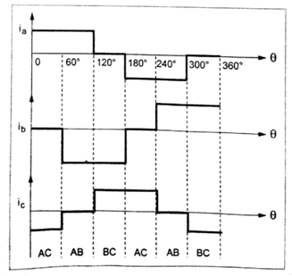

**Fig. Phase current waveforms of BLDC motor with 180° pole arc magnet**

**Flux – density distribution factor**

In practical case, the magnetic flux-density distribution cannot be perfectly rectangular as shown in the Fig. For a highly coercive magnets and full 180° magnetic arcs, there is a transition period of 10° - 20°, due to fringing effect.

Similarly, on the stator side, the mmf distribution is not rectangular but is a stepped wave form as shown in the following Fig. Upto some extent, these effects cancel each other in order to get satisfactory results with magnetic arc as short as 150°, and two slots per pole per phase.

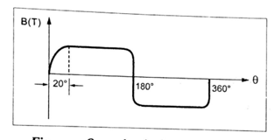

**Fig. Open circuit airgap flux density**

There is a dip in the torque wave form (Fig.) in the neighbourhood of the commutation angle. This torque dip occurs every 60° electrical, which gives rise to ripple in the torque waveform. The magnitude and width of the dip depends on the time taken to commuate the phase current.

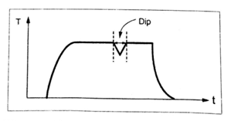

**Fig. Curve showin DIP in the waveform**

The phase currents corresponding to high speed and low speed operations are shown in the Fig.

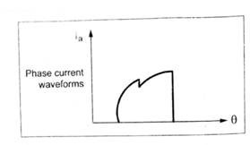

**Fig. Phase current waveform for high speed operation**

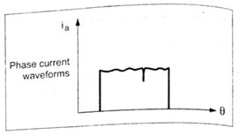

**Fig. Phase current waveform for low speed operation**

Note that the variatoin of flux density distribution in the airgap is smooth (i.e.,) the flux distribution of the magnet rotates with the rotor in a continuous fashion. But the mmf distribution remains stationary for 60° and then it jumps to a new position 60° ahead.

**Motor with 120° pole arc magnet**

For a motor with 120° pole arc magnets, similar analysis can be made with delta connected armature winding. The commutation table for different rotor positions is also shown.

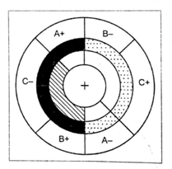

**Fig. (a) BLDC motor with 120° magnet arcs and 180° square wave phase currents**

**Commutation table**

120° magnetic pole arc delta winding 180° square wave phase currents.

|  |  |  |  |  |  |  |  |  |  |
| --- | --- | --- | --- | --- | --- | --- | --- | --- | --- |
| **Rotor Position** | **A** | **B** | **C** | **ab u(1)** | **ab L(4)** | **bc u(3)** | **bc L(6)** | **ca u(5)** | **ca L(2)** |
| 0° - 60° | +1 | +1 | -1 | 0 | 0 | 1 | 0 | 0 | 1 |
| 60° - 120° | +1 | -1 | -1 | 1 | 0 | 0 | 0 | 0 | 1 |
| 120° - 180° | +1 | -1 | +1 | 1 | 0 | 0 | 1 | 0 | 0 |
| 180° - 240° | -1 | -1 | +1 | 0 | 0 | 0 | 1 | 1 | 0 |
| 240° - 300° | -1 | +1 | +1 | 0 | 1 | 0 | 0 | 1 | 0 |
| 300° - 360° | -1 | +1 | -1 | 0 | 1 | 1 | 0 | 0 | 0 |

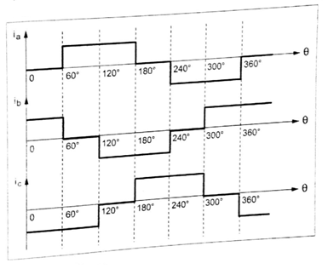

**Fig. (b) Phase current waveforms for 120° pole arc magnet**

The phase current waveforms with 120° pole arc is shown in the Fig (b). The converter required for this analysis with delta connected phase winding is shown in the Fig. (c).

In Fig. (c), the phase C belt remains covered by the magnetic poles. When the coverage of phase A increases, the coverage of phase B decreases. Thus the increasing torque contribution of phase A is being balanced by the decreasing contribution of phase B. Hence, the total torque remains constant.

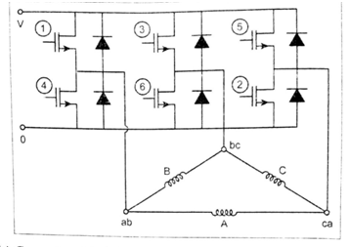

**Fig. (c) Converter with delta connected phase winding for brushless DC motor**

Likewise, there is a linear increase in the back emf of phase A and equal, opposite decrease in the back emf in phase B. Thus, the back emf at the terminal remains constant.

There are two paths. One path is formed by phase C while the other path is formed by these A and phase B in series. The line current is divided equally between the two paths.

The torque balance is not perfect in practice because of the resistance and inductances of the windings. But the current balance should be maintained, otherwise the circulating current may produce torque ripple and additional losses.

Now let us compare the 180° magnetic pole arc machine with the 120° magnetic pole arc machine.

**Comparison of 180° and 120° pole arc motors**

* 1. The 180° pole arc motor is more efficient than the 120° pole arc motor because for the same ampere conductors per slot and for the same peak flux density, the 120° pole arc machine has 1.5 times copper losses, but produces the same torque.
  2. Also in 120° pole arc motor the ampere conductors per slot would have to be reduced because the duty cycle is 1.0 instead of 2/3 as in the 180° pole arc motor.
  3. In 120° pole arc motor, for the same magnetic flux density, the total flux is only 2/3 of that of 180° pole arc motor, so that only 2/3 of the stator yoke thickness is required.
  4. If the stator outside diameter is kept the same, the slots can be made deeper so that the loss of ampere-conductors can be atleast partially covered. So the lag in efficiency when compared with the 180° pole arc motor is some what compensated. Hence, the efficiency of the motor may not be very much less than that of 180° pole arc motor.
  5. In both the motors, the effects of fringing flux slotting and commutation overlap combine to produce torque ripple.

**(b) BLPM sine wave DC motor**

The airgap flux density distribution of BLPMDC sine wave motor is shown in following Fig.

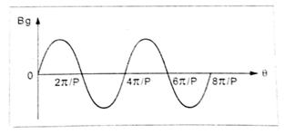

**Fig. Flux density distribution of BLPMDC sine wave motor**

1. **Sketch the structure of controller for PMBLDC motor and explain the functions of various**

**blocks. (16) [May /June 2007 April/May 2010 May/June 2013 May/June 2014 Nov 2016]**

**(OR)**

**Explain the closed loop control scheme of a permanent magnet brushless dc motor drive with a suitable schematic diagram. (16) [Apr/May2010 Nov/Dec2014]**

**(OR)**

**Explain the modes of operation of power controller for PMBLDC motors with a neat diagram. [Nov/Dec 2007 April/May 2008 April/May 2010]**

**Power Controller For BLPM Square Wave DC Motor**

The power controller structure of BLPM square wave DC motor is shown in following fig.

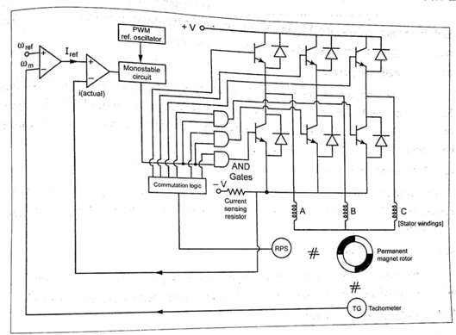

**Fig. Controller for Brushless DC motor**

**Power circuit**

The power circuit of a BLPM square wave d.c. motor consists of 6 power switching devices that are connected in bridge configuration across the d.c. supply. A shunt resistance ‘R’ is connected in series to get the current feedback signal. Feedback diodes are connected across the main devices. The stator armature winding is assumed to be star connected.

The rotor carries rotor position sensor and the shaft is coupled with tachogenerator to get speed feedback signal.

**Control circuit**

Control circuit consists of a communication logic circuit which gets information about the rotor position and decides about which devices are to be turned on and off.

**Commutation logic circuit**

It provides six output signals out of which three signals are used as the base drive for the upper leg devices. The other three output signals are logically ANDed with high frequency pulses (PWM) which are the output from the monostable circuit. The resultant signals are used to drive the lower leg devices.

**Speed comparator**

The speed comparator compares the reference speed (ωref) with the speed feed back signal (ωm) obtained from the tachogenerator. The output of the speed comparator (i.e.,) the speed error signal serves as the current reference for the current comparator.

**Current comparator**

The current comparator compares the reference current (iref) with the actual current signal (iactual) obtained from the current transducer. The resulting error signal is fed to the monostable circuit.

**Monostable circuit**

The monostable circuit is excited by high frequency pulse signals. The duty cycle of the output of monostablemultivibrator circuit is controlled by the error signal.

**Rotor position sensor**

The rotor position sensor converts the information of rotor shaft position into a suitable electrical signal. The signal from rotor position sensor is fed to the commutation logic circuit which inturn gives necessary output signals in order to switch on and switch off the various semiconductor devices of electronic switching and commutation circuitry of BLPM motor. Optical position sensor and hall effect position sensor are two popular rotor position sensors available for BLPM motor.

**Function of the controller**

The rotor position is sensed by a hall effect sensor. These signals are decoded by commutational logic circuit to provide the firing signals for 120° conduction of each of the three phases. It has six outputs which control the upper and lower phase leg transistors. The programmable logic arrays, gate arrays, EPROMs are suitable for this function.

The PWM signal is applied only to the lower leg transistors. It not only reduces the current ripple but also avoids the need for wide band width in the level shifting circuit that feeds the upper leg transistors.

The upper leg transistors need not be of the same type as the lower leg transistors and need only to be switched at the commutation frequency. The use of ‘AND’ gates is a simple way of combining both the commutation signals and chopping signals.

As already seen, the monostable circuit which is excited by high frequency signal, is controlled by the error signal obtained from the comparator. The output of this monostable circuit and the signal from the commutation logic circuit influences the conduction period and the duty cycle of the lower leg devices. Thus the desired current for desired speed is obtained.

**Rotor position sensors for BLPM motors:**

It converts the information of rotor shaft position into a suitable electrical signal. This signal is utilized to switch ON and OFF the various semiconductor devices of electronic switching and commutation circuitry of BLPM motor.

Two popular rotor position sensors are

* + Optical position sensor.
  + Hall effect position sensor.

1. **Optical position sensor:**

This makes use of six photo transistors. This device is turned into ON state when light rays fall on the device. Otherwise the device is in OFF state the schematic representation is as shown in fig.

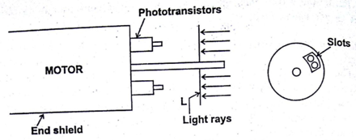

**Fig.Optical position sensor.**

The phototransistors are fixed at the end shield cover such that they are mutually displaced by 60° electrical (for star connected armature bridge circuit). These transistors are illuminated (excited) by a suitable light source. The shaft carries a circular disc which rotates along the shaft. The disc prevents the light rays falling on the devices. Suitable slots are punched in the disc such that at any position only 2 devices are excited. These devices which are turned into a state suitably turns the two main switching devices of electronic commutation circuitry into on state.

As the shaft rotates, the devices of electronic commutator which are turned into ON are successively changed.

The switches ON at any time depending upon rotor position are given below and shown in fig.

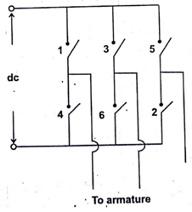

**Fig. Electronic switches**

1, 6-1, 2-3, 2-3, 4-5, 4-5, 6- … This is for one specific direction of rotation (i.e.) clockwise.

For counter clockwise direction of rotation the switching sequence is 5, 6-5, 4-3 4-3, 2-1, 2-1, 6-…

This mode of operation is called 120° mode of operation.

1. **Hall effect rotor position sensor:**

**Hall effect:**

Consider a small pellet of n-type semiconducting material as shown in figure.

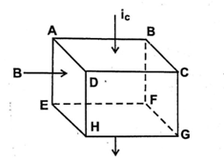

**Fig. Hall effect**

A current ic is allowed to pass from the surface ABCD to the surface EFGH. Let the surface ABEF be subjected to a North pole magnetic field of flux density B tesla. As per Flemings left hand rule, the positive charges in the pellet gets concentrated near surface ADHE and negative charges, there electrons gets concentrated near the surface BCGF. This change in distribution makes the surface ADHE more positive than the surface BCGF. This potential (i.e.) potential between surfaces ADHE and BCGF is known as Hall emf or emf due to hall effect.

It has been experimentally shown that emf due to hall effect is VH is given by



Where ic – current through the pellet in amps

B – Flux density in tesla

d – Thickness of the pellet in m.

RH – Constant which depends upon the physical dimensions or physical properties of the pellet.

If the polarity of B is changed from north pole to south pole the polarity of the emf due to hall effect also gets changed.

**Hall effect position sensor:**

Hall effect position sensor can be advantageously used in a BLPM motor. Consider a 2 pole BLPM motor with two windings w1 & w2 as shown in fig.

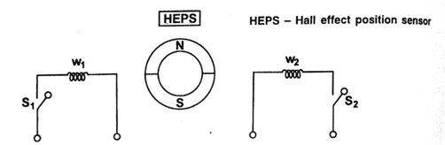

**Fig. 2 pole BLPM motor**

When w1 carries a current on closing S1 it sets up a north pole flux in the airgap. Similarly when S2 is closed w2 is energized and sets up a north pole flux. w1 and w2 are located in the stator such that their axes are 180° apart. A hall effect position sensor is kept in an axis of the windings.

When hall effect position sensor is influenced by north pole flux the hall emf is made to operate the switch S1. Then w1 sets up north pole flux. The rotor experiences a torque and south pole of the rotor tends to align with the axis of w1. Because of inertia, it overshoots the rotor hence rotates in clockwise direction.

Now HEPS is under the influence of S pole flux of the rotor. Then the polarity of hall emf gets changed. This makes the switch S1 in off state and S2 is closed. Now w2 sets up N-pole flux in the air gap, the rotor rotates in clockwise direction. So that the S pole gets aligned with w2 axis.Then this process continuous. The rotor rotates continuously.

**Driving circuit for a 2 pole motor:**

The circuit shown in fig. can be utilized as the driving circuit for a 2 pole BLPM motor.

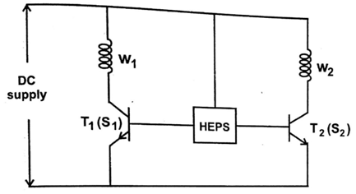

**Fig. Driving circuit for 2 pole motor**

S1 and S2 are replaced by the transistors T1 and T2.

In a conventional 3φ, 6 pulse BLPM motor 6 hall effect position sensors are kept in the stator such that they are displayed by 60° elec. apart. This position sensors are kept in the stator such that they are influence by the rotor positions. By suitably connecting the position sensors to the controller required pulses to the devices of the electronic commutator are given.

1. **Drive the expressions for the emf and torque of a PMBLDC motor. (16)[Nov/Dec 2007 May/June 2008 May/June 2014 April 2017]**

**EMF and Torque Equations of BLPM Square Wave DC Motor**

The basic emf and torque equations of the brushless d.c. motor are quite simple and resemble those of the d.c.commutator motor.

**EMF equation**

Consider a BLPM square wave d.c. motor. Let us assume that,

P – Number of poles

Bg – Flux density in the airgap of the motor (Wb/m2). (Note that ‘Bg’ is assumed to be constant over the entire pole pitch in the airgap)

r – Radius of the airgap (m)

l – Length of the armature (m)

ωm – Angular velocity in mech.rad/sec.

Tc – Number of full pitch turns per coil.

Assume the case that the axis of the permanent magnet rotor is along ‘x’ axis (i.e.,) the coordinate axis has been chosen so that the centre of a north pole of the magnet is aligned with the x-axis (i.e.,) at θ = 0. The stator has 12 slots and a three phase winding. Thus there are two slots per pole phase.

The flux density distribution in the airgap is as shown in the Fig. [It is assumed that the axis of the coil coincides with the axis of the permanent magnet at time t = 0].

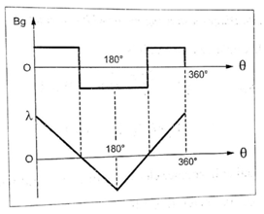

**Fig. Magnetic flux density around the airgap**

Let at ωmt = 0, the centre of N – pole magnet is aligned with x-axis, Atωmt = 0, X-axis is along the permanent magnet axis.

Therefore, the flux enclosed by the coil is,



= Flux/pole









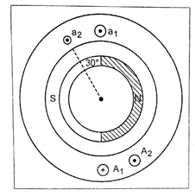

**Fig. Diagram showing motor with two coils of one phase**

At ωmt = 0, the flux linkage of the coil is,





Let the rotor be rotating in counter clockwise direction and when  the flux enclosed by the coil, φ = 0, therefore λ = 0.

The flux linkages of the coil varies with θ. The variation of the flux linkage is as shown in Fig.

The flux linkages of the coil changes from  at (i.e.,) t = 0 to the value zero (0) at The flux density distribution in the airgap of the motor is shown in following Fig.

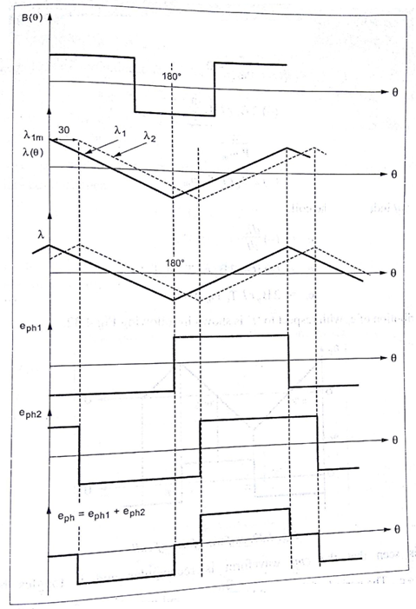

**Fig. Waveforms of flux density and flux linkage**

The rate of change of flux linkages of the coil (i.e.,) Δλ is,









The emf induced in the coil,







Distribution of ec with respect to ‘t’ is shown in following Fig

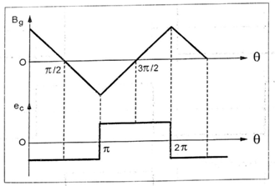

**Fig. emf waveform of coil**

It is seen that the emf waveform is rectangular and it toggles between +ec to ec. The period of the wave is sec and magnitude of ecis, 2BgrlωmTC volts.

Consider two coils a1A1 and a2A2 as shown in Fig. 4.30. Coil a2A2 is adjacent to a1A1 and is displaced from a1A1 by an angle 30° (i.e.,) slot angle γ.

The magnitude of emf induced in coil a1A1 is given by,



The magnitude of emf induced in coil a2A2 is given by,



The emf waveform of ‘ec2’ is also rectangular but it is displaced from emf waveform of coil ‘ec1’ by slot angle γ.

If the two coils are connected in series, the total phase voltage is the sum of the two separate coil voltages.

(i.e.,)



If there are ‘nc’ number of coils connected in series per phase, then the emf induced per phase is given by,



Here, eph = Resultant emf when all ‘nc’ coils are connected in series.

nCTC = Tph = Number of turns/phase.

The emfwaveforms of ec1 and ec2 with the displaced slot angle is shown in following Fig.

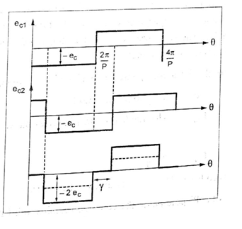

**Fig. Phase ‘a’ emf waveform**

It is to be noted that the waveform of eph is stepped and its amplitude is 

At any instant, two phase windings are connected in series across the supply terminals as shown in the Fig. (a).

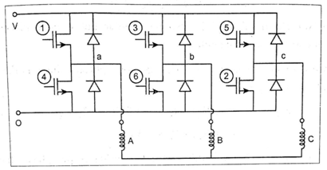

**Fig. (a) Circuit diagram showing the possibility of two phase windings connected in series across the supply.**

The armature winding is star connected and the power devices are operated depending upon the rotor position sensor such that the resultant emfs across the winding terminals is always equal to “2eph”.

**Torque equation**

In emf equation we have seen that the basis effect of distributing the winding into two coils is to produce a stepped emf waveform. In practices, fringing cause its corners, to be rounded. The waveform then has the ‘trapezoidal’ shape which is the characteristic of the brushless d.c. motor.

The magnitude of the flat –ropped phase emf is given by, (from equation 9)

e = 2 TphBglrωm volts.

Where, Tph – The number of turns in series/phase

In this case,

Tph = 2 T1 …10

because the two coils considered are assumed to be in series.

In a machine with ‘P’ pole-pairs, the equation remains valid provided Tph is the number of turns in series per phase and ωm is in mechanical radians per second.

We have also seen that, the ideal waveforms of phase currents are rectangular in nature in which the current pulses are 120° (electrical) wide as shown in following Fig. (b). and of magnitude I.

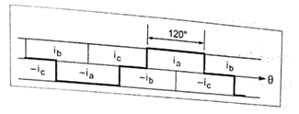

**Fig. (b) Ideal phase current waveforms**

The positive direction of current is against the emf (i.e.,) positive current is motoring current. The conduction periods of the three phases are symmetrically phased so as to produce a three phase set of balanced 120° square waves.

If the phase windings are star-connected, as shown in Fig. (a), then at any time there are just two phases and two power devices are conducting.

During any 120° interval of phase current, the instantaneous power being converted from electrical to mechanical is,

P = ωm Te …11

⇒ P = 2 eph I …12

The ‘2’ in this equation (4.32) arises from the fact that two phases are conducting.

Using the expression derived in the equation (4.29( for the emf, the electromagnetic torque can be obtained,

From 11 

Substituting from 12  in 13



From equation 9 substituting eph = 2BgrlωmTph in the equation 14

∴ 

⇒ 

⇒ 

The expression 15 gives the torque equation for squarewave PM brushless motor drive.

This equation is valid for any number of pole-pairs.

1. **Describe the constructional aspects of mechanical and electronic commutator of PMBLDC motors. [Nov/Dec 2012 May/June 2013]**

**(OR)**

**Draw the diagram of electronic Commutator. Explain the operation of electronic Commutator. (16) [Apr/May 2010]**

**(OR)**

**Analyze the operation of electronic commutator in PMBLDC motor with neat diagram.**

**[Apr/May 2015]**

**Commutator and Brushes Arrangement in Conventional D.C Motor**

The function of the commutator is to facilitate the collection of current from the armature conductors. It converts the alternating current induced in the armature conductors into unidirectional current in the external load circuit.

Because of the hetropolar magnetic field in the airgap of d.c machine, the emf induced in the armature conductors is alternating in nature. This emf is available across the brushes as unidirectional emf because of commutator and brushes arrangement. [This depicts the action of d.c. generator].

The d.c. current passing through the brushes is so distributed in the armature winding (because of commutator and brushes arrangement) that an unidirectional torque is developed in armature conductor. [In case of d.c. motor].

A d.c current passing through the brushes because of commutator and brushes action, always sets up a mmf whose axis is in quadrature with the main field axis, irrespective of the speed of the armature.

**Construction of mechanical commutator**

The commutator consists of special wedge-shaped segments made up of copper. These segments are insulated from each other by thin layer of mica of similar shape. These segments are tapered such that when assembled, they form a cylinder.

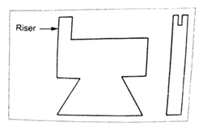

**Fig.Commutator segment**

These commutator segments (shown in Fig) are mechanically fixed to the shaft using V-shaped circular steel clamps, but are isolated electrically from the shaft using suitable insulation between the clamps and the segments as shown in above fig. In large d.c machines, flat copper strips (known as risers) are used to form dip connections to armature bar conductor.

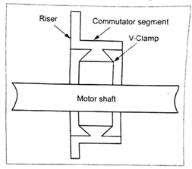

**Fig.Commutator segment connection with motor shaft**

**Mechanical commutator and brushes arrangement**

An alternating emf is induced in the armature conductors as the magnetic field is present in the airgap. Because of the commutator and brushes arrangement, an unidirectional emf will be available across the brushes.

The current passing through the brushes is distributed in the armature winding such that an unidirectional torque is developed in the armature conductors. The d.c current passing through the brushes always sets up an mmf (armature mm) which is In quadrature with the main field mmf irrespective of the speed of the motor The schematic representation of a mechanical commutator and brush arrangement is shown in the following Fig., which is a 2 pole machine with 12 commutator segments. Let us take the brushes of the 2 pole machine as X and Y.

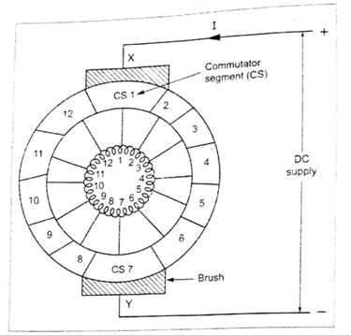

**Fig. Mechanical commutator and brushes arrangement**

As shown in the above Fig. the brush X contacts with CS1, and Y contactswith CS7. The brushes X and Y are connected across the d.c. supply. A d.c. current ispassing through the brush X. CS1, tapping 1, tapping 7, CS7 and brush Y. There aretwo armature parallel paths between the tappings 1 and 7.

(i) 1-2-3-4-5-6-17

(ii) 1-12-11-10-9-8-7

The current passing through the armature conductors sets up an mmf along the axis of the tappings 7 and 1 (i.e.,) along the axis of Y & X. The commutator rotates alongthe counter clockwise direction. Now the brush X contacts with CS2, and brush Ycontacts with CS8. Hence, the current passes through the tappings 2 and 8. There aretwo parallel paths,

(i) 2-3-4-5-6-7-8

(ii) 2-1-12-11-10-9-8

The mmf set up by the armature winding is form tapping 8 to 2 (i.e.,) alongbrush axis YX. Thus the armature mmf direction is always along the brush axis YX, eventhough the current distribution in the armature winding gets altered.

In a conventional d.c. machine. the brushes are placed in the interpolar axis.Therefore the armature mmf makes an angle of 90° electrical with the main fieldmmf

The important function of the commutator and brushes arrangement in aconventional d.c. machine is to set upan armature mmf whose axis is always inquadraturewith the main field irrespective of the speed of rotation of the rotor.

In case of BLPMDC motor, the same function is achieved with the help of poweredelectronic switching circuitry or "electronic commutator". The rotor of BLPMDCmotor carries permanent magnet and the stator accommodates the armature windingwhich is connected to the d.c. supply through the electronic commutator.

**Electronic commutator:**

The figure shows the schematic diagram of BLPM dc motor armaturecircuit along with the switching circuitry. The armature winding which is inthe stator has 12 tappings. Each tapping is connected to the positive of thedc supply (i.e.) node and through 12 switches designated as S1, S2...S12 andnegative of the supply at node Y through switches S’1, S’2...S’12

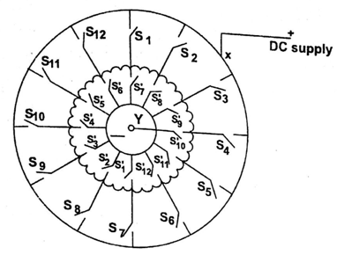

**Fig Electronic commutator**

When S1 and S'1 are closed the others are in open position, the de supplyis given to the trappings 1 and 7. There are two armature parallel path.

(i) 1-2-3-4-5-6-7

(ii) 1-12-11- 10-9-8-7

They set up armature mmf along the axis 7 to 1.

After a small interval S1 and S'1 are kept open and S2 and S'2 are closed. Then dc current passes from tapping 2 to 8 sets up an mmf in the direction8-2.

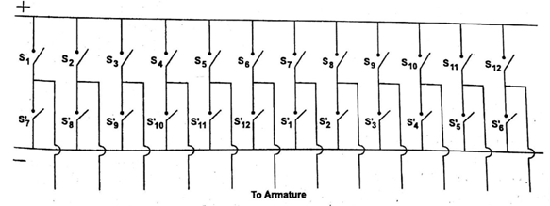

**Fig. Switching circuit of electronic commutator**

Thus by operating the switches in a sequential manner it is possibleget a revolving mmf in the air gap.

The switching circuit is redrawn as shown in fig.

The switches S1 to S12 and S'1 to S'12 can be replaced by power electronic switching devices such as SCRs, MOSFETs, IGBTs, power transistors etc.

When SCRs are used suitable commutating circuit should be included. Depending upon the type of forced commutation employed, each switchrequires on or two SCRs and other commutating devices. As number of devicesis increased, the circuit becomes cumbersome.

For normal electronic commutator, usually six switching devices areemployed. Then the winding should have three tappings. Therefore thewinding can be connected either in star or in delta.

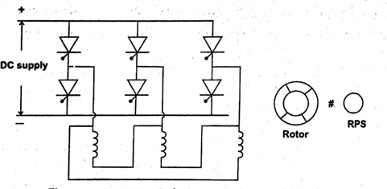

Fig.Δ -connected stator armature winding

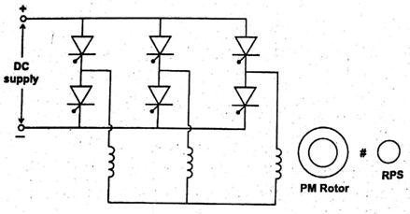

**Fig.γ- connected armature winding.**

The above circuits as shown in fig. are the same as that of 3φ bridge inverter, but here the switching of the devices is influenced by rotor position sensor.

**Comparison between mechanical commutator and brushes and electronic commutator:**

|  |  |  |
| --- | --- | --- |
| **S.No** | **Mechanical commutator and brushes** | **Electronic commutator** |
| 1. | Commutator is made up ofcopper segments and micainsulation. Brushes are of carbonor graphite. | Power electronic switching deviceare used in the commutator. Itrequires a position sensor. |
| 2. | . Commutator arrangement islocated in the rotor. | It is located in the stator. |
| 3. | Shaft position sensing is inherent in the arrangement. | Separate rotor position sensor is required. |
| 4. | Number of commutator segmentsare very high. | Number of switching devices is limited to 6. |
| 5. | There exists sliding contactbetween commutator andbrushes. Sparking takes placeRequires regular maintenance. | No sliding contact. No sparkingas it is possible to feedback thestored energy in the magneticfield to the mains. Requires lessmaintenance. |
| 6. | Difficult to control the voltageavailable across the tappings. | The voltage available acrossarmature tappings can becontrolled by employing PWMtechniques. |
| 7. | Highly reliable | Reliability is improved byspecially designing the devicesand protective circuits. |
| 8. | Interpole windings are employed to have sparkless commutation. | By suitably operating theswitching devices, betterperformance can be achieved. |

1. **Discuss the use of Hall sensors for position sensing in PMBLDC motor. [Apr/May 2010 Nov/Dec 2014]**

**Hall effect position sensor**

Before studying about the hall effect position sensor, let us bring back to ourmemory the hall effect.

**Hall effect**

Consider a n-type semiconducting material of small pellet as shown in theFig.

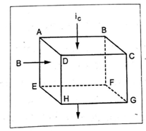

**Fig. n-type semiconductor material depicted for hall effect**

A current of ic is allowed to pass from the surface ABCD to the surface EFGH.Let the surface ABEF be subjected to a north pole magnetic field of the flux density'B' tesla. As per Fleming's left hand rule, the (+)ve charges in the pellet getsconcentrated near the surface ADHE and negative charges near the surface BCFG.Since, n-type material has free (-)ve charges, these electrons get concentrated nearthe surface BCGF. This change in distribution makes the surface ADHE morepositive than the surface BCGF. Thus the potential difference between the surfaceADHE & BCGF is known as 'Hall emf'.

It has been experimentally shown that the emf due to hall effect (VH) is given by,

Where,



VH = Hall emf

iC = Current through the pellet in Amps

B = Flux density in Tesla

d = Thickness of the pellet in metre.

RH= Constant depends upon the physical dimension of thepellet.

If the polarity of B is changed from north pole to south pole then the polarity of thehall emfis also changed.

**Hall effect position sensor**

The hall effect position sensor can be advantageously used in a BLPM motor. Consider a two pole BLPM motor with two windings W1 and W2 as shown infollowing Fig.

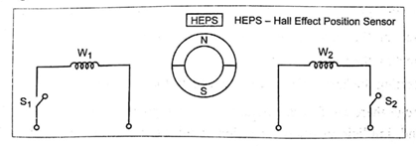

**Fig. A two pole BLPM motor with hall effect position sensor**

When the switch S1 is closed, the winding W1 is energized. It sets up a N-pole fluxin the airgap. If the switch S1 is opened and S2 is closed, the winding W2 isenergized. Now, it sets up a N-pole flux in the airgap. These two windings are locatedin the stator such that their axes180° apart. A hall effect position sensor [HEPS]is placedin between the axes of the two windings such that it is influenced by the rotor permanent magnet.

When HEPS is under the influence of N pole of the rotor, then the hall emfinduced is made to operate the switch S1. Now the winding W1 is energized and it sets up anorth-pole flux in the airgap.

Now the rotor will rotate in such a direction, as to align with the axis of the winding W1. But due to inertia, the rotor overshoots and the rotor rotates in clockwisedirection. Now, HEPS is under the influence of S pole flux of the rotor. Then thepolarity of the hall emfis changed.

This makes the switch S1 to open [OFF- state] and S2 is closed.

At this position, winding W2 is energized and it sets up a N pole flux in the airgap.Now the S-pole of rotor tends to align with the winding axis W2 since the rotor rotates in clockwise direction.

Thus the process continues and the rotor rotates continuously.

The hall effect position sensors in the motor windings are difficult to mount andtherefore quite expensive.

The explicit position sensors [optical sensors, hall sensors] need additionalwinding which increases the risk of failure as well as the costs of mounting.

**Implicit rotor position detection**

The implicit rotor position detection by using the motor voltages or currents,reduces the cost of the drives and increases reliability and life time of the drive.

There are three implicit methods by which the rotor position can be sensed by,

* 1. Detecting the saturation of the phase inductance
  2. Detecting the backward emf
  3. Detecting the harmonics of the induced motor voltages.

Eventhough there are few drawbacks in explicit position sensors [Optical and hallsensors] and implicit position detection methods are available, for majority ofapplications, the explicit position sensors only are implemented for BLPMDC motor.

1. **Sketch the torque-speed characteristics of a PMBLDC motor.[ May/June 2007 April/May 2008 Apr/May2010 Nov/Dec 2013]**

**TORQUE SPEED CHARACTERISTICS**

The ideal speed torque characteristics of BLPM square wave dc motor can be obtained,if the commutation is perfect, the phase current waveforms are ideal and if the converter issupplied from an ideal direct voltage source V.

Atany instant, by assuming the above idealcase, the following equation can be writtenfor d.c terminal voltage.

V=E+IR …1

where R is the sum of two phase resistances in series and E is the sum of two emfs in series. This equation is exactly the same as that of the d.ccommutator motor. The voltage dropsacross the two converter switches in series are omitted, but they correspond exactly to thetwo brush voltage drops inseries in the dc commutator motor.



From equation2,we can write that:



The no-load speed is:



The stall torque is written as:



This is the torque with the motor stalled. i.e., at zero speed.

The stall current is given by the equation,



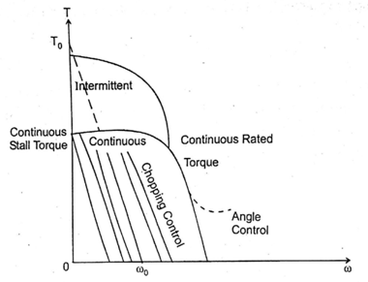

**Fig. Torque speed characteristics of ideal BLDC motor**

If phase resistance is small (assuming efficient) design, the characteristics is similar to that of a d.c shunt motor. The speed is essentially controlled by the voltage V and may be varied by varying the supply voltage.

The motor then draws just enough current to drive the torque at this speed. As the load torque is increased, the speed drops and the drop is directly proportional to the phase resistance and the torque. The voltage is usually controlled by chopping or pulse width modulation.

This gives the possibility of getting a family of torque/speed characteristics as shown in Fig.

Note that there are the boundaries of continuous and intermittent operation. The continuous limit is usually determined by heat transfer and temperature rise. The intermittent limit may be determined by the maximum ratings of semiconductor devices in the controller or by the temperature rise.

The torque speed characteristics in practice deviates from the ideal one because of the effects of inductance and other parasitic influences consider the practical case, let us assume that the supply voltage V be constant. A family of speed torque characteristics for various constant supply voltage is shown in the following Fig.

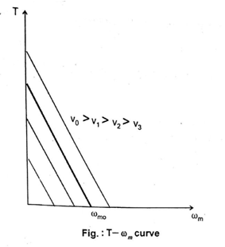

**Permissible Region of Operation in T - ωm plane**

**Constraints:**

The continuous current should not exceed the maximum permissible current In (i.e.,) the torque should not exceed Tn = KCIn. The supply voltage should not exceed its permissible limit Vn. The speed should not exceed ωmn.

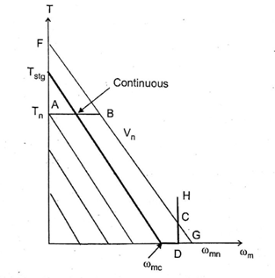

**Fig. Torque Speed Characteristics**

In the Fig., consider lines AB, FG and DH.

**Line AB:**

It is parallel to the x-axis and represents the maximum torque that can be developed.

**Line FG:**

This line represents the T - ωm characteristics for maximum voltage permissible (i.e.,) Vn. This line intersects the maximum torque line at point B.

**Line DH:**

This line is perpendicular to x-axis. It represents the maximum permissible speed ωm. DH intersects the FG line at point C.

The region OABCDO is the permissible region of operation.

1. **Discuss the magnetic circuit analysis relevant to PMBLDC motor. Also draw**

**The characteristics. [May/June 2013]**

**MAGNETIC CIRCUIT ANALYSIS**

The design of brushless permanent magnet motors is not a simple task. On a moregeneral level, the motor design requires knowledge of magnetics, electronics and material science. This section focuses on the magnetic circuit analysis (i.e.,) magnetic aspects of motor design.

The first step to analysis a magnetic circuit is to identify the main flux paths andassign reluctances or permeances to them.

Consider the fundamental motor structure and associated flux paths as shown inthe Fig. Here the rotor contains four magnetic poles facing the airgap. We knowthat, if there are 'P' poles in a machine.

Because the flux paths shown in Fig. repeat for every adjacent half pole pair, itis only necessary to model one such pair. So consider the cross section of a 2 polebrushless d.c. motor having high energy rare earth magnets on the rotor and thedemagnetization curve are as shown in following Fig.

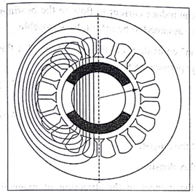

**Fig. Cross section and flux pattern of 2 pole brushless d.c motor**

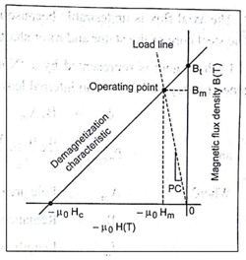

**Fig. Demagnetization curve**

The equivalent magnetic circuit is shown in following Fig. Only half of theequivalent circuit is shown and the lower half is the mirror image of the upper halfabout the horizontal axis, which is an equipotential.

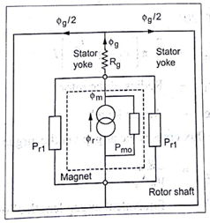

**Fig. Magnetic equivalent circuit**

the  
This assumption is true only if the two halves are balanced. If not, the horizontalaxis might still be an equipotential but the fluxes and the magnetic potentials in the two halves would be different and there could be residual flux in the axial direction (i.e.,) along the shaft.

The axial flux is undesirable because it can induce current to flow in the bearings. The steel core of the stator and rotor shaft are assumed to be infinitely permeable.

Each magnet isrepresented by a 'Norton' equivalent circuit consisting of a fluxgenerator in parallel with an internal leakage permeancePmo.

 …5

and …6

Where, Am - Pole area of the magnet

Br - Remanent flux density

lm - Length of the magnet in the direction of magnetization (In this case, its radial thickness)

μrec - Relative recoil permeability (i.e.,) the slope of thedemagnetization curve divided by μo.

In this case, the outer pole area is larger than the inner pole area but to keep theanalysis simple, let us consider the average pole area.

With a magnet arc of 120°



Where, r1 – Radius of the rotor

g – Airgap length

Most of the magnetic flux crosses the airgap via the airgap reluctance Rg.



Where, g' - Equivalent airgap length allowing for slotting.

The slotting can be taken into account by means of carter's coefficient, in which cases,

g' - KCg …9

Where, K- Constant

The airgap area Ag is the area through which the flux passes as it crosses the gap.The precise boundary of this area is uncertain because of fringing, both at the edgesof the magnet and at the ends of the rotor.

An approximate allowance for fringing can be made by adding ‘g’ at each of thefour boundaries, giving,



The remaining permeance in the magnetic circuit is the rotor leakage permeancewhich represents the paths of magnetic flux components that fail to cross theairgap. This can be conveniently included in a modified magnetic internal permeanceby expressing.

Pm = Pmo +Pr1



Where, ρrl- Normalized rotor leakage permeance (i.e.,)normalized to ρmo

ρrlis of the order of (0.05 - 0.2) range.

Magnetic circuit can now be solved. Equating the mmf across the magnet to themmfacross the airgap, we get,

















In order to get the expression for airgap flux density Bg, we have to know about the flux concentration factor Cφ.

The flux concentration factor Cφ is defined as the ratio of magnetic pole area to airgap area and it is given by,



Now the airgap flux density Bg is obtained by dividing the expression 13 by Ag.







In the above expression (4.14) (A) on LHS





Multiply and divide the RHS of above expression 15 by Am, we get









Where, 

Similarly, the magnetic flux density Bm can be derived as,



Note that due to rotor leakage,



The magnetizing force Hm is solved using the demagnetization characteristics and mathematically it is expressed as,



The negative sign indicates a demagnetizing force and shows that the magnet operates in the second quadrant of the B-H curve, as expected.

The line drawn from the origin through the operation point in the Fig. is called the load line and absolute value of its slope normalized to μo is called the “permeance coefficient” (PC). The following formula can be derived for PC,

PC =  …19

This permeance coefficient is useful as a measure of how far down the demagnetization curve, the magnet operates on open-circuit. It can be shown that,



In motors with a weak flux-concentration factor, the magnet should operate onopen-circuit at a high permeance coefficient to maximize the airgap flux density andthe torque per ampere, and to provide adequate margin against demagnetization by armature reaction.

The airgap flux-density on open-circuit is plotted in the Fig., but because of the effect of fringing, the distribution is not perfectly rectangular in practice and thereare circumferential as well as radial components of B at the edges of the magnetsBecause of the slotting of the stator bore, there will in general be an appreciableripple superimposed on the calculated waveform.

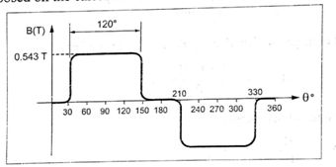

**Fig.Airgap flux density waveform (ideal)on open circuit**

The detailed analysis of all these effects requires a numerical method such as thefinite-element method. The analysis of multiple-pole motors is similar to that of thetwo-pole motor, using natural equipotentials the magnetic equivalent circuit can bereduced to the per-pole equivalent circuit.

1. **Explain the driver circuits for PMBLDC motors.**

**Classification of BLPM Motor Based On Drive Circuits**

The classification of BLPM motor depending on the number of phase windingand the number of pulses given to the devices in each cycle is enumerated as follows

1. Single phase and one pulse BLPM motor

2. Single phase and two pulse BLPM motor

3. Two phase and two pulse BLPM motor

4. Three phase and three pulse BLPM motor

5. Three phase and six pulse BLPM motor

**One phase winding and one pulse BLPMDC motor**

The Fig. shows the stator of BLPMmotor with one phase winding. It is connectedto the supply through a power semiconductorswitch. When the rotor position sensor isinfluenced by north pole flux, the stator isexcited and the rotor develops a torque. Whenthe rotor position sensor (RPS) is under theinfluence of south pole, the transistor is inOFF state.

So, the rotor develops torque, whenever the RPS is under the influence of north pole.

The current, torque are approximated as sinusoidally varying and the waveform are shown in the following Fig.

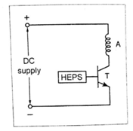

**Fig. One phase one pulse driving circuit**

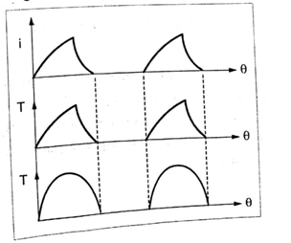

**Fig. Current and torque wave form**

**Merit**

The circuit uses only one transistors. Hence, one rotor position sensor is sufficient.

**Demerits**

1. Inertia should be such that the rotor rotates continuously

2. The utilization of transistor and winding are less.

**4.16.2. One phase winding and two pulse BLPM motor**

As shown in the Fig., in this type, thestator has only one phase winding, that isconnected to three wire d.c. supply through two semiconductor switches.

There is only one position sensor. When theposition sensor is under the north poleinfluence. T1 is in ON-state and T2 is in OFF-state. The phase winding carries current fromA to B.

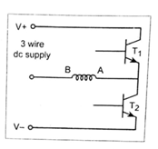

**Fig. One phase two pulse BLPM motor**

When the position sensor is under the influence of south pole, T2 is ON and T1isOFF.The phase winding carries current from B to A.

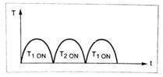

**Fig. Torque waveform**

The polarity of the flux setup by the winding,gets altered depending on theposition of the rotor. This provides unidirectional torque as shown in Fig.

**Merits**

1. The winding utilization is better

2. Torque developed is more uniform

**Demerits**

1. The transistor utilization is less

2. The circuit needs a 3-wire d.c. supply

**Two phase winding and two pulse BLPM motor**

In this type, the stator has two phase windings which are displaced by 180°electrical. The necessary circuit diagram is shown in following Fig

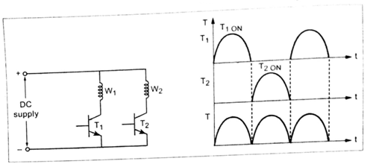

Fig Fig

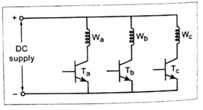

It is similar to that of one phase, two phase BLPM motor except that it requirestwo phase windings. The torque waveforms are shown in the Fig.

**Merit**

Torque developed is uniform

**Demerit**

Utilization of transistors and windings is less

**Three phase winding and three pulse BLPM motor**

The stator has three phase windingsas shown in the Fig. whose axes are displaced by 120° electrical apart. Each phase winding is controlled by asemiconductor switch, which is operateddepending upon the position of rotor. It requires three position sensors.

**Merit**

Torque developed is better

**Demerits**

1.Utilization of windings and devices are less

2. Cables with rotor position sensor should be properly connected

**Three phase six pulse BLPM motor**

This is the most commonly used circuit. It has three phase windings and sixswitching devices as shown in following Fig

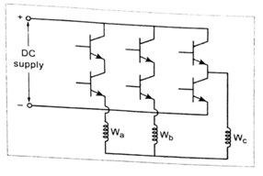

**Fig. Three phase, Six pulse BLPM motor**

The stator windings can be either star connected or delta connected. It requires sixposition sensors. Usually 120° or 180° conduction is adopted. This circuit producesunidirectional torque in all the three phase winding excitations as shown in Fig.4.50.

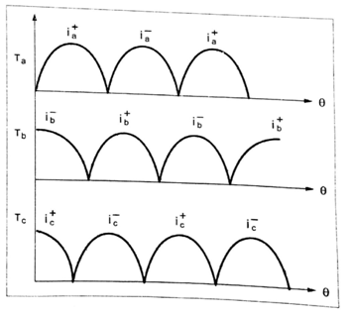

**Fig. Torque waveforms**

**Merits**

1. The utilization of winding is better

2. Torque and current ripple components are less

**Demerits**

1. Transistor utilization is less

2. Six position sensors are required.