UNIT I
- What is a synchronous reluctance motor? [NOV/DEC 2013]
A reluctance motor that utilizes an ac rotating field, which allows for the possibility of extremely smooth torque and good operation to low speeds.
- What are the types of rotor in synchronous reluctance motor? [April/May 2008 Nov/Dec 2009 April/May 2011, May/June 2013 April 2017].
1. Salient rotor
2. Radially laminated rotor
3. Axially laminated rotor
- Mention some applications of synchronous reluctance motor. [May/June 2007 Nov/Dec 2012 April/May 2015 Nov 2016 April 2017]
1. Fiber-spinning mills
2. Industrial process equipment
3. Metering pumps
4. Wrapping and folding machines
- What are the advantages of increasing Ld/Lq ratio in synchronous reluctance motor?
1. Motor power factor increases.
2. I²R losses reduced.
3. Reduced volt-ampere ratings of the inverter driving the machine.
- Compare synchronous reluctance motor and induction motor.
 | Synchronous reluctance motor | Induction motor
1.  2.  3.  4. | Better efficiency  Highcost  Low power factor.  Used for low and medium power application. | Efficiency is low compared with synchronous reluctance motor.  Lowcost  High power factor.  Used for high power application.
- Write down the torque equation of synchronous reluctance motor. ( NOV/DEC-14 & MAY/JUNE-14)
Where, V = supply voltage, δ = load angle,
ω_{s} = synchronous speed, X_{sd}, X_{sq} = synchronous reactances of d and q axis
- Draw the torque-angle characteristics of synchronous reluctance motor. (APR/MAY-2015)
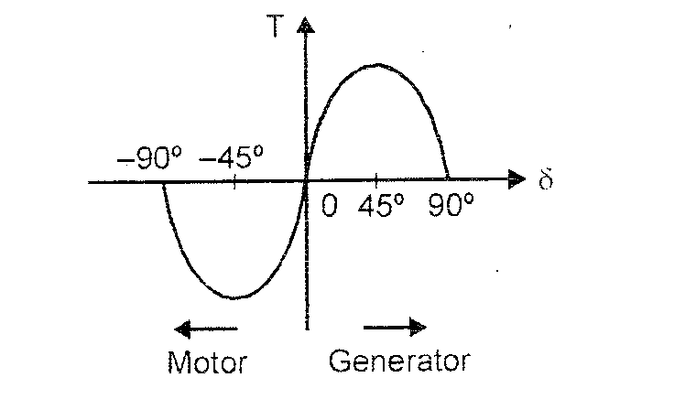
- Draw the speed-torque characteristics of synchronous reluctance motor.
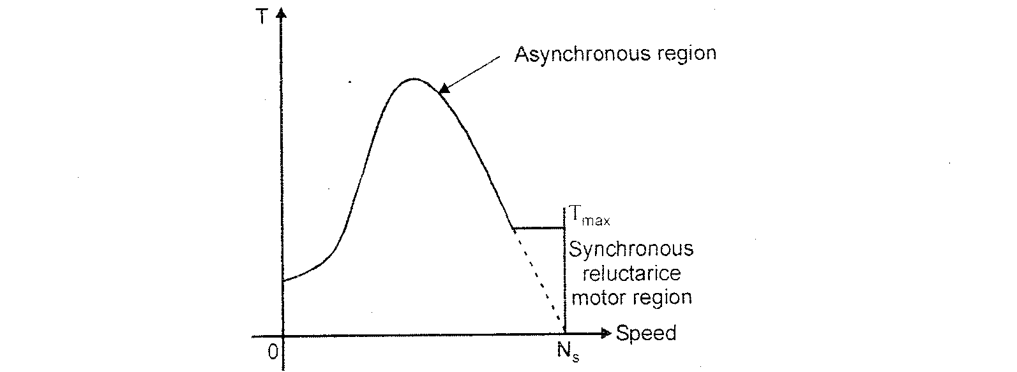
- Draw the steady-state phasor diagram of synchronous reluctance motor.
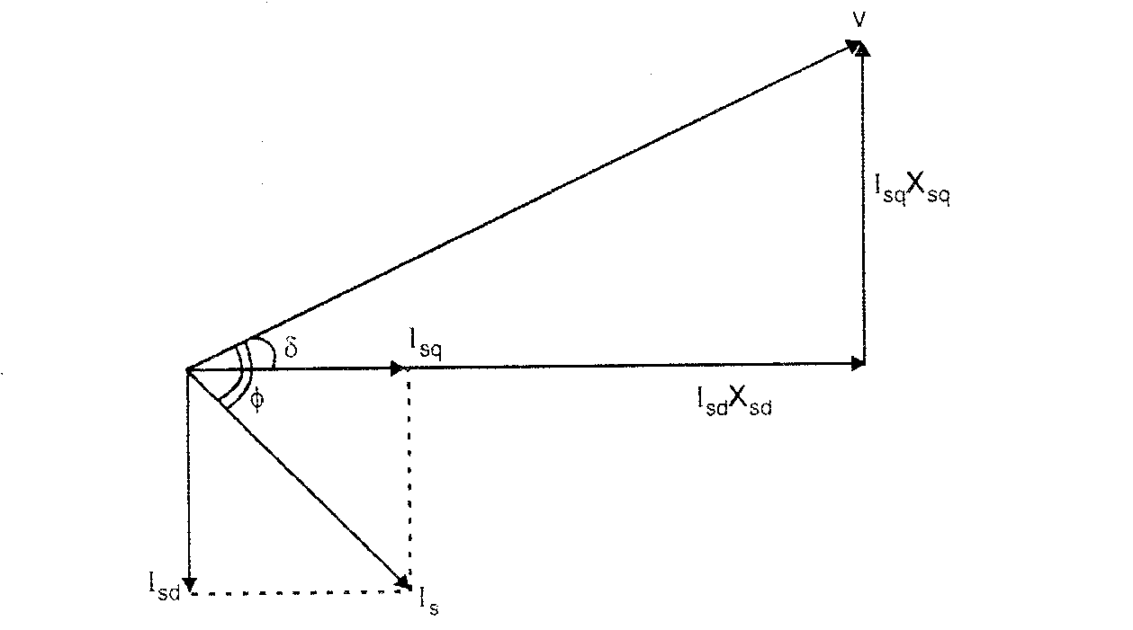
- 11. Mention some advantages and disadvantages of synchronous reluctance motor? (NOV/DEC-2013)
Advantages:
1. There is no concern with demagnetization, hence synchronous reluctance.
2. There need be no excitation field at zero torque, thus eliminating electromagnetic spinning losses.
3. Synchronous reluctance machine rotors can be constructed entirely from high strength, low-cost materials.
Disadvantages:
1. Compared to induction motor it is slightly heavier and has low power factor. But increasing the saliency ratio , the power factor can be improved.
2. High cost than induction motor.
3. Need speed synchronization to inverter output frequency by using rotor position sensor and sensor less control.
- Write down any two properties of synchronous reluctance motor.
1. High output power capability.
2. Ability of the rotor to withstand high speeds.
3. Negligible zero-torque spinning losses.
4. High reliability.
- What is reluctance torque in synchronous reluctance motor? [Nov 2013]
The torque exerted by the reluctance motor because of the tendency of the salient poles to align themselves in the minimum reluctance position. This torque is called reluctance torque.
- What are the design considerations in synchronous reluctance motor? [NOV/DEC-2012]
1. Power factor
2. Copper loss and core loss
3. Cost
4.Efficiency
- What are the main advantages of synchronous reluctance motor? [May/June 2007]
1) Freedom from permanent magnet
2) Ability to maintain full load torque at zero speed
3) A wide speed range at constant power.
- What is Vernier Motor? [Nov/Dec 2007 Nov/Dec 2009 April/May 2010]
It is an unexcited reluctance type synchronous motor the peculiar feature of this motor is that small displacement of the rotor products a large displacement of the axis of maximum and minimum permeance.
- Write down any two properties of synchronous reluctance motor. [Nov Dec 2007]
The synchronous reluctance motor is not self starting without the squirrel cage. During run up it behaves as an induction motor but as it approaches synchronous speed, the reluctance torque takes over and the motor locks into synchronous speed.
- List the application of Vernier Motor. [April/May 2008 April/May 2011]
The Vernier motor is mainly used where require low speed and high torque.
1) Direct Drive applications
2) High Torque at low speed applications.
- What are the types of rotor available in synchronous reluctance motor? [April/May 2010]
1) Cage rotor for line start.
2) Cageless-rotors for variable speed.
- Give the difference between synchronous reluctance motor and switched reluctance motor. [May/June 2013].
SYRM
- The motor has the same number of poles on stator and rotor.
- The stator of SYRM is cylindrical type with distributed winding.
- The stator has a smooth slot for slotting
- Excitation is a set of 3 phase balanced sine wave current.
SRM
1) In order to have starting capability and bi-directional control, the motor of a SRM has lesser pole than the stator.
2) The stator of SRM has salient poles with concentrated coils like on d.c motor.
3) Like a d.c motor, the stator and rotor have salient poles.
4) Excitation is a sequence of current pulse applied.
- What are the merits of 3-phase brushless PMSM?[Nov/Dec 2013]
(1)Regenerative breaking is possible
(2) Speed can be easily controllable
(3) It is possible to have high very speeds
(4) There is no field winding. So no copper loss.
- What are the different types of power controllers used for synchronous reluctance motors.[Nov/Dec 2014]
1. Two power semiconductors and two diodes per phase
2.(n+1) power semiconductors and (n+1) diodes per phase
3. Phase winding using bifilar wires
4. Dump C converter
5. Split power supply converter
- Give the operating Principle of radial flux motor. (May/June 2012)
It has salient rotor shape such that the quadrature air gap is much large than the direct air gap. This yields relatively small Ld /L0 ratio and results circulating flux in the rotor pole faces.
- What is the function of drive circuit in stepping motor? (May/June 2013)
The output from the logic sequence generator signals are low level signals which are two weak to energize stepper motor windings. To increase the voltage, current and power levels of the logic sequence output by using power semi-conductor swithcing circuit. This circuit is called power drive circuit.
- What are the types of synchronous reluctance motor? (May/June 2013)
The main types are:
- Cage less. 2. Line-start.
According to the magnetization
1. Radial Type. 2. Axial Type.
PART – B
- Explain the constructions and working principle of synchronous reluctance motor. [Nov 2007 May 2007 May 2008 May 2010 Nov 2012 Nov 2013 Nov 2014 May 2014 Nov 2016 April 2017]
(OR)
Describe the constructional features of axial and radial flux synchronous reluctance motors. [May/June 2013 April/May 2015]
Construction of Synchronous Reluctance motor:
The idealized structure of reluctance motor is same as that of the salient pole synchronous machine shown in fig. except that the rotor does not have any field winding. The stator has a three phase symmetrical winding, which creates sinusoidal rotating magnetic field in the air gap, and the reluctance torque is developed because the induced magnetic field in the rotor has a tendency to cause the rotor to align with the stator field at a minimum reluctance position.
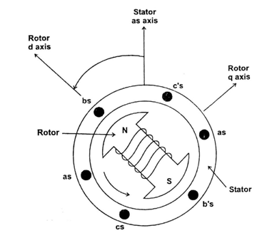
Fig. Idealized three phase two pole synchronous machine (Salient pole)
The rotor of the modern reluctance machine is designed with iron laminations in the axial direction separated by nonmagnetic material as shown in fig., to increase the reluctance to flux in the q-axis. Compared to the induction motor, it is slightly heavier and has a lower power factor. With proper design, the performance of the reluctance motor may approach that of induction machine. With a high saliency ratio (Lds/Lqs), a power factor of 0.8 can be reached. The efficiency of a reluctance machine may be higher than an induction motor because there is no rotor copper loss. Because of inherent simplicity, robustness of construction and low cost, reluctance machines have been popularly used in many low power applications such as fiber spinning mills, where a number of motors operate synchronously with a common power supply
The synchronous reluctance motor has no synchronous starting torque and runs up from stand still by induction action. There is an auxiliary starting winding. Subsequent design modifications involved the introduction of a segmental rotor construction of effort a flux barrier in each pole. This has increased the pull out torque, the power factor and the efficiency. The simple applications where several motors are required to rotate in close synchronism.
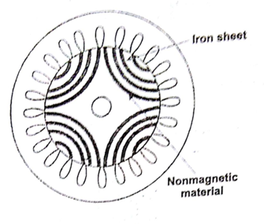
Fig. Cross-section of synchronous reluctance motor
Synchronous reluctance motor is designed for high power applications. It can broadly be classified into
(a) Axially laminated and
(b) Radially laminated
synchronous motors. These motors have the same stator construction as the multiphase induction motor. Generally three types of rotors used in synchronous reluctance motor. They are segmental, flux barrier (radially laminated) and axially laminated structure.
The ideal synchronous reluctance machine is having a rotor whose structure such that the inductance of the stator windings in the dq reference frame varies sinusoidally from a maximum value L_{d}(direct inductance) to a minimum value L_{q} (quadrature inductance) as a function of angular displacement of the rotor.
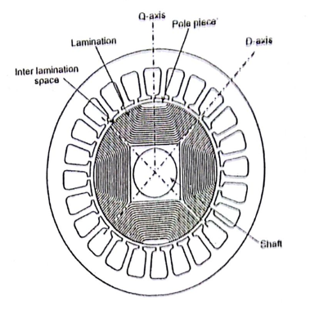
Fig. Cross section of axially laminated SyRM
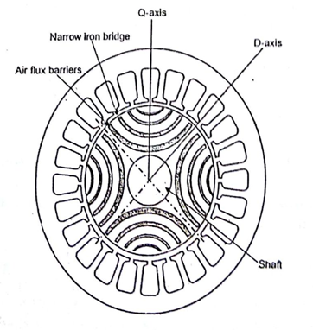
Fig. Cross section of radially laminated SyRM
Rotor Design:
Salient rotor (Segmental):
Salient rotor shape such that the quadrature air-gap is much larger than the direct air gap. This yields reactively small L_{d}/L_{q} ratios in the range of 2.3
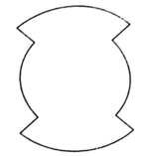
Fig. Salient Rotor.
Salient rotor design is shown in fig. The low L_{d}/L_{q} ratios are largely the result of circulating flux in the pole faces of the rotor. However the ruggedness and simplicity of the rotor structure has encouraged study of this approach for high speed applications.

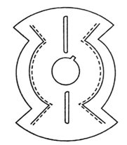
Fig. Radially laminated rotor
Another approach is to use laminations with "flux barriers" punched into the steel for a 4 pole machine as shown in fig. However these flux barriers and the central hole of the lamination required for the shaft weaken the rotor structurally and thus makes this approach a poor choice for high speed design.
Axially laminated rotor:
The fig. shows the axially laminated rotor.
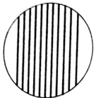
Fig. Axially laminated rotor.
This approach is to laminate the rotor in the axial direction. For a two pole two phase axially laminated rotor with an L_{d}/L_{q} ratio of 20, the maximum efficiency is 94% has been reported in the literature. It is observed that torque ripple and iron losses are more in axially laminated rotor than radially laminated rotor.
Another rotor design is shown in fig. In this case the rotor consists of alternating layers of ferromagnetic and non-magnetic steel. If choose the thickness of the steel such that the pitch of the ferromagnetic rotor segments matched the slot pitch of the stator. In this way the ferromagnetic rotor segments always see a stator tooth pitch regardless of the angle of rotation of the rotor. This is done to minimize flux variations and hence iron losses in the rotor.
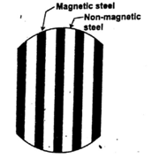
Fig New rotor design.
Special rotor laminations make it possible to produce the same number of reluctance path as there are magnetic poles in the stator. Synchronous speed is achieved as the salient poles lock in step with magnetic poles of the rotating stator field and cause the stator to run at the same speed as the rotating field. The rotor is pressure cast with end rings similar to induction motor. Stator windings are similar to squirrel cage induction motor
Rotor Construction:
To construct the rotor, we are using a joining technique known as explosion bonding. Explosion bonding uses explosive energy to force two or more metal sheets together at high pressures. Conventionally the high pressure causes several atomic layers on the surface of each sheet to behave as a fluid. The angle of collision between the two metals forces this fluid to jet outward. Effectively cleaning the metal surface, these ultra clean surfaces along with the high pressure forcing the metal plates together provide the necessary condition for solid phase welding.
Experimental tests on a stainless steel/mild steel bond indicate that the tensile and fatigue strengths of the bond are greater than those of either of the component materials due to the shock hardening which occurs during the process. The bond was also subjected to 10 cycles of temperature variation from 20°C - 70°C, with no significant reduction in tensile strength.
Explosion bonding technique is shown in fig. 7.9, other joining techniques such as brazing, roll bonding, or diffusion bonding may also appropriate for rotor construction.
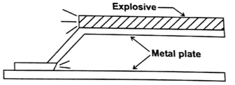
Fig. Explosion Bonding
First sheets of ferromagnetic and non-magnetic steel are bonded as shown in fig. The bonded sheets are then cut into rectangular blocks which are machined into the desired rotor. The rotor shaft can also be machined out of the same block as the rotor.
Working Of Synchronous Reluctance Motor:
In order to understand the working of synchronous reluctance motor, when a piece of magnetic material is located in a magnetic field, a force acts on the material tending to bring it into the densest portion of the field. The force tends to align the specimen of the material in such a way that the reluctance of the magnetic path that passes through the material will be minimum.
When supply is given to the stator winding, the revolving magnetic field will exert reluctance torque on the unsymmetrical rotor tending to align the salient pole axis of the rotor with the axis of the revolving magnetic field, because in this position, the reluctance of the magnetic path would be minimum as shown in fig. 7.10. If the reluctance torque is sufficient to start the motor and its load, the rotor will pull into step with the revolving field and continue to run at the speed of the revolving field. Actually the motor starts as an induction motor and after it has reached its maximum speed as an induction motor, the reluctance torque pulls its rotor into step with the revolving field, so that the motor now runs as synchronous motor by virtue of its saliency.
Fig. Rotor positions due to revolving magnetic field
Reluctance motors have approximately one-third the HP rating they would have as induction motors with cylindrical rotors. Although the ratio may be increased to one-half by proper design of the field windings, power factor and efficiency are poorer than for the equivalent induction motor Reluctance motors are subject to "cogging" since, the locked rotor torque varies with the rotor position, but the effect may be minimized by skewing the rotor bars and by not having the number of rotor slots exactly equal to an exact multiple of the number of poles.
Operating Principle Of Synchronous Reluctance Motor
To understand the working principle of synchronous reluctance motor, let us keep in mind the following basic fact.
When a piece of magnetic material is located in a magnetic field, a force acts on the material, tending to bring it into the most dense portion of the field. The force tends to align the specimen of material in such a way that the reluctance of the magnetic path lies through the material will be minimum.
In a nutshell, when a piece of magnetic material is free to move in a magnetic field, it will align itself with the field to minimize the reluctance of the magnetic circuit.
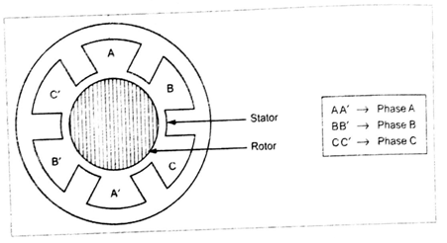
Fig. Synchronous reluctance motor
The Fig. shows the synchronous reluctance motor. The stator has open slot and semi closed slot structures. The rotor has two types of air gap viz., radial and axial. Here for simplicity, the synchronous reluctance motor having the open slot stator and axial air gap rotor structure is shown in Fig. All the configurations of synchronous reluctance motor are having the same working principle.
The stator has a 3φ, symmetrical winding, which creates a sinusoidal rotating field in the air gap when excited. The rotor has an unexcited ferromagnetic material with polar projections.
When the supply is given to the stator winding, the revolving magnetic field exerts reluctance torque on the unsymmetrical rotor tending to align the salient pole axis of the rotor with the axis of the revolving magnetic field. [It is the position, where the reluctance of the magnetic path would be minimum]. So the reluctance torque is developed by the tendency of ferromagnetic rotor to align itself with the magnetic field. The reluctance torque developed in this type of motor can be expressed as.
Where,
P → Number of poles
→ Stator flux linkage
→ Direct axis inductance with respect to synchronously rotating frame
→ Quadrature axis inductance with respect to synchronously rotating frame
δ → Torque angle
If the reluctance torque is sufficient to start the motor and its load, the rotor will pull into step with the revolving field and continue to run at the speed of the revolving field.
The motor starts as an induction motor and after it has reached its maximum speed as an induction motor, the reluctance torque pulls its rotor into step with the revolving field, so that the motor now runs as synchronous motor by virtue of its saliency. Even though the rotor revolves synchronously, its poles lag behind the stator poles by a certain angle known as torque angle, [something similar to that in a synchronous motor]. The reluctance torque increases with the increase in torque angle, attaining maximum value when α = 45°. Reluctance motors are subjected to “cogging” since, the locked rotor torque varies with the rotor position, but the effect may be minimized by skewing the rotor bars and by not having the number of rotor slots exactly equal to an exact multiple of the number of poles.
The operation of motor at synchronism with ideally zero rotor electrical losses will improve the efficiency. But the reluctance motors have approximately one third the hp rating, when compared with the condition that they would have operated as induction motors with cylindrical rotors. Although the ratio may be increased to one-half by proper design of the field windings, power factor and efficiency are poorer than for the equivalent induction motor.
Once the rotor of synchronous reluctance motor is synchronized, the cage winding rotates synchronously with the stator field. Thus, the rotor winding plays no part in the steady state synchronous operation of the motor. The machine continues to operate synchronously, provided the pull-out torque of the motor is not exceeded This is the load torque required to pull the rotor out of synchronism.
The pull in torque is defined as the maximum load torque which the rotor can pull into synchronism with a specified load inertia. The pull-in torque can be increased at the expense of larger starting current, but it is always less than the pull-out torque.
The reluctance motors have been widely used in adjustable-speed multimotor drives requiring exact speed coordination between individual motors. If all the motors in multimotor drive system are accelerated simultaneously from standstill by increasing the supply frequency, the machines operate synchronously at all times, and pull-in torque requirements.
The reluctance motor unfortunately exhibits a tendency towards instability at lower supply frequencies, but it forms a low cost. robust and reliable synchronous machine.
The constant speed characteristics of the synchronous reluctance motor makes it very suitable for the applications, such as, recording instruments, many kinds of timers, signaling devices and phonographs.
- Draw and explain the characteristics of synchronous reluctance motor. [Nov/Dec 2013 Apr/May2010]
(OR)
Draw and explain a typical torque-speed characteristics of a synchronous reluctance motor. [April/May 2008]
(OR)
Describe in detail, the speed-torque and torque-angle characteristics of synchronous reluctance motor with phasor diagrams.[Nov/Dec 2012 Nov/Dec 2013 Nov/Dec 2014 April/May 2015]
Characteristic Of Synchronous Reluctance Motor
Torque angle characteristic
We know that the developed electrical torque of synchronous reluctance motor can be expressed as,
The plotting of the above equation for different field excitations gives the various torque (T_{e}) - δ angle curves as shown in Fig.1.21, for both motoring and generating modes. The steady-state limit corresponds to the maximum points and is indicated by the dots in the Fig.
It is evident from the equation that if V_{s}/ω_{e} is maintained constant (i.e., the supply voltage is changed in proportional to the frequency), for a fixed excitation and torque angle, the developed torque remains constant.
But we have defined the synchronous reluctance motor as the motor which has the same structure as that of a salient pole synchronous motor except that it does not have a field winding on the rotor. So, there is no excitation in the motor. So, in the torque angle characteristics of Fig. drawn for salient pole machine, the reluctance torque component is the lowest curve which corresponds to zero percent excitation or zero excitation, where the stability limit is reached at δ ± π/4
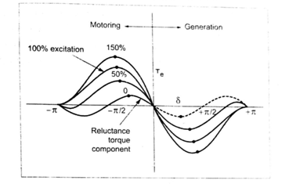
Fig. Torque-δ angle characteristics of salient pole machine
The reluctance torque component is in such a shape as shown in Fig. because the ideal synchronous reluctance machine is having a rotor whose structure is such that the inductance of the stator windings in the dq reference frame varies sinusoidally from a maximum value L_{d} [Direct inductance] to a minimum value L_{q} [Quadrature inductance] as a function of angular displacement of the rotor.
Torque - speed characteristic
In synchronous reluctance motor, the reluctance torque is developed by the tendency of a ferromagnetic material to align itself with a magnetic field. On a fixed frequency a.c. supply, the synchronous reluctance motor is not self-starting unless the rotor is fitted with a squirrel-cage winding to permit starting by induction motor action.
When the rotor speed approaches synchronous speed, the reluctance torque is super imposed on the induction motor torque, and as a result, the rotor speed oscillates above and below its average value. If the load torque and inertia are not excessive, the instantaneous rotor speed increases such as to reach synchronous speed and the rotor locks into synchronism with the stator field.
The Fig. shows the torque-speed characteristics of synchronous reluctance motor. The motor starts as an induction motor at anywhere from 300 to 400 percent of its full load torque (depending upon the salient pole axis of the rotor with the axis of the revolving magnetic field) as a two phase motor.
When the motor reaches its maximum speed as an induction motor, the reluctance torque pulls its rotor into step with the revolving field, so that the motor now runs as synchronous motor by virtue of its saliency. As it approaches synchronous speed, the reluctance torque is sufficient to pull the rotor into synchronism with the pulsating single phase field.
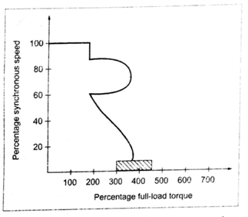
Fig. Torque-speed characteristics of synchronous reluctance motor
From the Fig, it is known that even though the torque is increased, the motor speed remains constant. But when the torque exceeds maximum value, the motor goes out of synchronism. The motor operates at constant speed upto a little over 200% of its full load torque. If it is loaded beyond the value of pull out torque, it will continue to operate as a single phase induction motor up to 500% of its rated output.
- The torque-speed characteristics of synchronous reluctance motor is shown in fig. The motor starts at anywhere from 300 to 400 percent of its full load torque as a two phase motor
- As a result of the magnetic rotating field created by a starting and running winding displaced 90 degree in both space and time.
- At 3/4th of the synchronous speed a centrifugal switch opens with starting winding and the motor continues to develop a single phase torque product by its running winding only.
- As its approaches synchronous speed the reluctance torque is sufficient to pull the rotor into synchronism with pulsating single phase field.
- The motor operates at constant speed up to a little over 200% of its full load torque.
- If it is loaded beyond the value of pull out torque it will continue to operate as a single phase induction motor upto 500% of its rated output.
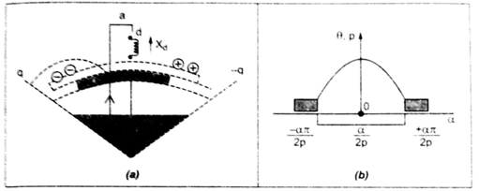
Fig. Circle diagram of synchronous reluctance motor
- In the complex phasor diagram the maximum continuous phase current defines a circular locus Fig. (a) and (b).
- With a sine-distribution of ampere conductors whose magnetic axis is aligned with the d-axis
- The mmf integral dl for flux lines that cross the air gap via the pole is given by
- Fig. (a) calculate of d-axis synchronous reactance showing the assumed magnetic potential boundaries. Fig.(b) Distribution of d-axis flux excited by sine-distributed stator winding.
- The expression equals one half the ampere-conductors enclosed within a closed flux line that crosses the air gap at the angle 0. The other half of the enclosed ampere conductors cab is thought of us forcing the flux line across the air gap via the adjacent poles. Thus the equations developed here arc all on a ‘per-pole’ basis.
- If all the poles are in series, N_{s} is the number of the turns in series per phase, and N_{s}/p is the number of turns per pole. Flux entering the sides of the pole is classified as fringing flux and is ignored at this stage.
- The dotted line drawn across the rotor and along the q-axis is in equipotential V₀ and as before, this potential may be assigned to zero with no loss generality, since it is common between adjacent poles.
- The pole piece is at a uniform magnetic potential V₁ as yet unknown, the Fig. circle diagram showing loci of maximum current limited by both current and voltage, for hybrid motor with ceramic magnets (0.4T; V₁ = 15V and 38 V).
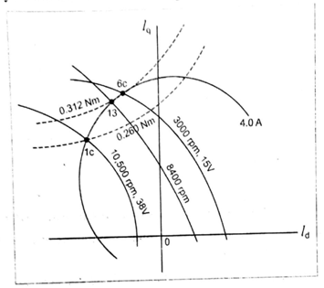
- This is a rectangular hyperbola asymptotic to the negative d-axis and to a q-axis offset to the right.
- Note that all these relationship are independent of frequency and speed.
- With high energy magnet the offset Eq/Δx is so large that the constant-torque contours are almost horizontal straight lines, as they arc for the surface magnet.
- This again shows the similarity between the two machines when high energy magnets are used.
- When the hybrid motor is ‘under excited’, as it may well be with ceramic magnets, the constant-torque contours have more curvature.
- For the pure synchronous reluctance motor the constant-torque contours are also rectangular hyperbolas but with no offset.
- The torque contour for 0.312 Nm in Fig.1.24 is tangent to the maximum current circle at point 1. This torque is attainable at 300 rpm with a controller of voltage only 15V.
- As the speed increases the size of the voltage-limited current locus can be maintained by increasing the voltage (by P.W.M control) up to maximum of 38V, which is reached at 8400 rpm. This is the highest speed at which the torque of 0.312 Nm can be attained, giving an electromagnetic power of 274.5 W at the air gap.
- If the speed is raised to 10500 rpm, the torque must decrease as the operating point is constrained by maximum current limit.
Torque - Speed Characteristics:
The torque speed characteristics of synchronous reluctance motor is shown in fig. The motor starts at anywhere from 300 to 400 percent of its full load torque (depending on the rotor position of the unsymmetrical rotor with respect to the field winding) as a two phase motor. As a result of the magnetic rotating field created by a starting and running winding displaced 90° in both space and time
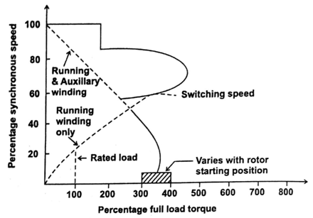
Fig. Torque - Speed characteristics.
At about 3/4th of the synchronous speed a centrifugal switch opens the starting winding and the motor continues to develope a single phase torque produced by its running winding only. As it approaches synchronous speed, the reluctance torque (developed as a synchronous motor) is sufficient to pull the rotor into synchronism with the pulsating single phase field. The motor operates at constant speed upto a little over 200% of its full load torque. If it is loaded beyond the value of pull out torque, it will continue to operate as a single phase induction motor upto 500% of its rated output.
Application characteristics:
- Comparable power density but better efficiency than induction motor.
- Slightly lower power factor than induction motor.
- Slightly small field weakening range than induction motor.
- High cost than induction motor but lower than any type of PM motors.
- Need speed synchronisation to inverter out frequency by rotor position sensor and sensorless control.
- Sensorless control is much easier due to motor saliency.
- By adding squirrel cage induction motor to synchronous reluctance motor one obtains line starting reluctance motors.
- Line started reluctance motors can be parallel with open loop control if the load does not change suddenly.
- Other combinations are possible such as adding PM for improved performance
- Rotor design for best manufacturability is still being optimized especially for high speed applications
- Explain in detail about vernier motor. [Nov/Dec 2007 April/May 2008 April/May 2010]
Vernier motor:
A vernier motor is an unexcited (or reluctance type) inductor synchronous motor. It is also named because it operates on the principle of a vernier. The peculiar feature of this kind of motor is that a small displacement of the rotor produces a large displacement of the axes of maximum and minimum permeance. When a rotating magnetic field is introduced in the air gap of the machine, the rotor will rotate slowly and at a definite fraction of the speed of the rotating field. This rotating field can be produced either by feeding poly phase current to the stator winding or by exciting the stator coil groups in sequence. As the rotor speed steps down from the speed of the rotating field, the motor torque steps up. A vernier motor, therefore works as an electric gearing. This kind of motor is attractive in applications which require low speed and high torque and where mechanical gearing is undesirable.
Since the vernier motor is a synchronous machine, useful torque is developed only when it operates at synchronous speed. To be capable of self-starting without any auxiliary means, the rotor must be pulled into synchronism within the time of one-half cycle. The vernier motor, therefore must be designed to run at a low speed [approximately 200 rpm or less] and to have high torque to inertia ratio.
Principle of operation:
The stator of a vernier motor has slots and a distributed winding just like the stator of an ordinary polyphase induction motor. The rotor is a slotted iron core without winding. To understand the principle of operation of a vernier motor consider the fig. shown. Fig. shows a 2 pole machine with 12 stator slots and 10 rotor slots. Small number of slots are purposely chosen as an example to facilitate the explanation.
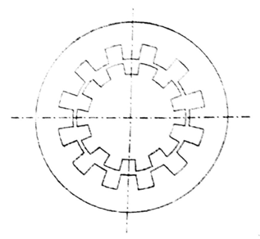
Fig. Vernier motor
At the position shown in fig., the stator and rotor teeth are facing each other in the vertical axis. The stator teeth are facing rotor slots in the horizontal axis. At this position therefore, the maximum permeance is along the vertical axis and the minimum permeance is along the horizontal axis When the rotor is rotated one half of its slot pitch, the rotor slots will face stator teeth in the vertical axis. The rotor and stator teeth will face each other in the horizontal axis. The axis of maximum permeance is no horizontal and the axis of minimum permeance is now vertical. Thus the rotor movement of one-half rotor slot pitch results in a 90 degree displacement o the permeance axes.
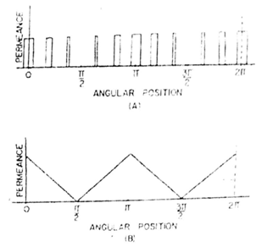
Fig. 7.16 (a) Air-gap permeance distribution of motor (b) Equivalent permeance distribution
Design of vernier motor:
In a polyphase reluctance motor the rotor (or the air-gap permeance wave) has the same number of poles as the stator mmf (magnetomotive force)wave. Similarly in a vernier motor the air gap permeance wave should have the same number of poles as the stator mmf wave. Therefore, the number of stator and rotor slots should has the following relation
N₁ = N₂ ± P
Where
N₁ - Number of stator slots
N₂ - Number of rotor slots
P - Number of poles of the rotating magnetic field
As explained before, when the rotor rotates through an angle corresponding to one rotor slot pitch, the permeance wave rotates through an angle corresponding to one pole pitch. The pole pitch of the permeance wave is the same as the pole pitch of the stator mmf wave, because they have the same number of poles. Also in a reluctance machine, the speed of the permeance wave is the same as the speed of rotating mmf.
Therefore,
or
and
It can be seen from equation 1 that the rotor speed is independent of the number of poles of the machine when the speed of rotating magnetic field is reduced by increasing the number of poles of the machine. It cannot be expected that the speed of the rotor be reduced proportionately because when P is increased the difference between N₂ and N₁ should also be increased, and the electric gear ratio is reduced in the inverse proportion Thus the rotor speed is not affected by the number of poles but depends on the number of rotor slots.
From the analysis of air gap permeance distribution in a vernier motor, it follows that the design of a vernier motor is equivalent to the design of an ordinary polyphase reluctance motor with an odd shaped rotor so that the air-gap permeance distribution is a displaced triangular wave as that shown n fig (b). The main step in design is to calculate the direct and quadrature axes reactances X_{d} and X_{q}
X_{d} = X₁ + X_{ad}
X_{q}= X₁ + X_{aq}
where X₁ is the stator leakage reactance and X_{ad} and Xaq are the direct and quadrature axes reactances of armature reaction. X_{ad} is the ratio of the fundamental component of reactive armature voltage, produced by the mutual flux due to the fundamental direct axis component of armature current, to this component under steady state conditions and at rated frequency.
Similarly X_{aq} is the ratio of the fundamental component of reactive armature voltage, produced by the mutual flux due to the fundamental quadratue axis component of armature current, to its component of current under steady state conditions and at rated frequency
- Draw the phasor diagram and characteristics of synchronous reluctance motor [Nov/Dec 2014]
(OR)
Derive the voltage and torque equations of synchronous reluctance motors. [May/June 2013 May/June 2014]

(OR)

Derive the torque equation of a synchronous reluctance motor and draw the torque angle characteristics. (8) [April 2017]
(OR)
Derive the expression for d-axis synchronous reactance of a synchronous reluctance motor. (8) [April 2017]
(OR)
Draw the steady state phasor diagram of synchronous reluctance motor and derive the expression for torque of synchronous reluctance motor. [Nov 2016]
Phasor Diagram Of Synchronous Reluctance Motor
The synchronous Reluctance machine is considered as a balanced three phase circuit, it is sufficient to draw the phasor diagram for only one phase. The phasor diagram of SyRM is shown in Fig.1.15. The basic voltage equation neglecting the effect of resistance is
Where
V = Supply voltage
I_{s} = Stator current.
E = excitation emf.
δ = load angle
φ = phase angle
X_{sd}, X_{qs} = synchronous reactance of direct axis and quadrature axis.
I_{sd}, I_{sq} = direct axis and quadracture axis current
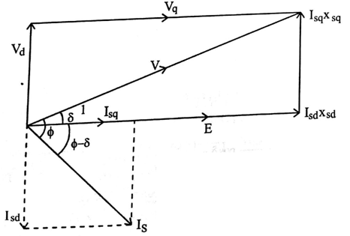
Figure Phasor diagram of SyRM
From the phasor diagram,
cos δ=
Similarly,
sin δ =
Let us write cosφ as
cos φ = cos(φ - δ + δ)
cos φ = cos(φ - δ) cosδ - sin (φ - δ)sinδ …4
From the phasor diagram.
Substitute equation 5 and 6 in equation 4
Substitute I_{sq} and I_{sd} in equation 7
We know that,
Power developed by the motor is given by
We knot that,
Since there is no source of flux on the rotor. E become zero (E = 0). Then the final torque expression becomes
Where ω_{s} = Synchronous speed.
This is the torque equation of synchronous reluctance motor.
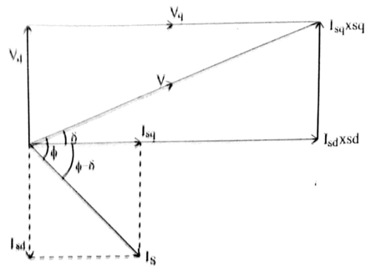
Figure Phasor diagram of synchronous reluctance motor with E = 0
Torque – Angle Characteristics
The torque equation of a synchronous reluctance motor is given by
The value of the torque is decided by the value of δ, as the δ varies the value of the torque (T) also varies. Now we are going to discuss how the value torque is varied. Generally (Lqs > Lds) and the torque has maximum value.
(iii) δ = 0°, T = 0
ii) δ = 45°,
when δ = 45°, we can able to obtain maximum positive torque
iii) δ = 90°, T = 0.
iv) δ = 135°,
when δ = 135°, we can able to obtain maximum negative torque value.
v) δ = 180°, T = 0.
Plotting the value of torque for different values of δ indicates that the stability limit is reached at and by increasing load angle δ, torque also increases, The torque follows sinusoidal distribution in the motoring and generating region as it is figure.
General torque – angle characteristics is shown in the figure
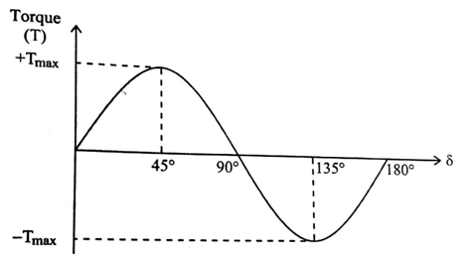
Figure Load Torque – Load angle characteristics
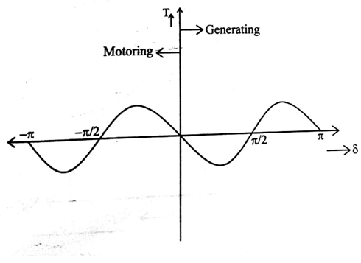
Figure General Torque angle characteristics
Torque Speed Characteristics
In the operation of synchronous reluctance motor, initially the motor starts as an Induction motor and after it reaches its maximum value as an induction motor the reluctance pull its rotor into step with the revolving field, so that the motor now runs as synchronous motor. Here after the motor continuous its operation as Synchronous Reluctance motor. The speed of the motor remains constant even though the torque is increased. When the torque exceeds maximum value, the motor goes out of synchronism and the motor stops.
The speed control of the machine can be achieved by combined volts/Hz control. The characteristics takes the natural shape (i.e) as the speed is increased from initial value, the variable load on the motor does not affect the speed of the motor but it controls the developed torque in the motor for the fixed frequency operation. The speed torque characteristics is also affected by the sudden loading and un loading of motor which leads to oscillatory motion of the rotor which may sometimes leads to asynchronous operation.
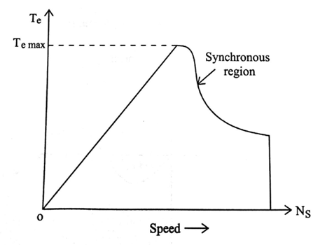
Figure Torque speed characteristics of SyRM

