UNIT I SOFTWARE PROCESS AND AGILE DEVELOPMENT
Introduction to Software Engineering, Software Process, Perspective and Specialized Process Models –Introduction to Agility-Agile process-Extreme programming-XP Process.
UNIT-I / PART-A
1 | What are the characteristics of software? (May/June 2016)  - Software is engineered or developed; it is not manufactured in the classical sense.  - Software doesn’t wear out.  - Although the industry is moving toward component based assembly, most software continues to be custom built.
2 | Write down the generic process framework that is applicable to any software project. (NOV/DEC 2010)(APR/MAY 2015)  The following generic process framework is applicable to vast majority of software projects:  - Communication: This framework activity involves heavy communication and collaboration with the customer and encompasses requirements gathering and other related activities.  - Planning: This activity establishes a plan for the software engineering work that follows. It describes the technical tasks to be conducted, the risks that are likely, the resources that will be required, the work products to be produced, and a work schedule.  - Modeling: The activity encompasses the creation of models that allow the developer and the customer to better understand software requirements and the design that will achieve those requirements.  - Construction: This activity combines code generation and the testing that is required to uncover errors in the code.  - Deployment: The software is delivered to the customer who evaluates the delivered product and provides feedback based on the evaluation.
3 | List the goals of Software Engineering. (APR/MAY 2011)  Software Engineering is the establishment and use of sound engineering principles in order to obtain economically software that is reliable and works efficiently on real machines. The goals of software engineering are:  - Software production which consists of developed programs and associated documentation.  - The software product should have the essential product attributes maintainability, dependability, efficiency and acceptability.  - It should also include suggestions for the process to be followed, the notations to be used, system models to be developed and rules governing these models and design guidelines.
4 | What are the difference levels of CMMI?
  - Level 0 – Incomplete. | - Level 3 – Defined.
  - Level 1 – Performed. | - Level 4 – Quantitatively Managed.
  - Level 2 – Managed. | - Level 5 – Optimized.
5 | Give two reasons why system engineers must understand the environment of a system. (MAY/JUN 2012)  - Limited scope for rework during system development: Once some system engineering decisions have been made, they are very expensive to change. Reworking the system design to solve these problems is rarely possible.  - Interdisciplinary involvement: Many engineering disciplines are involved in system engineering. There is a lot of scope for misunderstanding because different engineers use different terminology and conventions.
6 | What are the two types of software products? (MAY/JUN 2012)  The two fundamental types of software product are  - Generic products: These are stand alone systems developed by organizations and sold on open market to any customer who is able to buy them.  - Customized products: These are systems which are commissioned by a particular customer. A software contractor develops the software especially for that customer.
7 | What is Software Engineering? (NOV/DEC 2013)(NOV/DEC 2014)  Software engineering is a discipline in which theories, methods and tools are applied to develop professional software. (Or) Software engineering is the systematic approach to develop and maintain a software product in a cost effective and efficient way.
8 | What is RAD?  Rapid Application Development is an incremental software development process. When tools are interpreted so that information created by one tool can be used by another, a system for the support of software development called computer aided software engineering is established.
9 | List out evolutionary software process model.  - Incremental model  - Spiral model  - WINWIN spiral model  - Concurrent development model  - Object oriented model  - Embedded model
10 | What are the difference between product and process?
  PROCESS | PRODUCT
  It is a frame work which has a set of rules to be followed in key processing areas (KPA),rules for framing task sets, setting a milestone for it and applying s/w quality assurance points. | It is the final shipment outcome of the  process.
  It is used to obtain quality product. | Various process paradigms/models are used to build a quality product.
11 | What is CPF?  A Common Process Framework is established by defining a small number of framework activities that are applicable to all software projects, regardless of their size or complexity.
12 | Define Computer based system and specify its components.  A set of arrangement of elements that are organized to accomplish some predefined goals by processing information. Its components are software, hardware, people, database, documentation and procedure.
13 | What are the advantages and disadvantages of Waterfall Model?  Advantages: It provides a template into which methods for analysis, design, and other phases can be placed. It provides for baseline management. It is better than any haphazard approach to software development.  Disadvantages: It lacks the perception for a reverse engineering on how to engineer an existing legacy system. The client has to wait until the installation and checkout phase to see how a system works. Thus a complex system requires considerable time and effort. There is no rapid prototyping and incremental development. Real time software cannot follow this model. Customer satisfaction is not full filled.

14 |  | What are the advantages and disadvantage of Incremental Model?  Advantages: The software development activities are repeated each time there is a new release of software. It provides a platform for evaluation by the user. It can be planned to manage technical risks. It enables partial functionality to be delivered to end users without ordinary delay.  Disadvantage: It makes the unrealistic assumptions that system as well as software requirements remain stable which is not true.
15 |  | What are the advantages and disadvantages of Spiral Model?  Advantages: It provides the potential for rapid development for incremental versions of the software. It can be applied throughout the life of the computer software. It allows the developer to apply the prototyping approach at any stage. It demands a direct consideration of technical risks at all stages.  Disadvantages: It may be difficult to convince the customers at times especially in contrast solutions. It demands considerable risks assessment expertise and relies on them for success. It takes time for determining the efficacy and thus the model cannot be used as widely as others.
16 |  | What are the advantages and disadvantage of WINWIN SPIRAL MODEL?  Advantages: It has a provision for system stakeholders to negotiate mutually satisfactory specifications. Customer satisfaction is fulfilled. It overcame the problem of lack of anchor points to correlate the completion of the spiral cycles and organization major milestones.  Disadvantage: The model does not specifically address the issues of how developers specify, design and test the conceptual construct software.
17 |  | What are the advantages and disadvantage of Object Oriented Model?  Advantages: Object oriented concepts like encapsulation can be improvised in this model. It simplifies software development because it hides complexity. Reusability is enhanced.  Disadvantage: In safety critical conditions they require a design by contract in the construction of reliability software.
18 |  | Give the restraining factors that are to be considered to construct a system model. Assumptions that reduce the number of possible permutations and variations thus enabling the model to reflect the problem in a reasonable manner, Simplifications that enable the model to be created in a timely manner, Limitations that help to bound the system, Constraints that will guide the manner in which the model is created and the approach taken when the model is implemented. Preferences that indicate the preferred architecture for all data, functions, and technology.
19 |  | What does a System Engineering Model accomplish?  - Define processes that serve needs of view.  - Represent behavior of process and assumption.  - Explicitly define Exogenous and Endogenous Input.  - Represent all Linkages that enable engineer to better understand view.
20 |  | What are the advantages and disadvantages of Prototyping Model?  Advantages: It produces the products quickly and thus saves the time It and solves the waiting problem in waterfall model. It minimizes the cost and product failure. It is possible for the developers and client to check the function of preliminary implementations of system models before committing to a final system. It obtains feedback from clients and changes in system concept.  Disadvantages: It ignores quality, reliability maintainability and safety requirements. Customer satisfaction is not achieved.
21 |  | What led to the transition from product oriented development to process oriented development?(MAY/JUNE 2016)  The product-oriented approach to the teaching of writing emphasizes mechanical aspects of writing, such as focusing on grammatical and syntactical structures and imitating models. This approach is primarily concerned with "correctness" and form of the final product.  Process-oriented approaches concern the process of how ideas are developed and formulated in writing. Writing is considered a process through which meaning is created. This approach characterizes writing as following a number of processes: First, a writer starts writing ideas as drafts. Subsequently, he checks to see whether the writing and the organization makes sense to him or not. After that, he checks whether the writing will be clear to the reader. This approach focuses on how clearly and efficiently a user can express and organize his ideas, not on correctness of form.
22 |  | If you have to develop a word processing software product, what process model will you choose? Justify your answer. (NOV/DEC 2016)  Incremental process model is used to develop a word processing software product.  Justification:  - Word-processing software developed using the incremental paradigm might deliver  - Basic file management, editing, and document production functions in the first increment;  - More sophisticated editing and document production capabilities in the second increment;  - Spelling and grammar checking in the third increment;  - Advanced page layout capability in the fourth increment.
23 |  | Depict the relationship between work product, task, activity and System. (NOV/DEC 2016)(APR/MAY 17)  - A task focuses on a small, but well-defined objective that produces a tangible work product.  - Work Product is any deliverable or outcome of the set of activities.  - An activity is a major unit of work (set of tasks) that has to be completed to produce an outcome.  - System is a set of interconnected components that carries out a specific activity.
24. |  | Write the IEEE definition of software engineering.(NOV/DEC 17)  Software Engineering: The application of a systematic, disciplined, quantifiable approach to the development, operation, and maintenance of software; that is, the application of engineering to software.
25. |  | What is Software? List its Characteristics. ( April/May 2018)  Software is nothing but a collection of computer programs that are related documents that are indented to provide desired features, functionalities and better performance.  Features:  - Software is engineered, not manufactured  - Software does not wear out.  - Most software is custom built rather than being assembled from components
26. |  | If you have to develop a word processing software product, what process model will you choose? Justify your answer. ( April/May 2018)  Incremental development method- different components can be developed and added incrementally.
27 |  | What is Extreme Programming?  Extreme programming, requirements are expressed as scenarios (called user stories), which are implemented directly as a series of tasks. Programmers work in pairs and develop tests for each task before writing the code. All tests must be successfully executed when new code is integrated into the system. There is a short time gap between releases of the system.
28 |  | What are the key features of testing in XP?  The key features of testing in XP are:  - Test-first development,  - incremental test development from scenarios,  - user involvement in the test development and validation, and  - the use of automated testing frameworks.
29 |  | Briefly write about Agile methods.  The best way to achieve better software was through careful project planning, formalized quality assurance, the use of analysis and design methods supported by CASE tools, and controlled and rigorous software development processes. This view came from the software engineering community that was responsible for developing large, long lived software systems such as aerospace and government systems. This software was developed by large teams working for different companies. Teams were often geographically dispersed and worked on the software for long periods of time. An example of this type of software is the control systems for a modern aircraft, which might take up to 10 years from initial specification to deployment. These plan driven approaches involve a significant overhead in planning, designing, and documenting the system. This overhead is justified when the work of multiple development teams has to be coordinated, when the system is a critical system, and when many different people will be involved in maintaining the software over its lifetime.
UNIT-I / PART-B
1 | Explain the following: (i) waterfall model (ii) Spiral model (iii) RAD model (iv) Prototyping model(NOV/DEC 2010)(NOV/DEC 2013)(MAY/JUNE 2014)(APRIL/MAY 2015) (May/June 2016)(APR/MAY 17)(NOV/DEC 17)  WATERFALL MODEL  When the requirements of a problem are reasonably well understood-when work flows from communication through deployment in a reasonably linear fashion. This situation is encountered when  - Well defined adaptations or enhancements to an existing system must be made.  - In limited number of new development efforts, but only when requirements are well defined and reasonably stable.  The waterfall model, called the classic life cycle suggests a systematic, sequential approach  to software development.  - Begins with customer specification of requirements  - Progresses through planning  - Modelling  - Construction  - Deployment  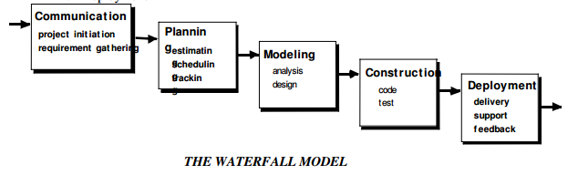  Problems encountered when Waterfall Model is applied:  - Real projects rarely follow the sequential flow that the model proposes. Although the linear model can accommodate iteration, it does so indirectly. As a result, changes can cause confusion as the project team proceeds.  - It is often difficult for the customer to state all the requirements explicitly. The waterfall model requires this and has difficulty accommodating uncertainty that exists at the beginning of many projects.  - The customer must have patience. A working version of the program will not be available until late in the project life-span. A major blunder, if undetected until the working program is reviewed can be disastrous.  Linear structure of the waterfall model leads to blocking states in which some project team members must wait for other members of the team to complete dependent tasks. Blocking states are more prevalent at the beginning and end of the linear sequential process.  SPIRAL MODEL  The spiral model is an evolutionary software process model that couples the iterative nature of prototyping with the controlled and systematic aspects of the waterfall model. It provides the potential for rapid development of increasingly more complex versions of the software. Boehm definition:  The spiral development model is a risk-driven process model generator. It has two main distinguishing features :  - One is a cyclic approach for incrementally growing a system’s degree of definition and implementation while decreasing its degree of risk.  - The other is a set of anchor point milestones for ensuring stakeholder commitment to feasible and mutually satisfactory system solutions.  Using spiral model, software is developed in a series of evolutionary releases. During early iterations, the release is a paper model or prototype. During later iterations, more complex versions of the engineered system are produced.  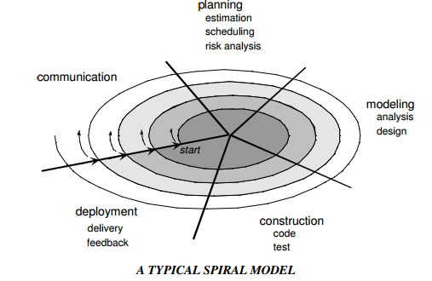  A spiral model is divided into a set of framework activities defined by the software engineering team. Each of the framework activities represents one segment of the spiral path as shown in the figure.  - As evolution begins the software team performs activities implied by the by the circuit around the spiral, in clockwise direction, beginning at the center.  - Risk is considered at each revolution made.  - Anchor point milestones-a combination of work products and conditions that are attained along the path of the spiral are noted for each evolutionary pass.  - First circuit around the spiral results in the development of product specifications.  - Subsequent passes develop a prototype, progressively lead to sophisticated version of the software.  - Cost and schedule are adjusted based on feedback derived from the customer after delivery.  - Unlike other process models that end when the software is delivered, the spiral model can be adapted throughout the life of the software.  - The first spiral represents a Concept Development Project which starts at core and continues for multiple iterations until concept development is implemented.  - The concept developed to an actual product, proceeds outward on the spiral and a New Product Development Project commences.  - The new product may evolve to represent Product Enhancement Project.  Features of Spiral Model:  - Realistic approach to the development of large scale-systems and software.  - Because the software evolves as the process progresses, the developer and customer better understand and react to risks at each evolutionary level.  - Enables the developer to apply the prototyping approach at any stage in the evolution of the product.  - It maintains the systematic stepwise approach of classic life cycle but in incorporates it into an iterative framework that realistically reflects the real world.  - It demands direct consideration of technical risks at all stages of the project and if applied properly, reduce risks before they become problematic.  RAD MODEL  Rapid Application Development (RAD) is an incremental software process model that emphasizes a short development cycle. The RAD model is a high-speed adaptation of the waterfall model, in which rapid development is achieved by using component-based construction approach. If requirements are well understood and project scope is constrained, the RAD process enables a development team to create a fully functional system within a very short time period.  Like other process models, RAD approach maps to the generic framework activities as  - Communication, works to understand the business problem and the information characteristics that the software must accommodate.  - Planning, is essential because multiple software teams work in parallel on different system functions.  - Modeling encompasses three major phases-business modeling, data modeling and process modeling- and establishes design representations that serve as the basis for RAD’s construction activity.  - Construction emphasizes the use of pre-existing software components and the application of automatic code generation.  - Deployment, establishes a basis for subsequent iterations, if required.  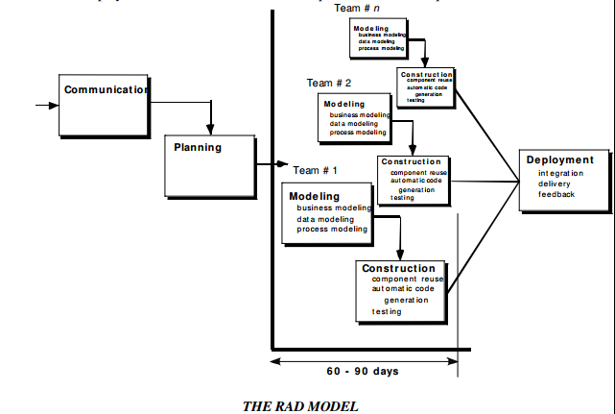  If a business application can be modularized in a way that enables each major function to be completed in less than three months, it is a candidate for RAD. Each major function can be addressed by a separate RAD team and then integrated to form a whole.  RAD Drawbacks:  - For large, but scalable projects, RAD requires sufficient human resources to create the right number of RAD teams.  - If developers and customers are not committed to the rapid fire activities, RAD project fails.  - If a system is not properly modularized, building the components for RAD will be problematic.  - If high performance is an issue and performance is to be achieved through tuning the interfaces to system components, the RAD approach may not work.  - Not appropriate when technical risks are high or when new technology is used.  PROTOTYPING MODEL  The customer usually defines a set of general objectives for software, but does not identify detailed input, processing or output requirements. The developer may be unsure of  - The efficiency of an algorithm  - The adaptability of an operating system  - The form that human-machine interaction should take  In these and many other situations, a prototyping paradigm may offer the best approach. Although prototyping can be used as a standalone process model, it is more often used as a technique that can be implemented within the context of any one of the other process models. The prototyping paradigm assists the software engineer and the customer to better understand what is to be built when the requirements are fuzzy.  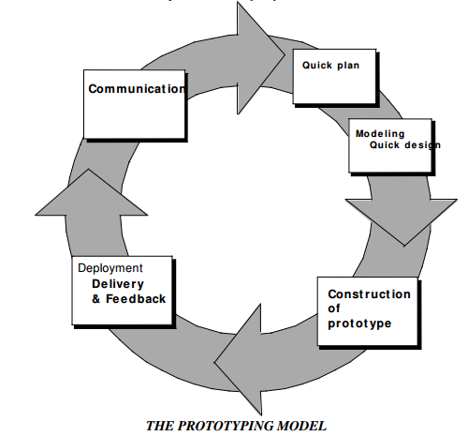  - The prototyping paradigm begins with communication. The software engineer and the customer meet and  - Define the overall objectives for the software  - Outline areas whether further definition is mandatory  - Identify whatever requirements are known  - The quick design leads to construction of a prototype.  - The prototype is deployed and then evaluated by customer/user. The feedback is used to refine requirements for the software.  - Iteration occurs as the prototype is tuned to satisfy the needs of the customer, while at the same time enabling the developer to better understand what needs to be done.  - Prototyping serves as a mechanism for identifying software requirements. If a working prototype is built, the developer attempts to make use of existing program fragments or applies tools that enable working programs to be generated quickly.  - The prototype can serve as the first system. Both customers and developers like the prototyping paradigm. Users get a feel for the actual system and developers get to build something immediately.  Problems with Prototyping  - The customer sees what appears to be a working version of the software, unaware that in the rush to get it working, the quality or maintainability is not considered. When informed that the software has to be rebuilt, demands for a few fixes to make it a working product.  The developer often makes implementation compromises to make the prototype work quickly. An inappropriate OS or programming language is used, but the developer forgets why these choices are inappropriate and gets comfortable with the system. The less-than-ideal choice has now become an integral part of the system.
2 | Describe waterfall, incremental and iterative models based SLCS and compare.(NOV/DEC 2012)  The Waterfall Model  The waterfall model is a sequential design process, used in software development processes, in which progress is seen as flowing steadily downwards (like a waterfall) through the phases of Conception, Initiation, Analysis, Design, Construction, Testing, Production/Implementation and Maintenance. The following phases are followed in order:  - Requirements specification resulting in the product requirements document  - Design resulting in the software architecture  - Construction (implementation or coding) resulting in the actual software  - Integration  - Testing and debugging  - Installation  - Maintenance  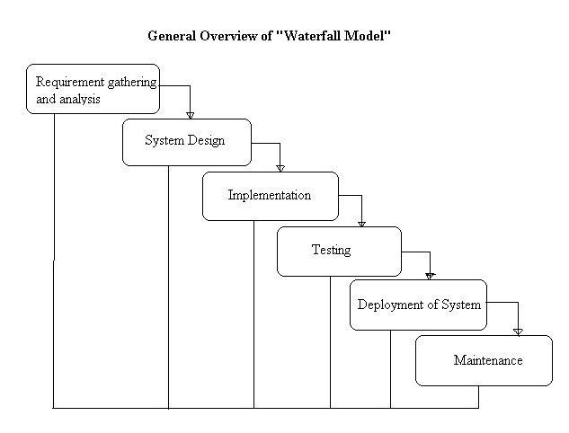  Advantages:  - Easy to understand and implement.  - Widely used and known (in theory!).  - Reinforces good habits: define-before- design, design-before-code.  - Identifies deliverables and milestones.  - Document driven, URD, SRD,. etc. Published documentation standards,  - Works well on mature products and weak teams.  Disadvantages:  - Idealized, doesn’t match reality well.  - Doesn’t reflect iterative nature of exploratory development.  - Unrealistic to expect accurate requirements so early in project.  - Software is delivered late in project, delays discovery of serious errors.  - Difficult to integrate risk management.  - Difficult and expensive to make changes to documents, ”swimming upstream”.  - Significant administrative overhead, costly for small teams and projects  Incremental models  The incremental model applies linear sequences in a staggered fashion as calendar time progresses. Each linear sequence produces deliverable “increments” of the software in a manner that is similar to the increments produced by an evolutionary process flow.  - When an incremental model is used, the first increment is often a core product.  - The core product is used by the customer (or undergoes detailed evaluation).  - As a result of use and/or evaluation, a plan is developed for the next increment. The plan addresses the modification of the core product to better meet the needs of the customer and the delivery of additional features and functionality.  - This process is repeated following the delivery of each increment, until the complete product is produced.  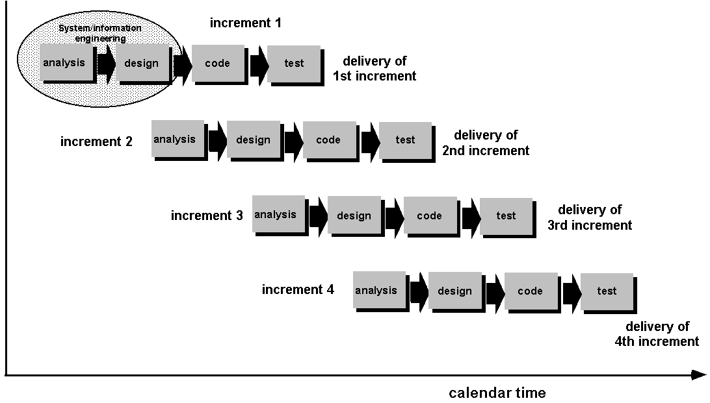  Advantages of Incremental model:  - Generates working software quickly and early during the software life cycle.  - This model is more flexible – less costly to change scope and requirements.  - It is easier to test and debug during a smaller iteration.  - In this model customer can respond to each built.  - Lowers initial delivery cost.  - Easier to manage risk because risky pieces are identified and handled during it’d iteration.  Disadvantages of Incremental model:  - Needs good planning and design.  - Needs a clear and complete definition of the whole system before it can be broken down and built incrementally.  - Total cost is higher than waterfall.  Iterative models  An iterative life cycle model does not attempt to start with a full specification of requirements. Instead, development begins by specifying and implementing just part of the software, which can then be reviewed in order to identify further requirements. This process is then repeated, producing a new version of the software for each cycle of the model.  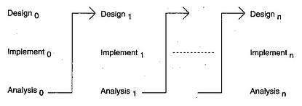  Advantages of Iterative model:  - In iterative model we can only create a high-level design of the application before we actually begin to build the product and define the design solution for the entire product. Later on we can design and built a skeleton version of that, and then evolved the design based on what had been built.  - In iterative model we are building and improving the product step by step. Hence we can track the defects at early stages. This avoids the downward flow of the defects.  - In iterative model we can get the reliable user feedback. When presenting sketches and blueprints of the product to users for their feedback, we are effectively asking them to imagine how the product will work.  - In iterative model less time is spent on documenting and more time is given for designing.  Disadvantages of Iterative model:  - Each phase of an iteration is rigid with no overlaps  - Costly system architecture or design issues may arise because not all requirements are gathered up front for the entire lifecycle
3 | Discuss in detail the project structure and programming team structure of a software organization. (NOV/DEC 2010)  A PROCESS FRAMEWORK  A process framework establishes the foundation for a complete software process by  identifying a small number of framework activities that are applicable to all software projects, regardless of their size or complexity. In addition, the process framework encompasses a set of umbrella activities that are applicable across the entire software process.  Each framework activity is populated by a set of software engineering actions-a collection of related tasks that produces a major software engineering work product. Each action is  populated with individual work tasks that accomplish some part of the work implied by the action.  The following generic process framework is applicable to vast majority of software projects:  - Communication: this framework activity involves heavy communication and collaboration with the customer and encompasses requirements gathering and other related activities.  - Planning: this activity establishes a plan for the software engineering work that follows. It describes the technical tasks to be conducted, the risks that are likely, the resources that will be required, the work products to be produced, and a work schedule.  - Modeling: the activity encompasses the creation of models that allow the developer and the customer to better understand software requirements and the design that will achieve those requirements.  - Construction: this activity combines code generation and the testing that is required to uncover errors in the code.  - Deployment: the software is delivered to the customer who evaluates the delivered product and provides feedback based on the evaluation.  The modeling activity is composed of two software engineering actions:  - Analysis encompasses a set of work tasks requirements gathering, elaboration, negotiation, specification and validation that lead to the creation of the analysis model or requirements specification.  - Design encompasses work tasks data design, architectural design, interface design and component-level design and create a design model or design specification.  Each software engineering action is represented by a number of different task sets-each a collection of software engineering work tasks, related work products, quality assurance points and project milestones. The task set that best accommodates the needs of the project and characteristics of the team is chosen. The framework described in the generic view of software engineering is completed by a number of umbrella activities. Typical activities in this category include:  - Software Project Tracking and Control-allows the software team to assess  progress against the project plan and take the necessary action to maintain schedule.  - Risk Management-assess the risks that may effect the outcome of the project or the  quality of the product.  - Software Quality Assurance-defines and conducts the activities required to ensure  software quality.  - Formal Technical Reviews-assesses software engineering work products in an effort to uncover or remove errors before they are propagated to the next action or activity.  - Measurement-defines and collects process, project and product measures that assist the team in delivering software that meets customer needs.  - Software Configuration Management-manages the effects of change throughout  the software process.  - Reusability Management-defines criteria for work product reuse and establishes mechanisms to achieve reusable components.  - Work Product Preparation and Production-encompasses the activities required to create work products such as models, documents, logs, forms and lists.  All process models can be categorized within the process framework discussed. But process models do differ fundamentally in:  - The overall flow of activities and tasks and the interdependencies among activities and tasks.  - The degree to which work tasks are defined within each framework activity.  - The degree to which work products are identified and required.  - The manner which quality assurance activities are applied.  - The manner in which project tracking and control activities are applied.  - The overall degree of detail and rigor with which the process is described.  - The degree to which customer and other stakeholders are involved within the project.  - The level of autonomy given to the software project team.  A PROCESS FRAMEWORK  A process framework establishes the foundation for a complete software process by  identifying a small number of framework activities that are applicable to all software projects, regardless of their size or complexity. In addition, the process framework encompasses a set of umbrella activities that are applicable across the entire software process.  Each framework activity is populated by a set of software engineering actions-a collection of related tasks that produces a major software engineering work product. Each action is  populated with individual work tasks that accomplish some part of the work implied by the action.  The following generic process framework is applicable to vast majority of software projects:  - Communication: this framework activity involves heavy communication and collaboration with the customer and encompasses requirements gathering and other related activities.  - Planning: this activity establishes a plan for the software engineering work that follows. It describes the technical tasks to be conducted, the risks that are likely, the resources that will be required, the work products to be produced, and a work schedule.  - Modeling: the activity encompasses the creation of models that allow the developer and the customer to better understand software requirements and the design that will achieve those requirements.  - Construction: this activity combines code generation and the testing that is required to uncover errors in the code.  - Deployment: the software is delivered to the customer who evaluates the delivered product and provides feedback based on the evaluation.  The modeling activity is composed of two software engineering actions:  - Analysis encompasses a set of work tasks requirements gathering, elaboration, negotiation, specification and validation that lead to the creation of the analysis model or requirements specification.  - Design encompasses work tasks data design, architectural design, interface design and component-level design and create a design model or design specification.  Each software engineering action is represented by a number of different task sets-each a collection of software engineering work tasks, related work products, quality assurance points and project milestones. The task set that best accommodates the needs of the project and characteristics of the team is chosen. The framework described in the generic view of software engineering is completed by a number of umbrella activities. Typical activities in this category include:  - Software Project Tracking and Control-allows the software team to assess  progress against the project plan and take the necessary action to maintain schedule.  - Risk Management-assess the risks that may effect the outcome of the project or the  quality of the product.  - Software Quality Assurance-defines and conducts the activities required to ensure  software quality.  - Formal Technical Reviews-assesses software engineering work products in an effort to uncover or remove errors before they are propagated to the next action or activity.  - Measurement-defines and collects process, project and product measures that assist the team in delivering software that meets customer needs.  - Software Configuration Management-manages the effects of change throughout  the software process.  - Reusability Management-defines criteria for work product reuse and establishes mechanisms to achieve reusable components.  - Work Product Preparation and Production-encompasses the activities required to create work products such as models, documents, logs, forms and lists.  All process models can be categorized within the process framework discussed. But process models do differ fundamentally in:  - The overall flow of activities and tasks and the interdependencies among activities and tasks.  - The degree to which work tasks are defined within each framework activity.  - The degree to which work products are identified and required.  - The manner which quality assurance activities are applied.  - The manner in which project tracking and control activities are applied.  - The overall degree of detail and rigor with which the process is described.  - The degree to which customer and other stakeholders are involved within the project.  - The level of autonomy given to the software project team.  - The degree to which team organization and roles are prescribed.
4 | Discuss the various life cycle models in software development.(APR/MAY 2011) (NOV/DEC 2014) (May/June 2016)  INCREMENTAL PROCESS MODEL  There are situations in which the initial software requirements are reasonably well-defined. There may be a need to provide the software functionality to users quickly and then refine and expand on that functionality. In such cases a process model that is designed to produce the software in increments is chosen  The Incremental Model  The incremental model combines the elements of the waterfall model applied in an iterative fashion.  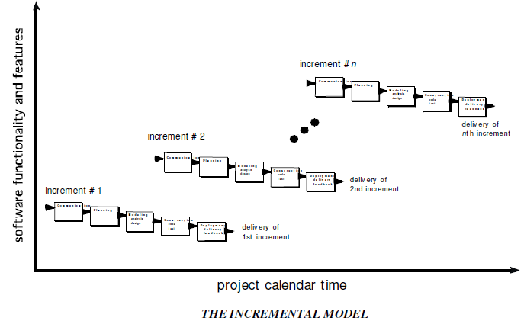  The incremental model applies linear sequences in a staggered fashion as calendar time progresses. Each linear sequence produces deliverable increments of the software. When an incremental model is used:  - The first increment is often called the core product.  - The basic requirements are addressed.  - Many supplementary features remain undelivered.  - The core product is used by the customer.  - As a result of use and/or evaluation, a plan is developed for the next increment.  - The plan includes modification of the core product to better meet the needs of the customer and the delivery of additional features and functionality.  - The process is repeated until the complete product is delivered.  The incremental process model, like prototyping is iterative in nature. But unlike prototyping, the incremental model focuses on the delivery of an operational product with each increment.  - Early increments are stripped down versions of the final product, but they do provide capability that serves the user and platform for evaluation by the user.  - Incremental development is particularly useful when staffing is unavailable for a complete implementation by the business deadline.  - Early increments are implemented with fewer people.  If the core product is received well, additional staff can be added to implement the next increment.  THE CONCURRENT DEVELOPMENT MODEL  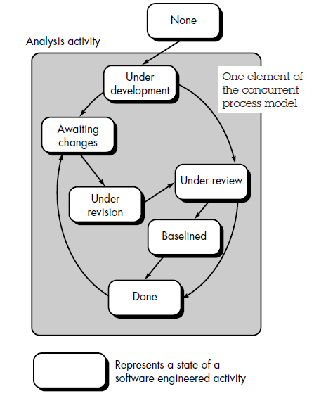  The Concurrent Development Model also called Concurrent Engineering, is represented as a  series of  - Framework activities  - Software engineering actions and tasks  - And their associated states  The figure provides a representation of one software engineering task within the modeling  activity for the concurrent process model. The activity-modeling-may be in any one of the states noted at a given time. Similarly other activities or tasks can be represented in an analogous manner. All activities exist concurrently but reside in different states.  For example  - Early in a project the communication activity has completed its first iteration and exists in the awaiting changes state.  - The modeling activity which exists in the none state while initial communication was completed, now makes a transition into the under development state.  - If customer indicates changes in the requirements, the modeling activity moves from the under development state into the awaiting changes state.  The concurrent process model defines a series of events that will trigger transitions from state to state for each of the software engineering activities, actions or tasks. The concurrent  process model is applicable to all types of software development and provides an accurate  picture of the current state of a project. This model defines a network of activities. Events triggered at one point in the process network trigger transitions among the states.
5 | Describe at least one scenario where  - RAD model would be applicable and not waterfall model.  - Waterfall model is preferable to all other models.  RAD Model would be applicable and not waterfall model  The RAD model is suitable for information system applications, business applications and for systems that can be modularized because of the following reasons:  - This model is similar to waterfall model but uses very short development cycle.  - It uses component based construction and emphasizes reuse and code generation.  - This model uses multiple teams on scalable projects.  - The RAD model is suitable for the projects where technical risks are not high.  - The RAD model requires heavy resources.  In waterfall model “blocking state” situation occurs. In blocking state situation, project team members have to wait for other members of the team to complete the dependent tasks. For high speed and short time development projects, RAD model would be applicable, whereas waterfall model is unsuited for these types of projects.  Waterfall model is preferable to all other models  - Waterfall model is useful for the projects in which the requirements are well  understood and unlikely to change radically during the system development.  - The waterfall model is simple to implement, compared to all other software models.  - For implementation of small systems waterfall model is useful.  - Waterfall model suggests a systematic, sequential approach to software development.  - This model consists of information domain, function, and behavioral requirements of the system.  - It is the oldest software paradigm. It is also called as “linear-sequential model” or “classic lifecycle model”.
6 | Compare and contrast the different lifecycle models. (NOV/DEC 2011)
  PROCESS  MODEL | CONCEPT | ADVANTAGE |  | DISADVANTAGE
  The waterfall model | The waterfall model,  called the classic life  cycle suggests a  systematic,  sequential approach  to software  development. | It provides a template  into which methods  for analysis, design,  and other phases can  be placed. It provides  for baseline  management. It is  better than any  haphazard approach  to software  development. |  | It lacks the  perception for a  reverse engineering  on how to engineer  an existing legacy  system. The client  has to wait until the  installation and  checkout phase to see  how a system works.  Thus a complex  system requires  considerable time and  effort. Real time  software cannot  follow this model.  Customer satisfaction  is not full filled.
  The incremental  model | The incremental  model combines the  elements of the  waterfall model  applied in an  iterative fashion. The  incremental model  applies linear  sequences in a  staggered fashion as  calendar time  progresses. Each  linear sequence  produces deliverable  increments of the  software. | The software  development  activities are repeated  each time there is a  new release of  software. It  provides a platform  for evaluation by the  user. It can be  planned to manage  technical risks. It  enables partial  functionality to be  delivered to end users  without ordinary  delay. |  | It makes the  Unrealistic assumptions that system as well as  Software  requirements remain  stable which is not  true.
  Prototyping | The prototyping  paradigm assists the  software engineer  and the customer to  better understand  what is to be built  when the  requirements are  fuzzy. The customer  usually defines a set  of general objectives  for software, but  does not identify  detailed input,  processing or output  requirements. | It produces the  products quickly and  thus saves the time It  and solves the  waiting problem in  waterfall model. It  minimizes the cost  and product failure. It  is possible for the  developers and client  to check the function  of preliminary  implementations of  system models before  committing to a final  system. It obtains  feedback from clients  and changes in  system concept. |  | It ignores quality,  reliability  maintainability and  safety requirements.  Customer satisfaction  is not achieved
  Spiral model | The spiral model is  an evolutionary  software process  model that couples  the iterative nature of  prototyping with the  controlled and  systematic aspects of  the waterfall model.  It provides the  potential for rapid  development of  increasingly more  complex versions of the software. | It provides the  potential for rapid  development for  incremental versions  of the software. It can  be applied throughout  the life of the  computer software. It  allows the developer  to apply the  prototyping approach  at any stage. It  demands a direct  consideration of  technical risks at all  stages. |  | It may be difficult to  convince the  customers at times  especially in contrast  solutions. It demands  considerable risks  assessment expertise  and relies on them for success. It takes  time for determining the efficacy and thus the  model cannot be used  as widely as others.
  RAD model | Rapid Application  Development (RAD)  is an incremental  software process  model that  emphasizes a short  development cycle.  The RAD model is a high-speed  adaptation of the  waterfall model, in  which rapid  development is  achieved by using  component-based  construction  approach. | If requirements are  well understood and project scope is  constrained, the RAD process enables a development team to create a fully  functional system  within a very short  time period. | RAD requires  sufficient human  resources to create  the right number of  RAD teams. If  developers and  customers are not  committed RAD  project fails. If a  system is not  properly modularized, building the components for  RAD will be  problematic.  High performance  cannot be achieved.  Not appropriate when technical risks are  high or when new  technology is used.
7 | What is CMMI? Explain the different levels of CMMI and its goals?(NOV/DEC 17)  The CMMI represents a process meta-model in two different ways: (1) as a “continuous” model and (2) as a “staged” model. Each process area (e.g., project planning or requirements management) is formally assessed against specific goals and practices and is rated according to the following capability levels:  Level 0: Incomplete—the process area (e.g., requirements management) is either not performed or does not achieve all goals and objectives defined by the CMMI for level 1 capability for the process area.  Level 1: Performed—all of the specific goals of the process area (as defined by the CMMI) have -been satisfied. Work tasks required to produce defined work products are being conducted.  Level 2: Managed—all capability level 1 criteria have been satisfied. In addition, all work associated with the process area conforms to an organizationally defined policy; all people doing the work have access to adequate resources to get the job done; stakeholders are actively involved in the process area as required; all work tasks and work products are “monitored, controlled, and reviewed; and are evaluated for adherence to the process description” .  Level 3: Defined—all capability level 2 criteria have been achieved. In addition, the process is “tailored from the organization’s set of standard processes according to the organization’s tailoring guidelines, and contributes work products, measures, and other process-improvement information to the organizational process assets” .  Level 4: Quantitatively managed—all capability level 3 criteria have been achieved. In addition, the process area is controlled and improved using measurement and quantitative assessment. “Quantitative objectives for quality and process performance are established and used as criteria in managing the process” .  Level 5: Optimized—all capability level 4 criteria have been achieved. In addition, the process area is adapted and optimized using quantitative (statistical) means to meet changing customer needs and to continually improve the efficacy of the process area under consideration.  The CMMI defines each process area in terms of “specific goals” and the “specific practices” required to achieve these goals. Specific goals establish the characteristics that must exist if the activities implied by a process area are to be effective. Specific practices refine a goal into a set of process-related activities.
8 | Explain Specialized Process and Unified Process Models in detail.  Specialized Process Models:  Component-based development  The component-based development model incorporates many of the characteristics of the spiral model. It is evolutionary in nature, demanding an iterative approach to the creation of software. However, the component-based development model constructs applications from pre-packaged software components.  The component-based development model incorporates the following steps:  - Available component-based products are researched and evaluated for the application domain in question.  - Component integration issues are considered.  - A software architecture is designed to accommodate the components.  - Components are integrated into the architecture.  - Comprehensive testing is conducted to ensure proper functionality.  Formal Methods Model  The formal methods model encompasses a set of activities that leads to formal mathematical specification of computer software.  - The development of formal models is currently quite time consuming and expensive.  - Because few software developers have the necessary background to apply formal methods, extensive training is required.  - It is difficult to use the models as a communication mechanism for technically +unsophisticated customers.  Aspect-oriented software development  Aspect-oriented software development (AOSD), often referred to as aspect-oriented programming (AOP), is a relatively new software engineering paradigm that provides a process and methodological approach for defining, specifying, designing, and constructing aspects—“mechanisms beyond subroutines and inheritance for localizing the expression of a crosscutting concern”.  Unified Process Model  The Unified Process recognizes the importance of customer communication and streamlined methods for describing the customer’s view of a system. It emphasizes the important role of software architecture and “helps the architect focus on the right goals, such as understandability, reliance to future changes, and reuse” [Jac99]. It suggests a process flow that is iterative and incremental, providing the evolutionary feel that is essential in modern software development  Phases of Unified Process Model  The inception phase of the UP encompasses both customer communication and planning activities. By collaborating with stakeholders, business requirements for the software are identified; a rough architecture for the system is proposed; and a plan for the iterative, incremental nature of the ensuing project is developed. Fundamental business requirements are described through a set of preliminary use cases that describe which features and functions each major class of users desires.  The elaboration phase encompasses the communication and modelling activities of the generic process model. Elaboration refines and expands the preliminary use cases that were developed as part of the inception phase and expands the architectural representation to include five different views of the software—the use case model, the requirements model, the design model, the implementation model, and the deployment model.  The construction phase of the UP is identical to the construction activity defined for the generic software process. Using the architectural model as input, the construction phase develops or acquires the software components that will make each use case operational for end users.  The transition phase of the UP encompasses the latter stages of the generic construction activity and the first part of the generic deployment (delivery and feedback) activity. Software is given to end users for beta testing and user feedback reports both defects and necessary changes.  The production phase of the UP coincides with the deployment activity of the generic process. During this phase, the ongoing use of the software is monitored, support for the operating environment (infrastructure) is provided, and defect reports and requests for changes are submitted and evaluated.  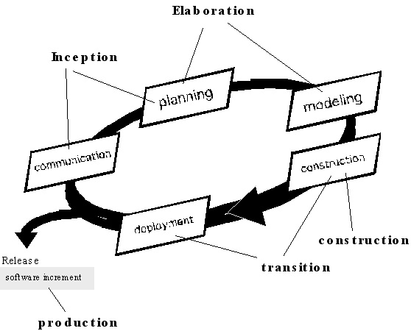
9 | i)What is the impact of reusability in software development process?(NOV/DEC 17)  Reuse is the use of work products (such as a code, design and test), which are the products or by-products of the software-development process, without modification in the development of other software . It includes multiple reuse programs in different division within the same company so that it has been largely positive. It maintains the result into product, having higher quality, because the work products can be used multiple times. Also, this reusability increases the productivity because it does not require much works for consumers. However, this productivity fails to satisfy the requirements for time-to-market. One of the potential ways for reducing time-to-market is that we efficiently apply the reuse on the critical path of a development project, the chain of activities that determine the total project duration. Reuse allows an organization to use personnel more effectively because it leverages expertise. Leveraged reuse is to modify existing work products to meet specific system requirements. Software experts, who have a lot of experiences, can concentrate on creating work product that can be reused by novice personnel. However, software reuse is not an inexpensive concept because it requires creating and maintaining reusable work products, a reuse library, and reuse tools. In this section, we use an economic analysis method to help evaluate the costs and benefits of reuse.  ii)Explain the component based software development model with a neat sketch.(NOV/DEC 17)  The component-based development model incorporates many of the characteristics of the spiral model. It is evolutionary in nature, demanding an iterative approach to the creation of software. However, the component-based development model constructs applications from pre-packaged software components.  The component-based development model incorporates the following steps:  - Available component-based products are researched and evaluated for the application domain in question.  - Component integration issues are considered.  - A software architecture is designed to accommodate the components.  - Components are integrated into the architecture.  - Comprehensive testing is conducted to ensure proper functionality.  Formal Methods Model  The formal methods model encompasses a set of activities that leads to formal mathematical specification of computer software.  - The development of formal models is currently quite time consuming and expensive.  - Because few software developers have the necessary background to apply formal methods, extensive training is required.  - It is difficult to use the models as a communication mechanism for technically +unsophisticated customers.  Aspect-oriented software development  Aspect-oriented software development (AOSD), often referred to as aspect-oriented programming (AOP), is a relatively new software engineering paradigm that provides a process and methodological approach for defining, specifying, designing, and constructing aspects—“mechanisms beyond subroutines and inheritance for localizing the expression of a crosscutting concern”.
10 | Write a note on the unique characters of software. (NOV/DEC 17)  CHARACTERISTICS OF SOFTWARE  - Software is developed or engineered; it is not manufactured in the classical sense.  - Software costs are concentrated in engineering.this means that software projects cannot be managed as if they were manufacturing projects.  - Software doesn’t “wear out.”  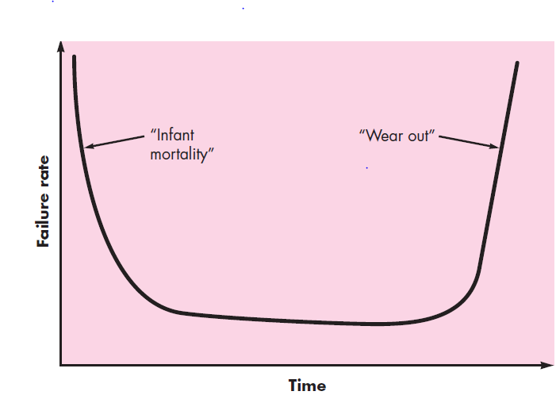  - Figure depicts failure rate as a function of time for hardware. The relationship, often called the “bathtub curve,” indicates that hardware exhibits relatively high failure rates early in its life (these failures are often attributable to design or manufacturing defects); defects are corrected and the failure rate drops to a steady-state level (hopefully, quite low) for some period of time. As time passes, however, the failure rate rises again as hardware components suffer from the cumulative effects of dust, vibration, abuse, temperature extremes, and many other environmental maladies. Stated simply, the hardware begins to wear out.  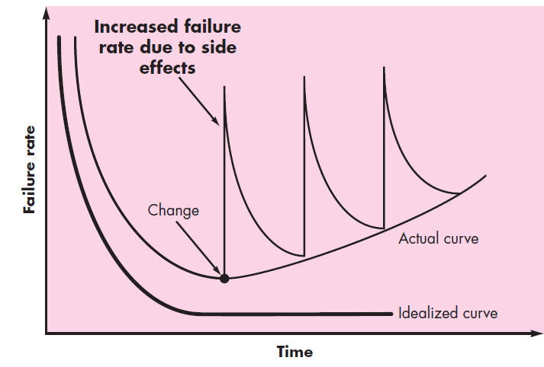  - Considering the time curve ,software will undergo change. As changes are made, it is likely that errors will be introduced, causing the failure rate curve to spike as shown in the “actual curve” (Figure 1.2). Before the curve can return to the original steady-state failure rate, another change is requested, causing the curve to spike again. Slowly, the minimum failure rate level begins to rise—the software is deteriorating due to change.  - Although the industry is moving toward component-based construction, most  software continues to be custom built.  - A software component should be designed and implemented so that it can be reused in many different programs. Modern reusable components encapsulate both data and the processing that is applied to the data, enabling the software engineer to create new applications from reusable parts.
11 | What is the significance of the spiral model when compared with other models.  A spiral model is divided into a set of framework activities defined by the software engineering team. Each of the framework activities represents one segment of the spiral path as shown in the figure.  - As evolution begins the software team performs activities implied by the by the circuit around the spiral, in clockwise direction, beginning at the center.  - Risk is considered at each revolution made.  - Anchor point milestones-a combination of work products and conditions that are attained along the path of the spiral are noted for each evolutionary pass.  - First circuit around the spiral results in the development of product specifications.  - Subsequent passes develop a prototype, progressively lead to sophisticated version of the software.  - Cost and schedule are adjusted based on feedback derived from the customer after delivery.  - Unlike other process models that end when the software is delivered, the spiral model can be adapted throughout the life of the software.  - The first spiral represents a Concept Development Project which starts at core and continues for multiple iterations until concept development is implemented.  - The concept developed to an actual product, proceeds outward on the spiral and a New Product Development Project commences.  - The new product may evolve to represent Product Enhancement Project.
12 | List out the various umbrella activities which support software development process and discuss about their necessity in maintaining the quality in both software process and product that is being developed for railway reservation system.  Umbrella Activities  • software project management  • formal technical reviews  • software quality assurance  • software configuration management  • reusability management  • measurement  • document preparation and production  • risk management  Software Project tracking and Control  Information about the route, cancellation of tickets, departure time, arrival time, number of trains available and other such information are provided. Store and retrieve information about the various transactions related to Rail travel. Keep track of all its passengers and thus schedule their journey accordingly. Maintains records of passengers travelling in the different trains on different dates reaching different destinations in the system. User can enquire about the PNR status, seat availability and trains on a route. User friendly interface to administrator and customer.  Risk Management  Tasks required to assess both technical and management risks.  Software Quality Assurance  Technical Review  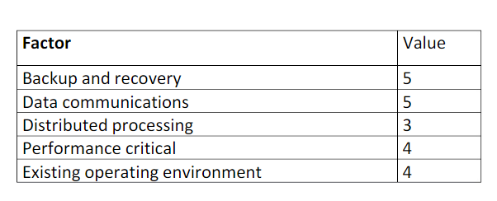  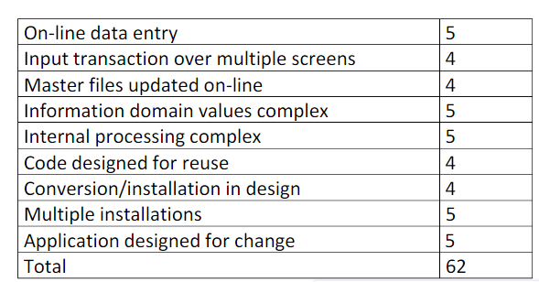  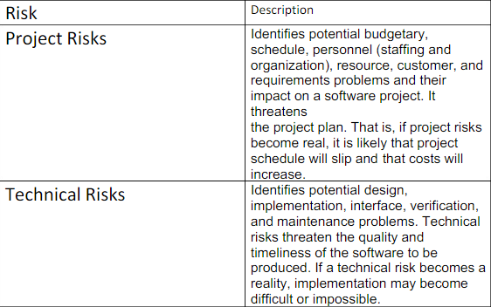  Each of these umbrella activities is defined by a set of tasks that are adapted to the project type and degree of rigor with which software engineering is to be applied.
13 | Which software process model is good for risk management? Explain the model. Describe how the model is used to layout the objectives, risks and plans for quality improvement. (APR/MAY 18)  SPIRAL MODEL  The spiral model is an evolutionary software process model that couples the iterative nature of prototyping with the controlled and systematic aspects of the waterfall model. It provides the potential for rapid development of increasingly more complex versions of the software. Boehm definition: The spiral development model is a risk-driven process model generator. It has two main distinguishing features :  • One is a cyclic approach for incrementally growing a system‘s degree of definition and implementation while decreasing its degree of risk.  • The other is a set of anchor point milestones for ensuring stakeholder commitment to feasible and mutually satisfactory system solutions.  Using spiral model, software is developed in a series of evolutionary releases. During early iterations, the release is a paper model or prototype. During later iterations, more complex versions of the engineered system are produced.  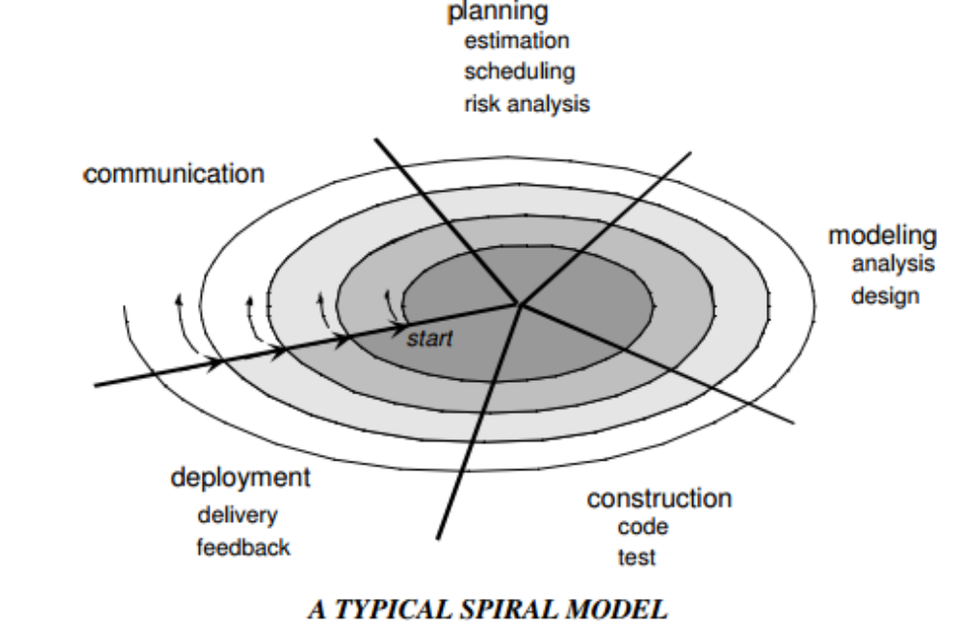  A spiral model is divided into a set of framework activities defined by the software engineering team. Each of the framework activities represents one segment of the spiral  path as shown in the figure.  • As evolution begins the software team performs activities implied by the by the circuit around the spiral, in clockwise direction, beginning at the center.  • Risk is considered at each revolution made.  • Anchor point milestones-a combination of work products and conditions that are attained along the path of the spiral are noted for each evolutionary pass.  • First circuit around the spiral results in the development of product specifications.  • Subsequent passes develop a prototype, progressively lead to sophisticated version of the software.  • Cost and schedule are adjusted based on feedback derived from the customer after delivery.  • Unlike other process models that end when the software is delivered, the spiral model can be adapted throughout the life of the software.  • The first spiral represents a Concept Development Project which starts at core and continues for multiple iterations until concept development is implemented.  • The concept developed to an actual product, proceeds outward on the spiral and a New Product Development Project commences.  • The new product may evolve to represent Product Enhancement Project.  Features of Spiral Model:  • Realistic approach to the development of large scale-systems and software.  • Because the software evolves as the process progresses, the developer and customer better understand and react to risks at each evolutionary level.  • Enables the developer to apply the prototyping approach at any stage in the evolution of the product.  • It maintains the systematic stepwise approach of classic life cycle but in incorporates it into an iterative framework that realistically reflects the real world.  • It demands direct consideration of technical risks at all stages of the project and if applied properly, reduce risks before they become problematic.  Incremental models  The incremental model applies linear sequences in a staggered fashion as calendar time progresses. Each linear sequence produces deliverable ―increments‖ of the software in a manner that is similar to the increments produced by an evolutionary process flow.  • When an incremental model is used, the first increment is often a core product.  • The core product is used by the customer (or undergoes detailed evaluation). As a result of use and/or evaluation, a plan is developed for the next increment. The plan addresses the modification of the core product to better meet the needs of the customer and the delivery of additional features and functionality.  • This process is repeated following the delivery of each increment, until the complete product is produced.  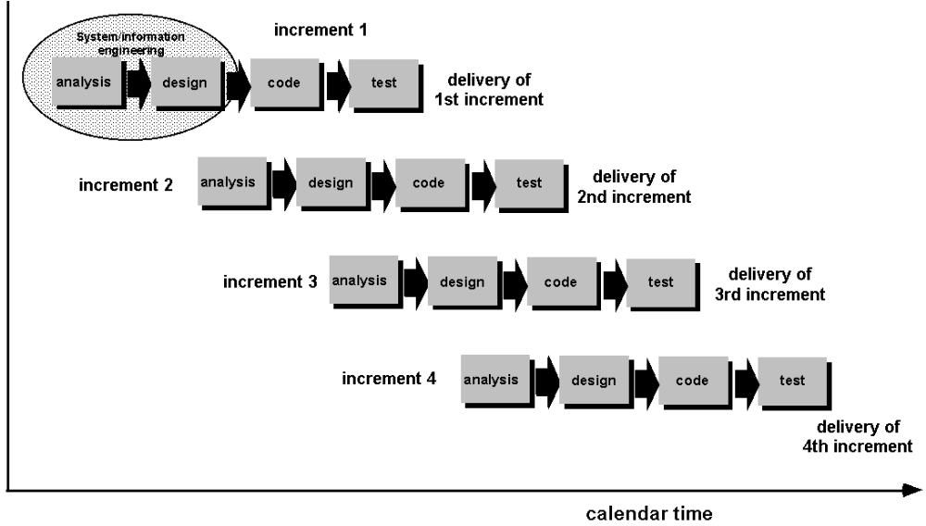  Advantages of Incremental model:  • Generates working software quickly and early during the software life cycle.  • This model is more flexible – less costly to change scope and requirements.  • It is easier to test and debug during a smaller iteration.  • In this model customer can respond to each built.  • Lowers initial delivery cost.  • Easier to manage risk because risky pieces are identified and handled during it‘d  iteration.  Disadvantages of Incremental model:  • Needs good planning and design.  • Needs a clear and complete definition of the whole system before it can be broken down and built incrementally.  • Total cost is higher than waterfall.
14 | Enumerate in detail about Agile planning.  Agile methods of software development are iterative approaches where the software is developed and delivered to customers in increments. Unlike plan-driven approaches, the functionality of these increments is not planned in advance but is decided during the development. The decision on what to include in an increment depends on progress and on the customer’s priorities.  The most commonly used agile approaches such as Scrum (Schwaber, 2004) and extreme programming (Beck, 2000) have a two-stage approach to planning, corresponding to the startup phase in plan-driven development and development planning:  1. Release planning, which looks ahead for several months and decides on the features that should be included in a release of a system.  2. Iteration planning, which has a shorter-term outlook, and focuses on planning the next increment of a system. This is typically 2 to 4 weeks of work for the team.  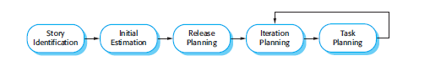  Planning in XP  The system specification in XP is based on user stories that reflect the features that should be included in the system. At the start of the project, the team and the customer try to identify a set of stories, which covers all of the functionality that will be included in the final system. Some functionality will inevitably be missing, but this is not important at this stage.  The next stage is an estimation stage. The project team reads and discusses the stories and ranks them in order of the amount of time they think it will take to implement the story. This may involve breaking large stories into smaller stories. Relative estimation is often easier than absolute estimation. People often find it difficult to estimate how much effort or time is needed to do something. However, when they are presented with several things to do, they can make judgments about which stories will take the longest time and most effort. Once the ranking has been completed, the team then allocates notional effort points to the stories.  Each developer knows their individual velocity so should not sign up for more tasks than they can implement in the time.  There are two important benefits from this approach to task allocation:  1. The whole team gets an overview of the tasks to be completed in an iteration. They therefore have an understanding of what other team members are doing and who to talk to if task dependencies are identified.  2. Individual developers choose the tasks to implement; they are not simply allocated tasks by a project manager. They therefore have a sense of ownership in  these tasks and this is likely to motivate them to complete the task.  In some agile methods, such as extreme programming, customers are directly involved in deciding whether a change should be implemented. When they propose a change to the system requirements, they work with the team to assess the impact of that change and then decide whether the change should take priority over the features planned for the next increment of the system. However, changes that involve software improvement are left to the discretion of the programmers working on the system. Refactoring, where the software is continually improved, is not seen as an overhead but rather as a necessary part of the development process. As the development team changes software components, they should maintain a record of the changes made to each component.
UNIT II REQUIREMENTS ANALYSIS AND SPECIFICATION
Software Requirements: Functional and Non-Functional, User requirements, System requirements, Software Requirements Document – Requirement Engineering Process: Feasibility Studies, Requirements elicitation and analysis, requirements validation, requirements management-Classical analysis: Structured system Analysis, Petri Nets- Data Dictionary.
PART-A
1 |  | What are User Requirements and System Requirements?  - User requirements are statements, in a natural language, of what services the system is  expected to provide and the constraints under which it must operate.  - System requirements set out the system's functions, services and operational constraints in detail. It should define exactly what is to be implemented. It may be part of the contract between the system buyer and the software developers.
2 |  | Define functional and non-functional requirements. (NOV/DEC 2010)(APR/MAY 2011) (MAY/JUN 2012)(NOV/DEC 2014)  The functional requirements of a system describe what the system should do. These requirements depend on the software being developed, the expected users of the software and the general approach taken by the organization when writing requirements.  Non-functional requirements are requirements that are not directly concerned with the specific functions delivered by the system. They relate to system properties such as:  1)Reliability 2) Response time 3) Storage capacity 4) Availability  5) Data representation in system interfaces 6) capability of I/O device  7) System performance 8) Security
3 |  | List two advantages of using traceability tables in the requirements management phase. (NOV/DEC 2013)  These traceability tables are maintained as part of a requirements database so that they may be quickly searched to understand how a change in one requirement will affect different aspects of the system to be built.
4 |  | Draw the DFD notations for a) External entity b) Data items. (NOV/DEC 2011)  - Data items-labeled arrows(→)  - External entity-boxes ( )
5 |  | What are the processes involved in requirement engineering? (MAY/JUN 2012)  - Requirements elicitation.  - Requirements analysis &negotiation.  - Requirements specification.  - System modeling.  - Requirements validation.  - Requirements management.
6 |  | What are the types of viewpoints?  Viewpoints can be used as a way of classifying stakeholders and other sources of requirements. There are three generic types of viewpoint:  - Interactor viewpoints represent people or other systems that interact directly with the system.  - Indirect viewpoints represent stakeholders who do not use the system themselves but who influence the requirements in some way.  - Domain viewpoints represent domain characteristics and constraints that influence the system requirements.
7 |  | Give the disadvantages of requirements elicitation.  - Problems of scope: The requirements may address too little or too much informations.  - Problems of understanding: Different stakeholders have different requirements, which they may express in different ways. Requirements engineers have to consider all potential sources of requirements and discover commonalities and conflict.  - Problems of volatility: It represents the changing nature of the requirements.
8 |  | Define requirements validation.  It examines the specifications to ensure that all system requirements have been stated unambiguously by detecting and correcting the inconsistencies, omissions, and errors. It also ensures whether the work products conform to the standards established for the process, the project, and the product.
9 |  | Define requirements management.  It is a set of activities that help the project team to identify, control, and track requirements and changes to requirements at any times as the project proceeds.
10 |  | Define requirement analysis.  It is a software engineering task that bridges the gap between system level requirements engineering and software design.
11 |  | How the software requirements analysis can be divided?  The software requirements analysis can be divided into the following:  - Problem recognition.  - Evaluation and synthesis.  - Modeling.  - Specification.  - Review.
12 |  | Define Traceability  Traceability is the overall property of requirements specification which reflects the ease of finding related requirements. Three types of traceability information to be maintained are:  - Source traceability information  - Requirement traceability information  - Design traceability information
13 |  | Mention some of the Notations for requirements specification.  - Structured natural language: Use standard form or Templates.  - Design description language: Programming language is used.  - Graphical notation: Text annotation is used.  - Mathematical Specifications: Based on finite state machines or sets.
14 |  | What are the different types of checks carried out during Requirement Validation?  (or) How are the requirements validated?(APR/MAY 2015)  - Validity checks  - Consistency checks  - Completeness checks  - Realism checks  - Verifiability.
15 |  | Give the set of guidelines principles for requirement engineering.  - Understand the problem before beginning the analysis model.  - Develop prototypes that enable a user to understand how human/machine interaction will occur.  - Record the origin of and the reason for each and every requirements.  - Use multiple views of requirements.  - Rank the requirements and eliminate the ambiguity.
16 |  | What is the need for feasibility analysis?(APR/MAY 2015)  The aim of a feasibility study is to find out whether the system is worth implementing within the given budget and schedule.  The purpose of feasibility study is not to solve the problem, but to determine whether the problem is worth solving. This helps to decide whether to proceed with the project or not.
17 |  | Name three generic classes of methods and tools used in prototyping.  Fourth generation techniques, Reusable software components, Formal specification and prototyping environments.
18 |  | Name the three objectives used in analysis model.  To descried what the customer requires, To establish a basis for the creation of a software design, To define a set of requirement that can be validated once the software is built.
19 |  | Give the two uses of data flow diagram (DFD).  - To provide an indication of how data are transformed as they move through the system.  - To depict the functions that transforms the data flow.
20 |  | Define data flow diagram.  It is a graphical representation that depicts information flow and the transforms that are applied as data move from input to output. It may be used to represent a system or software at any level of abstraction.
21 |  | What is data dictionary? What are the informations contained in data dictionary? (NOV/DEC 2014) (NOV/DEC 2016)(APR/MAY 17)  - Provides definitions for all elements in the system which include:  - Meaning of data flows and stores in DFDs  - Composition of the data flows e.g. customer address breaks down to street number, street name, city and postcode  - Composition of the data in stores e.g. in Customer store include name, date of birth, address, credit rating etc.  - Details of the relationships between entities  Informations in data dictionary:  Name, Alias, Where-used/how- used, Content description and Supplementary information.
22 |  | Give some guidelines to derived data flow diagram?  - The level 0 data flow diagram should depict the software/system as a single bubble.  - Primary input and output should be carefully noted.  - Refinement should begin by isolating candidate processes, data objects, and stores to be represented at the next level.  - All arrows and bubbles should be labeled with meaningful names.  - Information flow continuity must be maintained from level to level.  - One bubble at a time should be refined.
23 |  | Define Requirements engineering.  Requirement Engineering provides the appropriate mechanism for understanding what the customer wants, analyzing need, assessing feasibility, negotiating a reasonable solution, specifying the solution unambiguously, validating the specification and managing the requirements as they are transformed into an operational system.
24 |  | What are Petri Nets?(APR/MAY 17) Petri net is a directed bipartite graph, in which the nodes represent transitions (i.e. events that may occur, signified by bars) and places (i.e. conditions, signified by circles). The directed arcs describe which places are pre- and/or post conditions for the transitions (signified by arrows).
25 |  | Define throwaway prototyping.  A prototype serves solely as a rough demonstration of requirements. It is a close-ended approach.
26 |  | List the characteristics of a good SRS.(May/June 2016)  - Correct  - Unambiguous  - Complete  - Consistent  - Ranked for importance and/or stability  - Verifiable  - Modifiable  - Traceable
27 |  | What are the linkages between data flow and ER Diagram? (May/June 2016)  DFD and ERD are different data models that are mainly used for organizing business data for proper communication between members of a group.  DFD shows how data enter a system, are transformed in that system, and how it is stored in it. Meanwhile, ERD represents the entity model and will show what a system or a database will look like but not explain how to implement it.
28 |  | Classify the following as functional/non-functional requirements for a banking system. (NOV/DEC 2016)  - Verifying bank balance.  - Withdrawing money from bank.-FR  - Completion of transactions in less than one second.  - Extending the system by providing more tellers for customers.
  Functional Requirements | Non-functional Requirements
  Withdrawing money from bank | Verifying bank balance
  Completion of transactions in less than one second | Extending the system by providing more tellers for customers
29 |  | Differentiate between normal and exciting requirements.(APR/MAY 17)
  Normal Requirements | Exciting Requirements
  The objectives and goals that are stated for a product or system during meetings with the customer. | These features go beyond the customer’s expectations.
  If these requirements are present, the customer is satisfied. | Prove to be very satisfying when presence of the requirement.
  Examples- Requested types of graphical displays, Specific System functions, defined performance. | Examples-multi touch screen in smart phone, visual voice mail, provides unexpected performance and storage
30 |  | Draw a usecase diagram for an online shopping which should provide provisions for registering,authenticating the customers an also for online payment through and payment gateway like paypal.(NOV/DEC 17)  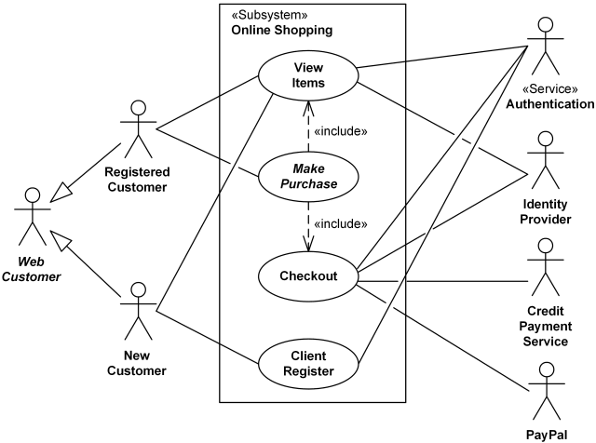
31 |  | Define quality function development(QFD)(NOV/DEC 17)  Quality function deployment (QFD) is a quality management technique that translates the needs of the customer into technical requirements for software. QFD “concentrates on maximizing customer satisfaction from the software engineering process”.
32 |  | What are the various types of traceability in software engineering? (April/May 2018)  - Source traceability: These are basically the links from requirement to stake holders.  - Requirement traceability: These are links between dependant requirements  - Design traceability: These are links from requirements to design.
33 |  | Compare prototyping approaches in a software process. (April/May 2018)  - Evolutionary Prototyping- the initial prototype is prepared and it is then refined through number of stages to final stage.  - Throw-away prototyping-a rough practical implementation of the system is produced. The requirement problems can be identified from this implementation.
UNIT-II / PART-B
1 |  |  | (i) What is the purpose of feasibility study? (APR/MAY 17)(NOV/DEC 17)  (ii) State the ‘inputs and results of the feasibility study.  (iii) List any four issues addressed by a feasibility study.  (iv) Elaborate the phases involved when carrying out a feasibility study. (NOV/DEC 2013)  (i) The aims of a feasibility study are to find out whether the system is worth implementing and if it can be implemented, given the existing budget and schedule.  The purpose of feasibility study is not to solve the problem, but to determine whether the problem is worth solving. This helps to decide whether to proceed with the project or not.  (ii) The input to the feasibility study is a set of preliminary business requirements, an outline description of the system and how the system is intended to support business processes. The results of the feasibility study should be a report that recommends whether or not it is worth carrying on with the requirements engineering and system development process.  (iii)  - Gives focus to the project and outline alternatives.  - Narrows business alternatives  - Identifies new opportunities through the investigative process.  - Identifies reasons not to proceed.  - Enhances the probability of success by addressing and mitigating factors early on that could affect the project.  - Provides quality information for decision making.  - Provides documentation that the business venture was thoroughly investigated.  - Helps in securing funding from lending institutions and other monetary sources.  - Helps to attract equity investment.  The feasibility study is a critical step in the business assessment process. If properly conducted, it may be the best investment you ever made  (iv)Carrying out a feasibility study involves information assessment, information collection and report writing.
2 |  |  | Explain functional and non-functional requirements in detail.(NOV/DEC 2014) (NOV/DEC 17)  Functional requirements  - Statements of services the system should provide, how the system should react to particular inputs and how the system should behave in particular situations.  - Describe functionality or system services  - Depend on the type of software, expected users and the type of system where the software is used  - Functional user requirements may be high-level statements of what the system should do but functional system requirements should describe the system services in detail  Examples of functional requirements  - The user shall be able to search either all of the initial set of databases or select a subset from it.  - The system shall provide appropriate viewers for the user to read documents in the document store.  Requirements Imprecision:  Problems arise when requirements are not precisely stated  Ambiguous requirements may be interpreted in different ways by developers and users  Consider the term ‘appropriate viewers’  - User intention - special purpose viewer for each different document type  - Developer interpretation - Provide a text viewer that shows the contents of the document  Requirements completeness and consistency:  In principle requirements should be both complete and consistent  Complete  - They should include descriptions of all facilities required  Consistent  - There should be no conflicts or contradictions in the descriptions of the system facilities  In practice, it is impossible to produce a complete and consistent requirements document  Non-functional requirements  - constraints on the services or functions offered by the system such as timing constraints, constraints on the development process, standards, etc.  - Define system properties and constraints e.g. reliability, response time and storage requirements. Constraints are I/O device capability, system representations, etc.  - Process requirements may also be specified mandating a particular CASE system, programming language or development method  - Non-functional requirements may be more critical than functional requirements. If these are not met, the system is useless  Non-functional Classification  Product requirements  - Requirements which specify that the delivered product must behave in a particular way e.g. execution speed, reliability, etc.  Organisational requirements  - Requirements which are a consequence of organisational policies and procedures e.g. process standards used, implementation requirements, etc.  External requirements  - Requirements which arise from factors which are external to the system and its development process e.g. interoperability requirements, legislative requirements, etc.  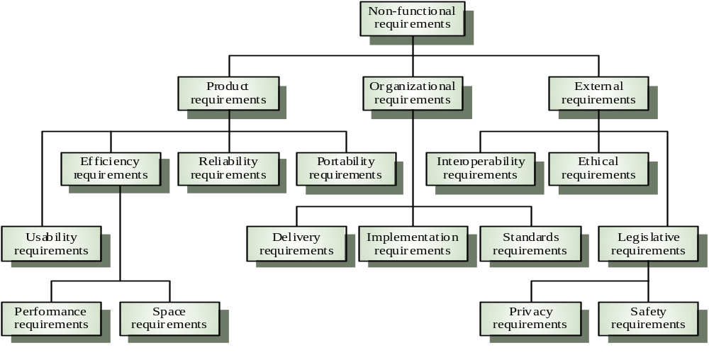  Examples of non-functional requirements:  Product requirement  - It shall be possible for all necessary communication between the APSE and the user to be expressed in the standard Ada character set  Organisational requirement  - The system development process and deliverable documents shall conform to the process and deliverables defined in XYZCo-SP-STAN-95  External requirement  - The system shall not disclose any personal information about customers apart from their name and reference number to the operators of the system  Goals and requirements:  Non-functional requirements may be very difficult to state precisely and imprecise requirements may be difficult to verify.  Goal  - A general intention of the user such as ease of use  Verifiable non-functional requirement  - A statement using some measure that can be objectively tested  Goals are helpful to developers as they convey the intentions of the system users  Requirement measures:  Requirements Interaction:  Conflicts between different non-functional requirements are common in complex systems  Spacecraft system  - To minimise weight, the number of separate chips in the system should be minimised  - To minimise power consumption, lower power chips should be used  - However, using low power chips may mean that more chips have to be used.
  Property | Measure
  Speed | Processed trasactions/second user/Event response time Screen refresh time
  Size | K Bytes Number of RAM chips
  Ease of Use | Training time  Number of help frames
  Reliability | Mean time to failure  Probability of unavailability  Rate of failure occurrence  Availability
  Robustness | Time to restart after failure  Percentage of events causing failure  Probability of data corruption on failure
  Probability | Percentage of target dependent statement  Number of target systems
3 |  |  | Explain the execution of seven distinct functions accomplished in requirement engineering process. (NOV/DEC 2010)(APR/MAY 2011) (NOV/DEC 2012)(MAY/JUNE 2013) (NOV/DEC 2014)(APR/MAY 2015)(APR/MAY 17)  - Seven distinct tasks  - Inception  During inception, the requirements engineer asks a set of questions to establish…  - A basic understanding of the problem  - The people who want a solution  - The nature of the solution that is desired  - The effectiveness of preliminary communication and collaboration between the customer and the developer  - Elicitation  Elicitation may be accomplished through two activities  - Collaborative requirements gathering  - Quality function deployment  - Elaboration  During elaboration, the software engineer takes the information obtained during inception and elicitation and begins to expand and refine it  Elaboration focuses on developing a refined technical model of software functions, features, and constraints  - Negotiation  During negotiation, the software engineer reconciles the conflicts between what the customer wants and what can be achieved given limited business resources  Requirements are ranked (i.e., prioritized) by the customers, users, and other stakeholders  Risks associated with each requirement are identified and analyzed  - Specification  A specification is the final work product produced by the requirements engineer  It is normally in the form of a software requirements specification  It serves as the foundation for subsequent software engineering activities  It describes the function and performance of a computer-based system and the constraints that will govern its development  - Validation  - During validation, the work products produced as a result of requirements engineering are assessed for quality  - The specification is examined to ensure that  - all software requirements have been stated unambiguously  - inconsistencies, omissions, and errors have been detected and corrected  - the work products conform to the standards established for the process, the project, and the product  - The formal technical review serves as the primary requirements validation mechanism  - Members include software engineers, customers, users, and other stakeholders  - Requirements Management  - During requirements management, the project team performs a set of activities to identify, control, and track requirements and changes to the requirements at any time as the project proceeds  - Each requirement is assigned a unique identifier  - The requirements are then placed into one or more traceability tables  - Some of these tasks may occur in parallel and all are adapted to the needs of the project  - All strive to define what the customer wants  - All serve to establish a solid foundation for the design and construction of the software
4 |  |  | Explain Petri Nets in detail.  - A Petri Nets (PN) comprises places, transitions, and arcs  - Places are system states  - Transitions describe events that may modify the system state  - Arcs specify the relationship between places  - Tokens reside in places, and are used  - to specify the state of a PN  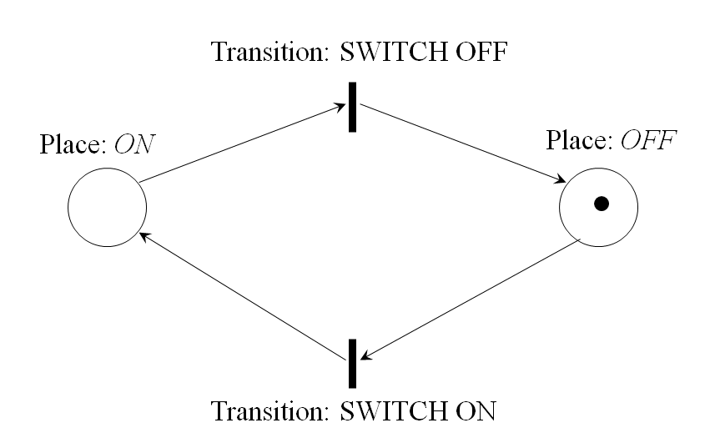  - Two places: Off and On  - Two transitions: Switch Off and Switch On  - Four arcs  - The off condition is true  - A transition can fire if an input token exists  - One token is moved from the input place to the output place.  PN properties  - 8-tuple mathematical model  - M={P,T,I,O,H,PAR,PRED,MP}  - P - the set of places  - T - the set of transitions  - I,O,H - Input, output, inhibition function  - PAR - the set of parameters  - PRED - Predicates restricting parameter range  - PM - Parameter value  - From this linear algebra can be used to analyze a network  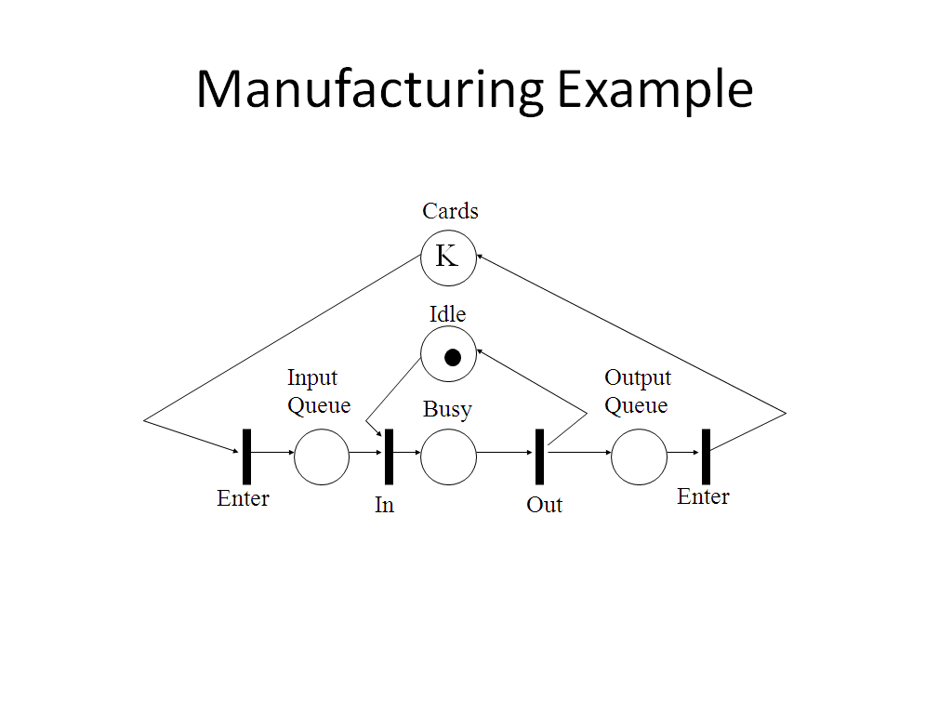  - Very rich modeling  - Easily capable of modeling software project, requirements, architectures, and processes  - Drawbacks  - Complex rules  - Analysis quite complex
5 |  |  | What is data dictionary? Explain with an example. (APR/MAY 2011)  - Provides definitions for all elements in the system which include:  - Meaning of data flows and stores in DFDs  - Composition of the data flows e.g. customer address breaks down to street number, street name, city and postcode  - Composition of the data in stores e.g. in Customer store include name, date of birth, address, credit rating etc.  - Details of the relationships between entities  - Data dictionary Notation  = is composed of  + and  ( ) optional ( may be present or absent)  { } iteration  [ ] select one of several alternatives  ** comment  @ identifier (key field) for store  | separates alternative choices in the [ ] construct  - Data dictionary Examples  name = courtesy-title + first-name + (middle-name) + last-name  courtesy-title = [Mr. | Miss | Mrs. | Ms. | Dr. | Professor]  first-name = {legal-character}  middle-name ={legal-character}  last-name = {legal-character}  legal-character = [A-Z|a-z|0-9|’|-| |]  Current-height =** *units: metres; range: 1.00-2.50*  sex =***values: [M|F]*  As both are elementary data, no composition need be shown, though an explanation of the relevant units/symbols is needed order = customer-name + shipping-address + 1{item}10 means that an order always has a customer name and a shipping address and has between 1 and 10 items.
6 |  |  | How does the analysis modeling help to capture unambiguous and consistent requirements? Discuss several methods for requirements validation. (NOV/DEC 2011)  Goals of Analysis Modeling  - Provides the first technical representation of a system  - Is easy to understand and maintain  - Deals with the problem of size by partitioning the system  - Uses graphics whenever possible  - Differentiates between essential information versus implementation information  - Helps in the tracking and evaluation of interfaces  - Provides tools other than narrative text to describe software logic and policy  - Flow-oriented modeling – provides an indication of how data objects are transformed by a set of processing functions  - Scenario-based modeling – represents the system from the user's point of view  - Class-based modeling – defines objects, attributes, and relationships  - Behavioral modeling – depicts the states of the classes and the impact of events on these states  Requirements validation  - Concerned with demonstrating that the requirements define the system that the customer really wants.  - Requirements validation covers a part of analysis in that it is concerned with finding problems with requirements.  - Requirements error costs are high so validation is very important  - Fixing a requirements error after delivery may cost up to 100 times the cost of fixing an implementation error.  - In fact, a change to the requirements usually means that the system design and the implementation must also be changed and the testing has to be performed again.  Checks required during the requirements validation process  - Validity checks. Does the system provide the functions which best support the customer’s needs? ( Other functions maybe identified by a further analysis )  - Consistency checks. Are there any requirements conflicts?  - Completeness checks. Are all the requirements needed to define all functions required by the customer sufficiently specified?  - Realism checks. Can the requirements be implemented given available budget, technology and schedule?  - Verifiability. Can the requirements be checked?  Requirements validation techniques  The following techniques can be used individually or in conjunction.  - Requirements reviews  - Systematic manual analysis of the requirements performed by a team of reviewers  - Prototyping  - Using an executable model of the system to check requirements.  - Test-case generation  - Developing tests for requirements to check testability.  - If the test is difficult to design, usually the related requirements are difficult to implement.
7 |  |  | Draw Use Case and Data Flow diagrams for a “Restaurant System”. The activities of the Restaurant system are listed below.  Receive the Customer food Orders, Produce the customer ordered foods, Serve the customer with their ordered foods, Collect Payment from customers, Store customer payment details, Order Raw Materials for food products, Pay for Raw Materials for food products, Pay for Raw Materials and Pay for Labor.(APR/MAY2015)  Use Case Diagram  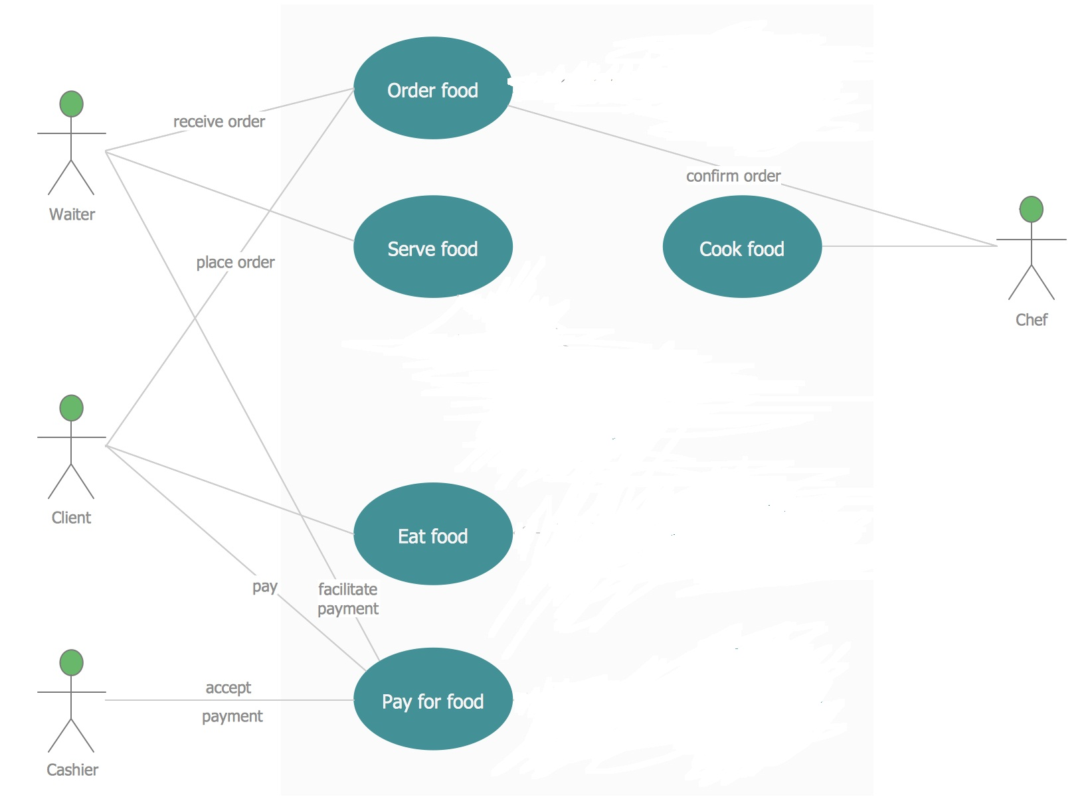  Data Flow Diagram  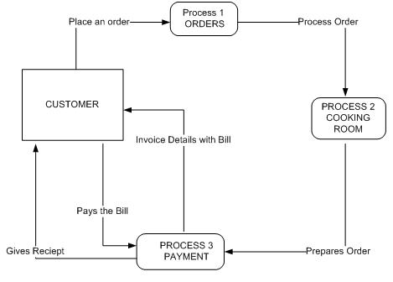
8 |  |  | (i)What are the components of the standard structure for the software requirements document? Explain in detail. (May/June 2016)  (ii)Write the software requirement specification for a system of your choice/Train reservation system (MAY/JUNE 2014)(NOV/DEC 17)  - The requirements document is the official statement of what is required of the system developers.  - Should include both a definition of user requirements and a specification of the system requirements.  - It is NOT a design document. As far as possible, it should set out WHAT the system should do rather than HOW it should do it  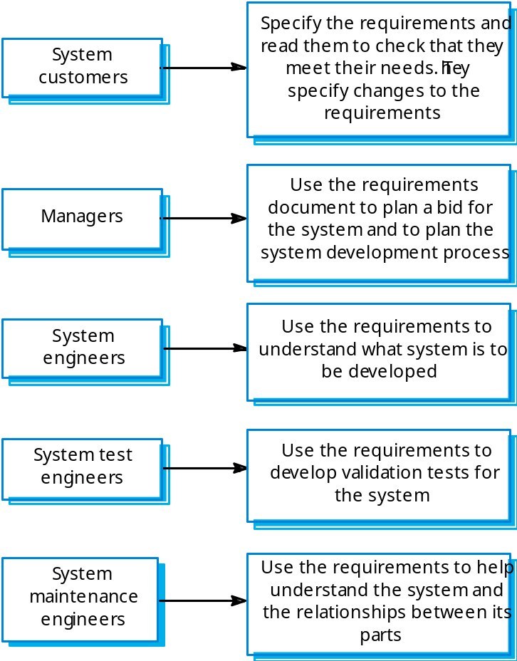  - IEEE Standard  - Defines a generic structure for a requirements document that must be instantiated for each specific system.  - Introduction.  - General description.  - Specific requirements.  - Appendices.  - Index.  - Requirement Document Structure  - Preface  - Introduction  - Glossary  - User requirements definition  - System architecture  - System requirements specification  - System models  - System evolution  - Appendices  - Index  (ii) Write the software requirement specification for a system of your choice. (MAY/JUNE 2014)  ONLINE TICKET RESERVATION SYSTEM  PROBLEM STATEMENT:  This project is about online ticket reservation and consists of two modules. The reservation and the cancellation module. The reservation module allows the user to reserve tickets for a particular train on a particular date. If there is a ticket available, the users can know the vacancy details through the enquiry module. The cancellation module allows user to cancel the tickets for a particular date through reservation officer (system). This module performs status reveal before tickets are being reserved and after they get booked. All these modules together prove to be a flexible online reservation system and it provides complete flexibility to end users and it assumes the desired performance.  OVERALL DESCRIPTION:  MODULES:  - Login  - Display train list  - Search for train  - Reservation  - Cancellation  - Train Status  MODULE DELIVERABLES:  1. LOGIN  Basic Flow  This use case starts when the passenger wishes to Login to the Online Ticket Reservation system  - The System requests that the passenger enter his/her name and password  - The passenger enters his/her name and password  - The System validates the entered name and password and logs the passenger into the System  Alternative Flows: Invalid Name/Password  If, in the Basic flow, the passenger enters an invalid name and/or password, the system displays an error message. The passenger chooses to either return to the beginning of the Basic flow or cancel the login, at which point the use case ends.  Pre-Conditions: None  Post-Conditions: If the use case was successful, the passenger is now logged into the system. If not, the system State is unchanged.  2. Display Train List  Basic Flow: This use case gives passenger information about each train namely train no, train name, Stations passes, Arrival Time, Departure Time etc  Alternative Flows: None  Pre-Conditions: None  Post-Conditions: If the use case was successful, the passenger information about each train namely train no, train name, Stations passes, Arrival Time, Departure Time etc  3. Search for Train  Basic flow  The passenger can obtain train information either by entering train no or Source and Destination Station  1. If the passenger train no gives the information about train  2. If the passenger enter Source and Destination Station from list gives information about list of trains passing through station. From the list link will be provided to each train, which contains the information  Alternate flow: If the passenger enters an invalid train no then it gives error message invalid train no and asks the passenger to enter a valid train no.  Pre-Conditions: None  Post-Conditions: If the use case was successful, the passenger can able to view the list of trains.  4.Reservation  Basic flow  1. The user reserves the ticket by giving following  a) Passenger name, Sex, Age, Address  b) Credit Card No, Bank Name  c) Class through passenger is going to travel i.e First class or Second class or AC  d) Train no and Train name, Date of Journey and number of tickets to be booked.  2. If the ticket is available in a train then the ticket will be issued with PNR No.else the ticket will be issued with a waiting list number.  Alternative flow: If the passenger gives an invalid credit card no or specified a bank where does have any account. Error message will be displayed.  Pre-Conditions: The passenger has to decide about the train he is going to travel.  Post-Conditions: If the use case was successful, the passenger will get the ticket.  5. Cancellation  Basic flow  This use case used by passenger to cancel the ticket, which he/she booked earlier by Entering PNR No. The cancellation has been done reallocating the tickets allotted to the Passenger.  Alternate flow: If the Passenger had entered invalid PNR No then has been asked to enter valid PNR No.  Pre-Conditions: The Passenger had reserved tickets in a train.  Post-Conditions: If the use case was successful, the passenger can cancel the ticket.  6. Ticket Status  Basic flow  1. The passenger should give PNR No to know the status of ticket, which he/she booked earlier.  2. If the PNR No is valid, the status of the ticket will be displayed.  Alternate flow: If passenger had entered an invalid no or PNR NO, which does not exists then error Message will be displayed.  Pre-Conditions: The Passenger had reserved tickets in a train.  Post-Conditions: If the use case was successful, the passenger can view status of the ticket.  FUNCTIONAL REQUIREMENTS
  Req # | Description | Priority
  REQ-S1 | The user will be able to search for trains through a | [Priority = High]
  standardized screen.
  Advanced options will be
  available by clicking
  appropriate links.
  REQ-S2 | Through the standard trains search method the user will be | [Priority = Medium]
  searching round trip trains. The search criteria can be modified by the user by selecting one-way and multi- destination options which would be displayed on a new
  window.
  REQ-S3 | Through the standard trains search method the user shall be | [Priority = High]
  able to specify the departure and return date of their trains.
  REQ-S4 | Through an advanced train search method the user shall be | [Priority = Medium]
  able to specify the arrival train times.
  REQ-S5 | The standard train search method will enable the user to | [Priority = Medium]
  search both precise dates as well as a range of arrival and
  departure dates.
  REQ-S6 | The standard train search method will allow the user to | [Priority = Low]
  specify a preferred railline. This is optional, i.e. the user may or may not specify the railline of preference.
  REQ-S7 | The user will have the option to express a preference of | [Priority = Low]
9 |  |  | Give an account about data models and explain with appropriate diagrams.  Data modeling examines data objects independently of processing, focuses attention on the data domain, creates a model at the customer’s level of abstraction and indicates how data objects relate to one another.  Data objects  Something that is described by a set of attributes and that will be manipulated within the software(system)  - Each instance of an object can be identified uniquely.  - Each plays a necessary role in the system (i.e) the system could not function without access to instance of the object.  - Each is described by attribute that are themselves data items  Typical objects  - External entities  - Things  - Occurrence or events  - Roles  - Organizational units  - Places  - Structures  Data objects and Attributes  - A data objects contains set of attributes that act as an aspect, quality, characteristics or descriptor of the object  Relationship  Relationship indicates “connectedness”; a fact that must be remembered by the system and cannot or is not computed or derived mechanically  - Several instance of a relationship can exist  - Objects can be related in many different ways  Person  Car  (a)A basic connection between data objects  Owns  Person  Car  Insured to drive  (b)Relationships between data objects  Cardinality  It specifies how the number of occurrence of one object are related to the number of occurrence of another object (1:1, 1:N, N:M)  Modality  Zero (0) – for optional object relationship  One (1) – for mandatory relationship
  Object : Automobiles
  Attributes:
  Make
  Model
  Body type
  Price
  Option code
10 |  |  | What are the types of behavioral models? Explain with examples. (MAY/JUNE 2013)  (MAY/JUNE 2014)  - The behavioral model indicates how software will respond to external events  - To create the model, you should perform the following steps:  - Evaluate all use cases to fully understand the sequence of interaction within  the system.  - Identify events that drive the interaction sequence and understand how these  events relate to specific objects.  - Create a sequence for each use case.  - Build a state diagram for the system.  - Review the behavioral model to verify accuracy and consistency.  Identifying Events with the Use Case  A use case is examined for points of information exchange.  - The homeowner uses the keypad to key in a four-digit password.  - The password is compared with the valid password stored in the system.  - If the password is incorrect, the once and reset itself for additional input.  - If the password is control panel will beep correct, the control panel awaits further action.  - Once all events have been identified, they are allocated to the objects involved.  - Objects can be responsible for generating events.  State Representations  - The state of each class as the system performs its function and  - The state of the system as observed from the outside as the system performs its function.  Two different behavioral representations are State diagrams for analysis classes that represent active states for each class and the events (triggers) that cause changes between these active states. The second type of behavioral representation, called a sequence diagram in UML, indicates how events cause transitions from object to object.
11 |  |  | i)Differentiate between user and system requirements. (MAY/JUNE 2016)  User requirements are statements, in a natural language plus diagrams, of what services the system is expected to provide to system users and the constraints under which it must operate.  The user requirements for a system should describe the functional and nonfunctional requirements so that they are understandable by system users who don’t have detailed technical knowledge. Ideally, they should specify only the external behavior of the system.  2. System requirements are more detailed descriptions of the software system’s functions, services, and operational constraints. The system requirements document (sometimes called a functional specification) should define exactly what is to be implemented. It may be part of the contract between the system buyer and the software developers.  System requirements are expanded versions of the user requirements that are used by software engineers as the starting point for the system design. They add detail and explain how the user requirements should be provided by the system. They may be used as part of the contract for the implementation of the system and should therefore be a complete and detailed specification of the whole system.  ii)Describe the requirement change management process in detail. (MAY/JUNE 2016)  Requirements change management (Figure 4.18) should be applied to all proposed changes to a system’s requirements after the requirements document has been approved. Change management is essential because you need to decide if the benefits of implementing new requirements are justified by the costs of implementation.  1. Problem analysis and change specification The process starts with an identified using a formal process for change management is that all change proposals are treated consistently and changes to the requirements document are made in a controlled way. There are three principal stages to a change management process: requirements problem or, sometimes, with a specific change proposal. During this stage, the problem or the change proposal is analyzed to check that it is valid. This analysis is fed back to the change requestor who may respond with a more specific requirements change proposal, or decide to withdraw the request.  2. Change analysis and costing The effect of the proposed change is assessed using traceability information and general knowledge of the system requirements.The cost of making the change is estimated both in terms of modifications to the requirements document and, if appropriate, to the system design and implementation. Once this analysis is completed, a decision is made whether or not to proceed with the requirements change.  3. Change implementation The requirements document and, where necessary, the system design and implementation, are modified. You should organize the requirements document so that you can make changes to it without extensive rewriting or reorganization. As with programs, changeability in documents is achieved by minimizing external references and making the document sections as modular as possible. Thus, individual sections can be changed and replaced without affecting other parts of the document.  If a new requirement has to be urgently implemented, there is always a temptation to change the system and then retrospectively modify the requirements document. You should try to avoid this as it almost inevitably leads to the requirements specification and the system implementation getting out of step. Once system changes have been made, it is easy to forget to include these changes in the requirements document or to add information to the requirements document that is inconsistent with the implementation.  Agile development processes, such as extreme programming, have been designed to cope with requirements that change during the development process. In these processes, when a user proposes a requirements change, this change does not go through a formal change management process. Rather, the user has to prioritize that change and, if it is high priority, decide what system features that were planned for the next iteration should be dropped.
12 |  |  | Write a note on what are the difficulties in elicitation, requirement elicitation ((APR/MAY 17)  Thin spread of domain knowledge  - It is rarely available in an explicit form  - distributed across many sources  - with conflicts between knowledge from different sources  Tacit knowledge (The “say-do” problem)  - People find it hard to describe knowledge they regularly use  Limited Observability  - The problem owners might be too busy coping with the current system  - Presence of an observer may change the problem  Bias  - People may not be free to tell you what you need to know  - People may not want to tell you what you need to know  Requirements Elicitation is one of the most difficult stages of analysis, with numerous communication barriers existing between the analyst and client that make eliciting requirements difficult. Analysts and clients often speak in different general languages, with analysts often being more technical in nature, while clients will often speak more from a business perspective. This makes common understanding difficult. Several other general challenges in requirements elicitation, including conflicting requirements, unspoken or assumed requirements, difficulty in meeting with relevant stakeholders, stakeholder resistance to change, and not enough time set for meeting with all stakeholders.  Problems of requirements elicitation can be grouped into three categories:  - problems of scope, in which the requirements may address too little or too much information;  - problems of understanding, within groups as well as between groups such as users and developers; and  - problems of volatility, i.e., the changing nature of requirements.  The list of ten elicitation problems could be classified according to this framework as follows:  Problems of scope  - the boundary of the system is ill-defined  - unnecessary design information may be given  Problems of understanding  - users have incomplete understanding of their needs  - users have poor understanding of computer capabilities and limitations  - analysts have poor knowledge of problem domain  - user and analyst speak different languages  - ease of omitting “obvious” information  - conflicting views of different users
13 |  |  | Consider the process of ordering a pizza over the phone. Draw the usecase diagram and also sketch the activity diagram representing each step of the process, from the moment you pick up the phone to the point where you start eating the pizza. Include activities that others nee to perform. Add exception handling to the activity diagram you developed. Consider at least two exception(e.g. delivery person wrote down wrong address, deliver person brings wrong pizza)(NOV/DEC 17)  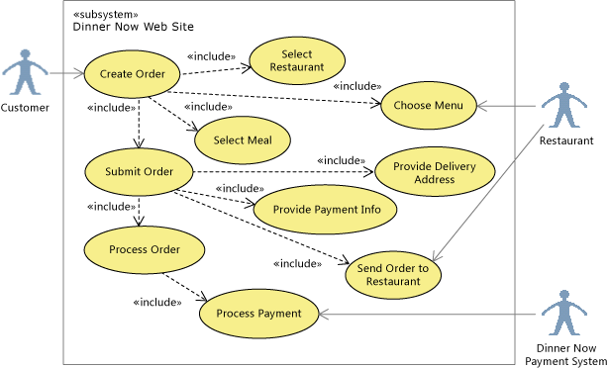  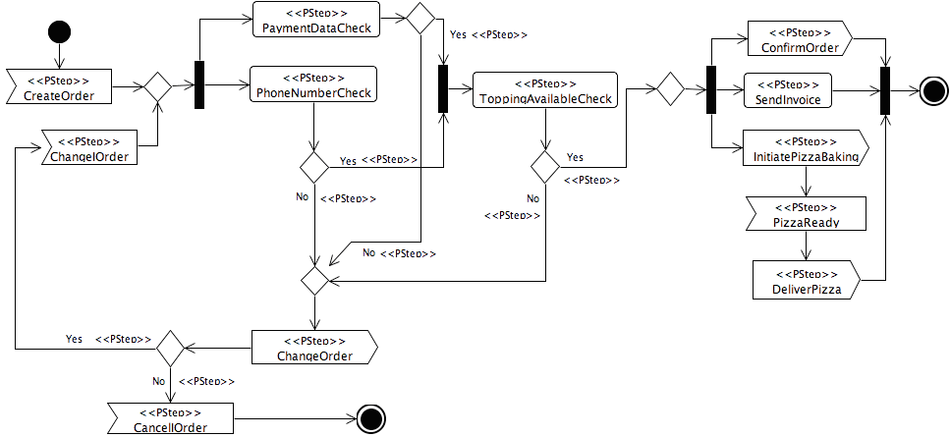
14 |  |  | What is requirements elicitation? Briefly describe the various activities performed in requirements elicitation phase with an example of a watch system that facilitates set time and alarm. (APR/MAY 18)  Requirements Elicitation is one of the most difficult stages of analysis, with numerous communication barriers existing between the analyst and client that make eliciting requirements difficult. Analysts and clients often speak in different general languages, with analysts often being more technical in nature, while clients will often speak more from a business perspective. This makes common understanding difficult. Several other general challenges in requirements elicitation, including conflicting requirements, unspoken or assumed requirements, difficulty in meeting with relevant stakeholders, stakeholder resistance to change, and not enough time set for meeting with all stakeholders.  The requirements elicitation and analysis has 4 main process  We typically start by gathering the requirements, this could be done through a general discussion or interviews with your stakeholders, also it may involve some graphical notation. Then you organize the related requirements into sub components and prioritize them, and finally, you refine them by removing any ambiguous requirements that may raise from some conflicts.  Here are the 4 main process of requirements elicitation and analysis.  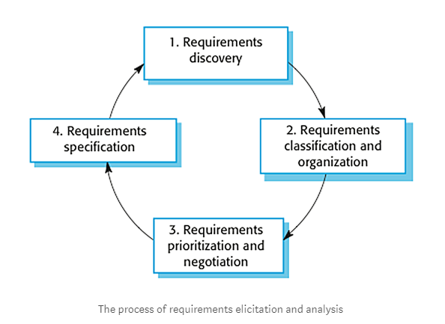  1. Requirements Discovery  It’s the process of interacting with, and gathering the requirements from, the stakeholders about the required system and the existing system (if exist).  Interviews  In Interviews, requirements engineering teams put the questions to the stakeholder about the system that’s currently used, and the system to be developed, and hence they can gather the requirements from the answers.  The questions fall under two categories:  - Closed-Ended questions: A pre-defined set of question.  - Open-Ended questions: There is no a pre-defined expected answer; they are more of generic questions. It’s used to explore issues that are not clear in a less structured way.  Use Cases & Scenarios  The use cases and scenarios are two different techniques, but, usually they are used together. Use cases identify interactions between the system and it’s users or even other external systems (using graphical notations), while a scenario is a textual description of one or more of these interactions.  Use case involves some symbols to describe the system:  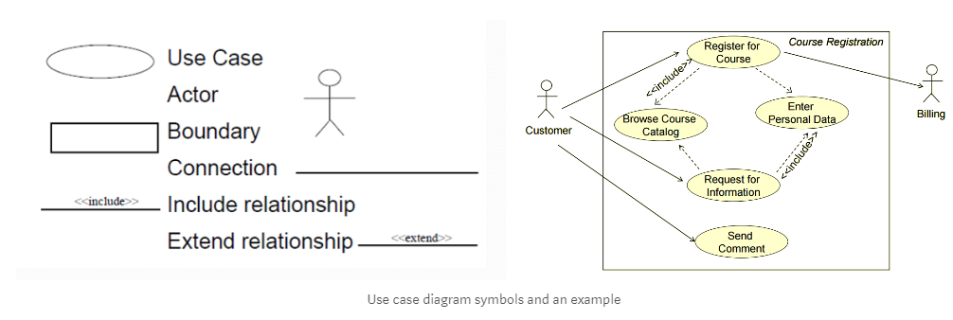  - Actors: Are those who interact with the system; human or other systems  - Interaction (Use Case): It denotes the name of the interaction (verb). It’s represented as a named ellipse.  - Connection: Lines that links between the actors and the interactions.  - Include Relationship: It denotes a connection between two interactions when an interaction is invoked by another. As an example, splitting a large interaction into several interactions.  - Exclude Relationship: It denotes a connection between two interactions when you want to extend an interaction by adding an optional behavior, but you can use the main interaction on its own without the extending interaction.  2. Requirements Classification & Organization  It’s very important to organize the overall structure of the system. Putting related requirements together, and decomposing the system into sub components of related requirements. Then, we define the relationship between these components.  3. Requirements Prioritization & Negotiation  We previously explained why eliciting and understanding the requirements is not an easy process. One of the reasons is the conflicts that may arise as a result of having different stakeholders involved. Why? Because it’s hard to satisfy all parties, if it’s not impossible. This activity is concerned with prioritizing requirements and finding and resolving requirements conflicts through negotiations until you reach a situation where some of the stakeholders can compromise.  4. Requirements Specification  The requirements are then documented. We’ll discuss requirements specification in more detail in “Requirements Engineering — Requirements Specification”.  Requirements Elicitation  The process through which the customers, buyers, or users of a software system discover, reveal, articulate, and understand a watch system that facilitates to set time and alarm. For example, gathering requirements based on time zone, framing windows, options to set alarm, etc  Requirements Analysis  The process of reasoning about the requirements that have been elicited; it involves activities such as examining requirements for conflicts or inconsistencies, combining related requirements, and identifying missing requirements. The above said requirements are analyzed properly and details are taken from device calendar database.  Requirements Specification  The process of recording the requirements in one or more forms, including natural language and formal, symbolic, or graphical representations; also, the product that is the document produced by that process.  Requirements Validation  The process of confirming with the customer or user of the software that the specified requirements are valid, correct, and complete.The following table represents elicitation and analysis which can be done by design, brainstorming activities, interviews and framework activities.  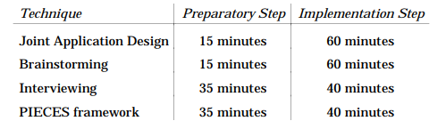  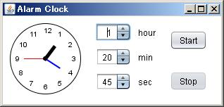
15 |  |  | What is SRS? Explain in detail the various components of an SRS. (APR/MAY 18)  The requirements document is the official statement of what is required of the system developers.  • Should include both a definition of user requirements and a specification of the system requirements.  • It is NOT a design document. As far as possible, it should set out WHAT the system should do rather than HOW it should do it.  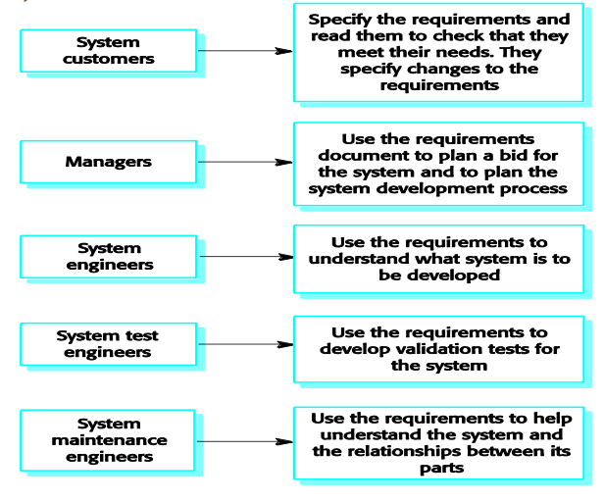  Defines a generic structure for a requirements document that must be instantiated for each specific system.  • Introduction.  • General description.  • Specific requirements.  • Appendices.  • Index.  • Requirement Document Structure  • Preface  • Introduction  • Glossary  • User requirements definition  • System architecture  • System requirements specification  • System models  • System evolution  • Appendices  • Index  • The information that is included in a requirements document depends on the type of software being developed and the approach to development that is to be used.  REQUIREMENTS SPECIFICATION  • Requirements specification is the process of writing down the user and system requirements in a requirements document. Ideally, the user and system requirements should be clear, unambiguous, easy to understand, complete, and consistent.  • The user requirements for a system should describe the functional and non-functional requirements so that they are understandable by system users who don’t have detailed technical knowledge.  • System requirements are expanded versions of the user requirements that are used by software engineers as the starting point for the system design. They add detail and explain how the user requirements should be provided by the system.  • The system requirements should simply describe the external behavior of the system and its operational constraints. They should not be concerned with how the system should be designed or implemented.  • At the level of detail required to completely specify a complex software system, it is practically impossible to exclude all design information. There are several reasons for this:  - The system requirements are organized according to the different subsystems that make up the system.  - Systems must interoperate with existing systems, which constrain the design and impose requirements on the new system.  - The use of a specific architecture to satisfy non-functional requirements may be necessary.

UNIT -III SOFTWARE DESIGN
Design process – Design Concepts-Design Model– Design Heuristic – Architectural Design –Architectural styles, Architectural Design, Architectural Mapping using Data Flow- User Interface Design: Interface analysis, Interface Design –Component level Design: Designing Class based components, traditional Components.
UNIT- III /PART -A
1. |  | Define design process.  Design process is a sequence of steps carried through which the requirements are translated into a system or software model.
2. |  | List the architectural models that can be developed. (NOV/DEC2010)  Architectural models that may be developed may include:  - A static structural model shows the sub-system or components that are to be developed as separate units.  - A dynamic process model shows how the system is organized into processes at run-time.  - An interface model defines the services offered by each sub-system through its public interface.  - Relationship model shows relationships, such as data flow between the subsystems.  - A distribution model shows how sub-systems may be distributed across computers
3. |  | What is a pattern?  A pattern is an insight which conveys the essence of a proven solution to a recurring problem within a certain context amidst competing concerns.
4. |  | List four design principles of a good design. (APR/MAY 2011) (NOV/DEC 2013)  The principles of a good design are:  - The design must implement all of the explicit requirements contained in the analysis model.  - It must accommodate all of the implicit requirements desired by the customer.  - The design must be readable, understandable guide for those who generate code and for those who test and subsequently support the software.  - The design should provide a complete picture of the software, addressing the data, functional, and behavioral domains from an implementation perspective.
5. |  | Distinguish fan-in and fan-out. (NOV/DEC 2011)
  FAN-OUT | FAN-IN
  Fan-out is a measure of the number of modules that are directly controlled by another module. | Fan-in indicates how many modules directly control a given modules.
6. |  | Explain the qualitative criteria for measuring independence. (NOV/DEC 2011)  Independence is assessed using two qualitative criteria:  - Cohesion is an indication of the relative functional strength of a module.  - Coupling is the indication of the relative interdependence among modules.
7. |  | List out design methods. (MAY/JUN 2012)  The design methods can be listed as:  - Data abstraction  - System architecture  - Design patterns  - Modularity  - Information hiding  - Functional independence  - Refinement  - Refactoring  - Design classes
8. |  | What is the work product of software design process and who does this?  A design model that encompasses architectural, interface, component level and their representations is the primary work product that is produced during software design. Software engineers conduct each of the design tasks.
9. |  | Define super-ordinate and subordinate.  The control relationship among modules is expressed in the following way: A module that controls another module is said to be super ordinate to it and conversely, a module controlled by another is said to be subordinate to the controller.
10. |  | Define information hiding and modularity.(NOV/DEC 2014)  The principle of information hiding suggests that modules be “characterized by design decisions that hides from all others”. In other words, modules should be specified and designed so that information contained within a module is inaccessible to other modules.  “Modularity is a single attribute of software that allows a program to be intellectually manageable”. Monolithic software cannot be easily grasped by a software engineer. This leads to “divide and conquer” strategy – it’s easier to solve a complex problem when you break it into manageable pieces which would reduce the effort.
11. |  | What is the use of Architectural design?  The Architectural design defines the relationship between major structural elements of the software, the “design patterns” that can be used and the constraints that affect the way in which architectural design patterns can be applied.
12. |  | Define procedure and data abstraction.  A procedural abstraction is a named sequence of instructions that has a specific and limited function. A data abstraction is named collection of data that describes a data object.
13. |  | Define software architecture and mention its characteristics.  Software architecture alludes to “the overall structure of the software and the ways in which that structure provides conceptual integrity for a system”. Structural properties, Extra functional properties, Families of related systems.
14. |  | What are the three distinct types of activities of software design?  External design, Architectural design and Detailed design.
15. |  | What are the characteristics of External design?  External design of software design involves conceiving, planning out and specifying the external observable characteristics of the software product.
16. |  | Which is referred as internal design? Mention its characteristics.  Architectural and detailed designs are collectively referred to as internal design. Internal design involves conceiving, planning out and specifying the internal structure and processing details of the software product.
17. |  | What are the goals of internal design?  The goals of Internal design are to specify internal design and processing details, to record design decisions, to elaborate the test plan and to provide a blueprint for implementation testing and maintenance activities.
18. |  | What are the work products of internal design?  The products of internal design include a specification of architectural structure, the details of algorithms and data structures and the test plan.
19. |  | What are the fundamental concepts of software design?  Fundamental concepts of software design include abstraction, structure information hiding, modularity, concurrency, and verification and design aesthetics.
20. |  | Define abstraction.  Abstraction is the intellectual tool that allows dealing with concept apart from particular instances of those concepts. During requirements definition and design, abstraction permits separation of the conceptual aspects of a system from the implementation details.
21. |  | What are the principles of Component-level design?  - The Open-Closed Principle(OCP)  - The Liskov-Substitution Principle(LSP)  - Dependency Inversion Principle(DIP)  - The Interface Segregation Principle(ISP)  - The Release Reuse Equivalency Principle(REP)  - The Common Closure Principle(CRP)
22. |  | Define Cohesion and Coupling.  Cohesion implies that the component or class encapsulates only attributes and operations that are closely related to one another and to the class or component itself.  Coupling is a quantitative measure of the degree to which classes are connected to one another. As classes become more interdependent, coupling increases.
23 | What are the steps for interface design?(APR/MAY 2015)  - Using information developed during interface analysis, the interface objects and operations are defined.  - The events that will cause the change in the state of the user interface are defined and modeled.  - Each interface state is depicted as it will actually look to the end-user.  An indication of how the user interprets the state of the system from information provided through the interface is provided.
24 | If a module has logical cohesion, what kind of coupling is this module likely to have?(May/June 2016)  When a module that performs a tasks that are logically related with each other is called logically cohesive. For such module CONTENT COUPLING can be suitable for coupling with another modules. The content coupling is a coupling when one module makes use of data or control information maintained in another module.
25 | Define Archetypes.  An archetype is a class or pattern that represents a core abstraction that is critical to the design of the architecture for the target system.
26 | Draw diagrams to demonstrate architectural styles.(APR/MAY 2015)  Data-Centric Architecture  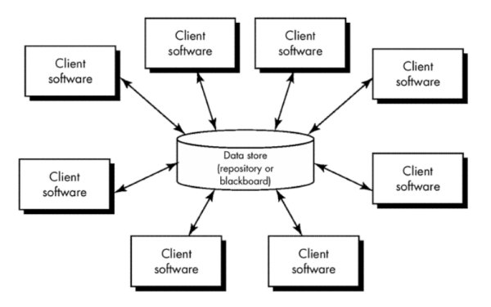  Data-Flow Architecture  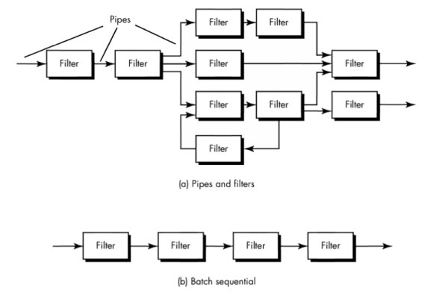
27 | What is the need for architectural mapping using data flow? (May/June 2016)  - Mainly for Transform Mapping  - Review the fundamental system model.  - Review and refine data flow diagrams for the software  - Determine whether the DFD has transform or transaction flow characteristics.  - Isolate the transform center by specifying incoming and outgoing flow boundaries.  - Perform “first-level factoring”  - Perform “second-level factoring”  - Refine the first-iteration architecture using design heuristics for improved software quality.
28 | What architectural styles are preferred for the following systems? Why?  a)networking b)web based systems c)Banking Systems.(NOV/DEC 2016)  a)Networking – Data Flow Architecture  Definition  This architecture is applied when input data are to be transformed through a series of computational or manipulative components into output data.  Reason  Networking allows computers to exchange data.  b)Web based systems-Data centered Architecture  Definition  A data store (e.g., a file or database) resides at the center of this architecture and is accessed frequently by other components that update, add, delete, or otherwise modify data within the store.Client software accesses a central repository.  Reason  Web-based applications often run inside a Web browser by sending requests. Web browser publishes and maintains data.  c)Banking system-Object oriented Architecture  Definition  The components of a system encapsulate data and the operations that must be applied to manipulate the data.  Reason  Banking systems are responsible for operating functionalities such as a payment system, providing loans, taking deposits and helping with investments.
29 | What UI design patterns are used for the following? (NOV/DEC 2016)(APR/MAY 17)  - Page layout –Layout UI design patterns  - Tables – Table design pattern  - Navigation through menus and web pages – Graphical User Interface  - Shopping cart-Miscellaneous UI design patterns or Web UI design patterns
30 | Write a note on FURPS model.(NOV/DEC 17)  Functionality is assessed by evaluating the feature set and capabilities of the program, the generality of the functions that are delivered, and the security of the overall system.  Usability is assessed by considering human factors, overall aesthetics, consistency, and documentation.  Reliability is evaluated by measuring the frequency and severity of failure, the accuracy of output results, the mean-time-to-failure (MTTF), the ability to recover from failure, and the predictability of the program.  Performance is measured by processing speed, response time, resource consumption, throughput, and efficiency.  Supportability combines the ability to extend the program (extensibility), adaptability, serviceability—these three attributes represent a more common term, maintainability—in addition, testability, compatibility, configurability , the ease with which a system can be installed, and the ease with which problems can be localized.
31 | Draw the context flow graph of ATM automation system(NOV/DEC 17)  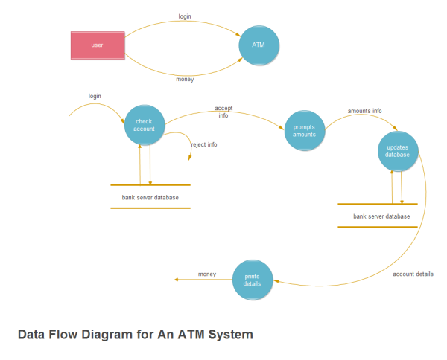
32 | List the principles of a software design. (April/May 2018)  - The design process should not suffer from “tunnel vision”.  - The design should be traceable to the analysis model.  - The design should exhibit uniformity and integration.  - Design is not coding.  - The design should not reinvent the wheel.
33 | What UI design patterns are used for the following? (April/May 2018)  - Page layout – card stack  - Tables – sortable table  - Navigation through menus and web pages – edit- in-place  - Shopping cart – shopping cart
UNIT-III / PART- B
1. | What is system modeling? Explain the process of creating models and the factors that should be considered when building models. (NOV/DEC 2013)  System modelling helps the analyst to understand the functionality of the system and models are used to communicate with customers  - Identify the process necessary to carry out the task you are creating the business process model for.  - Outline the processes necessary in the sequence they need to be performed in order to accomplish the business tasks presented by the process model.  - Discuss and document the business process in which you are creating the process model for.  - Create a flow chart of the steps necessary to achieve the process in which you are creating the model for.  - Begin the process by writing the first step to your task inside of an oval shape.  - Write the next step as an activity performed in the process using a rectangle shape  - Write yes or no questions in diamond shapes for steps that require decisions  - Create more rectangle boxes after your decision diamond in order to show what active tasks are necessary to continue the task's process.  - Finish the flow chart just as you started it, by using an oval shape to signify it's completion.  - Go over your flow chart numerous times with both employees who know the process as well as employees who have never done the process in order to ensure it is complete and successfully accuracy.
2. | Explain the core activities involved in user interface design process with necessary block diagrams. (NOV/DEC 2010) (NOV/DEC 2016)(NOV/DEC 17)  User interface (UI) design is an iterative process where users interact with designers and interface prototypes to decide on the features, organization and the look and feel of the system user interface. Sometimes the interface is separately prototyped in parallel with other software engineering activities. When iterative development is used, the user interface design proceeds incrementally as the software is developed. In both cases before programming starts, some paper-based designs must be developed and ideally tested. The overall UI design process is shown in the figure.  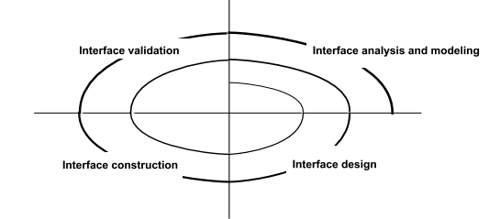  THE USER INTERFACE DESIGN PROCESS  There are three core activities in this process:  User analysis: In the user analysis process, develop an understanding of the tasks that the user does, their working environment, the other systems that they use, how they interact with other people in their work. For products with a diverse range of users, develop this understanding through focus groups, trails with potential users and similar exercises.  System prototyping: User interface design and development is an iterative process. Although users may talk about the facilities they need from an interface, it is very difficult for them to be specific until something tangible is seen. So prototype systems are developed and exposed to the users, which can guide the evolution of the interface.  Interface evaluation: Even though there are discussions with the users during the prototype process, a more formalized evaluation activity is required, where information about users’ actual experience with the interface is collected. The scheduling of the UI design within the software process depends to some extent on other activities. Prototyping may be used as a part of requirements engineering process and also to start the UI design process at this stage. In iterative processes UI design is integrated with the software development. Like the software itself the UI design may have to be refactored and redesigned during development.  User analysis: A critical user interface design activity is the analysis of the user activities that are to be supported by the computer system. To develop these understanding, task analysis, ethnographic studies, user interviews and observations or a mixture of all methods can be used.  The challenge for engineers involved in user analysis is to find a way to describe user analyses so that they communicate the essence of the tasks to other designers and to the users themselves. UML sequence charts can be used but they can be too technical for the users, so a natural language scenario to represent user activities must be developed.  Cannot expect users’ analysis to generate very specific user interface requirements. The analysis helps to understand the needs and concerns of the system users. As more information is obtained how they work, their concerns and their constraints it can be taken into account of the design.  User interface prototyping:  Because of the dynamic nature of user interfaces, textual description and diagrams are not good enough for expressing user interface requirements. Evolutionary or exploratory prototyping with end-user involvement is the only practical way to design and develop graphical user interfaces for software systems. The aim of prototyping is to gain direct experience with the interface. It is difficult to think abstractly about a user interface to explain exactly what is required. But when presented with examples it is easy to identify the characteristics that are liked and disliked.  When prototyping a user interface, a two-stage prototyping process is adopted:  - Very early in the process, develop paper prototypes-mock ups of screen designs-and  walk through these with end-users.  - Then refine the design and develop increasingly sophisticated automated prototypes,  - then make them available to users for testing and activity simulation.  There are three approaches that can be used for user interface prototyping:  - Script-driven approach  - Visual programming languages  - Internet-based prototyping  Interface evaluation:  Interface evaluation is the process of assessing the usability of an interface and checking that  it meets user requirements. It should be part of the normal verification and validation process  for software systems.
3. | (i) Discuss the design heuristics for effective modularity design.(NOV/DEC 2016)  (ii)Explain the architectural styles used in the architectural design. (MAY/JUNE 2013, 2014)(APR/MAY 17)  - Coupling describes the interconnection among modules  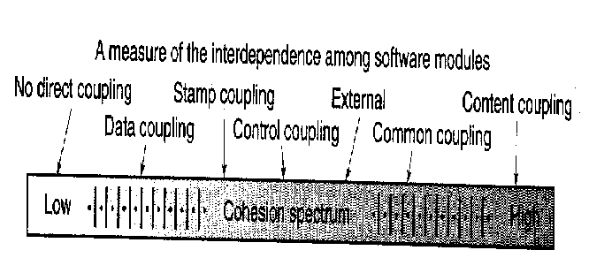  - Data coupling  - Occurs when one module passes local data values to another as parameters  - Stamp coupling  - Occurs when part of a data structure is passed to another module as a parameter  - Control Coupling  - Occurs when control parameters are passed between modules  - Common Coupling  - Occurs when multiple modules access common data areas such as Fortran Common or C extern  - Content Coupling  - Occurs when a module data in another module  - Subclass Coupling  - The coupling that a class has with its parent class  DESIGN HEURISTICS  - Evaluate 1st iteration to reduce coupling & improve cohesion  - Minimize structures with high fan-out; strive for depth  - Keep scope of effect of a module within scope of control of that module  - Evaluate interfaces to reduce complexity and improve consistency  - Define modules with predictable function & avoid being overly restrictive  - Avoid static memory between calls where possible  - Strive for controlled entry -- no jumps into the middle of things  - Package software based on design constraints and portability requirements  (ii)Explain the architectural styles used in the architectural design. (MAY/JUNE 2013, 2014)  ARCHITECTURAL DESIGN  - Establishing the overall structure of a software system  - Objectives  - To introduce architectural design and to discuss its importance  - To explain why multiple models are required to document a software architecture  - To describe types of architectural model that may be used  - Architectural (high-level) design = the process of establishing the subsystems of a larger software system and defining a framework for subsystem control and communication  - Software architecture = the output of the high-level design process  - Defining and documenting the software architecture provides support for:  - Stakeholder communication  - System analysis  - Large-scale software reuse  - The software architecture of a program or computing system is the structure or structures of the system, which comprise software components  - architecture is not the operational software  - Enables a software engineer  - Analyze the effectiveness of the design in meeting its stated requirements  - Consider architectural alternatives at a stage when making design changes is still relatively easy  - Reducing the risks associated with the construction of the software.  - Representations of software architecture are an enabler for communication between all parties  - The architecture highlights early design decisions that will have a profound impact on all software engineering work  - Architecture “constitutes a relatively small, intellectually graspable model of how the system is structured  Architectural Styles  - Each style describes a system category that encompasses:  - a set of components (e.g., a database, computational modules) that perform a function required by a system,  - a set of connectors that enable “communication, coordination, and cooperation” among components,  - constraints that define how components can be integrated to form the system, and  - semantic models that enable a designer to understand the overall properties of a system.  Specific Styles  - Data-centered architecture  - Data flow architecture  - Call and return architecture  - Object-oriented architecture  - Layered architecture
4. | Discuss class-based components along with its principles in detail. For a Case study of your choice show the architectural and Component design. (APR/MAY 2015)  Identifying Analysis Classes  - External entities that produce or consume information  - Things that are part of the information domain  - Occurrences or events  - Roles played by people who interact with the system  - Organizational units  - Places that establish context  - Structures that define a class of objects  Class Selection Criteria  - Retained information  - Needed services  - Multiple attributes  - Common attributes  - Common operations  - Essential requirement  Identifying Classes  Class Diagram  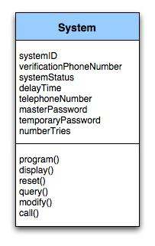  Class diagram for the system class  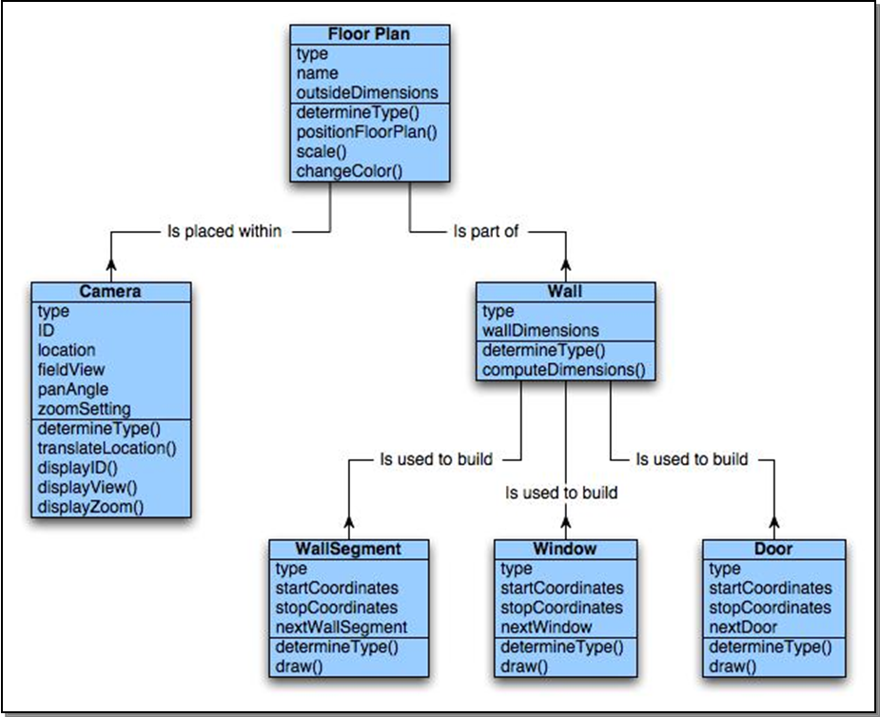  Class Responsibilities  - Distribute system intelligence across classes.  - State each responsibility as generally as possible.  - Put information and the behavior related to it in the same class.  - Localize information about one thing rather than distributing it across multiple classes.  - Share responsibilities among related classes, when appropriate.  Class Collaborations  - Relationships between classes:  - is-part-of — used when classes are part of an aggregate class.  - has-knowledge-of — used when one class must acquire information from another class.  - depends-on — used in all other cases.
  Potential class | Classification | Accept / Reject
  homeowner | role; external entity | reject: 1, 2 fail
  sensor | external entity | accept
  control panel | external entity | accept
  installation | occurrence | reject
  (security) system | thing | accept
  number, type | not objects, attributes | reject: 3 fails
  master password | thing | reject: 3 fails
  telephone number | thing | reject: 3 fails
  sensor event | occurrence | accept
  audible alarm | external entity | accept: 1 fails
  monitoring service | organizational unit; ee | reject: 1, 2 fail
5. | Explain the interface analysis and discuss the goals of task analysis involved in detail.  - Interface analysis means understanding  (1) the people (end-users) who will interact with the system through the interface;  (2) the tasks that end-users must perform to do their work,  (3) the content that is presented as part of the interface  (4) the environment in which these tasks will be conducted.  - Are users trained professionals, technician, clerical, or manufacturing workers?  - What level of formal education does the average user have?  - Are the users capable of learning from written materials or have they expressed a desire for classroom training?  - Are users expert typists or keyboard phobic?  - What is the age range of the user community?  - Will the users be represented predominately by one gender?  - How are users compensated for the work they perform?  - Do users work normal office hours or do they work until the job is done?  - Is the software to be an integral part of the work users do or will it be used only occasionally?  - What is the primary spoken language among users?  - What are the consequences if a user makes a mistake using the system?  - Are users experts in the subject matter that is addressed by the system?  - Do users want to know about the technology the sits behind the interface?  Task Analysis and Modeling  - Task Analysis answers the following questions …  - What work will the user perform in specific circumstances?  - What tasks and subtasks will be performed as the user does the work?  - What specific problem domain objects will the user manipulate as work is performed?  - What is the sequence of work tasks—the workflow?  - What is the hierarchy of tasks?  - Use-cases define basic interaction  - Task elaboration refines interactive tasks  - Object elaboration identifies interface objects (classes)  Workflow analysis defines how a work process is completed when several people (and roles) are involved
6. | What are the issues that have to be constrained in the design process? Explain the design evaluation in detail.  Design Issues  - Response time: System response time has 2 important characteristics: length and variability. Variability refers to the deviation from average response time.  - Help facilities: Help must be available for all system functions. Include help menus, print documents.  - Error handling: describe the problem in a language the user can understand. Never blame the user for the error that occurred.  - Menu and command labeling: menu options should have corresponding commands. Use control sequences for commands.  - Application accessibility: especially for the physically challenged.  - Internationalization: The Unicode standard has been developed to address the daunting challenge of managing dozens of natural languages with hundred of characters and symbols.  Design Evaluation Cycle  Two interface design evaluation techniques are mentioned in this section, usability questionnaires and usability testing. The process of learning how to design good user interfaces often begins with learning to identify the weaknesses in existing products.  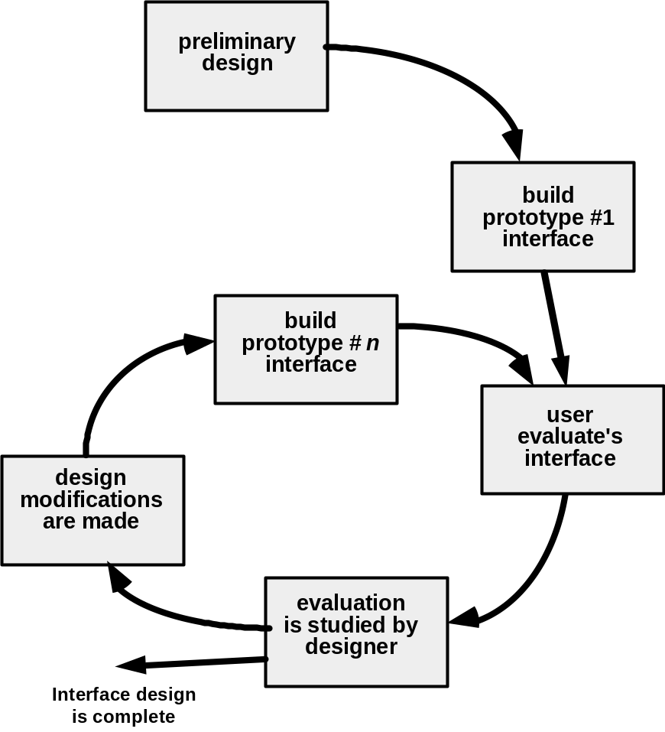  Once the first prototype is built, the designer can collect a variety of qualitative and quantitative data that will assess in evaluating the interface. Questions can be a simple Y/N response, numeric response, scaled response, Likert scale (strongly agree, etc.), percentage response, and open-ended ones.
7. | Discuss about software architecture design, which emphasize on fan in, fan out, coupling, cohesion and factoring? Explain in detail types of cohesion and coupling with examples.(APR/MAY 2018) (NOV/DEC 2011) (NOV/DEC 2012)(APR/MAY 2015)(APR/MAY 17)  - cohesion and factoring? (NOV/DEC 2011) (NOV/DEC 2012)(APR/MAY 2015)  In the AD phase, the software requirements are transformed into definitions of software components and their interfaces, to establish the framework of the software. This is done by examining the SRD and building a 'physical model' using recognized software engineering methods. The physical model should describe the solution in concrete, implementation terms. Just as the logical model produced in the SR phase structures the problem and makes it manageable, the physical model does the same for  the solution.  The physical model is used to produce a structured set of component specifications that are consistent, coherent and complete. Each specification defines the functions, inputs and outputs of the component  The major software components are documented in the Architectural Design Document (ADD). The ADD gives the developer's solution to the problem stated in the SRD. The ADD must cover all the  requirements stated in the SRD (AD20), but avoid the detailed consideration of software requirements that do not affect the structure.  The main outputs of the AD phase are the:  - Architectural Design Document (ADD);  - Software Project Management Plan for the DD phase (SPMP/DD);  - Software Configuration Management Plan for the DD phase(SCMP/DD);  - Software Verification and Validation Plan for the DD Phase (SVVP/DD);  - Software Quality Assurance Plan for the DD phase (SQAP/DD);  - Integration Test Plan (SVVP/IT).  Figure 2.1 summarizes activities and document flow in the AD phase. The following subsections describe the activities of the AD phase in more detail.  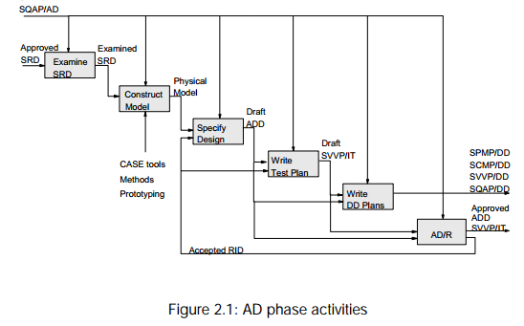  Design quality  Designs should be adaptable, efficient and understandable. Adaptable designs are easy to modify and maintain. Efficient designs make minimal use of available resources. Designs must be understandable if they are to be built, operated and maintained effectively.  Attaining these goals is assisted by aiming for simplicity. Metrics should be used for measuring simplicity/complexity (e.g. number of interfaces per component and cyclomatic complexity).  Simple components are made by maximizing the degree to which the activities internal to the component are related to one another (i.e. 'cohesion').  Simple structures can be made by:  - minimizing the number of distinct items that are passed between components (i.e. 'coupling');  - ensuring that the function a component performs is appropriate to its place in the hierarchy (i.e. 'system shape');  - ensuring the structure of the software follows the structure of the data it deals with (i.e. 'data structure match');  - designing components so that their use by other components can be maximised (i.e. 'fan-in');  - restricting the number of child components to seven or less (i.e. 'fanout');  - removing duplication between components by making new components (i.e. 'factoring').  Designs should be 'modular', with minimal coupling between components and maximum cohesion within each component. Modular designs are more understandable, reusable and maintainable than designs consisting of components with complicated interfaces and poorly matched groupings of functions. Each level of a design should include only the essential aspects and omit inessential detail. This means they should have the appropriate degree of 'abstraction'. This enhances understandability, adaptability and maintainability.  Design metrics  - Cohesion  The parts of a component should all relate to a single purpose.  Cohesion measures the degree to which activities within a component are related to one another. The cohesion of each component should be maximized. High cohesion leads to robust, adaptable, maintainable software.  Cohesion should be evaluated externally (does the name signify a specific purpose?) and internally (does it contain unrelated pieces of logic?).  Types of cohesion:  - functional cohesion;  - sequential cohesion;  - communicational cohesion;  - procedural cohesion;  - temporal cohesion;  - logical cohesion;  - coincidental cohesion.  Functional cohesion is most desirable and coincidental cohesion should definitely be avoided. The other types of cohesion are acceptable under certain conditions. The seven types are discussed below with reference to typical components that might be found in a statistics package.  Functionally cohesive components contain elements that all contribute to the execution of one and only one problem-related task. Names carry a clear idea of purpose (e.g. CALCULATE_MEAN). Functionally cohesive components should be easy to reuse. All the components at the  bottom of a structure should be functionally cohesive.  Sequentially cohesive components contain chains of activities, with the output of an activity being the input to the next. Names consist of specific verbs and composite objects (e.g. CALCULATE_TOTAL_AND_MEAN). Sequentially cohesive components should be split into functionally cohesive components.  Communicational cohesive components contain activities that share the same input data. Names have over-general verbs but specific objects (e.g. ANALYSE_CENSUS_DATA), showing that the object is used for a range of activities. Communicational cohesive components should be split into functionally cohesive components.  Procedurally cohesive components contain chains of activities, with control passing from one activity to the next. Individual activities are only related to the overall goal rather than to one another. Names of procedurally cohesive components are often 'high level', because they convey an idea of their possible activities, rather than their actual activities (e.g. PROCESS_CENSUS_DATA). Procedurally cohesive components are acceptable at the highest levels of the structure.  Temporally cohesive components contain activities that all take place simultaneously. The names define a stage in the processing (e.g. INITIALISE, TERMINATE). Bundling unrelated activities together on a temporal basis is bad practice because it reduces modularity. An initialization component may have to be related to other components by a global data area, for example, and this increases coupling and reduces the possibilities for reuse. Temporal cohesion should be avoided.  Logically cohesive components perform a range of similar activities. Much of the processing is shared, but special effects are controlled by means of flags or 'control couples'. The names of logically cohesive components can be quite general, but the results can be quite specialized (e.g. PROCESS_STATISTICS). Logical cohesion causes general sounding names to appear at the bottom levels of the structure, and this can make design less understandable. Logical cohesion should be avoided, but this may require significant restructuring. Coincidentally cohesive components contain wholly unrelated activities. Names give no idea of the purpose of the component (e.g. MISCELLANEOUS_ROUTINE). Coincidentally cohesive components are often invented at the end of the design process to contain miscellaneous activities that do not neatly fit with any others. Coincidental cohesion severely reduces understandability and maintainability, and should be avoided, even if the penalty is substantial redesign.  Practical methods for increasing cohesion are to:  - make sure that each component has a single clearly defined function;  - make sure that every part of the component contributes to that function;  - keep the internal processing short and simple.  - coupling  A 'couple' is an item of information passed between two components. The 'coupling' between two components can be measured by the number of couples passed. The number of couples flowing into and out of a component should be minimized.  The term 'coupling' is also frequently used to describe the relative independence of a component. 'Tightly' coupled components have a high level of interdependence and 'loosely' coupled components have a low level of interdependence. Dependencies between components should be minimized to maximize reusability and maintainability.  five types of coupling:  - data coupling;  - stamp coupling;  - control coupling;  - common coupling;  - content coupling.  Data coupling is most desirable and content coupling should be avoided. The other types of coupling are all acceptable under certain conditions, which are discussed below. Data coupling is passing only the data needed. The couple name is a noun or noun phrase. The couple name can be the object in the  component name. For example a component called 'CALCULATE_MEAN' might have an output data couple called 'MEAN'.  Stamp coupling is passing more data than is needed. The couple name is a noun or noun phrase. Stamp coupling should be avoided. Components should only be given the data that is relevant to their task. An example of stamp coupling is to pass a data structure called 'CENSUS_DATA' to a component that only requires the ages of the people in the census to calculate the average age.  Control coupling is communication by flags. The couple name may contain a verb. It is bad practice to use control coupling for the primary control flow; this should be implied by the component hierarchy. It is acceptable to use control coupling for secondary control flows such as in error handling.  Common coupling is communication by means of global data, and causes data to be less secure because faults in components that have access to the data area may corrupt it. Common coupling should normally be avoided, although it is sometimes necessary to provide access to data by components that do not have a direct call connection (e.g. if A calls B calls C, and A has to pass data to C).  Content coupling is communication by changing the instructions and internal data in another component. Communication coupling is bad because it prevents information hiding. Only older languages and assembler allow this type of coupling.  Practical methods of reducing coupling are to:  - structure the data;  - avoid using flags or semaphores for primary control flow and use messages or component calls;  - avoid passing data through components that do not use it;  - provide access to global or shared data by dedicated components.  - make sure that each component has a single entry point and exit point.  Fan-in  The number of components that call a component measures its 'fan-in'. Reusability increases as fan-in increases. Simple fan-in rules are: 'maximize fan-in' and 'reuse components as often as possible'.  Fan-out  The number of components that a component calls measures its 'fan-out'. Fan-out should usually be small, not more than seven. However some kinds of constructs force much higher fan-out values (e.g. case statements) and this is often acceptable. Simple fan-out rules are: 'make the average fan-out seven or less' or 'make components depend on as few others as possible'.
8. | Explain the various modular decomposition and control styles commonly used in any organizational model. (NOV/DEC 2010)  After a structural architecture has been designed , the next stage of the architectural designprocess is the decomposition of sub-systems into modules.  Two models are used when decomposing a sub-system into modules:  An object-oriented model  The system is decomposed into a set of communicating objects. Modules are objects withprivate state and defined operations on that state. In the data-flow model, modules arefunctional transformations.  Object Models  The system is divided into a set of loosely coupled objects with well defined interfaces.Objects call on the services provided by other objects. The system can issue invoices to customers, receive payments, issue receipts for thesepayments and remainders for unpaid invoices. Operations are represented as rounded rectangle representing the object. Dashed arrow indicates that an object uses the attributes orservices provided by other object.  This decomposition is concerned with object classes, their attribute and operations. When implemented, objects are created from these classes and some control model is used tocoordinate object operations.  Advantages  - Since objects are loosely coupled, the implementation of objects can be modified without affecting other objects.  - Objects are often represented of real –world entities so the structure of the system is readily understandable.  - Objects can be reused.  - Object-oriented programming languages have been developed which provide direct implementations of architectural components.  Disadvantages  - To use services, objects must explicitly reference the name and the interface of other objects.  - More complex entities are sometimes difficult to represent as objects.  Data-flow models  In a data-flow model, functional transformations process their inputs and produce output Data flows from one to another and is transformed as it moves through the sequence. Eacprocessing step is implemented as a transform. The transformations may execute sequentiallor in parallel. The data can be processed by each transform item by item or in a single batch. When the transformations are represented as separate processes, this model is sometimecalled the pipe and filter model.  Advantages  - It supports the reuse of transformations.  - It is intuitive in that many people think of their work in terms of input and output processing.  - Evolving the system by adding new transformations is usually straightforward.  - It is simple to implement either as a concurrent or a sequential system.  Disadvantage  - Need for a common format for data transfer which can be recognized by all transformations.  - Interactive systems are difficult to write using the data-flow model because of the need for a stream of data to be processed.
9. | Explain the basic concepts of software design. (APR/MAY 2011)(NOV/DEC 2014)  A set of fundamental software design concepts has evolved over the history of software  engineering. M. A. Jackson once said: “The beginning of wisdom for a [software engineer] is to recognize the difference between getting a program to work, and getting it right.”  Abstraction  When we consider a modular solution to any problem, many levels of abstraction can be posed. At the highest level of abstraction, a solution is stated in broad terms using the language of the problem environment. At the lower levels of abstraction, a more detailed description of the solution is provided.  A procedural abstraction refers to a sequence of instructions that have a specific and limited function. And on this abstraction details are suppressed. An example of a procedural abstraction would be the word open for a door. Open implies a long sequence of procedural steps (e.g., walk to the door, reach out and grasp knob, turn knob and pull door, step away from moving door, etc.).  A data abstraction is a named collection of data that describes a data object. In the context of the procedural abstraction open, we define a data abstraction called door. Like any data object, the data abstraction for door would encompass the a set of attributes that describe the door (e.g., door type, swing direction, opening mechanism, weight, dimensions). It follows that the procedural abstraction open would make use of information contained in the attributes of the data abstraction door.  Architecture  Software architecture alludes to “the overall structure of the software and the ways in which that structure provides conceptual integrity for a system”. Architecture is the structure or organization of program components (modules), the manner in which these components interact , and the structure of data that are used by the components. A set of architectural patterns enable a software engineer to reuse design-level concepts.  The architectural design can be represented using one or more of a number of different models. Structural models represent architecture as an organized collection of programs of program components. Framework models increase the level of design abstraction by attempting to identify repeatable architectural design frameworks that are encountered in similar types of application. Dynamic models address the behaviour aspects of the program architecture , indicating how the structure or system configuration may change as a function of external events. Process models focus on the design of the business or technical process that the system must accommodate. Finally, functional models can be used to represent the functional hierarchy of a system.  Patterns  “A pattern is a named nugget of insight which conveys the essence of a proven solution to a  recurring problem within a certain context amidst competing concerns”.  The intent of each design pattern is to provide a description that enables a designer to determine  - whether the pattern is applicable to the current work,  - whether the pattern can be reused, and  - whether the pattern can serve as a guide for developing a similar, but functionality or structurally different pattern.  Modularity  Software architecture and design patterns embody modularity. “ Modularity is a single attribute of software that allows a program to be intellectually manageable”. Monolithic software cannot be easily grasped by a software engineer. Consider two problems, p1 and p2. If the perceived complexity of p1 is greater than the perceived complexity of p2, it follows that the effort required to solve p1 is greater than the effort required to solve p2. As a general case, this result is intuitively obvious. It takes more time to solve a difficult problem. It also follows that the perceived complexity of two problems when they are combined is often greater than the sum of the perceived complexity when each is taken separately. This leads to “divide and conquer” strategy – it’s easier to solve a complex problem when you break it into manageable pieces. This has important implications with regard to modularity  and software. If we subdivide software indefinitely, the effort required to develop it will become negligibly small.  Information hiding  The principle of information hiding suggest that modules be “characterized by design decisions that hides from all others.” Modules should be specified and designed so that information contained within a module is inaccessible to other modules that have no need for such information.  Functional Independence  The concept of functional independence is a direct outgrowth of modularity and the concepts of abstraction and information hiding. It is achieved by developing modules with “single minded” function and an “aversion” to exercise interaction with other modules. Independence is assessed using two qualitative criteria: cohesion and coupling. Cohesion is an indication of the relative functional strength of a module. Coupling is a indication of the relative interdependence among modules.  Refinement  Stepwise refinement is a top-down design strategy. A program is developed successively refining levels of procedure detail. A hierarchy is developed by decomposing a macroscopic statement of function in a stepwise fashion until programming language statements are reached. Refinement is actually a process of elaboration. Abstraction and refinement are complementary concepts.  Refactoring  It is the process of a changing a software system in such a way that it does not alter the external behaviour of the code yet proves its internal structure. When software is refactored, then the existing design is examined for redundancy, unused design elements, inefficient or unnecessary algorithms, poorly constructed or inappropriate data structures, or any other design failure that can be corrected to yield a better design.  Design Classes  As the design model evolves, the software team must define a set of design classes that  - refine the analysis classes by providing design detail that will enable the classes to be implemented, and  - create a new set of design classes that implement a software infrastructure to support the business solution.  Five different types of design classes are created by the designer. They are  - User interface classes  - Business domain classes  - Process classes  - Persistent classes  - System classes  Design classes can be reviewed to ensure that it is “well-formed”. So four characteristics of a well-formed design classes are  - Complete and sufficient  - Primitiveness  - High cohesion  - Low Coupling
10 | Discuss the process of translating the analysis model into a software design. (APR/MAY 2011)  It provides the software designer with a representation of information, function, and behaviour that can be translated to architectural, interface, and component-level designs. Finally, the analysis model and the requirements specification provide the developer and the customer with the means to assess quality once software is built.  Overall objectives and Philosophy  It has three primary objectives.  - To describe what the customer requires.  - To establish a basis for the creation of a software design and  - To define a set of requirements that can be validated once the software is built.  Analysis Rule of Thumb  - The model should focus on requirements that are visible within the problem or business domain.  - Each element of the analysis model should add to an overall understanding of the software requirements and provide insight into the information design, function, and behaviour of the system.  - Delay consideration of infrastructure and other non-functional modules until design.  - Minimize coupling throughout the system.  - Be certain that the analysis model provides value to all stakeholders.  - Keep the model as simple as possible.  Domain Analysis  It is the identification, analysis, and specification of common requirements from a specific application domain, typically for reuse on multiple projects within the application domain. The “specific application domain” can range from avionics to banking, from multimedis video games to software embedded within the medical devices.  Analysis Modeling Approaches  One view of analysis modelling, called structured analysis, considers data and the processes that transform the data as separate entities. Data objects are modeled in a way that defines their attributes and relationships.  A second approach to analysis modelling, called object-oriented analysis, focuses on definition of classes and the manner in which they collaborate with one another to effect customer requirements.  Data Modeling Concepts  Analysis modelling begins with data modeling.  - Data Object  A data object is a representation of almost any composite information that must be understood by software. A data object can be an external entity. A data object encapsulates data only. e.g., Car  - Data Attribute  Data Attribute define the properties of a data object. They can be used to  - Name an instance of the data object  - Describe the instance, or  - Make reference to another instance in another table.  - Relationships  Data objects are connected to one another in different ways. Consider the two data objects, person and car. A connection is established between person and car because two objects are related.  For example,  - A person owns a car.  - A person is insured to drive a car.  - The relationship owns and insured to drive define the relevant connections between person and car.  - Cardinality and Modality  Cardinality is the specification of the number of occurrences of one object that can be related to the number of occurrences of another object. It also defines “ the maximum number of object that can participate in a relationship”. The modality of a relationship is 0 if there is no explicit need for the  relationship to occur or the relationship is optional. The modality is 1 if an occurrence of the relationship is mandatory.  - Object Oriented Analysis  To accomplish this, a number of tasks must occur:  - Basic user requirements must be communicated between the customer and the software engineer.  - Classes must be identified.  - Class hierarchy is defined.  - Object to object relationship should be represented.  - Object behaviour must be modelled.  - Above tasks are reapplied iteratively until the model is complete.  - Scenario based Modeling  - Writing usecases  The concept of a use case is relatively easy to understand and to describe a specific usage scenario in straight forward language from the point of view of a defined actor.  - What to write about  - How much to write about it  - How detailed to make a description  - How to organise the description  - Flow Oriented Modeling  A few simple guidelines can aid immeasurably during derivation of a data flow diagram. The level0 data flow diagram should depict the software as a single bubble .Primary input and output should be carefully noted.  - Refinement should begin by isolating candidate process, data objects and data stores to be represented.  - All arrows and bubbles should be labelled with meaningful names  - Information flow continuity must be maintained from level to level  - One bubble at a time should be refined.  - Class based modeling  Identifying analysis classes:  Analysis classes manifest themselves in one of the following ways  - External entities  - Things  - Occurences or events  - Roles  - Organizational event  - Places  - Structures  Behavioral Model  The behavioural model indicates how software will respond to external events or stimuli. To  create a model, the analyst must perform the following steps:  - Evaluate all use-cases to fully understand the sequence of interaction within the system.  - Identify events that derive the interaction sequence and understand how these events relate to specific classes.  - Create a sequence for each use-case.  - Build a state diagram for the system.  - Review the behaviour model to verify accuracy and consistency.
11 | i) What is modularity? State its importance and explain coupling and cohesion. (May/Jun 16)  Software is divided into separately named and addressable components, often called modules, that are integrated to satisfy problem requirements. "Modularity is the single attribute of software that allows a program to be intellectually manageable" Monolithic software (i.e., a large program composed of a single module) cannot be easily grasped by a reader.  The number of control paths, span of reference, number of variables, and overall complexity would make understanding close to impossible. To illustrate this point, consider the following argument based on observations of human problem solving.  Let C(x) be a function that defines the perceived complexity of a problem x, and  E(x) be a function that defines the effort (in time) required to solve a problem x. For  two problems, p1 and p2, if  C(p1) > C(p2)  it follows that  E(p1) > E(p2)  As a general case, this result is intuitively obvious. It does take more time to solve a  difficult problem.  Another interesting characteristic has been uncovered through experimentation  in human problem solving. That is,  C(p1 + p2) > C(p1) + C(p2)  Expression implies that the perceived complexity of a problem that combines  p1 and p2 is greater than the perceived complexity when each problem is considered  separately. Considering Expression and the condition implied by Expressions, it follows that  E(p1 + p2) > E(p1) + E(p2)  This leads to a "divide and conquer" conclusion—it's easier to solve a complex problem  when you break it into manageable pieces. The result expressed in Expression has important implications with regard to modularity and software. It is, in fact, an argument for modularity.  There is a number, M, of modules that would result in minimum development cost, but we do  not have the necessary sophistication to predict M with assurance.  Meyer defines five criteria that enable us  to evaluate a design method with respect to its ability to define an effective modular  system:  Modular decomposability. If a design method provides a systematic mechanism for decomposing the problem into sub problems, it will reduce the complexity of the overall problem, thereby achieving an effective modular solution.  Modular composability. If a design method enables existing (reusable) design components to be assembled into a new system, it will yield a modular solution that does not reinvent the wheel.  Modular understandability. If a module can be understood as a standalone unit (without reference to other modules), it will be easier to build and easier to change.  Modular continuity. If small changes to the system requirements result in changes to individual modules, rather than system wide changes, the impact of change-induced side effects will be minimized.  Modular protection. If an aberrant condition occurs within a module and its effects are constrained within that module, the impact of error-induced side effects will be minimized.  A cohesive module performs a single task within a software procedure, requiring little interaction with procedures being performed in other parts of a program.  Stated simply, a cohesive module should (ideally) do just one thing.  Cohesion may be represented as a "spectrum." We always strive for high cohesion, although the mid-range of the spectrum is often acceptable. The scale for cohesion is nonlinear. That is, low-end cohesiveness is much "worse" than middle range, which is nearly as "good" as high-end cohesion. In practice, a designer need not be concerned with categorizing cohesion in a specific module. Rather, the overall concept should be understood and low levels of cohesion should be avoided when modules are designed.  At the low (undesirable) end of the spectrum, we encounter a module that performs a set of tasks that relate to each other loosely, if at all. Such modules are termed coincidentally cohesive. A module that performs tasks that are related logically (e.g., a module that produces all output regardless of type) is logically cohesive. When a module contains tasks that are related by the fact that all must be executed with the same span of time, the module exhibits temporal cohesion.  Coupling is a measure of interconnection among modules in a software structure. Coupling depends on the interface complexity between modules, the point at which entry or reference is made to a module, and what data pass across the interface.  In software design, we strive for lowest possible coupling. Simple connectivity among modules results in software that is easier to understand and less prone to a "ripple effect", caused when errors occur at one location and propagate through a system.  Figure 13.6 provides examples of different types of module coupling. Modules a and d are subordinate to different modules. Each is unrelated and therefore no direct coupling occurs. Module c is subordinate to module a and is accessed via a conventional argument list, through which data are passed. As long as a simple argument list is present (i.e., simple data are passed; a one-to-one correspondence of items exists), low coupling (called data coupling) is exhibited in this portion of structure. A variation of data coupling, called stamp coupling, is found when a portion of a data structure (rather than simple arguments) is passed via a module interface. This occurs between modules b and a.  At moderate levels, coupling is characterized by passage of control between modules.  Control coupling is very common in most software designs and is shown in Figure  13.6 where a “control flag” (a variable that controls decisions in a subordinate or superordinate module) is passed between modules d and e. content coupling, occurs when one module makes use of data or control information maintained within the boundary of another module.  Secondarily, content coupling occurs when branches are made into the middle of a module.  ii) Discuss the differences between object oriented and functional oriented design. (May/June 2016)  1.FOD: The basic abstractions, which are given to the user, are real world functions.  OOD: The basic abstractions are not the real world functions but are the data abstraction where the real world entities are represented.  2.FOD: Functions are grouped together by which a higher level function is Page on obtained.an eg. of this technique is SA/SD.  OOD: Functions are grouped together on the basis of the data they operate since the classes are associated with their methods.  3.FOD: In this appproach the state information is often represented in a centralized shared memory.  OOD: In this approach the state information is not represented in a centralized memory but is implemented or distributed among the objects of the system.  4.FOD approach is mainly used for computation sensitive application,  OOD: whereas OOD approach is mainly used for evolving system which mimicks a business process or business case.  5. In FOD – we decompose in function/procedure level  OOD: – we decompose in class level  6. FOD: TOp down Approach  OOD: Bottom up approach  7. FOD: It views system as Black Box that performs high level function and later decompose it detailed function so to be mapped to modules.  OOD: Object-oriented design is the discipline of defining the objects and their interactions to solve a problem that was identified and documented during object-oriented analysis.  8. FOD: Begins by considering the use case diagrams and Scenarios.  OOD: Begins by identifying objects and classes.
12 | i) Describe the golden rules for interface Design. (NOV/DEC 2016)  Theo Mandel [MAN97] coins three “golden rules”:  1. Place the user in control.  2. Reduce the user’s memory load.  3. Make the interface consistent.  Place the User in Control  - Define interaction modes in a way that does not force a user into unnecessary or undesired actions.  - Provide for flexible interaction  - Allow user interaction to be interruptible and undoable.  - Streamline interaction as skill levels advance and allow the interaction to be customized  - Hide technical internals from the casual user  - Design for direct interaction with objects that appear on the screen.  Reduce the User’s Memory Load  - Reduce demand on short-term memory.  - Establish meaningful defaults.  - Define shortcuts that are intuitive  - The visual layout of the interface should be based on a real world metaphor.  - Disclose information in a progressive fashion  Make the Interface Consistent  - Allow the user to put the current task into a meaningful context  - Maintain consistency across a family of applications.  - If past interactive models have created user expectations, do not make changes unless there is a compelling reason to do so.  ii) Explain Component level design with suitable examples. (NOV/DEC 2016)  Component-level design, also called procedural design, occurs after data, architectural, and interface designs have been established. The intent is to translate the design model into operational software. But the level of abstraction of the existing design model is relatively high, and the abstraction level of the operational program is low. The translation can be challenging, opening the door to the introduction of subtle errors that are difficult to find and correct in later stages of the software process.  Graphical Design Notation  A flowchart is quite simple pictorially. A box is used to indicate a processing step.  A diamond represents a logical condition, and arrows show the flow of control. Figure 16.1 illustrates three structured constructs. The sequence is represented as two processing boxes connected by an line (arrow) of control. Condition, also called if then- else, is depicted as a decision diamond that if true, causes then-part processing to occur, and if false, invokes else-part processing. Repetition is presented using two slightly different forms. The do while tests a condition and executes a loop task repetitively as long as the condition holds true. A repeat until executes the loop task first, then tests a condition and repeats the task until the condition fails. The selection (or select-case) construct shown in the figure is actually an extension of the if-then-else. A parameter is tested by successive decisions until a true condition occurs and a case part processing path is executed.  Tabular Design Notation  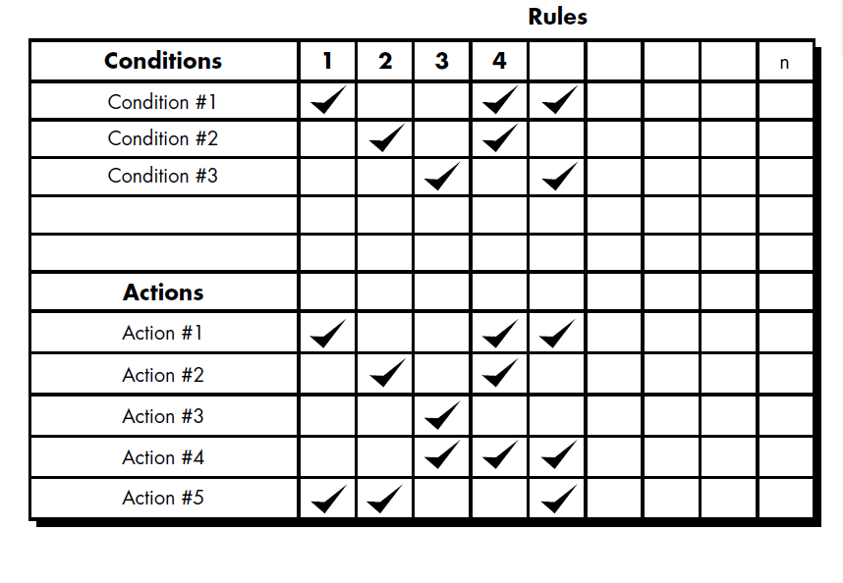  Decision tables provide a notation that translates actions and conditions (described in a processing narrative) into a tabular form.  Table is divided into four sections. The upper left-hand quadrant contains a list of all conditions. The lower left-hand quadrant contains a list of all actions that are possible based on combinations of conditions. The right-hand quadrants form a matrix that indicates condition combinations and the corresponding actions that will occur for a specific combination. Therefore, each column of the matrix may be interpreted as a processing rule.  The following steps are applied to develop a decision table:  1. List all actions that can be associated with a specific procedure (or module).  2. List all conditions (or decisions made) during execution of the procedure.  3. Associate specific sets of conditions with specific actions, eliminating impossible  combinations of conditions; alternatively, develop every possible permutation  of conditions.  4. Define rules by indicating what action(s) occurs for a set of conditions.  Program Design Language  Program design language (PDL), also called structured English or pseudocode, is "a pidgin language in that it uses the vocabulary of one language (i.e., English) and the overall syntax of another (i.e., a structured programming language)" [CAI75]. In this chapter, PDL is used as a generic reference for a design language.  At first glance PDL looks like a modern programming language. The difference between PDL and a real programming language lies in the use of narrative text (e.g., English) embedded directly within PDL statements.  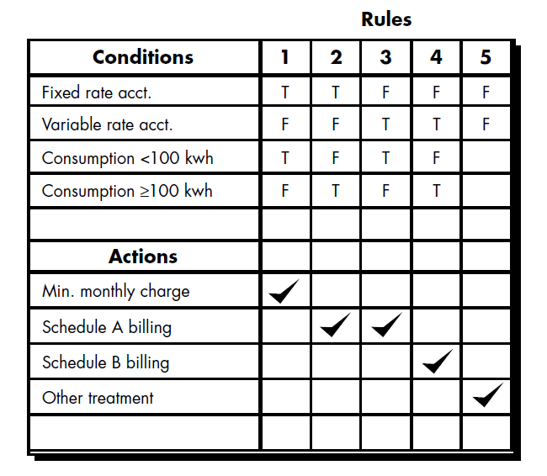  A design language should have the following characteristics:  • A fixed syntax of keywords that provide for all structured constructs, data declaration, and modularity characteristics.  • A free syntax of natural language that describes processing features.  • Data declaration facilities that should include both simple (scalar, array) and complex (linked list or tree) data structures.  • Subprogram definition and calling techniques that support various modes of interface description.
13 | Discuss about the design concepts in a software development process. (NOV/DEC 17)  A set of fundamental software design concepts has evolved over the history of software engineering. M. A. Jackson once said: “The beginning of wisdom for a [software engineer] is to recognize the difference between getting a program to work, and getting it right.”  Abstraction  When we consider a modular solution to any problem, many levels of abstraction can be posed. At the highest level of abstraction, a solution is stated in broad terms using the language of the problem environment. At the lower levels of abstraction, a more detailed description of the solution is provided.  A procedural abstraction refers to a sequence of instructions that have a specific and limited function. And on this abstraction details are suppressed. An example of a procedural abstraction would be the word open for a door. Open implies a long sequence of procedural steps (e.g., walk to the door, reach out and grasp knob, turn knob and pull door, step away from moving door, etc.).  A data abstraction is a named collection of data that describes a data object. In the context of the procedural abstraction open, we define a data abstraction called door. Like any data object, the data abstraction for door would encompass the a set of attributes that describe the door (e.g., door type, swing direction, opening mechanism, weight, dimensions). It follows that the procedural abstraction open would make use of information contained in the attributes of the data abstraction door.  Architecture  Software architecture alludes to “the overall structure of the software and the ways in which that structure provides conceptual integrity for a system”. Architecture is the structure or organization of program components (modules), the manner in which these components interact , and the structure of data that are used by the components. A set of architectural patterns enable a software engineer to reuse design-level concepts.  The architectural design can be represented using one or more of a number of different models. Structural models represent architecture as an organized collection of programs of program components. Framework models increase the level of design abstraction by attempting to identify repeatable architectural design frameworks that are encountered in similar types of application. Dynamic models address the behaviour aspects of the program architecture , indicating how the structure or system configuration may change as a function of external events. Process models focus on the design of the business or technical process that the system must accommodate. Finally, functional models can be used to represent the functional hierarchy of a system.  Patterns  “A pattern is a named nugget of insight which conveys the essence of a proven solution to a  recurring problem within a certain context amidst competing concerns”.  The intent of each design pattern is to provide a description that enables a designer to determine  - whether the pattern is applicable to the current work,  - whether the pattern can be reused, and  - whether the pattern can serve as a guide for developing a similar, but functionality or structurally different pattern.  Modularity  Software architecture and design patterns embody modularity. “ Modularity is a single attribute of software that allows a program to be intellectually manageable”. Monolithic software cannot be easily grasped by a software engineer. Consider two problems, p1 and p2. If the perceived complexity of p1 is greater than the perceived complexity of p2, it follows that the effort required to solve p1 is greater than the effort required to solve p2. As a general case, this result is intuitively obvious. It takes more time to solve a difficult problem. It also follows that the perceived complexity of two problems when they are combined is often greater than the sum of the perceived complexity when each is taken separately. This leads to “divide and conquer” strategy – it’s easier to solve a complex problem when you break it into manageable pieces. This has important implications with regard to modularity  and software. If we subdivide software indefinitely, the effort required to develop it will become negligibly small.  Information hiding  The principle of information hiding suggest that modules be “characterized by design decisions that hides from all others.” Modules should be specified and designed so that information contained within a module is inaccessible to other modules that have no need for such information.  Functional Independence  The concept of functional independence is a direct outgrowth of modularity and the concepts of abstraction and information hiding. It is achieved by developing modules with “single minded” function and an “aversion” to exercise interaction with other modules. Independence is assessed using two qualitative criteria: cohesion and coupling. Cohesion is an indication of the relative functional strength of a module. Coupling is a indication of the relative interdependence among modules.  Refinement  Stepwise refinement is a top-down design strategy. A program is developed successively refining levels of procedure detail. A hierarchy is developed by decomposing a macroscopic statement of function in a stepwise fashion until programming language statements are reached. Refinement is actually a process of elaboration. Abstraction and refinement are complementary concepts.  Refactoring  It is the process of a changing a software system in such a way that it does not alter the external behaviour of the code yet proves its internal structure. When software is refactored, then the existing design is examined for redundancy, unused design elements, inefficient or unnecessary algorithms, poorly constructed or inappropriate data structures, or any other design failure that can be corrected to yield a better design.  Design Classes  As the design model evolves, the software team must define a set of design classes that  - refine the analysis classes by providing design detail that will enable the classes to be implemented, and  - create a new set of design classes that implement a software infrastructure to support the business solution.  Five different types of design classes are created by the designer. They are  - User interface classes  - Business domain classes  - Process classes  - Persistent classes  - System classes  Design classes can be reviewed to ensure that it is “well-formed”. So four characteristics of a well-formed design classes are  - Complete and sufficient  - Primitiveness  - High cohesion  - Low Coupling
14 | What is software architecture? Describe the different software architectural styles with examples.  An Architectural style typically specifies the design vocabulary, constraints on how that vocabulary is used and semantic assumptions about that vocabulary. Each style has several views and structures. An architectural view represents a set of elements and the relationships among them. Thus an architectural style defines a family of such systems in terms of a pattern of structural organization.  Software architecture includes to ―the overall structure of the software and the ways in which that structure provides conceptual integrity for a system‖. Structural properties, Extra functional properties, Families of related systems.  Architectural Styles  Each style describes a system category that encompasses:  - a set of components (e.g., a database, computational modules) that perform a  function required by a system,  - a set of connectors that enable ―communication, coordination, and cooperation‖  among components,  - constraints that define how components can be integrated to form the system,  and  - semantic models that enable a designer to understand the overall properties of a  system.  Specific Styles  - Data-centered architecture  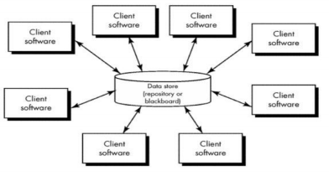  - Data flow architecture  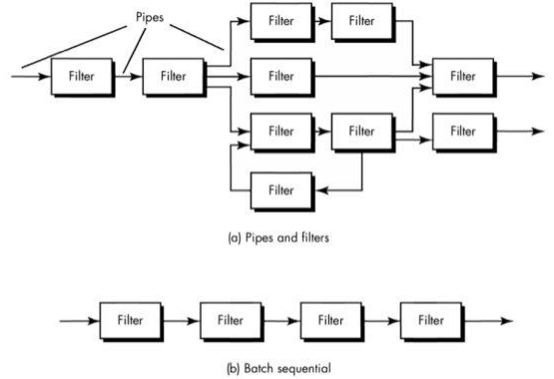  - Call and return architecture  - Object-oriented architecture  - Layered architecture  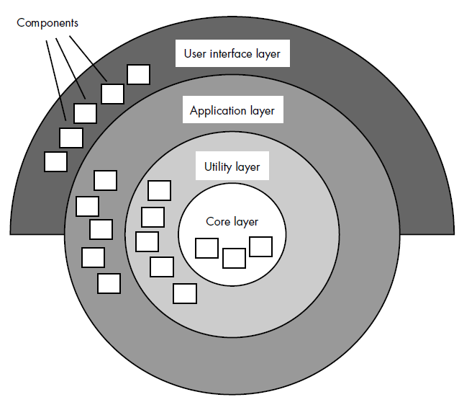
15 | Consider the problem of determining the number of different words in an input file. Carry out structured design by performing transform and transaction analysis construct the structured chart. (APR/MAY 2018)  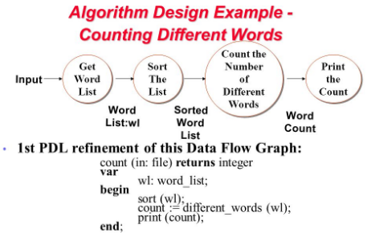
16 | What is the purpose of DFD? What are the components of DFD? Construct DFD for the following system:  An on-line shopping system for XYZ provides many services and benefits to its members and staffs. Currently, XYZ staffs manually handle the purchasing information with the use of basic office software, such as Microsoft Office Word and Excel. It may results in having mistakes easily and the process is very inconvenient. XYZ needs an online shopping system at their Intranet based on the requirements of users. XYZ online shopping system has five key features:  - To provide the user friendly online shopping cart function to members to replace hard copy ordering form;  - To store inventory and sales information in database to reduce the human mistakes, increase accuracy and enhance the flexibility of information processing;  - To provide an efficient inventory system which can help the XYZ staffs to gain enough information to update the inventory;  - To be able to print invoices to members and print a set of summary reports for XYZ’s internal usage.  - To design the system that is easy to maintain and upgrade.  A data flow diagram (DFD) is a graphical representation of the "flow" of data through an information system, modelling its process aspects. A DFD is often used as a preliminary step to create an overview of the system without going into great detail, which can later be elaborated. DFDs can also be used for the visualization of data processing (structured design)  A data flow diagram shows how data is processed within a system based on inputs and outputs. Visual symbols are used to represent the flow of information, data sources and destinations, and where data is stored. Data flow diagrams are often used as a first step toward redesigning a system. They provide a graphical representation of a system at any level of detail, creating an easy-to-understand picture of what the system does. A general overview of a system is represented with a context diagram, also known as a level 0 DFD, which shows a system as a single process. A level 1 diagram provides greater detail, focusing on a system’s main functions. Diagrams that are level 2 or higher illustrate a system’s functioning with increasing detail. It’s rare for a DFD to go beyond level 2 because of the increasing complexity, which makes it less effective as a communication tool.  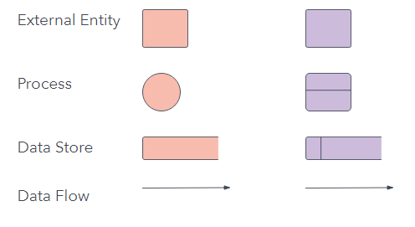  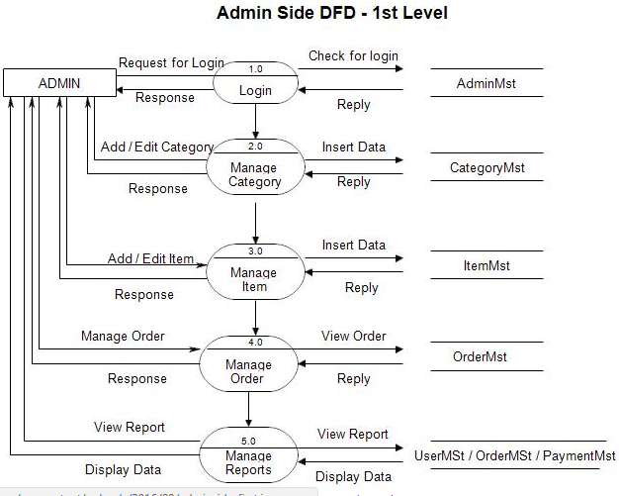  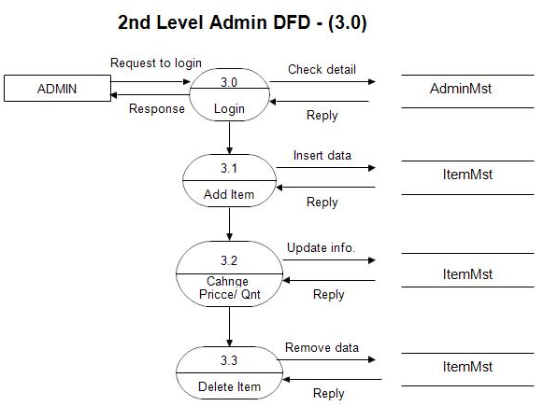  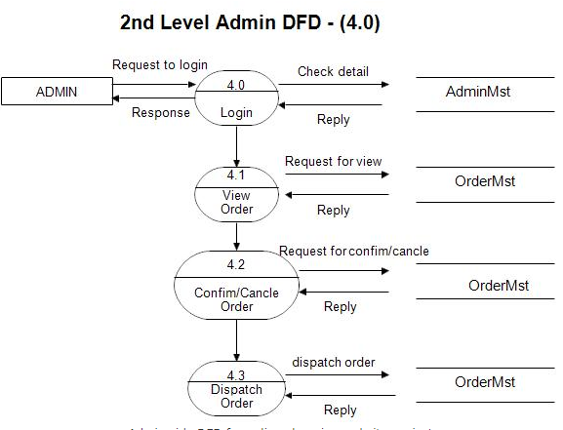  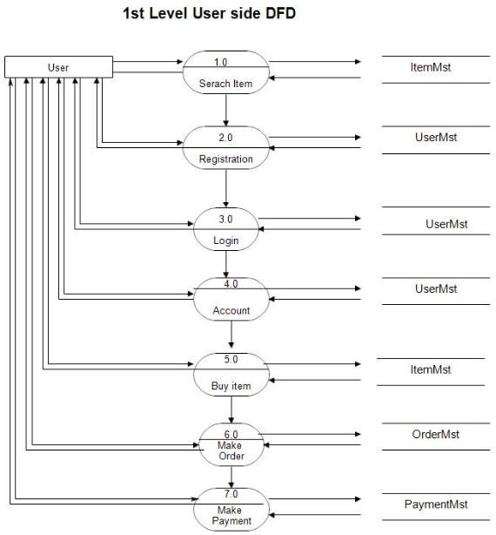  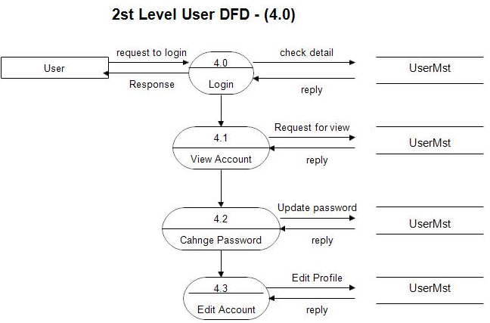  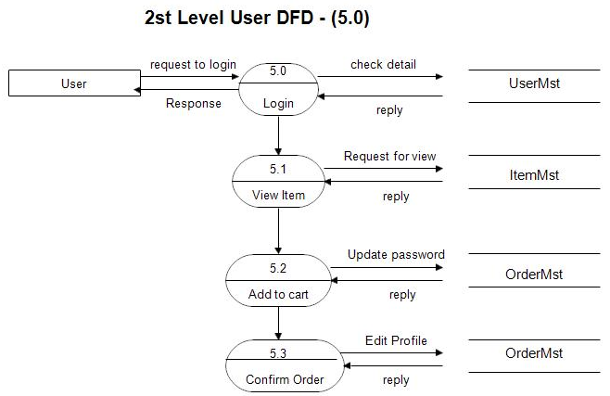  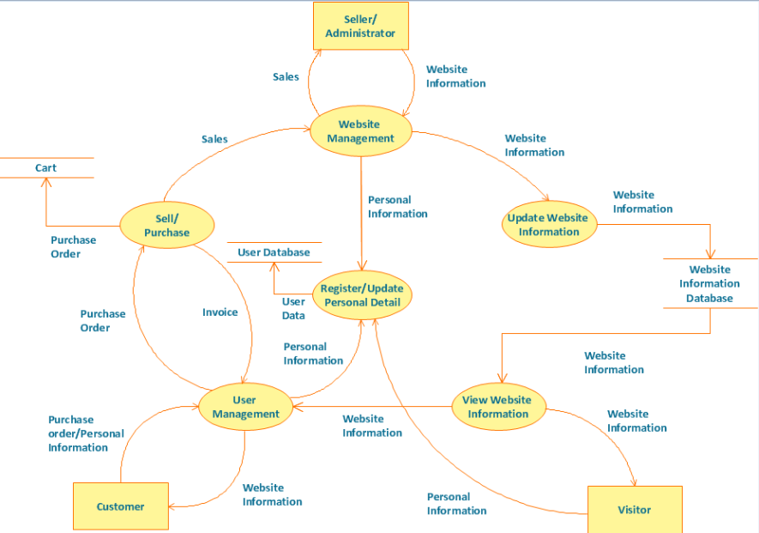

UNIT IV / TESTING AND IMPLEMENTATION
Software testing fundamentals-Internal and external views of Testing-white box testing - basis path testing-control structure testing-black box testing- Regression Testing – Unit Testing – Integration Testing – Validation Testing – System Testing And Debugging –Software Implementation Techniques: Coding practices-Refactoring-Maintenance and Reengineering-BPR model-Reengineering process model-Reverse and Forward Engineering.
UNIT IV/ PART- A
1 | Distinguish between stress and load testing. (MAY/JUN 2012)  Stress testing executes a system in a manner that demands resources in abnormal quality, frequency or volume. Load testing is a testing in which real world loading is tested at a variety of load levels and in a variety of combinations.
2 | What is boundary condition testing? (MAY/JUN 2012)  A greater number of errors occurs at the boundaries of the input domain rather than in “center”. It is a test case design that complements equivalence partitioning.
3 | Define black box testing. (MAY/JUN 2012)  Black-box testing is also called behavioral testing which focuses on the functional requirements of the software. This testing enables the software engineer to derive sets of input conditions that will fully exercise all functional requirements for a program.
4 | What is the purpose of regression testing?(NOV/DEC 2011)  Regression testing is the re-execution of some subset of tests that have already been conducted to ensure that changes have not propagated unintended side effects. The regression testing suite contains the following different test cases  - A representative sample of tests that will exercise all software functions  - Additional tests that focus on software functions that are likely to be affected by the change.  - Tests that focus on the software components that have been changed.
5 | What is integration testing? (APR/MAY 2011) Integration testing is a systematic technique for constructing the software architecture while at the same time conducting tests to uncover errors associated with interfacing. The objective is to take unit tested components and build a program structure that has been dictated by design.
6 | What is regression testing? (APR/MAY 2011) (NOV/DEC2013)(APR/MAY 2015)  Regression testing is the re-execution of some subset of tests that have already been conducted to ensure that changes have not propagated unintended side effects.
7 | Define error, fault and failure. (NOV/DEC2010)  - Error: A discrepancy between a computed, observed value and the true, specified correct value or condition.  - Failure: The inability of a system or component to perform its requirements functions within specified requirements.  - Fault: An incorrect step, process or definition in a computer program which causes the program in an unintended or unanticipated manner.
8 | What are the characteristics of a good tester? (NOV/DEC2010)  The characteristics of a good tester are  - A software team should conduct effective formal technical reviews. Many errors may be eliminated before testing commences.  - Testing should begin at component level and work outward toward the integration of the entire computer based system.  - Different testing techniques are appropriate at different points in time.  - Testing is conducted by the developer of the software and for large projects an independent test group.  - Testing and debugging must be accommodated in any test strategy.
9 | What are the levels at which testing is done? (NOV/DEC2013)  - Functional testing  - Non-Functional testing
10 | Give the two major groupings of software testing?  - Black Box Testing: This approach focuses on inputs, outputs, and principle function of software module.  - Glass Box Testing: This approach looks into the structure of code for a software module.
11 | What are the main steps followed in the testing scheme?  Select what is to be measured by the test, Decide how whatever is being is to be tested, develop the test cases, Determine what the expected results of the test, Execute the test cases, Compare the results.
12 | Give the major types of software testing?  Functional tests, Performance tests, Stress tests, Testing in the small , Testing in the large, Black box testing and White (glass) box testing.
13 | What are the objectives of testing?  - Testing is a process of executing a program with the intend of finding an error.  - A good test case is one that has high probability of finding an undiscovered error.  - A successful test is one that uncovers as an-yet undiscovered error.
14 | What are the various testing activities?  - Test planning  - Test case design  - Test execution  - Data collection  - Effective evaluation
15 | What is the purpose of stress tests?  Stress tests are designed to overload a system in ways. Examples of stress tests include attempting to sign or more than the maximum number of allowed terminals, processing more than the allowed number of identifies or static levels or disconnecting a communication links.
16 | What are the contents of maintenance guide?  A maintenance guide provides a technical description of the operational capabilities of the entire system and hierarchy diagrams, call graphs and cross reference directories for the system.
17 | Give some examples of functional boundary tests.  Examples of functional boundary tests include testing real-valued square root routines with small positive numbers, zero and negative numbers or testing matrix inversion routine on a one-by-one matrix and a singular matrix.
18 | What are Validation and Conditional testing?(NOV/DEC 2014)  Validation testing is the process to demonstrate that the product fulfills its intended use when deployed on appropriate environment.  Conditional testing is a test case design method that exercise the logical conditions contained in a program module.
19 | What is data flow testing?  The data flow testing method selects test paths of a program according to the locations of definitions and uses of variables in the program.
20 | What is system testing?  Software and hardware are integrated and a full range of system tests are conducted in an attempt to uncover errors at the software and hardware interfaces. Most real system process interrupts. Therefore testing the handling of these Boolean events is essential.
21 | What is the overall strategy for the software testing?  A Strategy for software testing may also be viewed in the context of the spiral. Unit test begins at the vertex of the spiral and concentrates on each unit of the software as implemented in the source code. Testing progresses by moving outward along the spiral to integration testing, where the focus is on design and the construction of the software architecture.
22 | What is security testing?  Security testing attempts to verify that protection mechanisms built into a system will in fact protect it from improper penetration. The system security is to of course be tested for invulnerability from frontal attack but must also be tested for invulnerability from flank or rear attack.
23 | What is Code Refactoring? What are best practices for “CODING”?(APR/MAY 2015)  Code refactoring is the process of restructuring existing computer code without changing its external behaviour. Refactoring improves non-functional attributes of the software.  The best practices for CODING are:  - To know what the code block must perform  - Indicate a brief description of what a variable is for (reference to commenting)  - To correct errors as they occur.  - Keep your code simple  - Maintain naming conventions which are uniform throughout.
24 | How can refactoring be made more effective? (May/June 2016)  - When refactoring, we maintain the behavior of the current system.  - When refactoring, we begin with the existing code and change it over time as needed.  - When refactoring, we can steadily improve existing code over time without disrupting the release schedule.  - When refactoring, we can start with less up-front work, change direction when needed and stop part-way through if that’s appropriate.  - When refactoring, we often support parts of the old and new system at the same time.
25 | Why does software fail after it has passed from acceptance testing? (May/June 2016)  Acceptance criteria may not require the software to be 100% bug-free.Test cases may not be able to test for everything that could possibly go wrong. (It is difficult to make things idiot proof because idiots are SO creative!)Interactions with new (or unexpected) hardware and third party software might cause the software in question to fail.The acceptance tests were not rigorous enough.
26 | What is the difference between verification and validation? Which types of testing address verification? Which type of testing address validation?(NOV/DEC 2016) (NOV/DEC 17) (APR/MAY 2018)
  Validation | Verification
  The process of checking that a system meets the needs and expectations of the customer. | The process of checking that a system meets its specification
  Checks “Are we building the right product”? | Checks “Are we building the product right”?
  Includes all the dynamic testing techniques. | Involves all the static testing techniques
  Involves activities like Unit, Integration and System testing. | Involves activities like Reviews, Walkthroughs and Inspections.
27 | What is “Smoke Testing”?(APR/MAY 17)  Smoke testing is an integration testing approach that is commonly used when “shrink wrapped” software products are being developed. It is designed as a pacing mechanism for time critical projects, allowing the software team to assess its project on a frequent basis.
28 | What are the errors commonly found during Unit testing?  Misunderstood or incorrect arithmetic precedence, Mixed mode operation. Incorrect initialization, Precision inaccuracy, Incorrect symbolic representation of an expression
29 | List two testing strategies that address verification .which types of testing address validation and verification?(APR/MAY 17)  Verification-Includes all the dynamic testing techniques. Involves Unit, Integration and System testing are addresses verification.  Validation- Involves all the static testing techniques. Alpha testing, Beta testing and acceptance testing addresses verification.
30 | Mention the purpose of stub and driver use for testing.(NOV/DEC 17)  Stubs are dummy modules that are always distinguish as "called programs", or you can say that is handle in integration testing (top down approach), it used when sub programs are under construction.  Stubs are considered as the dummy modules that always simulate the low level modules.  Drivers are also considered as the form of dummy modules which are always distinguished as "calling programs”, that is handled in bottom up integration testing, it is only used when main programs are under construction. Drivers are considered as the dummy modules that always simulate the high level modules.
31 | What is Reverse Engineering?  Reverse engineering for software is the process of analyzing a program in an effort to create a representation of the program at a higher level of abstraction than source code. Reverse engineering is a process of design recovery. Reverse engineering tools extract data, architectural, and procedural design information from an existing program. successful reverse engineering derives one or more design and manufacturing specifications for a product by examining actual specimens of the product.
32 | What are the testing principles the software engineer must apply while performing the software testing? (April/May 2018)  - All tests should be trace able to customer requirements.  - Tests should be planned long before testing begins.  - The pareto principle can be applied to software testing-80% of all errors uncovered during testing will likely be traceable to 20% of all program modules.  - Testing should begin “in the small” and progress toward testing “in the large”.  - Exhaustive testing is not possible.  - To be most effective, an independent third party should conduct testing.
33 | What is Forward Engineering?  Forward engineering would be rebuilt using a automated “reengineering engine.” The old program would be fed into the engine, analyzed, restructured, and then regenerated in a form that exhibited the best aspects of software quality.
34 | Define restructuring.  Software restructuring modifies source code and/or data in an effort to make it amenable to future changes. In general, restructuring does not modify the overall program architecture. It tends to focus on the design details of individual modules and on local data structures defined within modules.
UNIT IV/ PART- B
1 | Given a set of numbers ‘n’ ,the function Find Prime(a[ ],n) prints a number- if it is a prime number. Draw a control flow graph, calculate the cyclomatic complexity and enumerate all paths. State how many test case-s are- needed to adequately cover the code in terms of branches, decisions and statement? Develop the necessary test cases using sample values for ‘a’ and ‘n’. (NOV/DEC2013)  Ans:-Software metrics can be defined as the continuous application of measurement based techniques to the software development process and its products to supply meaningful and timely management information together with the use of those techniques to improve that process and its products.  cyclomatic complexity is a measure of the complexity of a module’s decision structure. It is the number of linearly independent paths and the minimum number of paths to be tested. Actual complexity is the number of independent paths traversed during testing.  Module design complexity metric is the complexity of design-reduced module and reflects the complexity of the module’s calling patterns to its subordinate modules. This metric differentiates between modules and complicates the design of the program.  A control flow graph (CFG) in computer science is a representation, using graph notation, of all paths that might be traversed through a program during its execution.  In a control flow graph each node in the graph represents a basic block, i.e. a straight-line piece of code without any jumps or jump targets; jump targets start a block, and jumps end a block. Directed edges are used to represent jumps in the control flow. There are, in most presentations, two specially designated blocks: the entry block, through which control enters into the flow graph, and the exit block, through which all control flow leaves.  Because of its construction procedure, in a non-trivial CFG (i.e. one with more than zero edges), every edge A→B has the property that:  Outdegree(A) > 1 or indegree(B) > 1 (or both).  Consider the following fragment of code:  0: (A) x = read_n  For (i=2,i<n/2,i++)  1: (A) if (n%i)== 0  2: (B) print n+ " is prime."  3: (B) goto 5  4: (C) print n + " iscomposite."  5: (D) end program  In the above, we have 4 basic blocks: A from 0 to 1, B from 2 to 3, C at 4 and D at 5. In particular, in this case, A is the "entry block", D the "exit block" and lines 4 and 5 are jump targets. A graph for this fragment has edges from A to B, A to C, B to D and C to D.  Based on this a control flow graph with logic involved .  Precondition:let the prime no be n  case1: expected o/p (prime no)result  divide the no n by 1 remainder=0 pass  divide the no n by n remainder=0 pass  divide the no n by 2 remainder!=0 pass  .  .  divide the no n by upto n-1 and if remanider not equal zero  then it is a prime no.Approximately 4 test cases can be roughly designed and tested.  Testcase ID test condition Result  1 1 true  2 3 true  3 4 false  4 5 true  Like this many other test cases can be formulated and output can be determined.
2 | (i)What is black box testing?  (ii)What is Equivalence Class Partitioning? List rules used to define valid and invalid equivalence classes. Explain the technique using examples.  (iii)What is Boundary Value Analysis? Explain the technique specifying rules and its usage with the help of an example. (NOV/DEC2013) (NOV/DEC2016)  Ans:- Black box testing is a software testing technique that focuses on the analysis of software functionality ,versus internal system mechanism.It was developed as a method of analyzing client requirements ,specifications and high level strategies.  A black box software tester selects a set of valid and invalid input and code execution conditions and checks for valid output responses. A black box software tester selects a set of valid and invalid input and code execution conditions and checks for valid output responses.  Black box testing is also known as functional testing.  (ii) What is Equivalence Class Partitioning? List rules used to define valid and invalid equivalence classes. Explain the technique using examples.  Ans:- Equivalence class portioning :-If a tester is viewing the software under test as a black box with well-defined inputs and outputs, a good approach to selecting test inputs is to use a method called equivalence partitioning.  It results in a partitioning of the input domain of the software under test..The technique can also be used to partition the output domain.  The finite number of partitions on equivalence classes that result allow the tester to select a member of the equivalence class as a representative of the class.  How do testers identify equivalence classes?:-  One approach is to use a set of what Glen Myers calls “interesting input conditions”. The input conditions usually come from a description in the specification of the software to be tested.The tester uses the conditions to partition the input domain into equivalence classes and then develops test cases to cover all the classes.  (iii)What is Boundary Value Analysis? Explain the technique specifying rules and its usage with the help of an example. (NOV/DEC2013)  Ans:- Boundary Value Analysis:-  A greater number of errors occurs at the boundaries of the input domain rather than  in the “center.” It is for this reason that boundary value analysis (BVA) has been developed as a testing technique. Boundary value analysis leads to a selection of test cases that exercise bounding values.  Boundary value analysis is a test-case design technique that complements equivalence partitioning. Rather than selecting any element of an equivalence class, BVA leads to the selection of test cases at the “edges” of the class. Rather than focusing solely on input conditions, BVA derives test cases from the output domain as well  Guidelines for BVA are similar in many respects to those provided for equivalence partitioning:-  1. If an input condition specifies a range bounded by values a and b, test cases should be designed with values a and b and just above and just below a and b.  2. If an input condition specifies a number of values, test cases should be developed that exercise the minimum and maximum numbers. Values just above and below minimum and maximum are also tested.  3. Apply guidelines 1 and 2 to output conditions. For example, assume that a temperature versus pressure table is required as output from an engineering analysis program. Test cases should be designed to create an output report that produces the maximum (and minimum) allowable number of table entries.  4. If internal program data structures have prescribed boundaries (e.g., a table has a defined limit of 100 entries), be certain to design a test case to exercise the data structure at its boundary.
3 | Illustrate black-box testing with an example. Write short notes on unit testing and debugging. (APR/MAY 2010) (APR/MAY 2015)  Ans:- Black-box testing, also called behavioral testing, focuses on the functional requirements of the software. That is, black-box testing techniques enable you to derive sets of input conditions that will fully exercise all functional requirements for a program. Black-box testing is not an alternative to white-box techniques. Rather, it is a complementary approach that is likely to uncover a different class of errors than white box testing.  Black-box testing attempts to find errors in the following categories: (1) incorrect or missing functions, (2) interface errors, (3) errors in data structures or external database access, (4) behavior or performance errors, and (5) initialization and termination errors.  Unlike white-box testing, which is performed early in the testing process, black box testing tends to be applied during later stages of testing .Because black-box testing purposely disregards control structure, attention is focused on the information domain. Tests are designed to answer the following questions:-  • How is functional validity tested?  • How are system behavior and performance tested?  • What classes of input will make good test cases?  • Is the system particularly sensitive to certain input values?  • How are the boundaries of a data class isolated?  • What data rates and data volume can the system tolerate?  • What effect will specific combinations of data have on system operation?  The concept of Black-box testing can be explained with model-based testing as an example:-.  Model-based testing (MBT) is a black-box testing technique that uses information contained in the requirements model as the basis for the generation of test cases. In many cases, the model-based testing technique uses UML state diagrams, an element of the behavioral model, as the basis for the design of test cases.  The MBT technique requires five steps:  - Analyze an existing behavioral model for the software or create one.  Recall that a behavioral model indicates how software will respond to external events or stimuli. To create the model, you should perform the steps:-  - evaluate all use cases to fully understand the sequence of interaction within the system,  - identify events that drive the interaction sequence and understand how these events relate to specific objects,  - create a sequence for each use case,  - build a UML state diagram for the system and  - review the behavioral model to verify accuracy and consistency.  - Traverse the behavioral model and specify the inputs that will force the software to make the transition from state to state. The inputs will trigger events that will cause the transition to occur.  - Review the behavioral model and note the expected outputs as the software makes the transition from state to state. Recall that each state transition is triggered by an event and that as a consequence of the transition, some function is invoked and outputs are created. For each set of inputs (test cases) you specified in step 2, specify the expected outputs as they are characterized in the behavioral model. “A fundamental assumption of this testing is that there is some mechanism, a test oracle, that will determine whether or not the results of a test execution are correct”. In essence, a test oracle establishes the basis for any determination of the correctness of the output. In most cases, the oracle is the requirements model, but it could also be another document or application, data recorded else where, or even a human expert.  - Execute the test cases. Tests can be executed manually or a test script can be created and executed using a testing tool.  - Compare actual and expected results and take corrective action as required. MBT helps to uncover errors in software behavior, and as a consequence, it is extremely useful when testing event-driven applications.  - Model-based testing can also be used when software.
4 | What is white box testing? Explain how basis path testing helps to derive test cases to test every statement of a program. (NOV/DEC 2012) (APR/MAY 2015)(APR/MAY 17)  Ans:-White box testing is a complimentary approach to test design where the tester has knowledge of the internal logic structure of the software under test.  Goal:-The tester’s goal is to determine if all the logic and data elements in the software unit function function properly. this is called white box or glass box approach to test case design.The knowledge needed for white box testing design approach becomes available to the tester in the later phases of the software life cycle specifically during the detailed design phase of development .It follows black box testing as the test efforts for the given project progress in time.  Goals of white box testing:-  - To ensure that the internal components of a program are functioning properly.  - A common focus is on structural elements like statements and branches.  - He tester develops test cases that exercise these structural elements to determine if defects exist in the program structure.  - By exercising all of the selected structural elements, the tester hopes to improve the chances of detecting defects.  Test Adequacy Criteria:-  Testers need a framework to decide which structural elements to select as a focus of testing,for choosing appropriate test data and for deciding when the testing efforts are adequate enough to terminate the process with confidence that the software is working properly.such a framework exists in the form of test adequacy criteria.  If a test Adequacy criteria focuses on the structural properties of a program,it is called program based adequacy criterion.  They use either:-  - logical & control structures (or)  - program text (or)  - data flow (or)  - faults as the focal point of an adequacy evaluation  Coverage Analysis:-  The concept of test data adequacy criteria and the requirement that certain properties or features of the code are to be exercised by test cases, leads to an approach called coverage analysis which in practice I used:- to set testing signals ,to develop & evaluate test data .  The logic elements mostly used in coverage are based on the flow of control in a unit of code:-They are :-program statements, decision/branches ,conditions, combinations of decisions & conditions and paths.
5 | Explain unit testing in detail. (NOV/DEC 2009)(MAY/JUNE 2013)  Ans:- Unit testing focuses verification effort on the smallest unit of software design—the software component or module. Using the component-level design description as a The relative complexity of tests and the errors those tests uncover is limited by the constrained scope established for unit testing. The unit test focuses on the internal processing logic and data structures within the boundaries of a component. This type of testing can be conducted in parallel for multiple components.  Unit-test considerations:-  The module interface is tested to ensure that information properly flows into and out of the program unit under test. Local data structures are examined to ensure that data stored temporarily maintains its integrity during all steps in an algorithm’s execution. All independent paths through the control structure are exercised to ensure that all statements in a module have been executed at least once. Boundary conditions are tested to ensure that the module operates properly at boundaries established to limit or restrict processing. And finally, all error-handling paths are tested. Data flow across a component interface is tested before any other testing is initiated. If data do not enter and exit properly, all other tests are moot. In addition, local data structures should be exercised and the local impact on global data should be ascertained (if possible) during unit testing.  Selective testing of execution paths is an essential task during the unit test. Test  cases should be designed to uncover errors due to erroneous computations, incorrect comparisons, or improper control flow.  Boundary testing is one of the most important unit testing tasks. Software often fails at its boundaries. That is, errors often occur when the nth element of an n-dimensional array is processed, when the ith repetition of a loop with i passes is invoked, when the maximum or minimum allowable value is encountered. Test cases that exercise data structure, control flow, and data values just below, at, and just above maxima and minima are very likely to uncover errors.  A good design anticipates error conditions and establishes error-handling paths to reroute or cleanly terminate processing when an error does occur. Yourdon [You75] calls this approach anti bugging. Unfortunately, there is a tendency to incorporate error handling into software and then never test it. A true story may serve to illustrate:  A computer-aided design system was developed under contract. In one transaction processing  module, a practical joker placed the following error handling message after a series of conditional tests that invoked various control flow branches: ERROR! THERE IS NO WAY YOU CAN GET HERE. This “error message” was uncovered by a customer during user training!  Among the potential errors that should be tested when error handling is evaluated are: (1) error description is unintelligible, (2) error noted does not correspond to error encountered, (3) error condition causes system intervention prior to error handling, (4) exception-condition processing is incorrect, or (5) error description does not provide enough information to assist in the location of the cause of the error.  Unit-test procedures.-  Unit testing is normally considered as an adjunct to the coding step. The design of unit tests can occur before coding begins or after source code has been generated. A review of design information provides guidance for establishing test cases that are likely to uncover errors in each of the categories discussed earlier. Each test case should be coupled with a set of expected results.  Because a component is not a stand-alone program, driver and/or stub software must often be developed for each unit test. The unit test environment is illustrated in Figure 17.4. In most applications a driver is nothing more than a “main program” that accepts test case data, passes such data to the component (to be tested), and prints relevant results. Stubs serve to replace modules that are subordinate (invoked by) the component to be tested. A stub or “dummy subprogram” uses the subordinate module’s interface, may do minimal data manipulation, prints verification of entry, and  returns control to the module undergoing testing.  Drivers and stubs represent testing “overhead.” That is, both are software that must be written (formal design is not commonly applied) but that is not delivered with the final software product. If drivers and stubs are kept simple, actual overhead is relatively low. Unfortunately, many components cannot be adequately unit tested with “simple” overhead software. In such cases, complete testing can be postponed until the integration test step (where drivers or stubs are also used). Unit testing is simplified when a component with high cohesion is designed. When only one function is addressed by a component, the number of test cases is reduced and errors can be more easily predicted and uncovered.
6 | Explain in detail about Basis path testing and validation testing? (NOV/DEC 2010)  (MAY/JUNE 2014)  Validation testing begins at the culmination of integration testing, when individual components have been exercised, the software is completely assembled as a package, and interfacing errors have been uncovered and corrected. At the validation or system level, the distinction between conventional software, object-oriented Validation can be defined in many ways, but a simple (albeit harsh) definition is that validation succeeds when software functions in a manner that can be reasonably expected by the customer. At this point a battle-hardened software developer might protest: “Who or what is the arbiter of reasonable expectations?” If a Software Requirements Specification has been developed, it describes all user-visible attributes of the software and contains a Validation Criteria section that forms the basis for a validation-testing approach.  Validation-Test Criteria:  Software validation is achieved through a series of tests that demonstrate conformity with requirements. A test plan outlines the classes of tests to be conducted, and a test procedure defines specific test cases that are designed to ensure that all functional requirements are satisfied, all behavioral characteristics are achieved, all content is accurate and properly presented, all performance requirements are attained, documentation is correct, and usability and other requirements are met (e.g., transportability, compatibility, error recovery, maintainability). After each validation test case has been conducted, one of two possible conditions exists: (1) The function or performance characteristic conforms to specification and is accepted or (2) a deviation from specification is uncovered and a deficiency list is created. Deviations or errors discovered at this stage in a project can rarely be corrected prior to scheduled delivery. It is often necessary to negotiate with the customer.  Basis path testing is a white-box testing technique first proposed by Tom McCabe. The basis path method enables the test-case designer to derive a logical complexity measure of a procedural design and use this measure as a guide for defining a basis set of execution paths. Test cases derived to exercise the basis set are guaranteed to execute every statement in the program at least one time during testing.  Flow Graph Notation:  Before we consider the basis path method, a simple notation for the representation of control flow, called a flow graph (or program graph) must be introduced. Each structured construct has a corresponding flow graph symbol.  3 In actuality, the basis path method can be conducted without the use of flow graphs. However, they serve as a useful notation for understanding control flow and illustrating the approach. Here, a flowchart is used to depict program control structure. maps the flowchart into a corresponding flow graph (assuming that no compound conditions are contained in the decision diamonds of the flowchart). Each circle, called a flow graph node, represents one or more procedural statements. A sequence of process boxes and a decision diamond can map into a single node. The arrows on the flow graph, called edges or links, represent flow of control and are analogous to flowchart arrows. An edge must terminate at a node, even if the node does not represent any procedural statements (e.g., see the flow graph symbol for the if-then-else construct). Areas bounded by edges and nodes are called regions. When counting regions, we include the area outside the graph as a region.
7 | Explain in detail about integration testing. (MAY/JUNE 2013,2014) (OR) Describe about the various Integration and Debugging strategies followed in Software development. What is integration testing? Discuss any one method in detail. (APR/MAY 18) (NOV/DEC 2014) (APR/MAY 2015) Explain top down integration testing with an example.  A neophyte in the software world might ask a seemingly legitimate question once all modules have been unit tested: “If they all work individually, why do you doubt that they’ll work when we put them together?” The problem, of course, is “putting them together”—interfacing. Data can be lost across an interface; one component can have an inadvertent, adverse effect on another; sub functions, when combined, may not produce the desired major function; individually acceptable imprecision may be magnified to unacceptable levels; global data structures can present problems. Sadly, the list goes on and on.  Integration testing is a systematic technique for constructing the software architecture while at the same time conducting tests to uncover errors associated with interfacing. The objective is to take unit-tested components and build a program structure that has been dictated by design. There is often a tendency to attempt non incremental integration; that is, to construct the program using a “big bang” approach. All components are combined in advance. The entire program is tested as a whole. And chaos usually results! A set of errors is encountered. Correction is difficult because isolation of causes is complicated by the vast expanse of the entire program. Once these errors are corrected, new ones appear and the process continues in a seemingly endless loop. Incremental integration is the antithesis of the big bang approach. The program is constructed and tested in small increments, where errors are easier to isolate and correct; interfaces are more likely to be tested completely; and a systematic test approach may be applied. In the paragraphs that follow, a number of different incremental integration strategies are discussed.  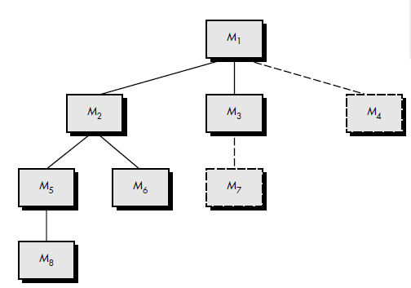  Top-down integration. Top-down integration testing is an incremental approach to construction of the software architecture. Modules are integrated by moving downward through the control hierarchy, beginning with the main control module .Modules subordinate (and ultimately subordinate) to the main control module are incorporated into the structure in either a depth-first or breadth-first manner.  Referring to the Figure depth-first integration integrates all components on a major control path of the program structure. Selection of a major path is somewhat arbitrary and depends on application-specific characteristics. For example, selecting the left-hand path, components M1, M2 , M5 would be integrated first. Next, M8 or (if necessary for proper functioning of M2) M6 would be integrated. Then, the central and right-hand control paths are built.  Breadth-first integration incorporates all components directly subordinate at each level, moving across the structure horizontally. From the figure, components M2, M3, and M4 would be integrated first. The next control level, M5, M6, and so on, follow.  The integration process is performed in a series of five steps:  1. The main control module is used as a test driver and stubs are substituted for  all components directly subordinate to the main control module.  2. Depending on the integration approach selected (i.e., depth or breadth first),  subordinate stubs are replaced one at a time with actual components.  3. Tests are conducted as each component is integrated.  4. On completion of each set of tests, another stub is replaced with the real component.  5. Regression testing (discussed later in this section) may be conducted to ensure that new errors have not been introduced. The process continues from step 2 until the entire program structure is built.
8 | What is the purpose of testing? Explain clearly several testing strategies for conventional softwares and object-oriented softwares. (NOV/DEC 2010)  Testing is the process of exercising a s/w component with a selected set of test cases with the intention of revealing defects, to evaluate quality.  The following are the testing strategies:-  - When the test objective is to detect defects,then a good test-case is one that has high probability of revealing a yet-undetected defect.  - Test result should be inspected meticulously.  - A test cse should contain the expected output.  - Test cases should be developed for both valid and invalid input conditions.  - The probability of detecting additional defects in a s/w component is directly proportional to the no of defects already detected in that component.  - Testing should be carried out by a group that is independent of the development group.  - It should be re-usable and repeatable.  - Testing should be planned.  - Testing activities should be integrated into the s/w development life cycle.  - It is a creative and challenging task.
9 | (i) Define regression testing.  (ii) Distinguish top down and bottom-up integration.  (iii) How testing different from debugging? Justify. (NOV/DEC 2010)  Regression testing. Each time a new module is added as part of integration testing, the software changes. New data flow paths are established, new I/O may occur, and new control logic is invoked. These changes may cause problems with functions that previously worked flawlessly. In the context of an integration test strategy, regression testing is the re execution of some subset of tests that have already been conducted to ensure that changes have not propagated unintended side effects. In a broader context, successful tests (of any kind) result in the discovery of errors, and errors must be corrected. Whenever software is corrected, some aspect of the software configuration (the program, its documentation, or the data that support it) is changed. Regression testing helps to ensure that changes (due to testing or for other reasons) do not introduce unintended behavior or additional errors.  Regression testing may be conducted manually, by re executing a subset of all test cases or using automated capture/playback tools. Capture/playback tools enable the software engineer to capture test cases and results for subsequent playback and comparison. The regression test suite (the subset of tests to be executed) contains three different classes of test cases:  • A representative sample of tests that will exercise all software functions.  • Additional tests that focus on software functions that are likely to be affected by the change.  • Tests that focus on the software components that have been changed.  (ii)Distinguish top down and bottom-up integration.  Top-down integration. Top-down integration testing is an incremental approach to construction of the software architecture. Modules are integrated by moving downward through the control hierarchy, beginning with the main control module (main program). Modules subordinating (and ultimately subordinate) to the main control module are incorporated into the structure in either a depth-first or breadth-first manner.  The top-down integration strategy verifies major control or decision points early in the test process. In a “well-factored” program structure, decision making occurs at upper levels in the hierarchy and is therefore encountered first. If major control problems do exist, early recognition is essential. If depth-first integration is selected, a complete function of the software may be implemented and demonstrated. Early demonstration of functional capability is a confidence builder for all stakeholders.  Bottom-up integration. Bottom-up integration testing, as its name implies, begins construction and testing with atomic modules (i.e., components at the lowest levels in the program structure). Because components are integrated from the bottom up, the functionality provided by components subordinate to a given level is always available and the need for stubs is eliminated. A bottom-up integration strategy may be implemented with the following steps:  Low-level components are combined into clusters (sometimes called builds) that perform a specific software sub function.  A driver (a control program for testing) is written to coordinate test case input and output.  The cluster is tested.  Drivers are removed and clusters are combined moving upward in the program structure.  (iii)How testing different from debugging? Justify. (NOV/DEC 2010)  - Software testing is a process that can be systematically planned and specified. Test case design can be conducted, a strategy can be defined, and results can be evaluated against prescribed expectations.  - Debugging occurs as a consequence of successful testing. That is, when a test case uncovers an error, debugging is the process that results in the removal of the error. Although debugging can and should be an orderly process, it is still very much an art. As a software engineer, you are often confronted with a “symptomatic” indication of a software problem as you evaluate the results of a test. That is, the external manifestation of the error and its internal cause may have no obvious relationship to one another. The poorly understood mental process that connects a symptom to a cause is debugging.  - Debugging is not testing but often occurs as a consequence of testing.
10 | What is system testing? Discuss types of system tests. (NOV/DEC 2014)  System Testing (ST) is a black box testing technique performed to evaluate the complete system the system's compliance against specified requirements. In System testing, the functionalities of the system are tested from an end-to-end perspective.  System testing is performed on the entire system in the context of a Functional Requirement Specification(s) (FRS) and/or a System Requirement Specification (SRS). System testing tests not only the design, but also the behaviour and even the believed expectations of the customer. It is also intended to test up to and beyond the bounds defined in the software/hardware requirements specification(s) .Some of system testing are as follows:  System testing is actually a series of different tests whose primary purpose is to fully exercise the computer-based system. Although each test has a different purpose, all work to verify that system elements have been properly integrated and perform allocated functions.  Recovery testing is a system test that forces the software to fail in a variety of ways and verifies that recovery is properly performed. If recovery is automatic (performed by the system itself), re-initialization, check pointing mechanisms, data recovery, and restart are evaluated for correctness. If recovery requires human intervention, the mean-time-to-repair (MTTR) is evaluated to determine whether it is within acceptable limits.  Security Testing  Security testing attempts to verify that protection mechanisms built into a system  Stress testing executes a system in a manner that demands resources in abnormal quantity, frequency, or volume. For example, (1) special tests may be designed that generate ten interrupts per second, when one or two is the average rate, (2) input data rates may be increased by an order of magnitude to determine how input functions will respond, (3) test cases that require maximum memory or other  resources are executed, (4) test cases that may cause thrashing in a virtual operating system are designed, (5) test cases that may cause excessive hunting for disk-resident data are created. Essentially, the tester attempts to break the program.  Performance testing occurs throughout all steps in the testing process. Even at the unit level, the performance of an individual module may be assessed as tests are conducted. However, it is not until all system elements are fully integrated that the true performance of a system can be ascertained.  Deployment testing-software must execute on a variety of platforms and under more than one operating system environment. Deployment testing, sometimes called configuration testing, exercises the software in each environment in which it is to operate. In addition, deployment testing examines all installation procedures and specialized installation software (e.g., “installers”) that will be used by customers and all documentation that will be used to introduce the software to end users.
11 | What is Code refactoring? Explain different techniques of refactoring? (MAY/JUNE 2016)  Code refactoring is the process of restructuring existing computer code– changing factoring without changing its external behavior. Refactoring improves nonfunctional attributes of the software.  It is the process of changing a software system in such a way that it does not always alter the external behavior of the code yet improves its internal structure."  Just cleaning up code.:-  Contrary to idealized development strategy:  - analysis and design  - code  - test  At first, code is pretty good but as requirements change or new features are added, the code structure tends to atrophy. Refactoring is the process of fixing a bad or chaotic design.  Amounts to moving methods around, creating new methods, adding or deleting classes, ...  TJP: Sometimes it means completely redoing the entire code base (i.e., throwing stuff away). Avoid the second system effect!  Why refactoring??  Improve code structure and design  - more maintainable  - easier to understand  - easier to modify  - easier to add new features  Cumulative effect can radically improve design rather than normal slide into decay.  Flip-flop code development and refactoring. Only refactor when refactoring--do not add features during refactoring.  TJP: kind of like an immune system that constantly grooms the body looking for offensive and intrusive entities.  Bad code usually takes more code to do the same thing often because of duplication:  When not to refactor?  - Sometimes you should throw things out and start again.  - Sometimes you are too close to a deadline.
12 | i) Why does software testing need extensive planning? Explain. (MAY/JUNE 2016)  Software testing is much harder then coding. You can develop a program easily, but to debug it is a tough task, so it needs extensive planning, because testing is required on the each phase or line of a program, it can be white box testing( line to line) or black box testing(function to function)  ii) Compare and contrast alpha and beta testing. (MAY/JUNE 2016)  Alpha and Beta Testing It is virtually impossible for a software developer to foresee how the customer will really use a program. Instructions for use may be misinterpreted; strange combinations of data may be regularly used; output that seemed clear to the tester may be unintelligible to a user in the field.  When custom software is built for one customer, a series of acceptance tests are conducted to enable the customer to validate all requirements. Conducted by the enduser rather than software engineers, an acceptance test can range from an informal "test drive" to a planned and systematically executed series of tests. In fact, acceptance testing can be conducted over a period of weeks or months, thereby uncovering cumulative errors that might degrade the system over time.  If software is developed as a product to be used by many customers, it is impractical to perform formal acceptance tests with each one. Most software product builders use a process called alpha and beta testing to uncover errors that only the end-user seems able to find.  The alpha test is conducted at the developer's site by a customer. The software is used in a natural setting with the developer "looking over the shoulder" of the user and recording errors and usage problems. Alpha tests are conducted in a controlled environment.  The beta test is conducted at one or more customer sites by the end-user of the software. Unlike alpha testing, the developer is generally not present. Therefore, the beta test is a "live" application of the software in an environment that cannot be controlled by the developer. The customer records all problems (real or imagined) that are encountered during beta testing and reports these to the developer at regular intervals. As a result of problems reported during beta tests, software engineers make modifications and then prepare for release of the software product to the entire customer base.
13 | Consider the pseudocode for simple subtraction given below? (APR/MAY 17) (APR/MAY 18)  Program ‘Simple Subtraction’  Input(x,y)  Output(x)  Output(y)  If x>y then DO  x-y=z  Else y-x=z  Endif  Output(z)  Output ‘End Program’  Perform basic path testing and generate test cases.  The construction of a program graph for this simple code is a basic task. Each line number is used to enumerate the relevant nodes of the graph.  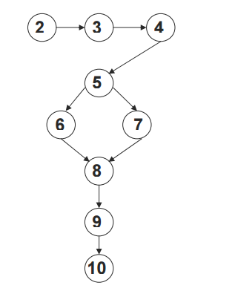  Starting at the source node and ending at the sink node, there exist two possible paths. The first path would be the result of the If-Then clause being taken, and the second would be the result of the Else clause being taken. A program graph provides us with some interesting details about the structure of a piece of code. In the example graph given in the above figure, we can see that nodes 2 through to 4 and nodes 9 to 10 are sequences. This means that these nodes represent simple statements such as variable declarations, expressions or basic input/output commands. Nodes 5 through to 8 are a representation of an if then-else construct, while nodes 2 and 10 are the source and sink nodes of the program respectively.  A program may contain thousands of lines of code and remain structured, whereas a piece of code only ten lines long may contain a loop that results in a loss of structure, and thus spores a potentially large number of execution paths. This is shown by the simple program graph given in the figure below.  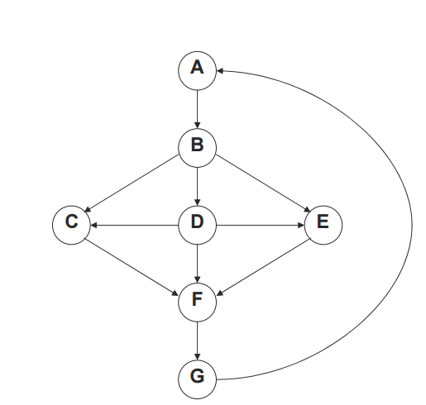  A simple yet unstructured graph  Basis Path Testing  The basis of a vector space contains a set of vectors that are independent of one another, and have a spanning property; this means that everything within the vector space can be expressed in terms of the elements within the basis. The method devised by McCabe to carry out basis path testing has four steps.  These are:  1. Compute the program graph.  2. Calculate the cyclomatic complexity.  3.Select a basis set of paths.  4. Generate test cases for each of these paths  It demonstrates how the basis of a graph containing a loop is computed. It should be noted that the graph is strongly connected; that is, there exists an edge from the sink node to the source node.  Strongly connected program graph  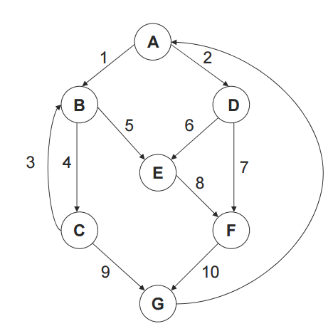  The cyclomatic complexity of a strongly connected graph is provided by the formula  V(G) = e – n + p  V(G) = e – n + p = 11 – 7 + 1 = 5  The five linearly independent paths of our graph are as follows:  Path 1: A, B, C, G.  Path 2: A, B, C, B, C, G.  Path 3: A, B, E, F, G.  Path 4: A, D, E, F, G.  Path 5: A, D, F, G  This now forms the basis set of paths for the graph in the above figure. In theory, if we allow for the basic notions of scalar multiplication and addition, we should now be able to construct any path from our basis. Let us attempt to create a 6th path: A, B, C, B, E, F, G. This is the basis sum p2 + p3 – p1. This equation means to concatenate paths 2 and 3 together to form the path A, B, C, B, C, G, A, B, E, F, G and then remove the four nodes that appear in path 1, resulting in the required path 6.
14 | Describe black box testing .Design the black box test suite for the following program .The program computes the intersection point of two straight line and display the result .It reads two integer pairs (m1, c1) and (m2,c2) defining the two straight lines of the form y=mx+c.(APR/MAY 17)  The equivalence classes are the following:  • Parallel lines (m1=m2, c1≠c2)  • Intersecting lines (m1≠m2)  • Coincident lines (m1=m2, c1=c2)  Now, selecting one representative value from each equivalence class, the test suit (2, 2)(2, 5), (5, 5) (7, 7), (10, 10) (10, 10) are obtained.  Boundary Value Analysis Boundary value analysis based test suit design involves designing test cases using the values at the boundaries of the different equivalent classes. A type of programming error frequently occurs at the boundaries of different equivalence classes of inputs. The reason behind such errors might purely be due to psychological factors.So in order todesign boundary value test cases, it is required to examine the equivalent class to check, if any of equivalence class contain a range of values. Programmers often fail to see thespecial processing required by the input values that lie at the boundary of the differentequivalence classes. For example, programmers may improperly use < instead of <=, or conversely <=for <. Boundary value analysis leads to selection of test cases at the boundaries of thedifferent equivalence classes.
15 | Consider the following program segment. (NOV/DEC 17)  /* num is the number the function searches in a presorted integer array arr */  int bin_search (int num)  {  Int min, max;min=0;max=100;  While(min!=max)  {  If(arr[(min+max)/2]>num)  Max = (min + max)/2;  Else if(arr[min + max)/2]  Min =(min +max)/2;  Else return ((min + max)/2);  }  Return(-1);  }  - Draw the control flow graph for this program segment.  - Define cyclomatic complexity.  - Determine the cyclomatic complexity for this program.  ii)Cyclomatic complexity is a software metric (measurement), used to indicate the complexity of a program. It is a quantitative measure of the number of linearly independent paths through a program's source code. Cyclomatic complexity is computed using the control flow graph of the program: the nodes of the graph correspond to indivisible groups of commands of a program, and a directed edge connects two nodes if the second command might be executed immediately after the first command. Cyclomatic complexity may also be applied to individual functions, modules, methods or classes within a program.  1  2  8  6  7  5  4  3  9  iii)V=E-N+2  =11-9+2  =4  V(G)=NO.OF PREICATES+1  =3+1  =4  NO OF PATHS=4  Path1:1 2 3 4 5 1 9  Path2:1 2 3 4 6 7 1 9  Path3:1 2 3 4 6 8 1 9  Path4:1 9
16 | Explain how the various types of loops are tested. (NOV/DEC 17)  Loop Testing  Loops are the cornerstone for the vast majority of all algorithms implemented in software. And yet, we often pay them little heed while conducting software tests. Loop testing is a white-box testing technique that focuses exclusively on the validity of loop constructs. Four different classes of loops can be defined: simple loops, concatenated loops, nested loops, and unstructured loops.  Simple loops. The following set of tests can be applied to simple loops, where n is the maximum number of allowable passes through the loop.  1. Skip the loop entirely.  2. Only one pass through the loop.  3. Two passes through the loop.  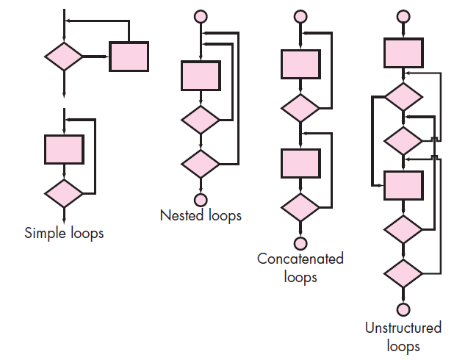  4. m passes through the loop where m _ n.  5. n _ 1, n, n _ 1 passes through the loop.  Nested loops. If we were to extend the test approach for simple loops to nested loops, the number of possible tests would grow geometrically as the level of nesting increases. This would result in an impractical number of tests. Bezier suggests an approach that will help to reduce the number of tests:  1. Start at the innermost loop. Set all other loops to minimum values.  2. Conduct simple loop tests for the innermost loop while holding the outer  loops at their minimum iteration parameter (e.g., loop counter) values. Add  other tests for out-of-range or excluded values.  3. Work outward, conducting tests for the next loop, but keeping all other outer  loops at minimum values and other nested loops to “typical” values.  4. Continue until all loops have been tested.  Concatenated loops. Concatenated loops can be tested using the approach defined for simple loops, if each of the loops is independent of the other. However, if two loops are concatenated and the loop counter for loop 1 is used as the initial value for loop 2, then the loops are not independent. When the loops are not independent, the approach applied to nested loops is recommended.  Unstructured loops. Whenever possible, this class of loops should be redesigned to reflect the use of the structured programming constructs
17 | Differentiate black box testing and white box testing.(NOV/DEC 17)  The Differences Between Black Box Testing and White Box Testing are listed below.
  Criteria | Black Box Testing | White Box Testing
  Definition | Black Box Testing is a software testing method in which the internal structure/ design/ implementation of the item being tested is NOT known to the tester | White Box Testing is a software testing method in which the internal structure/ design/ implementation of the item being tested is known to the tester.
  Levels Applicable To | Mainly applicable to higher levels of testing:Acceptance Testing  System Testing | Mainly applicable to lower levels of testing:Unit Testing  Integration Testing
  Responsibility | Generally, independent Software Testers | Generally, Software Developers
  Programming Knowledge | Not Required | Required
  Implementation Knowledge | Not Required | Required
  Basis for Test Cases | Requirement Specifications | Detail Design
18 | - Write notes on:  - Regression testing.  Each time a new module is added as part of integration testing, the software changes. New data flow paths are established, new I/O may occur, and new control logic is invoked. These changes may cause problems with functions that previously worked flawlessly. In the context of an integration test strategy, regression testing is the re execution of some subset of tests that have already been conducted to ensure that changes have not propagated unintended side effects. In a broader context, successful tests (of any kind) result in the discovery of errors, and errors must be corrected. Whenever software is corrected, some aspect of the software configuration (the program, its documentation, or the data that support it) is changed. Regression testing helps to ensure that changes (due to testing or for other reasons) do not introduce unintended behavior or additional errors.  Regression testing may be conducted manually, by re executing a subset of all test cases or using automated capture/playback tools. Capture/playback tools enable the software engineer to capture test cases and results for subsequent playback and comparison. The regression test suite (the subset of tests to be executed) contains three different classes of test cases:  • A representative sample of tests that will exercise all software functions.  • Additional tests that focus on software functions that are likely to be affected by the change.  • Tests that focus on the software components that have been changed.  - Refactoring  Refactoring is the process of restructuring existing computer code– changing factoring without changing its external behavior. Refactoring improves nonfunctional attributes of the software.  It is the process of changing a software system in such a way that it does not always alter the external behavior of the code yet improves its internal structure."  Just cleaning up code.:-  Contrary to idealized development strategy:  - analysis and design  - code  - test  At first, code is pretty good but as requirements change or new features are added, the code structure tends to atrophy. Refactoring is the process of fixing a bad or chaotic design.  Amounts to moving methods around, creating new methods, adding or deleting classes, ...  TJP: Sometimes it means completely redoing the entire code base (i.e., throwing stuff away). Avoid the second system effect!  Why refactoring??  Improve code structure and design  - more maintainable  - easier to understand  - easier to modify  - easier to add new features  Cumulative effect can radically improve design rather than normal slide into decay.  Flip-flop code development and refactoring. Only refactor when refactoring--do not add features during refactoring.  TJP: kind of like an immune system that constantly grooms the body looking for offensive and intrusive entities.  Bad code usually takes more code to do the same thing often because of duplication:  When not to refactor?  Sometimes you should throw things out and start again.  Sometimes you are too close to a deadline.  - Debugging  Debugging occurs as a consequence of successful testing. That is, when a test case uncovers an error, debugging is the process that results in the removal of the error. Although debugging can and should be an orderly process, it is still very much an art. As a software engineer, you are often confronted with a “symptomatic” indication of a software problem as you evaluate the results of a test. That is, the external manifestation of the error and its internal cause may have no obvious relationship to one another. The poorly understood mental process that connects a symptom to a cause is debugging.  Debugging is not testing but often occurs as a consequence of testing.
19 | Enumerate in detail about Business Process Reengineering (BPR).  Like most engineering activities, business process reengineering is iterative. Business  goals and the processes that achieve them must be adapted to a changing business environment.  Business definition. Business goals are identified within the context of four key drivers: cost reduction, time reduction, quality improvement, and personnel development and empowerment. Goals may be defined at the business level or for a specific component of the business.  Process identification. Processes that are critical to achieving the goals defined in the business definition are identified. They may then be ranked by importance, by need for change, or in any other way that is appropriate for the reengineering activity.  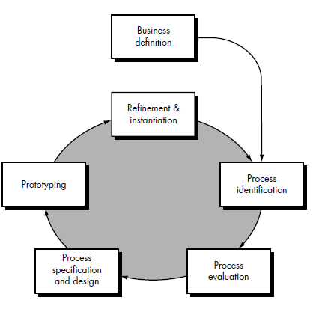  A BPR model  Process evaluation. The existing process is thoroughly analyzed and measured. Process tasks are identified; the costs and time consumed by process tasks are noted; and quality/performance problems are isolated.  Process specification and design. Based on information obtained during the first three BPR activities, use-cases are prepared for each process that is to be redesigned. Within the context of BPR, use-cases identify a scenario that delivers some outcome to a customer. With the use-case as the specification of the process, a new set of tasks are designed for the process.  Prototyping. A redesigned business process must be prototyped before it is fully integrated into the business. This activity “tests” the process so that refinements can be made.  Refinement and instantiation. Based on feedback from the prototype, the business process is refined and then instantiated within a business system. These BPR activities are sometimes used in conjunction with workflow analysis tools. The intent of these tools is to build a model of existing workflow in an effort to better analyze existing processes.  SOFTWARE REENGINEERING  Software Maintenance  The maintenance of existing software can account for over 60 percent of all effort expended by a development organization, and the percentage continues to rise as more software is produced.  A Software Reengineering Process Model  Reengineering takes time; it costs significant amounts of money; and it absorbs resources that might be otherwise occupied on immediate concerns. For all of these reasons, reengineering is not accomplished in a few months or even a few years. Reengineering of information systems is an activity that will absorb information technology resources for many years. Before you can start rebuilding, it would seem reasonable to inspect the house. To determine whether it is in need of rebuilding, you would create a list of criteria so that your inspection would be systematic.  • Before you tear down and rebuild the entire house, be sure that the structure is weak. If the house is structurally sound, it may be possible to “remodel” without rebuilding (at much lower cost and in much less time).  • Before you start rebuilding be sure you understand how the original was built. Take a peek behind the walls. Understand the wiring, the plumbing, and the structural internals. Even if you trash them all, the insight you’ll gain will serve you well when you start construction.  • If you begin to rebuild, use only the most modern, long-lasting materials. This may cost a bit more now, but it will help you to avoid expensive and time-consuming maintenance later.  • If you decide to rebuild, be disciplined about it. Use practices that will result in high quality—today and in the future.  Inventory Analysis  Every software organization should have an inventory of all applications. The inventory can be nothing more than a spreadsheet model containing information that provides a detailed description (e.g., size, age, business criticality) of every active application. By sorting this information according to business criticality, longevity, current maintainability, and other locally important criteria, candidates for reengineering appear. Resources can then be allocated to candidate applications for reengineering work.  It is important to note that the inventory should be revisited on a regular cycle. The status of applications (e.g., business criticality) can change as a function of time, and as a result, priorities for reengineering will shift.  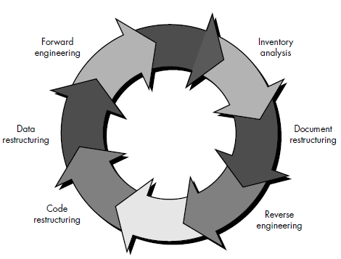  Document Restructuring.  1. Creating documentation is far too time consuming. If the system works, we’ll live with what we have. In some cases, this is the correct approach. It is not possible to re-create documentation for hundreds of computer programs. If a program is relatively static, is coming to the end of its useful life, and is unlikely to undergo significant change, let it be!  2. Documentation must be updated, but we have limited resources. We’ll use a “document when touched” approach. It may not be necessary to fully re-document an application. Rather, those portions of the system that are currently undergoing change are fully documented. Over time, a collection of useful and relevant documentation will evolve.  3. The system is business critical and must be fully re-documented. Even in this case, an intelligent approach is to pare documentation to an essential minimum.  Reverse Engineering  The term reverse engineering has its origins in the hardware world. A company disassembles a competitive hardware product in an effort to understand its competitor's design and manufacturing "secrets." These secrets could be easily understood if the competitor's design and manufacturing specifications were obtained. But these documents are proprietary and unavailable to the company doing the reverse engineering. In essence, successful reverse engineering derives one or more design and manufacturing specifications for a product by examining actual specimens of the product.  Code Restructuring  The most common type of reengineering (actually, the use of the term reengineering is questionable in this case) is code restructuring. Some legacy systems have a relatively solid program architecture, but individual modules were coded in a way that makes them difficult to understand, test, and maintain. In such cases, the code within the suspect modules can be restructured. To accomplish this activity, the source code is analyzed using a restructuring tool. Violations of structured programming constructs are noted and code is then restructured (this can be done automatically). The resultant restructured code is reviewed and tested to ensure that no anomalies have been introduced. Internal code documentation is updated.  Data Restructuring.  A program with weak data architecture will be difficult to adapt and enhance. In fact, for many applications, data architecture has more to do with the long-term viability of a program that the source code itself. Unlike code restructuring, which occurs at a relatively low level of abstraction, data structuring is a full-scale reengineering activity. In most cases, data restructuring begins with a reverse engineering activity. Current data architecture is dissected and necessary data models are defined. Data objects and attributes are identified, and existing data structures are reviewed for quality. When data structure is weak (e.g., flat files are currently implemented, when a relational approach would greatly simplify processing), the data are reengineered. Because data architecture has a strong influence on program architecture and the algorithms that populate it, changes to the data will invariably result in either architectural or code-level changes.
20 | Appraise the concept of Forward and Reverse Engineering.  Forward Engineering. In an ideal world, applications would be rebuilt using a automated “reengineering engine.” The old program would be fed into the engine, analyzed, restructured, and then regenerated in a form that exhibited the best aspects of  software quality. In the short term, it is unlikely that such an “engine” will appear, but  CASE vendors have introduced tools that provide a limited subset of these capabilities that addresses specific application domains (e.g., applications that are implemented using a specific database system). More important, these reengineering tools are becoming increasingly more sophisticated.  Forward engineering, also called renovation or reclamation, not only recovers design information from existing software, but uses this information to alter or reconstitute the existing system in an effort to improve its overall quality. In most cases, reengineered software re-implements the function of the existing system and also adds new functions and/or improves overall performance.  REVERSE ENGINEERING  Reverse engineering can extract design information from source code, but the abstraction level, the completeness of the documentation, the degree to which tools and a human analyst work together, and the directionality of the process are highly variable.  The abstraction level of a reverse engineering process and the tools used to effect it refers to the sophistication of the design information that can be extracted from source code. Ideally, the abstraction level should be as high as possible. That is, the reverse engineering process should be capable of deriving procedural design representations (a low-level abstraction), program and data structure information (a somewhat higher level of abstraction), data and control flow models (a relatively high level of abstraction), and entity relationship models (a high level of abstraction). As the abstraction level increases, the software engineer is provided with information that will allow easier understanding of the program.  The completeness of a reverse engineering process refers to the level of detail that is provided at an abstraction level. In most cases, the completeness decreases as the abstraction level increases. For example, given a source code listing, it is relatively easy to develop a complete procedural design representation. Simple data flow representations may also be derived, but it is far more difficult to develop a complete set of data flow diagrams or entity-relationship models. Completeness improves in direct proportion to the amount of analysis performed by the person doing reverse engineering. Interactivity refers to the degree to which the human is "integrated" with automated tools to create an effective reverse engineering process. In most cases, as the abstraction level increases, interactivity must increase or completeness will suffer. If the directionality of the reverse engineering process is one way, all information extracted from the source code is provided to the software engineer who can then use it during any maintenance activity. If directionality is two way, the information is fed to a reengineering tool that attempts to restructure or regenerate the old program.  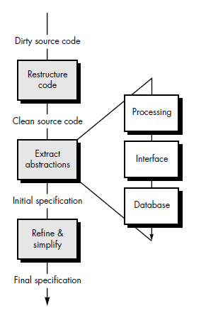  Reverse Engineering to Understand Processing  The first real reverse engineering activity begins with an attempt to understand and then extract procedural abstractions represented by the source code. To understand procedural abstractions, the code is analyzed at varying levels of abstraction: system, program, component, pattern, and statement.  Reverse Engineering to Understand Data  Reverse engineering of data occurs at different levels of abstraction. At the program level, internal program data structures must often be reverse engineered as part of an overall reengineering effort. At the system level, global data structures (e.g., files, databases) are often reengineered to accommodate new database management paradigms.  Internal data structures.  Reverse engineering techniques for internal program data focus on the definition of classes of objects. This is accomplished by examining the program code with the intent of grouping related program variables. In many cases, the data organization within the code identifies abstract data types. For example, record structures, files, lists, and other data structures often provide an initial indicator of classes. Breuer and Lano suggest the following approach for reverse engineering of classes:  1. Identify flags and local data structures within the program that record important information about global data structures (e.g., a file or database).  2. Define the relationship between flags and local data structures and the global data structures. For example, a flag may be set when a file is empty; a local data structure may serve as a buffer that contains the last 100 records acquired from a central database.  3. For every variable (within the program) that represents an array or file, list all other variables that have a logical connection to it. These steps enable a software engineer to identify classes within the program that interact with the global data structures.  Database structure. Regardless of its logical organization and physical structure, a database allows the definition of data objects and supports some method for establishing relationships among the objects. Therefore, reengineering one database schema into another requires an understanding of existing objects and their relationships.  The following steps may be used to define the existing data model as a precursor to reengineering a new database model:  1. Build an initial object model. The classes defined as part of the model may be acquired by reviewing records in a flat file database or tables in a relational schema. The items contained in records or tables become attributes of a class.  2. Determine candidate keys. The attributes are examined to determine whether they are used to point to another record or table. Those that serve as pointers become candidate keys.  3. Refine the tentative classes. Determine whether similar classes can be combined into a single class.  4. Define generalizations. Examine classes that have many similar attributes to determine whether a class hierarchy should be constructed with a generalization class at its head.  5. Discover associations. Use techniques that are analogous to the CRC approach to establish associations among classes. Once information defined in the preceding steps is known, a series of transformations can be applied to map the old database structure into a new database structure.
UNIT V PROJECT MANAGEMENT
Software Project Management: Estimation – LOC, FP Based Estimation, Make/Buy Decision COCOMO I & II Model – Project Scheduling – Scheduling, Earned Value Analysis Planning – Project Plan, Planning Process, RFP Risk Management – Identification, Projection - Risk Management-Risk Identification-RMMM Plan-CASE TOOLS.
UNIT V/ PART-A
1 | What is project planning. (MAY/JUN 2012)(APR/MAY 2015)  The objective of project planning is to provide a framework that enables the manager to make reasonable estimates of resources, cost and schedule.
2 | What is risk management? (NOV/DEC2016)  Risk management is a series of steps that helps a software team to understand and manage uncertainty.
3 | What are the processes of risk management? (NOV/DEC 2010)  - Risk identification  - Risk analysis  - Risk Monitoring
4 | What are different risk strategies?  - Reactive risk strategy-monitors the project for likely risks.  - Proactive risk strategy-Potential risks are identified, their probability and impact are assessed, and they are ranked by importance.
5 | Define Software Quality (NOV/DEC 2013)  Software quality is a complex mix of factors that will vary across different applications and the customers who request them
6 | What is Risk? Give an example of risk (NOV/DEC 2013)(NOV/DEC 2014)  Risk concerns with failure happenings. Risk involves change, such as in changes in mind, opinion, actions, or places. Risk involves choice and the uncertainty that choice itself entails. A risk is a potential problem—it might happen, it might not. But, regardless of the outcome, it’s a really good idea to identify it, assess its probability of occurrence, estimate its impact, and establish a contingency plan should the problem actually occur.  Example: Unrealistic delivery rate, Staff turnover
7 | How are the software risks assessed? (NOV/DEC 2012)  By answering the questions have derived from risk data obtained by surveying experienced software project managers in different part of the world . The questions are ordered by their relative importance to the success of a project. If any one of these questions is answered negatively, mitigation, monitoring, and management steps should be instituted without fail.
8 | Give the interpretation of software metrics?  - Number derived from a software process or product of resource.  - Scale of measurement identifiable software attributes.  - Data- driven model.
9 | Define software measure. Give the 5 characteristics of the software measurement.  A Software measure is a mapping from a set of objects in the software engineering world into a set of mathematical constructs such as numbers or vectors of numbers.  - Object of measurement.  - Purpose of measurement.  - Source of measurement.  - Measured property.  - Context of measurement.
10 | How is the accuracy of a software project is estimated?  - The degree to which the planner has properly estimated the size of the product to be built.  - The ability to translate the size estimate to human effort.  - The degree to which the project plan reflects the abilities of the software team.  - The stability of the product requirements and the environment that supports the software engineering effort.
11 | What is called software maintenance?  The maintenance of existing software can account for over 60% of all effect expend by a development organization, and the percentage continues to rise as more software is produced.
12 | What is Risk exposure?  The risk exposure is determined by,  RE=P*C  where P is the probability of occurrence for a risk and C is the cost to the project should the risk occur.
13 | What is application composition model?  Application Composition model uses object points, an indirect software measure that is computed using user interfaces, reports and components.
14 | What is Early stage design model?  Early stage design model is used once requirements have been stabilized and the basic software architecture has been established.
15 | What are the different sizing options?  - Object points.  - Function points.  - Lines of Source code.
16 | What are the various cost estimation techniques?  - Problem-based estimation  - LOC-based estimation.  - FP-based estimation.  - Process-based estimation.
17 | What are the methods of cost estimation?  - Constructive cost model.  - Delphi method of cost estimation.
18 | What are the three different types of software maintenance?  - Perfective maintenance or enhancement.  - Preventive maintenance or reengineering.  - Corrective maintenance.  - Adaptive maintenance.
19 | What is meant by Process metrics?  Process metrics assess the effectiveness and quality of software process, determine maturity of the process, effort required in the process , effectiveness of defect removal during development and so on.
20 | Define Product metrics.  In software development process, a working product is developed at the end of each successful phase. Each product can be measured at any stage of its development. Product metrics help software engineer to detect and correct potential problems before they result in catastrophic defects. They also help to assess internal product attributes to know the efficiency.
21 | Give the procedure of the Delphi method.  - The coordinator presents a specification and estimation form to each expert.  - Coordinator calls a group meeting in which the experts discuss estimation issues with the coordinator and each other.  - Experts fill out forms anonymously.  - Coordinator prepares and distributes a summary of the estimates.  - The Coordinator then calls a group meeting. In this meeting the experts mainly discuss the points where their estimates vary widely.  - The experts again fill out forms anonymously.  - Again coordinator edits and summarizes the forms and the steps 5 and 6 are followed until the coordinator is satisfied with the overall prediction synthesized from experts.
22 | What is Post-architecture stage model?  Post-architecture stage model is used during the construction of the software.
23 | What is EVA? (APR/MAY 2018)  Earned Value Analysis is a technique of performing quantitative analysis of the software project. It provides a common value scale for every task of software project. It acts as a measure for software project progress.
24 | What is COCOMO model?  COnstructive COst MOdel is a cost model, which gives the estimate of number of man-months it will take to develop the software product.
25 | What are the advantages and disadvantages of size measure?  Advantages: Artifact of software development which is easily counted. Many existing methods use LOC as a key input. A large body of literature and data based on LOC already exists.  Disadvantages: This method is dependent upon the programming language. This method is well designed but shorter program may get suffered. It does not accommodate non procedural languages. In early stage of development it is difficult to estimate LOC.
26 | List a few process and project metrics. (May/June 2016)  Project metrics:  Schedule Variance, Effort Variance, Size Variance, Requirement Stability Index, Productivity, Schedule variance for a phase, Effort variance for a phase.  Process Metrics:  Cost of quality, Cost of poor quality, Defect density, Review efficiency, Testing Efficiency, Defect removal efficiency.
27 | Will exhaustive testing guarantee that the program is 100% correct? (May/June 2016)  No, even exhaustive testing will not guarantee that the  program is 100 percent correct.
28 | How is productivity and cost related to function points?(NOV/DEC 2016)  Productivity:  The definition of productivity is the output-input ratio within a time period with due consideration for quality.  Productivity = outputs/inputs (within a time period, quality considered)  The formula indicates that productivity can be improved by (1) by increasing outputs with the same inputs, (2) by decreasing inputs but maintaining the same outputs, or (3) by increasing outputs and decreasing inputs change the ratio favorably.  Software Productivity = Function Points / Inputs  Software productivity is defined as hours/function points or function points/hours. This is the average cost to develop software or the unit cost of software. Average cost is the total cost of producing a particular quantity of output divided by that quantity i.e., Total Cost/Function Points. Marginal cost is the change in total cost attributable to a one-unit change in output.
29 | What are the different types of productivity estimation measures?(APR/MAY 17)  LOC and FP measures are often used to derive productivity metrics. LOC and FP based metrics have been found to be relatively accurate predictors of software development effort and cost.
30 | List two customer related and technology related risks.(APR/MAY 17)  Customer related risks  - Is the customer technically sophisticated in the product area  - Does the customer have a solid idea of what is required  - Is the customer willing to establish rapid communication links with the developer  Technology related risks  - Is the technology to be built new to your company  - Is a specialized user interface demanded by product requirements
31 | List out the principle of project scheduling.(NOV/DEC 17)  Compartmentalization. The project must be compartmentalized into a number of manageable activities and tasks. To accomplish compartmentalization, both the product and the process are refined. Interdependency. The interdependency of each compartmentalized activity or task must be determined. Some tasks must occur in sequence, while others can occur in parallel. Some activities cannot commence until the work product produced by another is available. Other activities can occur independently.  Time allocation. Each task to be scheduled must be allocated some number of work units (e.g., person-days of effort). In addition, each task must be assigned a start date and a completion date that are a function of the interdependencies and whether work will be conducted on a full-time or part-time basis.  Effort validation. Every project has a defined number of people on the software team. As time allocation occurs, you must ensure that no more than the allocated number of people has been scheduled at any given time. For example, consider a project that has three assigned software engineers (e.g., three person-days are available per day of assigned effort4). On a given day, seven concurrent tasks must be accomplished. Each task requires 0.50 person-days of effort. More effort has been allocated than there are people to do the work.  Defined responsibilities. Every task that is scheduled should be assigned to a specific team member. Defined outcomes. Every task that is scheduled should have a defined outcome.For software projects, the outcome is normally a work product (e.g., the design of a component) or a part of a work product. Work products are often combined in deliverables.  Defined milestones. Every task or group of tasks should be associated with a project milestone. A milestone is accomplished when one or more work products has been reviewed for quality (Chapter 15) and has been approved.
32 | Write a note on Risk information sheet(RIS)  Some software teams do not develop a formal RMMM document. Rather, each risk is documented individually using a risk information sheet (RIS) In most cases, the RIS is maintained using a database system so that creation and information entry, priority ordering, searches, and other analysis may be accomplished easily.
33 | Identify the type of maintenance for each for the following  - Correcting the software faults  - Adapting the change in environment  Ans: corrective, adaptive
UNIT-V / PART -B
1 | (i) Explain the COCOMO II model for estimation. (NOV/DEC 2012) (NOV/DEC 2013, 2009) (MAY/JUNE 2016)(APR/MAY 17)(NOV/DEC 17) (APR?MAY 2018)  (ii) Make/Buy decision. (MAY/JUNE 2016)  Barry Boehm introduced COCOMO II (COst COnstructive MOdel) which is an hierarchy of estimation models that addresses the following areas:  - Application composition model. Used during the early stages of software engineering, when prototyping of user interfaces, consideration of software and system interaction, assessment of performance, and evaluation of technology maturity are paramount.  - Early design stage model. Used once requirements have been stabilized and basic software architecture has been established.  - Post-architecture-stage model. Used during the construction of the software.  Three different sizing options are available as part of the model hierarchy: object points, function points, and lines of source code.  The object point is an indirect software measure that is computed using counts of the number of (1) screens (at the user interface), (2) reports, and (3) components likely to be required to build the application.  When component-based development or general software reuse is to be applied, the percent of reuse (%reuse) is estimated and the object point count is adjusted:  NOP=(Object points)*[(100-%reuse)/100]  where NOP is defined as new object points.  To derive an estimate of effort based on the computed NOP value, a “productivity rate” must be derived.  NOP  PROD = -------------------------  Person-month  for different levels of developer experience and development environment maturity.  Once the productivity rate has been determined, an estimate of project effort is computed using  NOP  Estimated effort=------------  PROD  In more advanced COCOMO II models,12 a variety of scale factors, cost drivers, and adjustment procedures are required.  (ii)State ZIPF’s law.  Frequency of occurrence of words is inversely proportional to the rank in this frequency of occurrence  (iii)What is the purpose of Delphi method? State advantages and disadvantages of the method. (NOV/DEC 2014)  Under this method of software estimation, the project specifications would be given to a few experts and their opinion taken. The actual number of experts chosen would depend on their availability. A minimum of three is normally selected to have a range of values. Delphi method has the following steps –  - Selection of experts  - Briefing to the experts  - Collation of estimates from experts  - Convergence of estimates and finalization  Merits of Delphi technique  - Very useful when the organization does not have any in-house experts with the domain  - knowledge or the development platform experience to come out with a quick estimate  - Very quick to derive an estimate  - Simple to administer and use  Demerits of Delphi technique  - This is too simplistic  - It may be difficult to locate right experts  - It may also be difficult to locate adequate number of experts willing to participate in the  - estimation  - The derived estimate is not auditable  - It is not possible to determine the causes of variance between the estimated value and the  - actual values  - Only size and effort and estimation are possible – schedule would not be available.
  OBJECT TYPE | COMPLEXITY WEIGHT
  OBJECT TYPE | SIMPLE | MEDIUM | DIFFICULT
  Screen | 1 | 2 | 3
  Report | 2 | 5 | 8
  3GL component |  |  | 10
  Developer’s experience/capability | Very low | Low | Nominal | High | Very high
  Environment maturity/capability | Very low | Low | Nominal | High | Very high
  PROD | 4 | 7 | 13 | 25 | 50
2 | What are the metrics used for measuring software quality? Explain the defect removal efficiency along with its equations.  Correctness, maintainability, integrity, and usability provide useful indicators for the project team for measuring software quality.  Correctness: A program must operate correctly or it provides little value to its users. Correctness is the degree to which the software performs its required function. The most common measure for correctness is defects per KLOC, where a defect is defined as a verified lack of conformance to requirements. When considering the overall quality of a software product, defects are those problems reported by a user of the program after the program has been released for general use. For quality assessment purposes, defects are counted over a standard period of time, typically one year.  Maintainability: Software maintenance and support accounts for more effort than any other software engineering activity. Maintainability is the ease with which a program can be corrected if an error is encountered, adapted if its environment changes, or enhanced if the customer desires a change in requirements. There is no way to measure maintainability directly; therefore, you must use indirect measures. A simple time-oriented metric is mean-time-to-change (MTTC), the time it takes to analyze the change request, design an appropriate modification, implement the change, test it, and distribute the change to all users. On average, programs that are maintainable will have a lower MTTC (for equivalent types of changes) than programs that are not maintainable.  Integrity: Software integrity has become increasingly important in the age of cyber terrorists and hackers. This attribute measures a system’s ability to withstand attacks (both accidental and intentional) to its security. Attacks can be made on all three components of software: programs, data, and documention.  To measure integrity, two additional attributes must be defined: threat and security. Threat is the probability (which can be estimated or derived from empirical evidence) that an attack of a specific type will occur within a given time. Security is the probability (which can be estimated or derived from empirical evidence) that the attack of a specific type will be repelled. The integrity of a system can then be defined as:  Integrity=∑[1-(threat*(1-security))]  Usability: If a program is not easy to use, it is often doomed to failure, even if the functions that it performs are valuable. Usability is an attempt to quantify ease of use.  Defect Removal Efficiency  A quality metric that provides benefit at both the project and process level is defect removal efficiency (DRE).When considered for a project as a whole, DRE is defined in the following manner:  E  DRE=------------------  E+D  where E is the number of errors found before delivery of the software to the end user and D is the number of defects found after delivery. DRE can also be used within the project to assess a team’s ability to find errors before they are passed to the next framework activity or software engineering action.  For example, requirements analysis produces a requirements model that can be reviewed to find and correct errors. Those errors that are not found during the review of the requirements model are passed on to design (where they may or may not be found). When used in this context, we redefine DRE as  E_{j}  DRE_{j} =------------------  E_{j}+D_{j+1}  where Ei is the number of errors found during software engineering action i and Ei+ 1 is the number of errors found during software engineering action i + 1 that are traceable to errors that were not discovered in software engineering action i. A quality objective for a software team (or an individual software engineer) is to achieve DREi that approaches 1. That is, errors should be filtered out before they are passed on to the next activity or action.
3 | Explain in detail about Empirical Estimation models.  An estimation model should be calibrated to reflect local conditions. The model should be tested by applying data collected from completed projects, plugging the data into the model, and then comparing actual to predicted results. If agreement is poor, the model must be tuned and retested before it can be used.  The Structure of Estimation Models  A typical estimation model is derived using regression analysis on data collected from past software projects. The overall structure of such models takes the form  E=A+B*(e_{v})^{c}  where A, B, and C are empirically derived constants, E is effort in person-months, and ev is the estimation variable (either LOC or FP).  Among the many LOC-oriented estimation models proposed in the literature are  E=5.2*(KLOC)^{0.91} Walston-Felix model  E=5.5+0.73*(KLOC)^{1.16} Bailey-Basili model  E=3.2*(KLOC)^{1.05} Boehm simple model  E=5.288*(KLOC)^{1.047} Doty model for KLOC>9  FP-oriented models have also been proposed. These include  E= -91.4+0.355 FP Albrecht and Gaffbey model  E=-37+0.96 FP Kemerer model  E=-12.88+0.405 FP Small project regression model  A quick examination of these models indicates that each will yield a different result for the same values of LOC or FP. The implication is clear. Estimation models must be calibrated for local needs.  The COCOMO II Model  Barry Boehm introduced COCOMO II (COst COnstructive MOdel) which is an hierarchy of estimation models that addresses the following areas:  - Application composition model. Used during the early stages of software engineering, when prototyping of user interfaces, consideration of software and system interaction, assessment of performance, and evaluation of technology maturity are paramount.  - Early design stage model. Used once requirements have been stabilized and basic software architecture has been established.  - Post-architecture-stage model. Used during the construction of the software.  Three different sizing options are available as part of the model hierarchy: object points, function points, and lines of source code.  The object point is an indirect software measure that is computed using counts of the number of (1) screens (at the user interface), (2) reports, and (3) components likely to be required to build the application.  When component-based development or general software reuse is to be applied, the percent of reuse (%reuse) is estimated and the object point count is adjusted:  NOP=(Object points)*[(100-%reuse)/100]  where NOP is defined as new object points.  To derive an estimate of effort based on the computed NOP value, a “productivity rate” must be derived.  NOP  PROD=--------------------------  Person-month  for different levels of developer experience and development environment maturity.  Once the productivity rate has been determined, an estimate of project effort is computed using  NOP  Estimated effort=------------  PROD  In more advanced COCOMO II models,12 a variety of scale factors, cost drivers, and adjustment procedures are required.  The Software Equation  The software equation is a dynamic multivariable model that assumes a specific distribution of effort over the life of a software development project.  LOC*B^{0.333} 1  E=-------------------- * ----------  P3 t⁴  where  E --effort in person-months or person-years  t --project duration in months or years  B-- “special skills factor”13  P -- “productivity parameter” that reflects: overall process maturity and management practices, the extent to which good software engineering practices are used, the level of programming languages used, the state of the software environment, the skills and experience of the software team, and the  complexity of the application software equation has two independent parameters:  (1) an estimate of size (in LOC) and  (2) an indication of project duration in calendar months or years.  To simplify the estimation process and use a more common form for their estimation model, Putnam and Myers suggest a set of equations derived from the software equation. Minimum development time is defined as  LOC  T_{min}=8.14----------- IN months for t_{min}>6 months  P ^{0.43}  E=180Bt³ in person-months for E>=20 person-months
  OBJECT TYPE | COMPLEXITY WEIGHT
  OBJECT TYPE | SIMPLE | MEDIUM | DIFFICULT
  Screen | 1 | 2 | 3
  Report | 2 | 5 | 8
  3GL component |  |  | 10
  Developer’s experience/capability | Very low | Low | Nominal | High | Very high
  Environment maturity/capability | Very low | Low | Nominal | High | Very high
  PROD | 4 | 7 | 13 | 25 | 50
4 | Describe in detail about project scheduling. (MAY/JUN 2013) (APR/MAY 2015)  Software project scheduling is an action that distributes estimated effort across the planned project duration by allocating the effort to specific software engineering tasks. Scheduling for software engineering projects can be viewed from two rather different perspectives. In the first, an end date for release of a computer-based system has already (and irrevocably) been established. The software organization is constrained to distribute effort within the prescribed time frame. The second view of  software scheduling assumes that rough chronological bounds have been discussed but that the end date is set by the software engineering organization.  Basic Principles  - Compartmentalization. The project must be compartmentalized into a number of manageable activities and tasks. To accomplish compartmentalization, both the product and the process are refined.  - Interdependency. The interdependency of each compartmentalized activity or task must be determined. Some tasks must occur in sequence, while others can occur in parallel. Some activities cannot commence until the work product produced by another is available. Other activities can occur independently.  - Time allocation. Each task to be scheduled must be allocated some number of work units (e.g., person-days of effort). In addition, each task must be assigned a start date and a completion date that are a function of the interdependencies and whether work will be conducted on a full-time or part-time basis.  - Effort validation. Every project has a defined number of people on the software team. As time allocation occurs, you must ensure that no more than the allocated number of people has been scheduled at any given time. For example, consider a project that has three assigned software engineers (e.g., three person-days are available per day of assigned effort4). On a given day, seven concurrent tasks must be accomplished. Each task requires 0.50 person-days of effort. More effort has been allocated than there are people to do the work.  - Defined responsibilities. Every task that is scheduled should be assigned to a specific team member.  - Defined outcomes. Every task that is scheduled should have a defined outcome. For software projects, the outcome is normally a work product (e.g., the design of a component) or a part of a work product. Work products are often combined in deliverables.  - Defined milestones. Every task or group of tasks should be associated with a project milestone. A milestone is accomplished when one or more work products has been reviewed for quality.  The Relationship Between People and Effort  L, is related to effort and development time by the equation:  L=P*E¹/3t^{4/3}  Rearranging this software equation, we can arrive at an expression for development effort E:  L³  E=-------------------  P³ t⁴  Effort Distribution  A recommended distribution of effort across the software process is often referred to as the 40–20–40 rule. Forty percent of all effort is allocated to frontend analysis and design. A similar percentage is applied to back-end testing. 20 percent of effort is deemphasized in the coding.  Because of the effort applied to software design, code should follow with relatively little difficulty. A range of 15 to 20 percent of overall effort can be achieved. Testing and subsequent debugging can account for 30 to 40 percent of software development effort. The criticality of the software often dictates the amount of testing that is required. If software is human rated (i.e., software failure can result in loss of life), even higher percentages are typical.
5 | Explain problem-based and process-based estimations with relevant illustrations.  Problem-Based Estimation  LOC and FP data are used in two ways during software project estimation: (1) as estimation variables to “size” each element of the software and (2) as baseline metrics collected from past projects and used in conjunction with estimation variables to develop cost and effort projections.  There is often substantial scatter in productivity metrics for an organization, making the use of a single-baseline productivity metric suspect. In general, LOC/pm or FP/pm averages should be computed by project domain. That is, projects should be grouped by team size, application area, complexity, and other relevant parameters. Local domain averages should then be computed. When a new project is estimated, it should first be allocated to a domain, and then the appropriate domain average for past productivity should be used in generating the estimate.  The LOC and FP estimation techniques differ in the level of detail required for decomposition and the target of the partitioning. When LOC is used as the estimation variable, decomposition is absolutely essential and is often taken to considerable levels of detail. The greater the degree of partitioning, the more likely reasonably accurate estimates of LOC can be developed.  For FP estimates, decomposition works differently. Rather than focusing on function, each of the information domain characteristics—inputs, outputs, data files, inquiries, and external interfaces—as well as the 14 complexity adjustment values are estimated. The resultant estimates can then be used to derive an FP value that can be tied to past data and used to generate an estimate. Regardless of the estimation variable that is used, you should begin by estimating a range of values for each function or information domain value. Using historical data or (when all else fails) intuition, estimate an optimistic, most likely, and pessimistic size value for each function or count for each information domain value. An implicit indication of the degree of uncertainty is provided when a range  of values is specified.  A three-point or expected value can then be computed. The expected value for the estimation variable (size) S can be computed as a weighted average of the optimistic (s_{opt}), most likely (s_{m}), and pessimistic (s_{pess}) estimates. For example  S_{opt}+4S_{m}+S_{pess}  S= --------------------------  6  gives heaviest credence to the “most likely” estimate and follows a beta probability distribution.  Process-based Estimation  Process-based estimation begins with a delineation of software functions obtained from the project scope. A series of framework activities must be performed for each function.  Costs and effort for each function and framework activity are computed as the last step. If process-based estimation is performed independently of LOC or FP estimation, two or three estimates for cost and effort are considered that may be compared and reconciled. If both sets of estimates show reasonable agreement, there is good reason to believe that the estimates are reliable. If, on the other hand, the results of these decomposition techniques show little agreement, further investigation and analysis must be conducted.
6 | Brief about calculating Earned Value Measures. (MAY/JUN 2012)  The earned value system provides a common value scale for every [software project] task, regardless of the type of work being performed. The total hours to do the whole project are estimated, and every task is given an earned value based on its estimated percentage of the total.  To determine the earned value, the following steps are performed:  - The budgeted cost of work scheduled (BCWS) is determined for each work task represented in the schedule.  - The BCWS values for all work tasks are summed to derive the budget at completion (BAC). Hence,  BAC=∑(BCWS_{k}) for all task k  - Next, the value for budgeted cost of work performed (BCWP) is computed. The value for BCWP is the sum of the BCWS values for all work tasks that have actually been completed by a point in time on the project schedule.  Given values for BCWS, BAC, and BCWP, important progress indicators can be computed:  BCWP  Schedule performance index, SPI = -------------  BCWS  Schedule Variance, SV = BCWP-BCWS  BCWS  Percent scheduled for completion=--------------------  BAC  BCWP  Percent complete=----------------  BAC  BCWP  Cost performance index,CPI=---------------  ACWP  Cost variance, CV=BCWP-ACWP  A CPI value close to 1.0 provides a strong indication that the project is within its defined budget. CV is an absolute indication of cost savings (against planned costs) or shortfall at a particular stage of a project. Like over-the-horizon radar, earned value analysis illuminates scheduling difficulties before they might otherwise be apparent. This enables you to take corrective action before a project crisis develops.
7 | Define Risk. Explain its four major categories. (MAY/JUN 2012, 2014) (OR) State the need for Risk Management and explain the activities under Risk Management.(APR/MAY 2015)(NOV/DEC 17)  Risk concerns with failure happenings. Risk involves change, such as in changes in mind,  opinion, actions, or places.  - uncertainty—the risk may or may not happen;  - loss—if the risk becomes a reality, unwanted consequences or losses will occur  Project risks threaten the project plan. That is, if project risks become real, it is likely that the project schedule will slip and that costs will increase. Project risks identify potential budgetary, schedule, personnel (staffing and organization), resource, stakeholder, and requirements problems and their impact on a software project.  Technical risks threaten the quality and timeliness of the software to be produced. If a technical risk becomes a reality, implementation may become difficult or impossible. Technical risks identify potential design, implementation, interface, verification, and maintenance problems.  Business risks threaten the viability of the software to be built and often jeopardize the project or the product. Candidates for the top five business risks are  - building an excellent product or system that no one really wants (market risk),  - building a product that no longer fits into the overall business strategy for the company (strategic risk),  - building a product that the sales force doesn’t understand how to sell (sales risk),  - losing the support of senior management due to a change in focus or a change in people (management risk), and  - losing budgetary or personnel commitment (budget risks).  Known risks are those that can be uncovered after careful evaluation of the project plan, the business and technical environment in which the project is being developed, and other reliable information sources (e.g., unrealistic delivery date, lack of documented requirements or software scope, poor development environment).  Predictable risks are extrapolated from past project experience (e.g., staff turnover, poor communication with the customer, dilution of staff effort as ongoing maintenance requests are serviced). Unpredictable risks are the joker in the deck. They can and do occur, but they are extremely difficult to identify in advance.  Risk Identification  Risk identification is a systematic attempt to specify threats to the project plan (estimates, schedule, resource loading, etc.). By identifying known and predictable risks, the project manager takes a first step toward avoiding them when possible and controlling them when necessary.  There are two distinct types of risks for each of the categories: generic risks and product-specific risks.  - Generic risks are a potential threat to every software project.  - Product-specific risks can be identified only by those with a clear understanding of the technology, the people, and the environment that is specific to the software that is to be built.  One method for identifying risks is to create a risk item checklist. The checklist can be used for risk identification and focuses on some subset of known and predictable risks in the following generic subcategories:  - Product size—risks associated with the overall size of the software to be built or modified.  - Business impact—risks associated with constraints imposed by management or the marketplace.  - Stakeholder characteristics—risks associated with the sophistication of the stakeholders and the developer’s ability to communicate with stakeholders in a timely manner.  - Process definition—risks associated with the degree to which the software process has been defined and is followed by the development organization.  - Development environment—risks associated with the availability and quality of the tools to be used to build the product.  - Technology to be built—risks associated with the complexity of the system to be built and the “newness” of the technology that is packaged by the system.  - Staff size and experience—risks associated with the overall technical and project experience of the software engineers who will do the work.  Risk Projection  Risk projection, also called risk estimation, attempts to rate each risk in two ways— the likelihood or probability that the risk is real and the consequences of the problems associated with the risk, should it occur. You work along with other managers and technical staff to perform four risk projection steps:  - Establish a scale that reflects the perceived likelihood of a risk.  - Delineate the consequences of the risk.  - Estimate the impact of the risk on the project and the product.  - Assess the overall accuracy of the risk projection so that there will be no misunderstandings.  A risk table provides you with a simple technique for risk projection.  The overall risk exposure RE is determined using the following relationship:  RE =P * C  Risk Refinement  One way to do this is to represent the risk in condition-transition-consequence (CTC) format. That is, the risk is stated in the following form:  Given that <condition> then there is concern that (possibly) <consequence>.  This general condition can be refined in the following manner:  Subcondition 1. Certain reusable components were developed by a third party with no knowledge of internal design standards.  Subcondition 2. The design standard for component interfaces has not been solidified and may not conform to certain existing reusable components.  Subcondition 3. Certain reusable components have been implemented in a language that is not supported on the target environment.  Risk Mitigation, Monitoring and Management  An effective strategy must consider three issues: risk avoidance, risk monitoring, and risk management and contingency planning.  To mitigate this risk, a strategy has to be developed for reducing turnover. Among the possible steps to be taken are:  - Meet with current staff to determine causes for turnover (e.g., poor working conditions, low pay, competitive job market).  - Mitigate those causes that are under your control before the project starts.  - Once the project commences, assume turnover will occur and develop techniques to ensure continuity when people leave.  - Organize project teams so that information about each development activity is widely dispersed.  - Define work product standards and establish mechanisms to be sure that all models and documents are developed in a timely manner.  - Conduct peer reviews of all work (so that more than one person is “up to speed”).  - Assign a backup staff member for every critical technologist.
8 | Describe in detail about software maintenance.  It begins almost immediately. Software is released to end users, and within days, bug reports filter back to the software engineering organization. Within weeks, one class of users indicates that the software must be changed so that it can accommodate the special needs of their environment. And within months, another corporate group who wanted nothing to do with the software when it was released now recognizes that it may provide them with unexpected benefit.  The challenge of software maintenance has begun by facing with a growing queue of bug fixes, adaptation requests, and outright enhancements that must be planned, scheduled, and ultimately accomplished. Before long, the queue has grown long and the work it implies threatens to overwhelm the available resources. As time passes, your organization finds that it’s spending more money and time maintaining existing programs than it is engineering new applications. In fact, it’s not unusual for a software organization to expend as much as 60 to 70 percent of all resources on software maintenance.  Another reason for the software maintenance problem is the mobility of software people. It is likely that the software team (or person) that did the original work is no longer around. Worse, other generations of software people have modified the system and moved on. Maintainability is a qualitative indication of the ease with which existing software can be corrected, adapted, or enhanced.  - Corrective maintenance is a maintenance task performed to identify, isolate, and rectify a fault.  - Adaptive maintenance includes changes to the functionality of the system developed for specific customer needs.  - Perfective maintenance or enhancement involves making enhancements to improve processing performance, interface usability, or to add desired, but not necessarily required, system features.  - Preventive maintenance or reengineering involves changes made to a system to reduce the chance of future system failure.
9 | Briefly explain about decomposition techniques.  The decomposition approach was discussed from two different points of view: decomposition of the problem and decomposition of the process.  Software Sizing  The accuracy of a software project estimate is predicated on a number of things:  - the degree to which you have properly estimated the size of the product to be built;  - the ability to translate the size estimate into human effort, calendar time, and dollars  (a function of the availability of reliable software metrics from past projects);  - the degree to which the project plan reflects the abilities of the software team; and  - the stability of product requirements and the environment that supports the software engineering effort.  Problem-Based Estimation  LOC and FP data are used in two ways during software project estimation: (1) as estimation variables to “size” each element of the software and (2) as baseline metrics collected from past projects and used in conjunction with estimation variables to develop cost and effort projections.  There is often substantial scatter in productivity metrics for an organization, making the use of a single-baseline productivity metric suspect. In general, LOC/pm or FP/pm averages should be computed by project domain. That is, projects should be grouped by team size, application area, complexity, and other relevant parameters. Local domain averages should then be computed. When a new project is estimated, it should first be allocated to a domain, and then the appropriate domain average for past productivity should be used in generating the estimate.  The LOC and FP estimation techniques differ in the level of detail required for decomposition and the target of the partitioning. When LOC is used as the estimation variable, decomposition is absolutely essential and is often taken to considerable levels of detail. The greater the degree of partitioning, the more likely reasonably accurate estimates of LOC can be developed.  For FP estimates, decomposition works differently. Rather than focusing on function, each of the information domain characteristics—inputs, outputs, data files, inquiries, and external interfaces—as well as the 14 complexity adjustment values are estimated. The resultant estimates can then be used to derive an FP value that can be tied to past data and used to generate an estimate. Regardless of the estimation variable that is used, you should begin by estimating a range of values for each function or information domain value. Using historical data or (when all else fails) intuition, estimate an optimistic, most likely, and pessimistic size value for each function or count for each information domain value. An implicit indication of the degree of uncertainty is provided when a range  of values is specified.  A three-point or expected value can then be computed. The expected value for the estimation variable (size) S can be computed as a weighted average of the optimistic (s_{opt}), most likely (s_{m}), and pessimistic (s_{pess}) estimates. For example  S_{opt}+4S_{m}+S_{pess}  S= --------------------------  6  gives heaviest credence to the “most likely” estimate and follows a beta probability distribution.  Process-based Estimation  Process-based estimation begins with a delineation of software functions obtained from the project scope. A series of framework activities must be performed for each function.  Costs and effort for each function and framework activity are computed as the last step. If process-based estimation is performed independently of LOC or FP estimation, two or three estimates for cost and effort are considered that may be compared and reconciled. If both sets of estimates show rea sonable agreement, there is good reason to believe that the estimates are reliable. If, on the other hand, the results of these decomposition techniques show little agreement, further investigation and analysis must be conducted.(LOC and FP-based estimations, process and problem-based estimations examples has to be provided.  Estimation with Use Cases  - Use cases are described using many different formats and styles—there is no standard form.  - Use cases represent an external view (the user’s view) of the software and can therefore be written at many different levels of abstraction.  - Use cases do not address the complexity of the functions and features that are described.  - Use cases can describe complex behaviour (e.g., interactions) that involve many functions and features.  Reconciling Estimates  The estimation techniques discussed in the preceding sections result in multiple estimates that must be reconciled to produce a single estimate of effort, project duration, or cost.  - the scope of the project is not adequately understood or has been misinterpreted by the planner, or  - productivity data used for problem-based estimation techniques is inappropriate for the application, obsolete (in that it no longer accurately reflects the software engineering organization), or has been misapplied.
10 | i)An application has the following:10 low external inputs ,8 high external outputs,13 low internal logical files,17 high external interface files,11 average external inquiries and complexity adjustment factor of 1.10.What are the unadjusted and adjusted function point counts? (MAY/JUNE 2016)  FP=count total*[0.65+0.01*]  Adjustment factor given,=1.10  So,Adjusted function points =391*[1.75]  =684.25 adjusted function points.  ii)Discuss Putnam resources allocation model. Derive the time and effort equations. (MAY/JUNE 2016)  The software equation is a dynamic multivariable model that assumes a specific distribution of effort over the life of a software development project. The model has been derived from productivity data collected for over 4000 contemporary software projects. Based on these data, an estimation model of the form  E=[LOC*B˄0.333/P]˄3 * (1/t4)  where E = effort in person-months or person-years  t = project duration in months or years  B = “special skills factor”16  P = “productivity parameter” that reflects:  - Overall process maturity and management practices  - The extent to which good software engineering practices are used  - The level of programming languages used  - The state of the software environment  - The skills and experience of the software team  - The complexity of the application  Typical values might be P = 2,000 for development of real-time embedded software; P = 10,000 for telecommunication and systems software; P = 28,000 for business systems applications. The productivity parameter can be derived for local conditions using historical data collected from past development efforts.  It is important to note that the software equation has two independent parameters: (1) an estimate of size (in LOC) and (2) an indication of project duration in calendar months or years.  To simplify the estimation process and use a more common form for their estimation model, Putnam and Myers suggest a set of equations derived from the software equation. Minimum development time is defined as  tmin = 8.14 (LOC/P)˄0.43 in months for tmin > 6 months  E = 180 Bt˄3 in person-months for E ≥ 20 person-months  Note that t in Equation is represented in years.  tmin = 8.14 (33200/12000)˄0.43  tmin = 12.6 calendar months  E=180 * 0.28* (1.05) ˄ 3  E = 58 person-months  The results of the software equation correspond favorably with the estimates developed.
  Measurement Parameter | count | Weighting Factor |  |  | Total
  Measurement Parameter | count | Simple | Average | Complex | Total
  External inputs | 10 | 3 | 4 | 6 | 30
  External outputs | 8 | 4 | 5 | 6 | 56
  internal logical files | 13 | 7 | 10 | 15 | 91
  external interface files | 17 | 5 | 7 | 10 | 170
  External inquiries | 11 | 3 | 4 | 6 | 44
   |  |  |  |  | 391
11 | Given the following project plan of table1 and table 2:(APR/MAY 17)  ID Task Immediate predecessor(*) Expected Duration Budget  A Meet with client 5 500  B Write SW A 20 10000  C Debug SW B 5 1500  D Prepare draft manual B 5 1000  E Meet with clients D 5 1000  F Test SW C,E 20 2000  G Make modification F 10 8000  H Finalize manual G 10 5000  I Advertise C,E 20 8000  (*) all depen dencies are assumed to be FS-Finish to start  And the following progress status:  Table 2  ID Task Status Actual Start Actual Duration Actual Costs  (days) (days) ($)  A Meet with clients 100% 1500  B Write SW 100% +5 days +10 days 9000  C Debug SW 100% +15 days +5 days 2500  D Prepare Draft 100% As per other delays 1000  manuals  E Meet with clients 100% As per other delays 1000  F Test SW 100% As per other delays 750  G Make 0% As per other delays 0  Modification  H Finalise manual 0% As per other delays 0  I Advertise 10% +5 on top of other delays 1000  Perform an analysis of the project status at week 13 ,using EVA. Use the CPI and SPI to determine project efficiency .Explain the process involved.  We organize the solution as follows:  1. Drawing the Gantt chart of the plan  2. Drawing the Gantt chart of the actual plan (progress status)  3. Perform the analysis (plot PV, AC, EV, CPI, SPI)  1. Drawing the Gantt chart of the plan  We start by drawing the network diagram using the information about immediate predecessors.  (This is not stritcly necessary: the Gantt chart can be drawn directly, if you manage to take into  account dependencies and durations at the same time, which should not be too complex.)  This is shown in the following figure, where we use the AON (Activity on Node) notation:  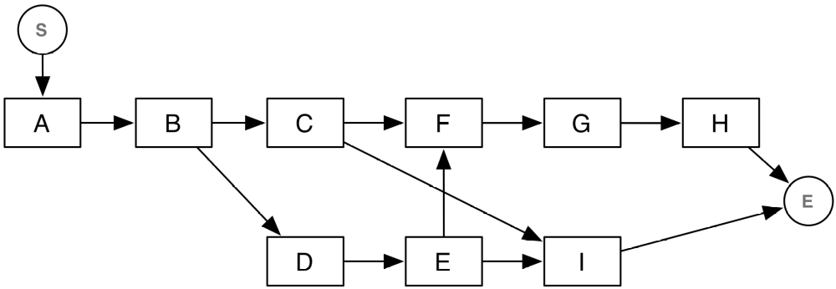  The Gantt chart can now be easily drawn, by taking into account the expected duration of each  activity. The result is shown in the following diagram (notice that we are assuming the duration to be expressed in working-days and that we are using a “standard” calendar, in which saturday and sunday are non-working time):  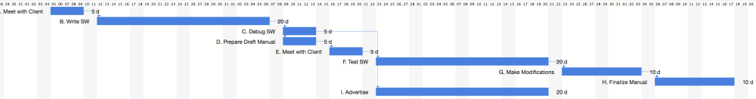  2. Drawing the Gantt chart of the actual plan (progress status)  The actual Gantt chart can be drawn by taking into account the information about delays, variations in duration, and actual completion. The main point of attention (when doing this work manually), is taking into account the constraints. Gantt charting tools, fortunately, can do this for us automatically.The following figure shows the two plans, the baseline (or initial) plan, shown in the lower part of each activity and the actual plan, shown in the upper part of each activity:  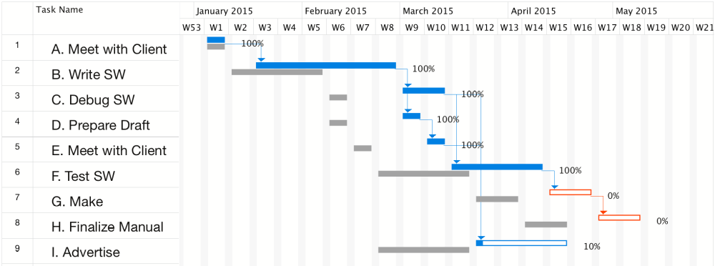  As it can ben seen, the delay on activity B delays all other activities in the plan. The activities  marked in red are in the critical path.  3. Perform the analysis (plot PV, AC, EV, CPI, SPI)  To perform the assessment, we start by computing and plotting PV, AC, and EV.PV is the sum of planned costs. It is computed by determining for each reporting period, the cost associated to each activity and by summing and cumulating them over time.The following table summarizes the planned costs over time. It is computed as follows:  • Each column of the table represents one week (we show only the first 13 weeks)  • The planned costs of each activity is taken from the first table of the question  • For each activity, we compute the weekly cost (activity cost / duration in weeks) and accrue  the cost for each week in which the activity lasts. For instance B has a total planned cost of  10000 and a duration of four weeks, from W2 to W5. Therefore we accrue 2500 in weeks  W2 to W5 for B.  • We then compute the cumulative costs, by summing planned expenditure week by week.  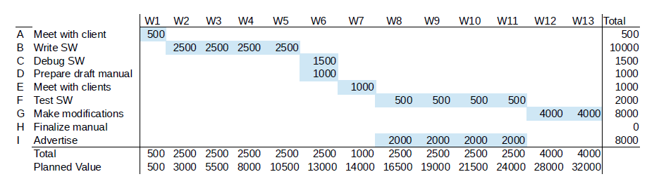  AC is the sum of the actual costs incurred into. It is computed by looking at the actual costs  when they took place. Similar to the previous case:  • For each activity, we look at its actual costs (second table of the question) and split them  evenly for the actual duration of the activity, up to the monitoring date (that is, the date in  which the analysis is performed)  The result is shown in the following table:  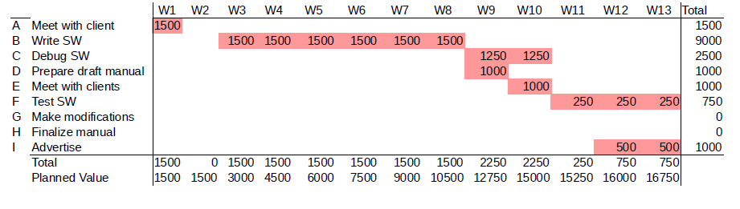  EV is the sum of the planned costs on the actual schedule.  There are different rules for computing EV. We use 50%-50% (50% of planned costs when an activity starts, the remaining 50%,when the activity ends.  The result is shown in the following table:  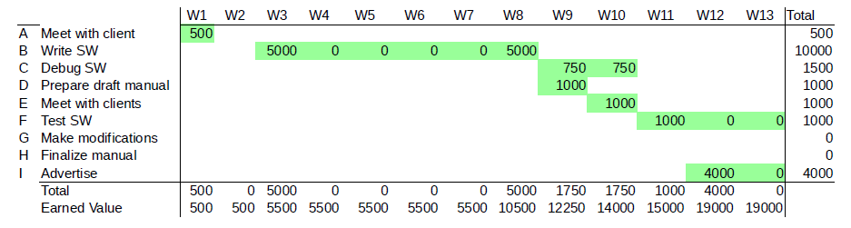  We can now plot all three values together. The result is shown in the following diagram:  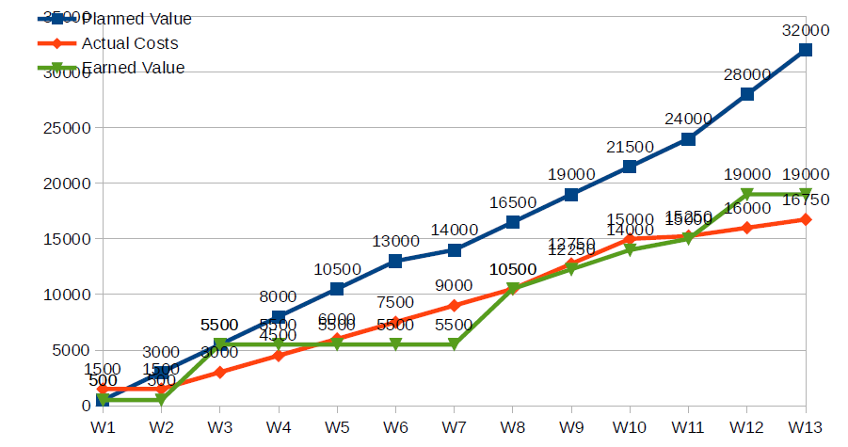  From the data at W13 we can observe the following:  • PV > AC indicates that the project is under budget. However, it might be under budget because of two reasons: it is, in fact, efficient or, alas, it is late (the expenditure has not yet  occurred, because activities did not start).  • EV < PV indicates that the project is late. At W13, in fact, the value we currently produced  is the one we should have had at W9.For more precise analyses about the project efficiency, we can compute CPI and SPI, which measure cost efficiency and schedule efficiency.  More in details: CPI = EV/AC, that is, how many dollars we produce (EV) for each dollar we  spend (AC). Clearly CPI > 1 is a good sign, while CPI < 1 indicates that the project is inefficient  and will probably end over budget.  The following graphs shows the behaviour of CPI over time. If we do not consider some noise (due to the 50%-50% rule, which causes, for instance, the peak at W3), we can see that CPI is getting close to 1, indicating that the project should end on budget, if the trend is confirmed.  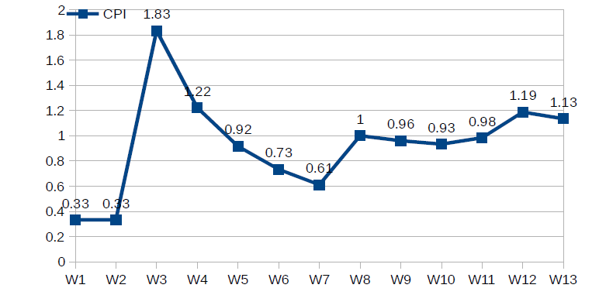  The SPI index measure the schedule: SPI = EV/PV and indicates how much we produce (EV) with respect to what we thought we would produce. Also in this case SPI > 1 is a good sign (ahead of schedule), while SPI < 1 indicates that the project is late. In our example we should expect SPI to be < 1, as it is, in fact, shown by the following diagram, which plots SPI over time:
12 | Consider an online book stores .It accepts individual/bulk orders, process payments ,triggers delivery of the books .some of the major features of the system include:  - Order books  - User friendly online shopping cart function  - Create ,view, modify and delete books to be sold  - To store inventory and sales information in database  - To provide an efficient inventory system  - Register for book payment options  - Add a wish list  - Place request for books not available  - To be able to print invoices to members and print a set of summary reports  - Internet access  Analyse the system using the context diagram and level 1 DFD for the system .Explain the components of DFD.(APR/MAY 17)  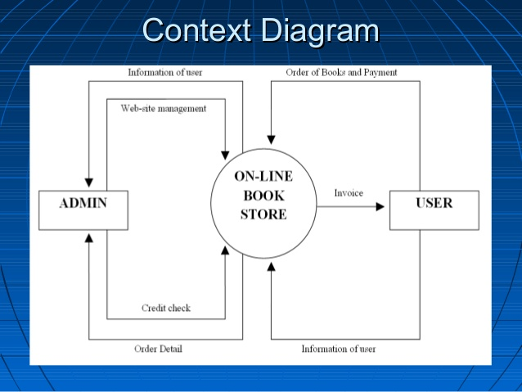  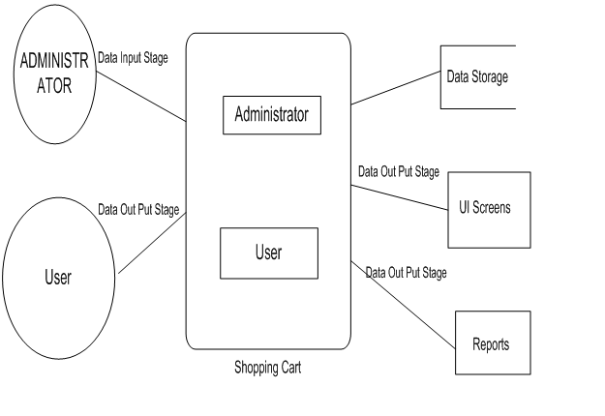  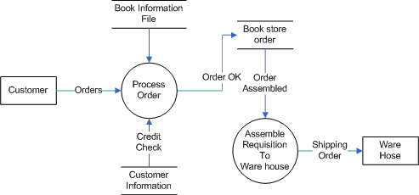  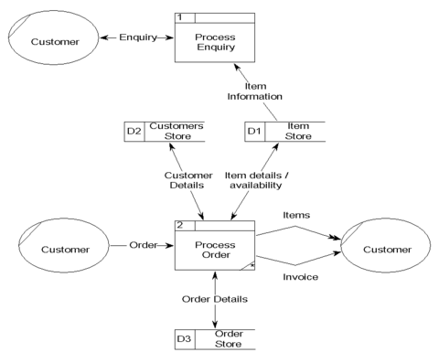  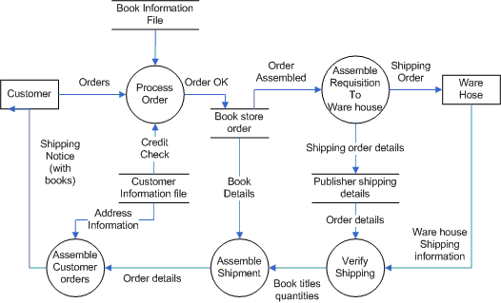
13 | Explain about the factors that cause difficulty in testing a software.  - Human factor. Due to human propensity to make mistakes, the software cannot be made perfectly without any bugs in it.  - Communication failure. This factor takes place in the different levels. Communication failure, such as miscommunication, lack of communication or incorrect communication can arise when the requirements are incomplete or indistinct, also when the code is modified for second time.  - Unreal development timeframe. The situations when tester doesn’t have enough information and his/her development schedule is limited by deadlines arise very often. It could lead to bad-quality and defective service.  - Poor design login. For today the software development is improved every day. So many applications need more time and brainstorming to high quality of the technical feasibility. So it is not because programmers are not smart enough; it’s just because they are not allow thinking and not have enough time.  - Poor coding practices. When lock of validation or missing error happen it could lead to arise of defects in the code. Poor tools, faulty debuggers, profiles, etc. make almost unavoidable for many programmers attracting defects and make it more difficult to debug.  - Lack of version control. Parallel version systems help tracking all changings in set of code base. If the programmer has not make sure that the recent version control system was available, bugs could still stay into the code.  - Buggy third-party tools. Very often the development process requires a lot of thirty-party tools, which may contain many defects in them. Such kind of bugs may in turn cause defects in the current software.  Lack of skilled testing. Nobody wants face it, but it is very important to have the seriousness for testing and enough skill’s base.
14 | Model a data flow diagram for a “Library Management System”.state functional requirement you are considering.(NOV/DEC 17)  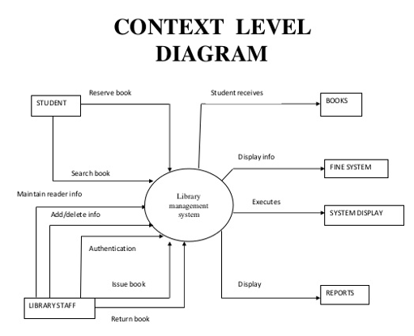
15 | If team A found 342 errors prior to release of software and Team B found 182 errors. What additional measures and metrics are needed to find out if the teams have removed the errors effectively? Explain.  DRE= E/(E+D) E- Error found before release  D- No.of Defect after release  DRE= 342/(342+182)= 342/524= 0.65  Since DRE is not equal to 1 there exists some defect in the software. DRE can also be used within the project to assess a team’s ability to find errors before they are passed to the next framework activity or software engineering task. For example, the requirements analysis task produces an analysis model that can be reviewed to find and correct errors. Those errors that are not found during the review of the analysis model are passed on to the design task (where they may or may not be found). When used in this context, we redefine DRE as  DREi = Ei/(Ei + Ei+1)  where Ei is the number of errors found during software engineering activity i and Ei+1 is the number of errors found during software engineering activity i+1 that are traceable to errors that were not discovered in software engineering activity i. A quality objective for a software team (or an individual software engineer) is to achieve DREi that approaches 1. That is, errors should be filtered out before they are passed on to the next activity.  Measures are:  All the errors are categorized and forwarded to respective team. Internal and external product metrics are measured based on the category of the error.  Example Metrics:  Defects per KLOC  Errors per FP or Defects per FP  Defect Density  Mean time to failure  Defect density  Customer problems  Customer satisfaction.
16 | Discuss the process of function point analysis. Explain function point analysis with sample cases for components of different complexity.  Decomposition for FP-based estimation focuses on information domain values rather than software functions, you would estimate inputs, outputs, inquiries, files, and external interfaces for the CAD software. For the purposes of this estimate, the complexity weighting factor is assumed to be average.  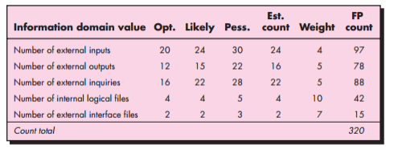  Each of the complexity weighting factors is estimated, and the value adjustment factor is computed as below.  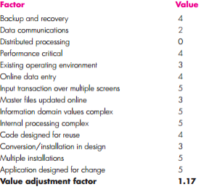  Finally, the estimated number of FP is derived: FP estimated count total [0.65 0.01 (Fi)] 375 The organizational average productivity for systems of this type is 6.5 FP/pm. Based on a burdened labor rate of $8000 per month, the cost per FP is approximately $1230. Based on the FP estimate and the historical productivity data, the total estimated project cost is $461,000 and the estimated effort is 58 person-months. The LOC and FP estimation techniques differ in the level of detail required for decomposition and the target of the partitioning. When LOC is used as the estimation variable, decomposition is absolutely essential and is often taken to considerable levels of detail. The greater the degree of partitioning, the more likely reasonably accurate estimates of LOC can be developed. For FP estimates, decomposition works differently. Rather than focusing on function, each of the information domain characteristics—inputs, outputs, data files, inquiries, and external interfaces—as well as the 14 complexity adjustment values discussed in Chapter 23 are estimated. The resultant estimates can then be used to derive an FP value that can be tied to past data and used to generate an estimate.

