UNIT I

PART A

1.what are the nine decisions in the design of data warehouse [NOV/DEC 2016]
The following nine-step method is followed in the design of a data warehouse:
1. Choosing the subject matter
2. Deciding what a fact table represents
3. Identifying and conforming the dimensions
4. Choosing the facts
5. Storing pre calculations in the fact table
6. Rounding out the dimension table
7. Choosing the duration of the db
8. The need to track slowly changing dimensions
9. Deciding the query priorities and query models

2.Define Star Schema [NOV/DEC 2016]

In computing, the star schema is the simplest style ofdata mart schema and is the approach most widely used to develop data warehouses and dimensionaldata marts. The star schema consists of one or more fact tables referencing any number of dimension tables.

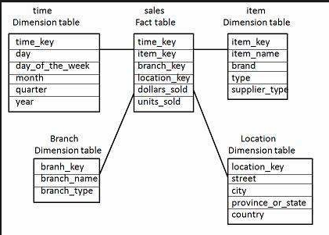
3. Define star schema and snowflake schema.[Nov 2014]

In star schema data warehouse contains 1) a large central table (fact table) containing the bulk of the data containing no redundancy and 2) set of smaller attendant tables (dimension tables) one for each dimension. The schema graph resembles a star burst with the denormalised dimension table displayed in a radial pattern around a central fact table. It may have any number of dimension tables and many-to-one relationship between the fact table and each dimension table.Snowflake schema is the further splitting of star schema dimension tables into one or more multiple normalized table thereby reducing the redundancy. A snowflake schema can have any number of dimensions and each dimension can have any number of levels.

- What are the advantages of dimensional modeling?[June 2014]

  - Single version of the truth
  - Data integration
  - Analyze on the fly
  - Drill up or drill down to any level of detail contained in the data
  - Maximize flexibility and scalability.
  - Optimize the end-user experience.

- What is the need for back end process in data warehouse design?[June 2014]or What is ETL process?Give its significance.[Dec 2013]
Extract – Transformation – Load(ETL) processes, which take place in the back stage of the data warehouse environment are data intensive, complex, and costly. The functionality of these processes includes:
(a) the identification of relevant information at the source side;
(b) the extraction

of this information;
(c) the transportation of this information from the sources to an intermediate place called Data Staging Area (DSA);
(d) the customization and integration of the information coming from multiple sources into a common format;
(e) the cleaning of the resulting data set, on the basis of database and business rules; and
(f) the propagation of the homogenized and cleansed data to the data warehouse and/or data marts.

- What is a Meta data?Give an example.[May 2011] [Dec 2013][Nov 2014] or Mention the role of meta data in a data warehouse.[June 2012]

Metadata are data about data. When used in data Warehouse, metadata are data that define warehouse objects. Meta data are created for the data names and definitions of the given warehouse. Metadata summarizes basic information about data, which can make finding and working with particular instances of data easier. For example, author, date created and date modified and file size are examples of very basic document metadata. Having the abilty to filter through that metadata makes it much easier for someone to locate a specific document.
The role of meta data is to specify data about data which will be like structure of data warehouse, background data. It is calssified into technical metadata and business metadata.

7. Define data cube. [May 2013]

A data cube allows data to be modeled and viewed in multiple dimensions. It is defined by dimensions and facts.

8. What is a dimension table? [Dec 2013]

Dimensions are perspectives or entities with respect to whish an organization wants to keep records. Each dimension may have a table associated with it called dimension table which further describes the dimension.

9. Define datawarehouse. [Dec 2013] [May 2012]

A data warehouse is a subject oriented, integrated, time-variant and nonvolatile collection of data in support of management’s decision making process. Data warehouse refers to a database that is maintained separately from an organization’s operational databases. They support information processing by providing a solid platform of consolidated historical data for analysis.

10.List the two ways the parallel execution of the tasks within SQL statements can be done.[Dec 2012]

The “partitioning of data” for parallel processing is commonly done in two basic, but fundamentally different ways. The main differentiation is whether or not physical data partitioning (placement) is used as a foundation – and therefore as static prerequisite – for parallelizing the work.

These fundamental conceptually different approaches are known as shared everything architecture and shared nothing architecture respectively.

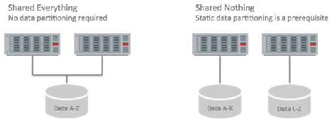

11. Define data mart. [Dec 2011] [May 2013]

A data mart is a department subset of the data warehouse that focuses on selected subjects and thus it is department-wide. For data marts star schema or snowflake schema is used since both are geared towards modeling single subjects although star schema is more popular and efficient.

12. State one of the biggest challenges when designing a data warehouse.[June 2013]

The biggest challenge when designing a data warehouse is the data placement and distribution. The data placement and distribution should consider factors like

  - Subject area

  - Location
  - Time

Distribution solves many problems but creates network related problems.

- What are the types of data partitioning? [May 2013]

  - Hash partitioning
  - Key range partitioning
  - Schema partitioning
  - Use defined partitioning

- What are the data design issues and technical isues in building data warehouse? [May 2013]
Heterogeneity of data sources, which affects data conversion, quality, timeliness.

Use of historical data, which implies that data may be “old”

Tendency of databases to grow very large

End user requirements and data sources will change.

Technical issues
The hardware platform that would house the data warehouse

The DBMS that supports the warehouse database

The communications infrastructure that connects the warehouse, data marts, operational systems, and end users.

The hardware platform and software to support the metadata repository.

- How is a data warehouse different from a database? How are they similar?[May 2012]
Data warehouse | Database
Online Analytical Processing | Online Transaction Processing
Data analysis and decision making | Day-to-day | operations | purchasing,
 | inventory, banking,payroll, registration etc.
Structure for corporate view of data | Structure to suite departmental view of data
Up-to-date driven | Query driven
Similarity

Both store data and information. Data warehouse is a repository of multiple heterogeneous data sources, organized under a unified schema at a single site in order to facilitate management decision-making.

Database consists of a collection of interrelated data.

- Why data transformation is essential in the process of knowledge discovery? [June 2012][May 2011]

In this step, data is transformed or consolidated into forms appropriate for mining by performing summary or aggregation operations. Methods here include dimension reduction (such as feature selection and extraction and record sampling), and attribute transformation (such as discretization of numerical attributes and functional transformation). This step can be crucial for the success of the entire KDD project, and it is usually very project-specific. For example, in medical examinations, the quotient of attributes may often be the most important factor, and not each one by itself.

- List the three important issues that have to be considered during data integration.[Nov 2011]
The three important issues to be addresses during integration are

    - Schema integration and object matching

    - Redundancy

    - Detection and resolution of data value conflict.

- Define data transformation. [May 2011]

Data transformation from one format to another on the basis of possible differences between the source and the target platforms. Ex: calculating age from the date of birth, replacing a possible numeric gender code with a more meaningful “male” and “female”.

- Give the major features of data warehouse. [April/May 2010]
Subject-oriented, integrated, time-variant and nonvolatile.

- Give the data warehouse applications.[May 2008]
Information processing, analytical processing, data mining,decision mining

21. Define facts.

A multidimensional data model is typically organized around a central theme and the theme is represented by a fact table. Facts are numerical measures. Fact table contains the names of the facts and keys to each of the related dimension tables.

22. Give the advantages and disadvantages of snowflake schema.

Advantage: Dimension table are kept in a normalized form and thus it is easy to maintain and saves the storage space.

Disadvantage: It reduces the effectives of browsing since more join is needed to execute a query.

23. Define fact constellation.

Sophisticated applications may require multiple fact tables to share dimension tables. This kind of schema can be viewed as a collection of stars and hence it is called as galaxy schema or fact constellation.

- List the steps involved in Warehouse design process
Choose a business process to model
Choose the grain of the business process
Choose the dimensions
Choose the measures.

25.What are the approaches for building a data warehouse? Or How can we design a data warehouse?
A data warehouse can be designed using a top-down approach, bottom-up approach, or a combination of both. In combined approach an organization can exploit the planned strategic nature of top-down approach while retaining the rapid implementation and opportunistic approach of the bottom-up approach.

The top-down approach: Meaning that an organization has developed an enterprise data model, collected enterprise wide business requirements, and decided to build an enterprise data warehouse with subset data marts. The top-down approach starts with overall design and planning.

The bottom-up approach: Implying that the business priorities resulted in developing individual data marts, which are then integrated into the enterprise data warehouse. The bottom-up approach starts with experiments and prototypes.

26.What a metadata repository should contain?

A metadata repository should contain the following:
A description of the structure of the data warehouse.

Operational Meta data.

Algorithms used for summarization

Mapping from operational environment to data warehouses.

Data related to system performance.

Business Meta data.

- What are the nine steps involed in the design of a data warehouse?

  - Choosing the subject matter
  - deciding what a fact table represents
  - Identofying and confirming the dimensions
  - choosing the facts
  - storing precalculations in the table
  - rounding out the dimension table
  - choosing the duration of the table
  - the need to track slowly changing dimensions
  - deciding the query priorities and the query modes.

28.What are the components of datawarehousing?
  - Sourcing, Acquisition, cleanup, and transformation tools
  - Repository
  - Data warehouse database
4. Data mart
5.Applications and tools
6.Management platform
7.Information delivery systems

29. Compare data mart and data warehouse.

Data mart is a department subset of a data warehouse. It focuses on selected subjects and thus its scope is department wide. On the other hand data warehouse collects information about subjects that span an entire organization and thus its scope is department wide.

30.Explain the different types of data repositories on which mining can be performed?[Nov 2014]
The different types of data repositories on which mining can be performed are:

●Relational Databases ●DataWarehouses

●Transactional Databases ●Advanced Databases
●Flat files
  - World Wide Web

31.Explain in detail the DBMS Schema for decision support
Multidimensional data model
Star Schema

DBA Viewpoint
Performance problems of star schema

Solutions to the Problems
Star join and Star index
Bitmap indexing

UNIT I
PART B

1.Explain seven components of Data warehouse architecture with neat diagram [NOV/DEC 2016]

Overall Architecture
The data warehouse architecture is based on the data base management system server.
The central information repository is surrounded by number of key components
Data warehouse is an environment, not a product which is based on relational database management system that functions as the central repository for informational data.
The data entered into the data warehouse transformed into an integrated structure and format. The transformation process involves conversion, summarization, filtering and condensation.
The data warehouse must be capable of holding and managing large volumes of data as well as different structure of data structures over the time.
Key components
1. Data sourcing, cleanup, transformation, and migration tools
2. Metadata repository
3. Warehouse/database technology
4. Data marts
5. Data query, reporting, analysis, and mining tools
6. Data warehouse administration and management
7. Information delivery system

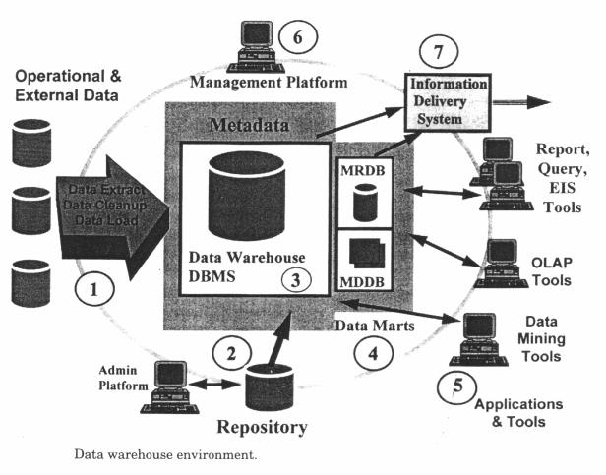
1. Data warehouse database
This is the central part of the data warehousing environment.
This is implemented based on RDBMS technology.
2 Sourcing, Acquisition, Clean up, and Transformation Tools
They perform conversions, summarization, key changes, structural changes
The data transformation is required to use by decision support tools.
The transformation produces programs, control statements.
It moves the data into data warehouse from multiple operational systems. The functionalities of these tools are listed below:
To remove unwanted data from operational db
Converting to common data names and attributes
Calculating summaries and derived data
Establishing defaults for missing data
Accommodating source data definition changes

3. Meta data
It is data about data. It is used for maintaining, managing and using the data warehouse. It is classified into two:
Technical Meta data: It contains information about data warehouse data used by warehouse designer, administrator to carry out development and management tasks. It includes,
Info about data stores
Transformation descriptions. That is mapping methods from operational db to warehouse db
Warehouse Object and data structure definitions for target data
The rules used to perform clean up, and data enhancement
Data mapping operations
Access authorization, backup history, archive history, info delivery history, data acquisition history, data access etc.,
Business Meta data: It contains info that gives info stored in data warehouse to users. It includes,
Subject areas, and info object type including queries, reports, images, video, audio clips etc.
Internet home pages
Info related to info delivery system
Data warehouse operational info such as ownerships, audit trails etc.,
Meta data helps the users to understand content and find the data. Meta data are stored in a separate data stores which is known as informational directory or Meta data repository which helps to integrate, maintain and view the contents of the data warehouse.
The following lists the characteristics of info directory/ Meta data:
It is the gateway to the data warehouse environment
It supports easy distribution and replication of content for high performance and availability
It should be searchable by business oriented key words
It should act as a launch platform for end user to access data and analysis tools
It should support the sharing of info
It should support scheduling options for request
It should support and provide interface to other applications
It should support end user monitoring of the status of the data warehouse environment
4 Access tools
Its purpose is to provide info to business users for decision making. There are five categories:

Data query and reporting tools
Application development tools
Executive info system tools (EIS)
OLAP tools
Data mining tools
Query and reporting tools: used to generate query and report. There are two types of reporting tools. They are:
Production reporting tool used to generate regular operational reports
Desktop report writer are inexpensive desktop tools designed for end users.
Managed Query tools: used to generate SQL query. It uses Meta layer software in between users and databases which offers a point-and-click creation of SQL statement.
Application development tools: This is a graphical data access environment which integrates OLAP tools with data warehouse and can be used to access all db systems.
OLAP Tools: Are used to analyze the data in multi dimensional and complex views.
Data mining tools: are used to discover knowledge from the data warehouse data

5 Data marts
It is inexpensive tool and alternative to the data ware house. it based on the subject area
. Data mart is used in the following situation:
Extremely urgent user requirement
The absence of a budget for a full scale data warehouse strategy
The decentralization of business needs
6. Data warehouse admin and management
The management of data warehouse includes,
Security and priority management
Monitoring updates from multiple sources
Data quality checks
Managing and updating meta data
Auditing and reporting data warehouse usage and status
Purging data
Replicating, sub setting and distributing data
Backup and recovery
Data warehouse storage management which includes capacity planning, hierarchical storage management and purging of aged data etc.,
7 Information delivery system
• It is used to enable the process of subscribing for data warehouse info.
• Delivery to one or more destinations according to specified scheduling algorithm

- Discuss DBMS schemas for decision support. Describe performance problems with star schema [NOV/DEC 2016]

DBMS Schemas for Decision Support

1. Data layout for business access

All industries have developed considerable expertise in implementing efficient operational systems such as payroll, inventory tracking, and purchasing. the original objectives in developing an abstract model known as the relational model.
The relational model is based on mathematical principals. The existing relational database management ( RDBMSs) offer power full solution for a wide variety of commercial and scientific applications
The data warehouse RDBMS typically needs to process queries that are large complex, ad hoc, and data intensive. so data warehouse RDBMS are very different ,it use a database schema for maximizing concurrency and optimizing insert, update, and delete performance
For solving modern business problems such as market analysis and financial forecasting requires query-centric database schemas that are array oriented and multidimensional in nature.

2. Multidimensional data model
Note –need write about Multidimensional data model

3. Star schema
Note –need write about star schema

3.1 DBA view point

A star schema is a relational schema organized around a central table joined to few smaller tables (dimension tables)using foreign key references
The fact table contains raw numeric items that represent relevant business facts (price,dicont values, number of units sold,dollar sold,dollar vaue,etc
The fact are accessed via dimensions since fact tables are pre summarized and aggregated along business dimensions
The dimension table defines business dimension in terms already familiar to user.the dimension table contain a non compound primary key and are heavily indexed and these table are grouped and joined with fact table using foreign key references.
A star schema created for every industry
3.2 Potential performance problem with star schemas
Indexing
It improve the performance in the star schema design
The table in star schema design contain the entire hierarchy of attributes(PERIOD dimension this hierarchy could be day->week->month->quarter->year),one approach is to create multi part key of day, week, month ,quarter ,year .it presents some problems in the star schema model because it should be in normalized
Problems
It require multiple metadata definitions
Since the fact table must carry all key components as part of its primary key, addition or deletion of levels in the physical modification of the affected table.
Carrying all the segments of the compound dimensional key in the fact table increases the size of the index, thus impacting both performance and scalability.

Solutions
One alternative to the compound key is to concatenate the key into a single key for the attributes (day, week, month, quarter, year) this is used to solve the first above two problems.
The index is remains problem the best approach is to drop the use of meaningful keys in favor of using an artificial, generated key which is the smallest possible key that will ensure the uniqueness of each record

Level indicator
Problems
Another potential problem with the star schema design is that in order to navigate the dimensions successfully.
The dimensional table design includes a level of hierarchy indicator for every record.
Every query that is retrieving detail records from a table that stores details & aggregates must use this indicator as an additional constraint to obtain a correct result.

Solutions
The best alternative to using the level indicator is the snowflake schema
The snowflake schema contains separate fact tables for each level of aggregation. So it is Impossible to make a mistake of selecting product detail. The snowflake schema is even more complicated than a star schema.
Other problems with the star schema design:
The next set of problems is related to the relational DBMS engine & optimization technology.
Pairwise problem:
The traditional OLAP RDBMS engines are not designed for the set of complex queries that can be issued against a star schema.
We need to retrieve related information from several query in a single query has several limitation
Many OLTP RDBMS can join only two tables, so the complex query must be in the RDBMS needs to break the query into series of pairwise joins. And also provide the intermediate result. this process will be do up to end of the result
Thus intermediate results can be large & very costly to create. It affects the query performance. The number of ways to pairwise join a set of N tables is N!( N factorial) for example.
The query has five table 5!=(6x5x4x3x2x1)=120 combinations.

Star schema join problem:
Because the number of pairwise join combinations is often too large to fully evaluate many RDBMS optimizers limit the selection on the basis of a particular criterion. In data warehousing environment this strategy is very inefficient for star schemas.
In a star schema the only table directly related to most other tables in the fact table this means that the fact table is natural candidate for the first pairwise join
Unfortunately the fact table is typically the very largest table in the query. A pairwise join order generates very large intermediate result set. So it affects query performance.
3.3 Solution to performance problems:
A common optimization provides some relief for the star schema join problem.
The basic idea of this optimization is to get around the pairwise join strategy of selecting only related tables.
When two tables are joined and no columns ―link‖ the tables every combination of two tables’ rows are produced. In terms of relational algebra this is called a Cartesian product.
Normally the RDBMS optimizer logic would never consider Cartesian product but star schema considering these Cartesian products. Can sometimes improve query.
Alternatively it is a Cartesian product of all dimension tables is first generated.
The key cost is the need to generate the Cartesian product of the dimension tables as long as the cost of generating the Cartesian product is less than the cost of generating intermediate results with the fact table.

4. STARjoin and STARindex
A STARjoin is a high-speed, single-pass, parallelizable multitable joins, and Brick’s RDBMS can join more than two tables in a single operation.
Red Brick’s RDBMS supports the creation of specialized indexes called STARindexes. It created on one or more foreign key columns of a fact table.

5. Bitmapped indexing
The new approach to increasing performance of a relational DBMS is to use innovative indexing techniques to provide direct access to data. SYBASE IQ uses a bit mapped index structure. The data stored in the SYBASE DBMS.

5.1 SYBASE IQ- it is based on indexing technology; it is a stand alone database.
Overview: It is a separate SQL database. Data is loaded into a SYBASE IQ very much as into any relational DBMS once loaded SYBASE IQ converts all data into a series of bitmaps which are than highly compressed to store on disk.

Data cardinality:
Data cardinality bitmap indexes are used to optimize queries against a low cardinality data.
That is in which-The total no. of potential values in relatively low. Example: state code data cardinality is 50 potential values and general cardinality is only 2 ( male to female) for low cardinality data.

The each distinct value has its own bitmap index consisting of a bit for every row in a table, if the bit for a given index is ―on‖ the value exists in the record bitmap index representation is a 10000 bit long vector which has its bits turned on(value of 1) for every record that satisfies ―gender‖=‖M‖ condition‖
Bit map indexes unsuitable for high cardinality data

Another solution is to use traditional B_tree index structure. B_tree indexes can often grow to large sizes because as the data volumes & the number of indexes grow.

B_tree indexes can significantly improve the performance,
SYBASE IQ was a technique is called bitwise (Sybase trademark) technology to build bit map index for high cardinality data, which are limited to about 250 distinct values for high cardinality data.

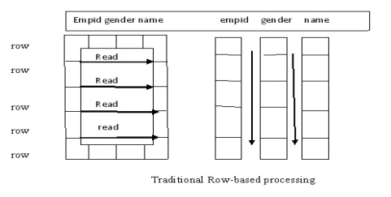

Index types:

The first of SYBASE IQ provide five index techniques, Most users apply two indexes to every column.
The default index called projection index and other is either a low or high – cardinality index. For low cardinality data SYBASE IQ provides.
Low fast index: it is optimized for queries involving scalar functions like SUM,AVERAGE,and COUNTS.
Low disk index which is optimized for disk space utilization at the cost of being more CPU-intensive.

Performance:
SYBAEE IQ technology achieves the very good performance on adhoc quires for several reasons
Bitwise technology: this allows various types of data type in query. And support fast data aggregation and grouping.
Compression: SYBAEE IQ uses sophisticated algorithms to compress data in to bit maps.

Optimized m/y based programming: SYBASE IQ caches data columns in m/y according to the nature of user’s queries, it speed up the processor.
Column wise processing: SYBASE IQ scans columns not rows, it reduce the amount of data. the engine has to search.
Low overhead: An engine optimized for decision support SYBASE IQ does not carry on overhead associated with that. Finally OLTP designed RDBMS performance.
Large block I/P: Block size of SYBASE IQ can turn from 512 bytes to 64 Kbytes so system can read much more information as necessary in single I/O.
Operating system-level parallelism: SYBASE IQ breaks low level like the sorts, bitmapmanipulation, load, and I/O, into nonblocking operations.
Projection and ad hoc join capabilities: SYBASE IQ allows users to take advantage of known join relation relationships between tables by defining them in advance and building indexes between tables.

Shortcomings of indexing:-
The user should be aware of when choosing to use SYBASE IQ include
No updates-SYNBASE IQ does not support updates .the users would have to update the source database and then load the update data in SYNBASE IQ on a periodic basis.

Lack of core RDBMS feature:-Not support all the robust features of SYBASE SQL server, such as backup and recovery
Less advantage for planned queries: SYBASE IQ, run on preplanned queries.
High memory usage: Memory access for the expensive i\o operation
SYBASE IQ promise increased performance without deploying expensive parallel hardware system.

6. Column local storage:-

It is an another approach to improve query performance in the data warehousing environment
For example thinking machine operation has developed an innovative data layout solution that improves RDBMS query performance many times. Implemented in its CM_SQL RDBMS product, this approach is based on storing data columnwise as opposed to traditional row wise approach.

In figure-.(Row wise approach) This approach works well for OLTP environment in which a typical transaction accesses a record at a time. However in data warehousing the goal is to retrieve multiple values of several columns.

For example if a problem is to calculate average minimum, maximum salary the column wise storage of the salary field requires a DBMS to read only one record.(use Column –wise approach)
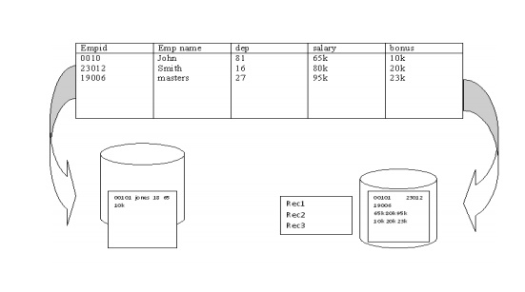

7. Complex data types:-

The best DBMS architecture for data warehousing has been limited to traditional alphanumeric data types. But data management is the need to support complex data types, Include text, image, full-motion video &sound.
Large data objects called binary large objects what’s required by business is much more than just storage:
The ability to retrieve the complex data type like an image by its content. The ability to compare the content of one image to another in order to make rapid business decision and ability to express all of this in a single SQL statement.

The modern data warehouse DBMS has to be able to efficiently store, access and manipulate complex data. The DBMS has to be able to define not only new data structure but also new function that manipulates them and often new access methods, to provide fast and often new access to the data.
An example of advantage of handling complex data types is a insurance company that wants to predict its financial exposure during a catastrophe such as flood that wants to support complex data.

Data Warehouse Scheme
i) Star scheme is the multidimensional view of data that is expressed using relational database semantics provided by the database schema. It is organized around a central table (fact table) joined to a few smaller tables (dimension table) using foreign key references.
- There are three basic elements in the dimensional model projected by star scheme;
(1) a central table called the fact table,
(2) two or more smaller tables called the dimensional tables, and
(3) and a set of relationships called the star join.

Figure 1: Components of star scheme
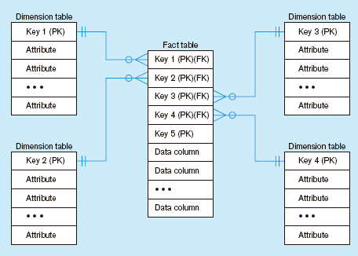

The basic premise of star schema can be divided into :
i) facts – core data elements being analyzed. Fact tables contains raw numeric items that represent relevant business facts such as units of individual items sold, dollars sold and dollars cost. Facts table are presummarized and aggregated along business dimensions.
ii) dimensions – attributed about the facts. Dimension table defines business dimensions contains a non compound primary key. Example of dimensions tables are the product purchased and the period of purchase. Dimensions table typically represents the majority of data elements and are heavily indexed.

Figure 2: Star schema example (sales)
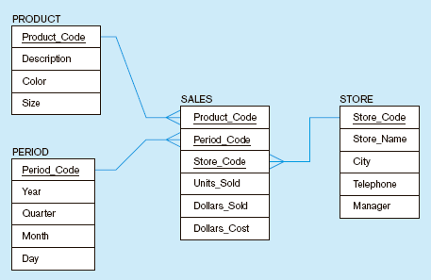
Fact table provides statistics for sales broken down by product, period and store dimensions

- In the typical star schema, the fact table is much larger than any of its dimensions tables. This point becomes an important consideration of the performance issues associated with star schemas.

- In a typical business analysis problem: Find the share of total sales represented by each product in different markets, categories and periods, compared with the same period a year ago. To do so, you could calculate the percentage – each number is of the total of its column, a simple and common concept.
- However, in a classic relational database these calculations and display would require definition of a separate view, requiring over 20 SQL commands. The star schema is designed to overcome this limitation of the 2 dimensional relational models.
- A star schema can be created for every industry – consumer packaged goods, retail, telecommunications, transportation, insurance, health care, manufacturing, banking etc.

Figure 3: Star schema with sample data
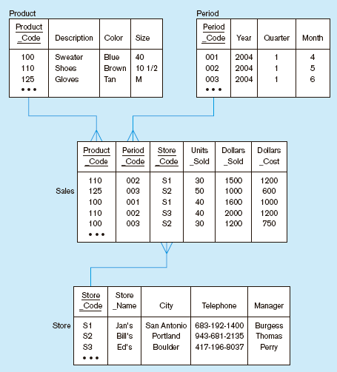

Potential performance problems with star schemas
Although most experts agree that star schemas are the preferred modeling method for data warehousing, there are numbers of issues associated with its implementation:
i) Indexing problem
- requires multiple metadata definitions adds to design complexity and slowness in performance
- addition and deletion of levels in the hierarchy will require physical modification of the affected table, which is a time-consuming process that limits flexibility
- increases size of index, thus impacting both performance and scalability.
* solution – to make sure for one dimensions only have one key column
ii) Level indicator problem
iii) Pair wise join problem
iv) Star schema join problem

3. Define data warehouse. Explain its features. Diagrammatically illustrate and discuss the data warehouses architecture [May 2011] [Dec 2011][Nov 2014] or Explain the multi-tier architecture suitable for evolving a data warehouse with suitable diagram. [Dec 2013] [May 2012] [May 2010]
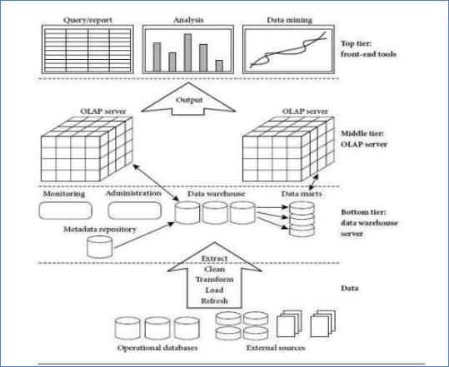

BOTTOM TIER: It is a warehouse database server. Data is fed using Back end tools and utilities. Data extracted using programs called gateways. It also contains Meta data repository.

MIDDLE TIER: The middle tier is an OLAP server that is typically implemented using either(1) a relational OLAP (ROLAP) model, that is, an extended relational DBMS that maps operations on multidimensional data to standard relational operations.

TOP TIER: The top tier is a front-end client layer, which containsquery and reporting tools, analysis tools, and/or datamining tools.
A common way of introducing data warehousing is to refer to the characteristics of a data warehouse.
Subject Oriented
Integrated
Nonvolatile
Time Variant

Subject Oriented:

Data warehouses are designed to help you analyze data. For example, to learn more about your company's sales data, you can build a warehouse that concentrates on sales. Using this warehouse, you can answer questions like "Who was our best customer for this item last year?" This ability to define a data warehouse by subject matter, sales in this case, makes the data warehouse subject oriented.

Integrated:

Integration is closely related to subject orientation. Data warehouses must put data from disparate sources into a consistent format. They must resolve such problems as naming conflicts and inconsistencies among units of measure. When they achieve this, they are said to be integrated.

Nonvolatile:

Nonvolatile means that, once entered into the warehouse, data should not change. This is logical because the purpose of a warehouse is to enable you to analyze what has occurred.

Time Variant:

In order to discover trends in business, analysts need large amounts of data. This is very much in contrast to online transaction processing (OLTP) systems, where performance requirements demand that historical data be moved to an archive. A data warehouse's focus on change over time is what is meant by the term time variant.

3.Explain the role played by sourcing, acquisition, cleanup, and transformation tools in building a data warehouse. [May 2013]

The data sourcing, cleanup, transformation and migration tools perform all of the conversions, summarizations, key changes, structural changes and condensations needed to transform disparate data into information that can be used by the decision support tool. Data Integration includes combining several source records into a single record to be loaded into the warehouse. Data transformation means converting data from one format to another on the basis of possible differences between the source and the target platforms.A significant portion of the implementation effort is spent extracting data from operational systems and putting it in a format suitable for informational applications that run off the data warehouse.

The data sourcing, cleanup, transformation and migration tools perform all of the conversions, summarizations, key changes, structural changes and condensations needed to transform disparate data into information that can be used by the decision support tool. They produce the programs and control statements, including the COBOL programs, MVS job-control language (JCL), UNIX scripts, and SQL data definition language (DDL) needed to move data into the data warehouse for multiple operational systems. These tools also maintain the meta data. The functionality includes:

Removing unwanted data from operational databases
Converting to common data names and definitions
Establishing defaults for missing data
Accommodating source data definition changes

The data sourcing, cleanup, extract, transformation and migration tools have to deal with some significant issues including:

Database heterogeneity. DBMSs are very different in data models, data access language, data navigation, operations, concurrency, integrity, recovery etc.

Data heterogeneity. This is the difference in the way data is defined and used in different models homonyms, synonyms, unit compatibility (U.S. vs metric), different attributes for the same entity and different ways of modeling the same fact.

These tools can save a considerable amount of time and effort. However, significant shortcomings do exist. For example, many available tools are generally useful for simpler data extracts. Frequently, customized extract routines need to be developed for the more complicated data extraction procedures.

4.List and Discuss the steps involved in mapping the data warehouse to a multiprocessor architecture. [May 2011] [Dec 2011][Nov 2014]

The goals of linear performance and scalability can be satisfied by parallel hardware architectures, parallel operating systems, and parallel DBMSs. Parallel hardware architectures are based on Multi-processor systems designed as a Shared-memory model, Shared-disk model or distributed-memory model.

Parallelism can be achieved in three different ways:1.Horizontal Parallelism (Database is partitioned across different disks) 2.Vertical Parallelism (occurs among different tasks – all components query operations i.e. scans, join, sort) 3.Data Partitioning

Shared-memory Architecture- multiple processors share the main memory space, as well as mass storage (e.g. hard disk drives) Shared Disk Architecture - each node has its own main memory, but all nodes share mass storage, usually a storage area network Shared-nothing Architecture - each node has its own mass storage as well as main memory

5.i) Describe the steps involved in the design and construction of data warehouses.[June 2012][Dec 2012]

In general, building any data warehouse consists of the following steps:
  - Extracting the transactional data from the data sources into a staging area

  - Transforming the transactional data

  - Loading the transformed data into a dimensional database

  - Building pre-calculated summary values to speed up report generation

  - Building (or purchasing) a front-end reporting tool
- Suppose that the data for analysis includes the attribute age. The age values for the data tuples

are (in increasing order):13, 15, 16, 16, 19, 20, 20, 21, 22, 22, 25, 25, 25, 25, 30, 33, 33, 35, 35, 35, 35, 36, 40, 45, 46, 52, 70.

1.Use smoothing by bin means to smooth the above data, using a bin depth of 3. Illustrate your steps. Comment on the effect of this technique for the given data.

Step 1: Sort the data (this step is not required here as the data is already sorted.) Step 2: Partition the data into equidepth bins of depth 3
Bin 1: 13, 15, 16 | Bin 2: 16,19,20 |  | Bin 3: 20, 21, 22
Bin 4: 22, 25, 25 | Bin 5: | 25,25,30 | Bin 6: 33, 33, 35
Bin 7: 35, 35, 35 | Bin 8: | 36, 40, 45 | Bin 9: 46, 52, 70
Step 3: calculate the arithmetic mean of each bin

Step 4: Replace each of the values in each bin by the arithmetic mean calculated for the bin.

Bin 1: 44/3, 44/3, 44/3 | Bin 2: 55/3, 55/3, 55/3 | Bin 3: 21, 21, 21
Bin 4: 24, 24, 24 | Bin 5: 80/3, 80/3, 80/3 | Bin 6: 101/3, 101/3, 101/3
Bin 7: 35, 35, 35 | Bin 8: 121/3, 121/3, 121/3 | Bin 9: 56, 56, 56

6.i) How do datawarehousing and OLAP relate to data mining? Explain.[Dec 2012]

OLAP and data mining are used to solve different kinds of analytic problems:

OLAP provides summary data and generates rich calculations. For example, OLAP answers questions like "How do sales of mutual funds in North America for this quarter compare with sales a year ago? What can we predict for sales next quarter? What is the trend as measured by percent change?"

Data mining discovers hidden patterns in data. Data mining operates at a detail level instead of a summary level. Data mining answers questions like "Who is likely to buy a mutual fund in the next six months, and what are the characteristics of these likely buyers?"

OLAP and data mining can complement each other. For example, OLAP might pinpoint problems with sales of mutual funds in a certain region. Data mining could then be used to gain insight about the behavior of individual customers in the region. Finally, after data mining predicts something like a 5% increase in sales, OLAP can be used to track the net income. Or, Data Mining might be used to identify the most important attributes concerning sales of mutual funds, and those attributes could be used to design the data model in OLAP.

- Explain metadata in detail. Classify metadata and explain the same. [May 2013]

Metadata is simply defined as data about data. The data that are used to represent other data is
known as metadata.
Metadata is a road map to data warehouse.
Metadata in data warehouse define the warehouse objects.
The metadata act as a directory: This directory helps the decision support system to locate the

contents of data warehouse.

Categories of Metadata:The metadata can be broadly categorized into three categories:

- Business Metadata - This metadata has the data ownership information, business definition and changing policies.

- Technical Metadata - Technical metadata includes database system names, table and column names and sizes, data types and allowed values. Technical metadata also includes structural information such as primary and foreign key attributes and indices.

- Operational Metadata - This metadata includes currency of data and data lineage.Currency of data means whether data is active, archived or purged. Lineage of data means history of data migrated and transformation applied on it.

Role of Metadata

Metadata has very important role in data warehouse. The role of metadata in warehouse is different from the warehouse data yet it has very important role. The various roles of metadata are explained below.

The metadata act as a directory.
This directory helps the decision support system to locate the contents of data warehouse.

Metadata helps in decision support system for mapping of data when data are transformed from operational environment to data warehouse environment.

Metadata helps in summarization between current detailed data and highly summarized data.
Metadata also helps in summarization between lightly detailed data and highly summarized data.
Metadata are also used for query tools.
Metadata are used in reporting tools.
Metadata are used in extraction and cleansing tools.
Metadata are used in transformation tools.
Metadata also plays important role in loading functions.

Metadata Repository

The Metadata Repository is an integral part of data warehouse system. The Metadata Repository has the following metadata:

Definition of data warehouse - This includes the description of structure of data warehouse. The description is defined by schema, view, hierarchies, derived data definitions, and data mart locations and contents.

Business Metadata - This metadata has the data ownership information, business definition and changing policies.

Operational Metadata - This metadata includes currency of data and data lineage. Currency of data means whether data is active, archived or purged. Lineage of data means history of data migrated and transformation applied on it.

Data for mapping from operational environment to data warehouse - This metadata includes source databases and their contents, data extraction,data partition cleaning, transformation rules, data refresh and purging rules.

The algorithms for summarization - This includes dimension algorithms, data on granularity, aggregation, summarizing etc.

Challenges for Metadata Management

The importance of metadata can not be overstated. Metadata helps in driving the accuracy of reports, validates data transformation and ensures the accuracy of calculations. The metadata also enforces the consistent definition of business terms to business end users. With all these uses of Metadata it also has challenges for metadata management. The some of the challenges are discussed below.

The Metadata in a big organization is scattered across the organization. This metadata is spreaded in spreadsheets, databases, and applications.

The metadata could present in text file or multimedia file. To use this data for information management solution, this data need to be correctly defined.

There are no industry wide accepted standards. The data management solution vendors have narrow focus.

There is no easy and accepted methods of passing metadata.

7.Draw any two multidimensional schemas suitable for representing weather data and give their advantages and disadvantages.[Dec 2013]

A number of data models have been proposed to conceptually model the multi-dimensional data maintained in the warehouse. These include the star schema, the snowflake schema, and the fact constellation schema. Since our data model, the cascaded star model, is an extension of the star model, in the following, we present these three models with examples, and bring out the limitations of these models in representing the data in our spatial data warehouse.

The Star Schema

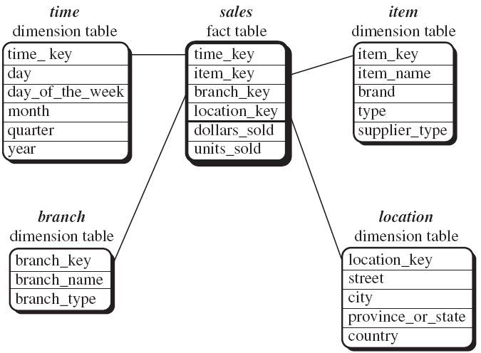

Perhaps, star schema, first introduced by Ralph Kimball, is the earliest schema used to model the data warehouse implemented as a relational databases. In this schema, the data warehouse contains a large central table (fact table) containing the bulk of data (dimensions) with no redundancy, and a set of smaller attendant tables (dimension tables) with one for each dimension. The schema graph resembles a starburst, with the dimension tables displayed in a radial pattern around the central fact table, as shown in Figure 4, where A is the fact table, and b, c, d, e and f are dimensions and represented by dimensional tables.

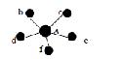

The Star Model

Note that in the star schema, only one dimension table represents each dimension, and each dimension table contains a set of attributes and joins with fact table by common keys when implemented as a relational database. Moreover, the attributes within a dimension table may form either a hierarchy (total order) or a lattice (partial order). Currently, most traditional data strong support for OLAP operations.
Suppose the multi-dimensional data for the weather in northeast region in USA consists of four dimensions: temperature, precipitation, time, and region_name, and three measures: region_map, area, and count, where region_map is a spatial measure which represents a collection of spatial pointers pointing to corresponding regions, area is a numerical measure which represents the sum of the total areas of the corresponding spatial objects, and count is a numerical measure which represents the total number of base regions accumulated in the corresponding cell.

8.Explain mapping of datawarehouse architecture to multiprocessor architecture.

Relational data base technology for data warehouse
Linear Speed up: refers the ability to increase the number of processor to reduce response time
Linear Scale up: refers the ability to provide same performance on the same requests as the database size increases

1.1 Types of parallelism
Inter query Parallelism: In which different server threads or processes handle multiple requests at the same time.
Intra query Parallelism: This form of parallelism decomposes the serial SQL query into lower level operations such as scan, join, sort etc. Then these lower level operations are executed concurrently in parallel.
Intra query parallelism can be done in either of two ways:
· Horizontal parallelism: which means that the data base is partitioned across multiple disks and parallel processing occurs within a specific task that is performed concurrently on different processors against different set of data
· Vertical parallelism: This occurs among different tasks. All query components such as scan, join, sort etc are executed in parallel in a pipelined fashion. In other words, an output from one task becomes an input into another task.
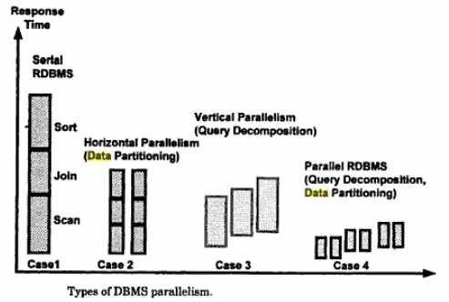

1.2 Data partitioning:
Data partitioning is the key component for effective parallel execution of data base operations. Partition can be done randomly or intelligently.
Random portioning:
· Includes random data striping across multiple disks on a single server.
· Another option for random portioning is round robin fashion partitioning in which each record is placed on the next disk assigned to the data base.
Intelligent partitioning:
Assumes that DBMS knows where a specific record is located and does not waste time searching for it across all disks. The various intelligent partitioning include:
· Hash partitioning: A hash algorithm is used to calculate the partition number based on the value of the partitioning key for each row
· Key range partitioning: Rows are placed and located in the partitions according to the value of the partitioning key. That is all the rows with the key value from A to K are in partition 1, L to T are in partition 2 and so on.
· Schema portioning: an entire table is placed on one disk; another table is placed on different disk etc. This is useful for small reference tables.
· User defined portioning: It allows a table to be partitioned on the basis of a user defined expression.
·2. Data base architectures of parallel processing
There are three DBMS software architecture styles for parallel processing:
1. Shared memory or shared everything Architecture
2. Shared disk architecture
3. Shred nothing architecture

2.1 Shared Memory Architecture:
Tightly coupled shared memory systems, illustrated in following figure have the following
characteristics:
· Multiple PUs share memory.
· Each PU has full access to all shared memory through a common bus.
· Communication between nodes occurs via shared memory.
· Performance is limited by the bandwidth of the memory bus.
· It is simple to implement and provide a single system image, implementing an RDBMS on
SMP(symmetric multiprocessor)
A disadvantage of shared memory systems for parallel processing is as follows:
· Scalability is limited by bus bandwidth and latency, and by available memory.

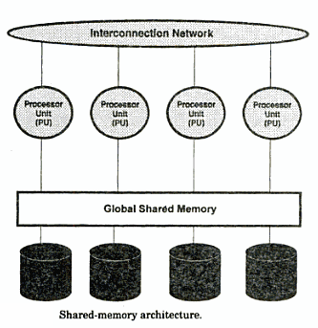

2.2 Shared Disk Architecture
Shared disk systems are typically loosely coupled. Such systems, illustrated in following figure,
have the following characteristics:
· Each node consists of one or more PUs and associated memory.
· Memory is not shared between nodes.
· Communication occurs over a common high-speed bus.
· Each node has access to the same disks and other resources.
· A node can be an SMP if the hardware supports it.
· Bandwidth of the high-speed bus limits the number of nodes (scalability) of the system.
. The Distributed Lock Manager (DLM ) is required.
Parallel processing advantages of shared disk systems are as follows:
· Shared disk systems permit high availability. All data is accessible even if one node dies.
· These systems have the concept of one database, which is an advantage over shared nothing systems.
· Shared disk systems provide for incremental growth. Parallel processing disadvantages of shared disk systems are these:
· Inter-node synchronization is required, involving DLM overhead and greater dependency on high-speed interconnect.
· If the workload is not partitioned well, there may be high synchronization overhead.
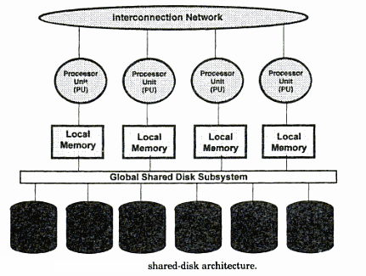
2.3 Shared Nothing Architecture
· Shared nothing systems are typically loosely coupled. In shared nothing systems only one
CPU is connected to a given disk. If a table or database is located on that disk
· Shared nothing systems are concerned with access to disks, not access to memory.
· Adding more PUs and disks can improve scale up.
· Shared nothing systems have advantages and disadvantages for parallel processing:
Advantages
· Shared nothing systems provide for incremental growth.
· System growth is practically unlimited.
· MPPs are good for read-only databases and decision support applications.
· Failure is local: if one node fails, the others stay up.
Disadvantages
· More coordination is required.
· More overhead is required for a process working on a disk belonging to another node.
· If there is a heavy workload of updates or inserts, as in an online transaction processing system, it may be worthwhile to consider data-dependent routing to alleviate contention.

9.Explain Bitmap indexing with an example.
The new approach to increasing performance of a relational DBMS is to use innovative indexing
techniques to provide direct access to data. SYBASE IQ uses a bit mapped index structure. The data stored in the SYBASE DBMS.
5.1 SYBASE IQ- it is based on indexing technology; it is a stand alone database.
Overview: It is a separate SQL database. Data is loaded into a SYBASE IQ very much as into any relational DBMS once loaded SYBASE IQ converts all data into a series of bitmaps which are than highly compressed to store on disk.
Data cardinality:
Data cardinality bitmap indexes are used to optimize queries against a low cardinality data.
That is in which-The total no. of potential values in relatively low. Example: state code data cardinality is 50 potential values and general cardinality is only 2 ( male to female) for low cardinality data.
The each distinct value has its own bitmap index consisting of a bit for every row in a table, if the bit for a given index is ―on‖ the value exists in the record bitmap index representation is a 10000 bit long vector which has its bits turned on(value of 1) for every record that satisfies ―gender‖=‖M‖ condition‖
Bit map indexes unsuitable for high cardinality data
Another solution is to use traditional B_tree index structure. B_tree indexes can often grow to large sizes because as the data volumes & the number of indexes grow.
B_tree indexes can significantly improve the performance,
SYBASE IQ was a technique is called bitwise (Sybase trademark) technology to build bit map index for high cardinality data, which are limited to about 250 distinct values for high cardinality data.
Index types:
The first of SYBASE IQ provide five index techniques, Most users apply two indexes to every column.The default index called projection index and other is either a low or high – cardinality index. For low cardinality data SYBASE IQ provides.Low fast index: it is optimized for queries involving scalar functions like SUM,AVERAGE,and COUNTS.
Low disk index which is optimized for disk space utilization at the cost of being more CPU- intensive.
Performance.
SYBASE IQ technology achieves the very good performance on adhoc quires for several reasons
Bitwise technology: this allows various types of data type in query. And support fast data aggregation and grouping.
Compression: SYBAEE IQ uses sophisticated algorithms to compress data in to bit maps.
Optimized m/y based programming: SYBASE IQ caches data columns in m/y according to the nature of user’s queries, it speed up the processor.
Columnwise processing: SYBASE IQ scans columns not rows, it reduce the amount of data. the engine has to search.
Low overhead: An engine optimized for decision support SYBASE IQ does not carry on overhead associated with that. Finally OLTP designed RDBMS performance.
Large block I/P: Block size of SYBASE IQ can turned from 512 bytes to 64 Kbytes so system can read much more information as necessary in single I/O.
Operating system-level parallelism: SYBASE IQ breaks low level like the sorts, bitmap manipulation, load, and I/O, into nonblocking operations.
Projection and ad hoc join capabilities: SYBASE IQ allows users to take advantage of known join relation relationships between tables by defining them in advance and building indexes between tables.
Shortcomings of indexing:-
The user should be aware of when choosing to use SYBASE IQ include
No updates-SYNBASE IQ does not support updates .the users would have to update the source database and then load the update data in SYNBASE IQ on a periodic basis.
Lack of core RDBMS feature:-Not support all the robust features of SYBASE SQL server, such as backup and recovery
Less advantage for planned queries: SYBASE IQ, run on preplanned queries.
High memory usage: Memory access for the expensive i\o operation
5.2 Conclusion:-
SYBASE IQ promise increased performance without deploying expensive parallel hardware system.
6. Column local storage:-
It is an another approach to improve query performance in the data warehousing environment
For example thinking machine operation has developed an innovative data layout solution that improves RDBMS query performance many times. Implemented in its CM_SQL RDBMS product, this approach is based on storing data columnwise as opposed to traditional row wise approach.
In figure-.(Row wise approach) This approach works well for OLTP environment in which a typical transaction accesses a record at a time. However in data warehousing the goal is to retrieve multiple values of several columns.
For example if a problem is to calculate average minimum, maximum salary the columnwise storage of the salary field requires a DBMS to read only one record.(use Column –wise approach)

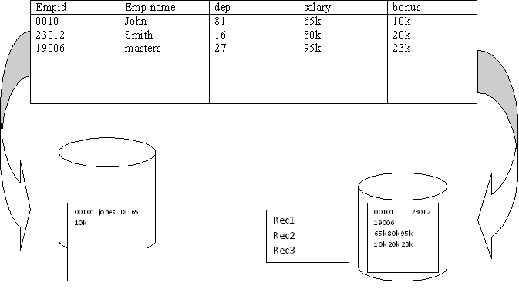
7. Complex data types:-
The best DBMS architecture for data warehousing has been limited to traditional alphanumeric data types. But data management is the need to support complex data types , Include text, image, full-motion video &sound.
Large data objects called binary large objects what’s required by business is much more than just storage:
The ability to retrieve the complex data type like an image by its content. The ability to compare the content of one image to another in order to make rapid business decision and ability to express all of this in a single SQL statement.
The modern data warehouse DBMS has to be able to efficiently store, access and manipulate complex data. The DBMS has to be able to define not only new data structure but also new function that manipulates them and often new access methods, to provide fast and often new access to the data.
An example of advantage of handling complex data types is a insurance company that wants to predict its financial exposure during a catastrophe such as flood that wants to support complex data.

UNIT II
PART A
- List OLAP guidelines[Nov/Dec 2016] [Dec 2013]

  - Multidimensional conceptual view: The OLAP should provide an appropriate multidimensional Business model that suits the Business problems and Requirements.
  - Transparency: The OLAP tool should provide transparency to the input data for the users.

  - Accessibility: The OLAP tool should only access the data required only to the analysis needed.

  - Consistent reporting performance: The Size of the database should not affect in any way the performance.

  - Client/server architecture: The OLAP tool should use the client server architecture to ensure better performance and flexibility.

- Comment on OLAP tools on internet [Nov/Dec 2016]

  - The internet is a virtually free resource which provides a universal connectivity within and between companies.

  - The web eases complex administrative tasks of managing distributed environments.

  - The web allows companies to store and manage both data and applications on servers that can be centrally managed, maintained, and updated, thus eliminating problems with software and data currency.

- What are the categories of decision support tools?[Nov 2014]

  - Reporting
  - Managed query

  - Executive information systems
  - On-line analytical processing
  - Data mining

- What is the use of reporting tools? [May 2013]

  - Reporting tools can be divided into production reporting tools and desktop report writers. Production reporting tools will let companies generate regular operational reports or support high volume batch jobs, such as calculating and printing paychecks. Desktop tools designed for end users.

- Define metalayer.

  - Managed query tools shield end users from the complexities of SQL and database structures by inserting a matalayer between users and the database. Metalayer is the software that provides subject-oriented views of a database and supports point-and-click creation of SQL.
- Define EIS.

  - Executive Information Systems (EIS) tools predate report writers and managed query tools; they were first deployed on mainframes. EIS tools allow developers to build customized, graphical decision support application. That gives managers and executives a high-level view of the business and access to external resources.

- What is the use of OLAP tools?

  - Online Analytical Processing (OLAP) tools provide an intuitive way to view corporate data. These tools aggregate data along common business subjects or dimensions and then let users navigate through the hierarchies and dimensions with the click of a mouse button. Users can drill down, across, or up levels in each dimension or pivot and swap out dimensions to change their view of the data.

- What is the use of Cognos Impromptu tool?

  - Impromptu is the database reporting tool that exploits the power of the database, while offering complete control over all reporting within the enterprise. Users access Impromptu through its easy-to-use graphical user interface. Impromptu has been well received by users because querying and reporting are unified in one interface, and the users can get meaningful views of corporate data quickly and easily.

- What are the special reporting options in Impromptu tool?

    - Picklists and prompts

    - Custom templates

    - Exception reporting

    - Interactive reporting

    - Frames

- What are the features of Impromptu tool?
  - Unified query and reporting interface

  - Object oriented architecture

  - Complete integration with powerplay

  - Database independent catalogs.

- What is the need of OLAP?

  - Modern business problems need query centric database schemas that are array oriented and multidimensional in nature. The characteristics of such problems are:

  - i)Need to retrieve large number of records from very large datasets ii) summarize the data on the fly.

  - To solve these problems OLAP is needed. Eg:Solving modern business problems such as market analysis and financial forecasting requires query-centric database schemes that are array-oriented and multidimensional in nature. These business problems need OLAP to retrieve large number of records. from very large data sets and summarize them.

- List the OLAP operations used in multidimensional data model.
  - Roll-up, drill-down, slice and dice, pivot (rotate)

- List the categories of OLAP tools. [May 2011][Dec 2013]
  - MOLAP (Multidimensional OLAP)

  - ROLAP (Relational OLAP).

  - Hybrid OLAP (HOLAP)

  - Web OLAP

- Differentiate MOLAP and OLAP. [Dec 2013]

MOLAP: In this type of OLAP, a cube is aggregated from the relational data source (data warehouse). When user generates a report request, the MOLAP tool can generate the create quickly because all data is already pre-aggregated within the cube.

- ROLAP: In this type of OLAP, instead of pre-aggregating everything into a cube, the ROLAP engine essentially acts as a smart SQL generator. The ROLAP tool typically comes with a 'Designer' piece, where the data warehouse administrator can specify the relationship between the relational tables, as well as how dimensions, attributes, and hierarchies map to the underlying database tables.

- Differentiate multidimensional and multirelational OLAP.

  - Relational implementations of multidimensional database systems are referred to as multirelational database systems. To achieve the required speed, these products use the star or snowflake schemas – specially optimized and denormalized data models that involve data restructuring and aggregation.

- List out the two different types of reporting tools.[June 2014]
a)production reporting tools
b)Desktop report writer

- Define Data cube.[June 2013]
A data cube refers is a three-dimensional (3D) (or higher) range of values that are generally used to explain the time sequence of an image's data. It is a data abstraction to evaluate aggregated data from a variety of viewpoints. A data cube can also be described as the multidimensional extensions of two-dimensional tables. It can be viewed as a collection of identical 2-D tables stacked upon one another. Data cubes are used to represent data that is too complex to be described by a table of columns and rows. As such, data cubes can go far beyond 3-D to include many more dimensions.

- Define OLAP.[June 2014]
OLAP can be defined as computer-based techniques used to analyze trends and perform business analysis using multidimensional views of business data. OLAP (online analytical processing) enables a user to easily and selectively extract and view data from different points of view.

- What are the features of first generation web enabled data access.

  - Web sites used a static distribution model, in which clients access static HTML pages via web browsers. In this model, the decision support reports were stored as HTML documents and delivered to users on request.

- What are the features of second generation and third generation web enabled data access. Second generation

  - Web sites support interactive database queries by utilizing a multitiered architecture in which a web client submits a query in the form of HTML encoded request to a web server, which in turn transforms the request for structured data into a CGI scripts.

  - Third generation

  - Web sites replace HTML gateways with web based application servers. These servers can download java applets or ActiveX applications that can execute on clients, or interact with corresponding applets running on the server.

- What is Virtual Warehouse?[Dec 2014]

  - The view over an operational data warehouse is known as a virtual warehouse. It is easy to build a virtual warehouse. Building a virtual warehouse requires excess capacity on operational database servers.

- Name some OLAP tools. [Dec 2013]
  - Arbor’sEssbase, Oracle Express, Planning Sciences’ Gentia, Kenan Technologies’ Acumate ES.

- What are the various approaches for deploying OLAP tools on the web?

  - HTML publishing

  - Helper applications

  - Plug-ins

  - Server-centric components

  - Java and ActiveX applications

- Define OLTP systems.

  - The major task of online operational database system is to perform online transaction and query processing. These systems are called On Line Transaction Processing (OLTP) systems. They cover most of the day-to-day operations of an organization such as purchasing, inventory, manufacturing and banking.

- What is the need of tools for applications?

  - Easy-to-use

  - Point-and-click tools accept SQL or generate SQL statements to query relational data stored in the warehouse

  - Tools can format the retrieved data into easy-to-read reports

- What is apex cuboid?Give Example.[May 2011][Dec 2011]

  - The 0-D cuboid which holds the highest level of summarization is called the apex cuboid. The apex cuboid is typically denoted by all.

- What is multidimensional database?[Dec 2011]

A multidimensional database (MDB) is a type of database that is optimized for data warehouse and online analytical processing (OLAP) applications. Multidimensional databases are frequently created using input from existing relational databases.

- What is time series analysis?[June 2012]

Time series analysis comprises methods for analyzing time series data in order to extract meaningful statistics and other characteristics of the data. Time series forecasting is the use of a model to predict future values based on previously observed values.

- What is a reporting tool?[Dec 2012]

  - Reporting is one of the most important part of performance management process. It's data presentation performed to allow target make more efficient decisions. Reporting tool enable business users without technical knowledge to extract corporate data, analyze it and assemble reports.

- Give examples for managed query tools.[Dec 2012]

  - IQ Software’s IQ Objects, Andyne Computing Ltd’s GQL,IBM’s Decision server,Oracle Corp’s Discoverer/2000, Speedware Corp’s Esperant.

- What are production reporting tools? Give examples[June 2013]

Third Generation Language COBOL, Fourth generation language

Information Builder, Focus, Client server tools MITI’s SQR.

UNIT II
PART B
- Discuss different tool categories in data warehouse business analysis [Nov/Dec 2016]

TOOL CATEGORIES IN DATA WAREHOUSE BUSINESS ANALYSIS
· Data Cleansing,
· Data Transformation and Load,
· Data Access and Analysis (Query),
· Report Writing.
Data Cleansing Tools
Tools in this category typically analyze, standardize, and consolidate data (i.e., “scrub” data) from disparate legacy systems. Techniques such as lexical analysis, statistical matching, and pattern processing are used to clean data prior to migrating data to the data warehouse.
Data Transformation and Load Tools
These tools convert data from source system formats into formats used in the data warehouse. Various data formats and notations are transformed into a standard notation within the data warehouse (e.g., a common notation to which all data can be translated).
The tools are also used to load integrated data to various types of target databases, including mainframe and client/server platforms.
Data Access and Analysis (Query) Tools
Access and analysis tools can be further subdivided into the following three categories: data dipping, data analysis, and data mining.
Data dippers are basic business tools that allow for generation of standard reports and queries. Data dippers perform simple analysis to answer standard business questions such as how many sales occurred last week or how many new customers were added last month. These tools typically use metadata to distance users from data warehouse complexities and to provide a user-friendly interface.
On-line analytical processing (OLAP) tools provide complex on-line analysis against live data. These tools are designed to process large amounts of data and perform business analysis such as budgeting and forecasting, profitability analysis, tax planning and financial consolidations. OLAP tools provide multi-dimensional analysis, the ability to calculate ratios and variances, and the ability to display results in various formats (e.g., 2D and 3D cross-tabs, charts, and graphs). There are three distinct categories of OLAP tools, each of which is used to solve different business problems.
Multi-dimensional OLAP (MOLAP) tools were the first OLAP tools to be developed. The tools typically create data cubes (three-dimensional views of data versus traditional relational views) to be used to efficiently analyze data. Large amounts of summarized data are used to provide efficient response times. Data (and metadata) administration and deployment are controlled from a central location.
Database OLAP (DOLAP) tools create portable data that can be accessed and analyzed via user desktops. Data is typically extracted from the warehouse, formatted (e.g., dimensional data is assembled into cubes), and then provided to users. DOLAP tools are also becoming more effective at distributing data using mechanisms such as e-mail and the web (Web OLAP or WOLAP). These tools are very useful for providing data to users who are disconnected from the network (e.g., notebook computers used by travelling sales staff).
As data warehouses continued to grow, it became clear that MOLAP databases could not be used to maintain massive amounts of data. Relational OLAP (ROLAP) tools and databases have been developed to address this problem. Multi-dimensional front ends are used to process information in a relational format. Tools allow for the transformation of two-dimensional data into multi-dimensional information. ROLAP is frequently implemented when users need to analyze large amounts of current data.
Data mining tools are used to analyze data to find trends and patterns within data and relationships between data. Artificial intelligence and neural networks are frequently used to create competitive intelligence by finding connections in data that may not be readily obvious (e.g., people who buy product A from a company are more inclined to buy product B). Business analysts who use data mining tools are typically very familiar with the data being searched.
Report Writing Tools
These tools provide a permanent record of the business at a specific point in time, in standard formats. Report writers typically offer a variety of attractive formats that are often used to present information to executives and other decision makers. It is also standard for these tools to produce reports in HTML format, providing the ability to have reports viewed from web sites. Users within a wide distribution can then access reports using a web browser, without the need for any special software to be installed on user workstations.
Reports are frequently produced by data specialists so a commitment to building a report “library” will increase the benefits to be obtained from these tools.

- Explain the categories of OLAP tools. [May 2013]or Discuss the architecture of MOLAP and ROLAP.[DEC 2012] or compare multidimensional OLAP(MOLAP) and multirelational OLAP(ROLAP)[June 2014] or With relevant examples discuss multidimensional online analytical processing(MOLAP) and multirelational online analytical processing(ROLAP). [May 2011]

MOLAP

This is the more traditional way of OLAP analysis. In MOLAP, data is stored in a multidimensional cube. The storage is not in the relational database, but in proprietary formats. That is, data stored in array-based structures.

Advantages:

Excellent performance: MOLAP cubes are built for fast data retrieval, and are optimal for slicing and dicing operations.

Can perform complex calculations: All calculations have been pre-generated when the cube is created. Hence, complex calculations are not only doable, but they return quickly.

Disadvantages:

Limited in the amount of data it can handle: Because all calculations are performed when the cube is built, it is not possible to include a large amount of data in the cube itself. This is not to say that the data in the cube cannot be derived from a large amount of data. Indeed, this is possible. But in this case, only summary-level information will be included in the cube itself.

Requires additional investment: Cube technology are often proprietary and do not already exist in the organization. Therefore, to adopt MOLAP technology, chances are additional investments in human and capital resources are needed.
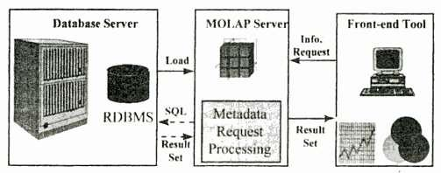

Examples: Hyperion Essbase, Fusion (Information Builders)

ROLAP
This methodology relies on manipulating the data stored in the relational database to give the appearance of traditional OLAP's slicing and dicing functionality. In essence, each action of slicing and dicing is equivalent to adding a "WHERE" clause in the SQL statement. Data stored in relational tables

Advantages:

Can handle large amounts of data: The data size limitation of ROLAP technology is the limitation on data size of the underlying relational database. In other words,

ROLAP itself places no limitation on data amount.

Can leverage functionalities inherent in the relational database: Often, relational database already comes with a host of functionalities. ROLAP technologies, since they sit on top of the relational database, can therefore leverage these functionalities.
Disadvantages:

Performance can be slow: Because each ROLAP report is essentially a SQL query (or multiple SQL queries) in the relational database, the query time can be long if the underlying data size is large.

Limited by SQL functionalities: Because ROLAP technology mainly relies on generating SQL statements to query the relational database, and SQL statements do not fit all needs (for example, it is difficult to perform complex calculations using SQL), ROLAP technologies are therefore traditionally limited by what SQL can do. ROLAP vendors have mitigated this risk by building into the tool out-of-the-box complex functions as well as the ability to allow users to define their own functions.

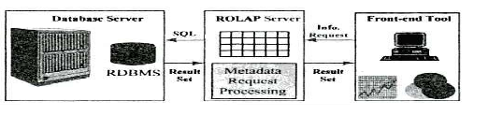
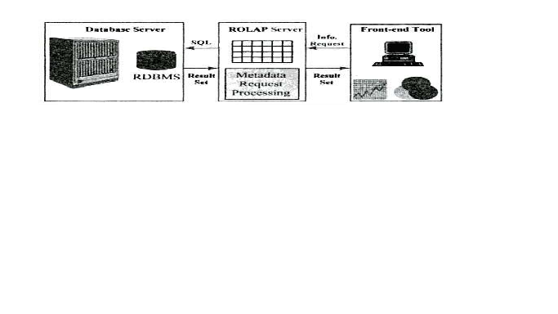
Examples: Microstrategy Intelligence Server, MetaCube (Informix/IBM)

HOLAP (MQE: Managed Query Environment)

HOLAP technologies attempt to combine the advantages of MOLAP and ROLAP. For summary-type information, HOLAP leverages cube technology for faster performance. It stores only the indexes and aggregations in the multidimensional form while the rest of the data is stored in the relational database.
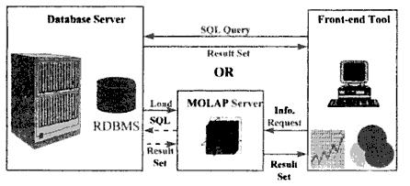

Examples: PowerPlay (Cognos), Brio, Microsoft Analysis Services, Oracle Advanced Analytic

Services

- Summarize the major differences between OLTP and OLAP system design [Nov/Dec 2016]
Differentiate OLTP and OLAP. [Nov 2014] [June 2012][Dec 2011].

OLTP stands for On Line Transaction Processing and is a data modeling approach typically used to facilitate and manage usual business applications. Most of applications you see and use are OLTP based. OLTP technology used to perform updates on operational or transactional systems (e.g., point of sale systems)

OLAP stands for On Line Analytic Processing and is an approach to answer multi-dimensional queries. OLAP was conceived for Management Information Systems and Decision Support Systems. OLAP technology used to perform complex analysis of the data in a data warehouse.

4. Describe about Cognos Impromptu [Nov/Dec 2016]
Explain the features of the reporting and query tool COGNOS IMPROMPTU. [Dec 2013][May 2011][Dec 2012]
Impromptu is an interactive database reporting tool. It allows Power Users to query data without
programming knowledge. It is only capable of reading the data.
Impromptu's main features includes,
· Interactive reporting capability
· Enterprise-wide scalability

Impromptu stores metadata in subject related folders.. A catalog contains:
• Folders-meaningful groups of information representing columns from one or more tables
• Columns-individual data elements that can appear in one or more folders
• Calculations-expressions used to compute required values from existing data
• Conditions-used to filter information so that only a certain type of information is displayed
• Prompts-pre-defined selection criteria prompts that users can include in reports they create
• Other components, such as metadata, a logical database name, join information, and user classes
You can use catalogs to
• view, run, and print reports
• export reports to other applications
• disconnect from and connect to the database
• create reports
• change the contents of the catalog
• add user classes
Prompts
You can use prompts to
• filter reports • calculate data items • format data
Picklist Prompts
A picklist prompt presents you with a list of data items from which you select one or more values,
so you need not be familiar with the database. The values listed in picklist prompts can be retrieved from
· a database via a catalog when you want to select information that often changes.
· a column in another saved Impromptu report, a snapshot, or a HotFile
A report can include a prompt that asks you to select a product type from a list of those available in the database. Only the products belonging to the product type you select are retrieved and displayed in your report.
Reports
Reports are created by choosing fields from the catalog folders. This process will build a
SQL (Structured Query Language) statement behind the scene. No SQL knowledge is required to use Impromptu. The data in the report may be formatted, sorted and/or grouped as needed. Titles, dates, headers and footers and other standard text formatting features (italics, bolding, and font size) are also available.
Once the desired layout is obtained, the report can be saved to a report file.
This report can then be run at a different time, and the query will be sent to the database. It is also possible to save a report as a snapshot. This will provide a local copy of the data. This data will not be updated when the report is opened.
Cross tab reports, similar to Excel Pivot tables, are also easily created in Impromptu.
Frame-Based Reporting
Frames are the building blocks of all Impromptu reports and templates. They may contain report
objects, such as data, text, pictures, and charts.
There are no limits to the number of frames that you can place within an individual report or template. You can nest frames within other frames to group report objects within a report.
Different types of frames and its purpose for creating frame based reporting
· Form frame: An empty form frame appears.
· List frame: An empty list frame appears.
· Text frame: The flashing I-beam appears where you can begin inserting text.
· Picture frame: The Source tab (Picture Properties dialog box) appears. You can use this tab to select the image to include in the frame.
· Chart frame: The Data tab (Chart Properties dialog box) appears. You can use this tab to select the data item to include in the chart.
· OLE Object: The Insert Object dialog box appears where you can locate and select the file you want to insert, or you can create a new object using the software listed in the Object Type box.
Impromptu features
· Unified query and reporting interface: It unifies both query and reporting interface in a single user interface
· Object oriented architecture: It enables an inheritance based administration so that more than 1000 users can be accommodated as easily as single user
· Complete integration with PowerPlay: It provides an integrated solution for exploring trends and patterns
· Scalability: Its scalability ranges from single user to 1000 user
· Security and Control: Security is based on user profiles and their classes.
· Data presented in a business context: It presents information using the terminology of the business.
· Over 70 pre defined report templates: It allows users can simply supply the data to create an interactive report
· Frame based reporting: It offers number of objects to create a user designed report
· Business relevant reporting: It can be used to generate a business relevant report through filters, pre conditions and calculations
· Database independent catalogs: Since catalogs are in independent nature they require minimum maintenance
5.List out the OLAP operations in multidimensional data model and explain with an example.[Dec 2009] [May 2013][Nov 2014]

In the multidimensional data model, data are organized into multiple dimensions, and each dimension contains multiple levels of abstraction defined by concept hierarchies. This organization provides users with the flexibility to view data from different perspectives.

Ex: At the centre of the figure is a data cube for AllElectronics sales. The cube contains dimensions location, time and item, where location is aggregated with respect to city values, time is aggregated with respect to quarters and item is aggregated with respect to item types. The measure displayed is dollars_sold ( in thousands).

Roll-up: The roll-up operation performs aggregation on a data cube, either by climbing up a concept hierarchy for a dimension or by dimension reduction. The fig shows the result of a roll-up operation performed on the central cube by climbing up the concept hierarchy for the location from the level of city to the level of country. In other words, rather than grouping the data by city, the resulting cube groups the data by country.

Drill-down: It is the reverse of roll-up. It can be realized by either stepping down a concept hierarchy for a dimension or introducing additional dimensions. In the fig. drill-down occurs by descending the time hierarchy from the level of quarter to the more detailed level of month. The resulting data cube details the total sales per month rather than summarized by quarter. Slice and dice: The slice operation performs a selection on one dimension of the given cube, resulting a sub cube.

6.Compare multidimensional OLAP(MOLAP) and multirelational OLAP(ROLAP)[June 2014]

MOLAP vs ROLAP

Sr.No. | MOLAP | ROLAP
1 | Information retrieval is fast. | Information retrieval is
 |  | comparatively slow.
2 | Uses sparse array to store | Uses relational table.
 | data-sets.
3 | MOLAP is best suited for | ROLAP is best suited for
 | inexperienced users, since it | experienced users.
 | is very easy to use.
4 | Maintains a separate database | It may not require space other
 | for data cubes. | than available in the Data
 |  | warehouse.
5 | DBMS facility is weak. | DBMS facility is strong.

7.Explain the OLAP tool with the internet.

Web sites used a static distribution model, in which clients access static HTML pages via web browsers. In this model, the decision support reports were stored as HTML documents and delivered to users on request. Web sites support interactive database queries by utilizing a multitiered architecture in which a web client submits a query in the form of HTML encoded request to a web server, which in turn transforms the request for structured data into a CGI scripts. Web sites replace HTML gateways with web based application servers. These servers can download java applets or ActiveX applications that can execute on clients, or interact with corresponding applets running on the server.

8.Explain OLAP guidelines.

Dr. E.F. Codd the “father” of the relational model, created a list of rules to deal with the OLAP systems. Users should priorities these rules according to their needs to match their business requirements (reference 3). These rules are:

- Multidimensional conceptual view: The OLAP should provide an appropriate multidimensional Business model that suits the Business problems and Requirements.

- Transparency: The OLAP tool should provide transparency to the input data for the users.

- Accessibility: The OLAP tool should only access the data required only to the analysis needed.

- Consistent reporting performance: The Size of the database should not affect in any way the performance.

- Client/server architecture: The OLAP tool should use the client server architecture to ensure better performance and flexibility.

- Generic dimensionality: Data entered should be equivalent to the structure and operation requirements.

- Dynamic sparse matrix handling: The OLAP too should be able to manage the sparse matrix and so maintain the level of performance.

- Multi-user support: The OLAP should allow several users working concurrently to work together.

- Unrestricted cross-dimensional operations: The OLAP tool should be able to perform operations across the dimensions of the cube.

- Intuitive data manipulation. “Consolidation path re-orientation, drilling down across columns or rows, zooming out, and other manipulation inherent in the consolidation path outlines should be accomplished via direct action upon the cells of the analytical model, and should neither require the use of a menu nor multiple trips across the user interface.”(Reference 4)

- Flexible reporting: It is the ability of the tool to present the rows and column in a manner suitable to be analyzed.

- Unlimited dimensions and aggregation levels: This depends on the kind of Business,

9.List and discuss the basic features that are provided by reporting and query tools used for business analysis. [May 2011] [Dec 2011]
Production reporting tool used to generate regular operational reports, Desktop report writer are inexpensive desktop tools designed for end users.

Application development tools:This is a graphical data access environment which integrates OLAP tools with data warehouse and can be used to access all db systems OLAP Tools: are used to analyze the data in multi dimensional and complex views. To enable multidimensional properties it uses MDDB and MRDB where MDDB refers multi dimensional data base and MRDB refers multi relational data bases.

Data mining tools:are used to discover knowledge from the data warehouse data also can be used for data visualization and data correction purposes.

Reporting features:
Topline results

Simple cross tables
Interlocking cross breaks(e.g. age by gender - male/18-24)
View data in tabular and graphical formats (i.e. as tables or charts)

Report exportable to Excel and/or PowerPoint
Multiple reports exportable to Excel

Charts exportable to Powerpoint
Report features
Statistical tests

Score values can be applied to variable to compute mean scores

T-tests (significance testing)

Report formatting

Hide blank rows columns

Show row column percentages

Show or hide counts
Show indices

10.Describe multidimensional data model in detail.[June 2013]

The multidimensional data model is an integral part of On-Line Analytical Processing, or OLAP. Because OLAP is on-line, it must provide answers quickly; analysts pose iterative queries duringinteractive sessions, not in batch jobs that run overnight. And because OLAP is also analytic, the queries are complex. The multidimensional data model is designed to solve complex queries in real time. Multidimensional data model is to view it as a cube. The cable at the left contains detailed sales data by product, market and time. The cube on the right associates sales number (unit sold) with dimensions-product type, market and time with the unit variables organized as cell in an array.This cube can be expended to include another array-price-which can be associates with all or only some dimensions. As number of dimensions increases number of cubes cell increase exponentially. Dimensions are hierarchical in nature i.e. time dimension may contain hierarchies for years, quarters, months, weak and day.

11.Explain with diagrammatic illustration managed query environment (MQE) architecture.[June 2013]

HOLAP (MQE: Managed Query Environment)

HOLAP technologies attempt to combine the advantages of MOLAP and ROLAP. For summary-type information, HOLAP leverages cube technology for faster performance. It stores only the indexes and aggregations in the multidimensional form while the rest of the data is stored in the relational database.

Examples: PowerPlay (Cognos), Brio, Microsoft Analysis Services, Oracle Advanced Analytic

Services

Client Runtime Steps:

Fetch data from MOLAP Server, or RDBMS directly

Build memory-based data structures, as required

Execute the analysis application

Advantages:

Distributes workload to the clients, offloading the servers
Simple to install, and maintain => reduced cost

Disadvantages:

Provides limited analysis capability (i.e., client is less powerful than a server)

Lots of redundant data stored on the client systems

Client-defined and cached datacubes can cause inconsistent data

Uses lots of network bandwidth

12.Discuss how datawarehousing is used in retail and telecommunication industry.[Dec 2013]

Uses of Data Warehousing in Telecommunications
Churn

Differentiate between the propensity to churn and actual churn

Differentiate between product church and customer churn

Fraud Detection

Data mining tools can predict fraud by spotting patterns in consolidated customer information and call detail records

Product Packaging and Custom Pricing

Using knowledge discover and modeling, companies can tell which products will see well together, as well as which customers or customer segments are most likely to buy them

Packaging of vertical features

Voice products such as caller ID, call waiting

Employ price elasticity models to determine the new package's optimal price
Network Feature Management

By monitoring call patterns and traffic routing, a carrier can install a switch or cell in a location where it is liable to route the maximum amount of calls

Historical activity analysis can help telecommunications companies predict equipment outages before they occur

Call Detail Analysis

Analysis of specific call records

Helps provide powerful information about origin and destination patterns that could spur additional sales to important customers

Customer Satisfaction

13.Suppose that a data warehouse consists of the three dimensions time, doctor, and patient, and the two measures count and charge, where charge is the fee that a doctor charges a patient for a visit.[Dec 2014]

- Enumerate three classes of schemas that are popularly used for modeling data warehouses.
  - star schema: a fact table in the middle connected to a set of dimension tables

snowflake schema: a refinement of star schema where some dimensional hierarchy is normalized into a set of smaller dimension tables, forming a shape similar to snowflake.

Fact constellations: multiple fact tables share dimension tables, viewed as a collection of stars, therefore called galaxy schema or fact constellation.

- Draw a schema diagram for the above data warehouse using one of the schema classes listed in
(a).

- Starting with the base cuboid [day, doctor, patient], what specific OLAP operations should be performed in order to list the total fee collected by each doctor in 2004?

- To obtain the same list, write an SQL query assuming the data are stored in a relational database with the schema fee (day, month, year, doctor, hospital, patient, count, charge).
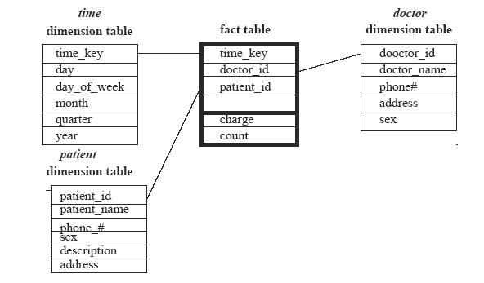

C.Starting with the base cuboid [day, doctor, patient], what specific OLAP operations should be performed in order to list the total fee collected by each doctor in 2004?

- roll up from day to month to year
- slice for year = “2004”
- roll up on patient from individual patient to all
- slice for patient = “all”
get the list of total fee collected by each doctor in 2004 d.

Select doctor, Sum(charge) From fee

Where year = 2004 Group by doctor

14. Explain in detail about OLAP Guidelines

Dr. E.F. Codd the ―father‖ of the relational model, created a list of rules to deal with the OLAP systems. Users should priorities these rules according to their needs to match their business requirements. These rules are:
1) Multidimensional conceptual view: The OLAP should provide an appropriate multidimensional Business model that suits the Business problems and Requirements.
2) Transparency: The OLAP tool should provide transparency to the input data for the users.
3) Accessibility: The OLAP tool should only access the data required only to the analysis needed.
4) Consistent reporting performance: The Size of the database should not affect in any way the performance.
5) Client/server architecture: The OLAP tool should use the client server architecture to ensure better performance and flexibility.
6) Generic dimensionality: Data entered should be equivalent to the structure and operation requirements.
7) Dynamic sparse matrix handling: The OLAP too should be able to manage the sparse matrix and so maintain the level of performance.
8) Multi-user support: The OLAP should allow several users working concurrently to work together.
9) Unrestricted cross-dimensional operations: The OLAP tool should be able to perform
operations across the dimensions of the cube.
10) Intuitive data manipulation. ―Consolidation path re-orientation, drilling down across columns or rows, zooming out, and other manipulation inherent in the consolidation path outlines should be accomplished via direct action upon the cells of the analytical model, and should neither require the use of a menu nor multiple trips across the user interface.‖(Reference 4)
11) Flexible reporting: It is the ability of the tool to present the rows and column in a manner suitable to be analyzed.
12) Unlimited dimensions and aggregation levels: This depends on the kind of Business, where multiple dimensions and defining hierarchies can be made.
In addition to these guidelines an OLAP system should also support:
Comprehensive database management tools: This gives the database management to control distributed Businesses

UNIT III
PART A

- What are the different steps in Data Transformation [Nov/Dec 2016]

Data transformation can be divided into two steps:
- data mapping maps data elements from the source data system to the destination data system and captures any transformation that must occur
- code generation that creates the actual transformation program
Data element to data element mapping is frequently complicated by complex transformations that require one-to-many and many-to-one transformation rules.
The code generation step takes the data element mapping specification and creates an executable program that can be run on a computer system. Code generation can also create transformation in easy-to-maintain computer languages such as Java or XSLT.

2. Give the classification of data mining tasks.[June 2014]

Descriptive – Characterizes the general property of the data in the database. Predictive – perform inference on the current data in order to make predictions.

- What is a legacy database?[June 2014]

It is a group of heterogeneous databases that combines different kinds of data systems such as relational or object oriented databases, hierarchical databases, spreadsheets, network databases, multimedia databases or file systems. The heterogeous databases in legact database may be connected by inter or intra computer networks.

- What is meta learning.[Dec 2014]

Meta learning is a subfield of Machine learning where automatic learning algorithms are applied on meta-data about machine learning experiments.

5.What are the types of data?[Nov 2014]

Qualitative data

Quantitative data

6.Define data discrimination. [Dec 2013]

It is a comparison of the general features of target data objects with the general features of objects from one or a set of contrasting classes. The target and contrasting classes are specified by the user and the corresponding data objects retrieved through database queries.

7.Define pattern interestingness. What makes a pattern interesting? Or What is Pattern evaluation.[June 2013][Dec 2011]

Pattern evaluation is used to identify the truly interesting patterns representing knowledge based on some interestingness measures.A pattern is interesting if it validates a hypothesis that the user sought to confirm. An interesting pattern represents knowledge. A pattern is interesting if it is 1). Easily understood by humans 2).valid on new or test data with some degree of certainty 3).potentially useful 4).Novel.

8. Give the steps involved in KDD. [Dec 2013]
KDD consists of the iterative sequence of the following steps:
Data cleaning

Data integration.

Data selection

Data transformation

Data mining

Pattern Evaluation

Knowledge Presentation

9. State the need of data cleaning. [Dec 2011] [May 2013]

Data cleaning removes noise and correct inconsistencies in the data. It cleans the data by filling in missing values smoothing noisy data, identifying or removing outliers and resolving inconsistencies.

  - State the need for data pre-processing.[Dec 2013]

Real world data are generally 1)Incomplete: lacking attribute values, lacking certain attributes of interest, or containing only aggregate data 2)Noisy: containing errors or outliers 3)Inconsistent: containing discrepancies in codes or names. So to remove all these data preprocessing is needed.

  - Differentiate between data characterization and discrimination.[Dec 2013]

Characterization: provides a concise and succinct summarization of the given collection of data Discrimination or Comparison: provides descriptions comparing two or more collections of data.

12. Define data characterization. [April/May 2010] [Dec 2013][Dec 2012]

It is a summarization of the general characteristics or feature of a target class of data. The data corresponding to the user-specified class are typically collected by a database query.

13. State why preprocessing data an important issue for data mining and data warehousing. Or Why preprocess the data? [May 2011] [Dec 2013] [June 2012]
Data that is to be analyzed by data mining techniques are incomplete, noisy, and inconsistent. These are the common place properties of large real world databases and data warehouses. To remove all these errors data must be preprocessed.

14. What is the significance of task relevant data.[June 2012]
It specifies only the concept and relevant data for a task in a summarative & consise manner.

15.List the primitives that specify a data mining task.[June 2012]
- The set of task-relevant data to be mined

- The kind of knowledge to be mined

- The background knowledge to be used in the discovery process.

16.Mention the steps involved in the class comparison procedure[June 2012]

It is basically the comparison of the general features of objects between two classes referred to as the target class and the contrasting class. For example, one may want to compare the general characteristics of the customers who rented more than 30 movies in the last year with those whose rental account is lower than 5. The techniques used for data discrimination are very similar to the techniques used for data characterization with the exception that data discrimination results include comparative measures.

17. State why concept hierarchies are useful in data mining[Dec 2012]

The concept hierarchies are induced by a partial order over the values of a given attribute. Usually data can be abstracted at different conceptual levels. The raw data in a database is called at its primitive level and the knowledge is said to be at a primitive level if it is discovered by using raw data only. Abstracting raw data to a higher conceptual level and discovering and expressing knowledge at higher abstraction levels have superior advantage over data mining at a primitive level.

18. Give the issues to be considered during data integration. [Dec 2011]
Schema integration, Redundancy, detection and resolution of data value conflicts.

19.What are the data mining functionalities? Or What kind of patterns can be mined? [May 2011]
It is used to specify the kinds of patterns or knowledge to be found in data mining tasks. It includes
Concept description: Characterization and

discrimination

Generalize, summarize, and contrast data

characteristics, e.g., dry vs. wet regions

Classification and Prediction

Clusters and outliers

20. What is Data mining?

Data mining refers to extracting or “mining” knowledge from large amount of data. It is considered as a synonym for another popularly used term Knowledge Discovery in Databases or KDD.

21.Give the architecture of a typical data mining system.
The architecture of a typical data mining system consists of the following components:

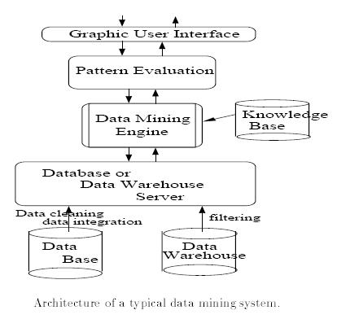

22.Give the classification of data mining systems.
Data mining systems can be categorized according to various criteria:
Classification according to the kinds of databases mined.

Classification according to the kinds of knowledge mined.

Classification according to the kinds of techniques utilized.

Classification according to the kinds of the application adapted.

23.What kind of data can be mined?

Kinds of data are Database data, data warehouses, transactional data, other kinds of data like time related data, data streams, spatial data, engineering design data, multimedia data and web data.

24.What are the data preprocessing techniques?
Data preprocessing techniques are
Data cleaning-removes noise and correct inconsistencies in the data.

Data integration-merges data from multiple sources into a coherent data store such as data warehouse or a data cube.

Data transformations-such as normalization improve the accuracy and efficiency of mining algorithms involving distance measurements.

Data reduction-reduces the data size by aggregating, eliminating redundant features, or clustering.

.

25. Give the various data smoothing techniques.
Binning, clustering, combined computer and human inspection, regression.

26. Define data integration.

Data integration combines data from multiple sources into a coherent data store. These sources may include multiple databases, data cubes or flat files.

27.Define data generalization.

Data generalization is a process that abstracts a large set of task-relevant data in a database from a relatively low conceptual level to higher conceptual levels. Methods for generalization can be categorized according to two approaches: 1) data cube approach and 2) attribute-oriented induction approach.

28. Define data reduction.

It is used to obtain a reduced representation of the data set that is much smaller in volume yet closely maintains the integrity of the original data. I-e mining on the reduced set should be more efficient yet produce the same analytical results.

29. Give the strategies used for data reduction.

Data cube aggregation, dimension reduction, data compression, numerosity reduction, and discretization and concept hierarchy generation.

30. What is data cube aggregation?

Data cube store multidimensional aggregated information. Each cell holds an aggregate data value data value, corresponding to the data point in multidimensional space. Concept hierarchies may exist for each attribute allowing the analysis of data at multiple levels of abstraction. Data cubes provide

fast access to precomputed, summarized data, thereby benefiting on-line analytical processing as well as data mining.

31. What is dimensionality reduction?

Dimensionality reduction reduces the data set size by removing such attributes from it. Mining on a reduced set of attributes reduces the number of attributes appearing in the discovered patterns, helping to make the patterns easier to understand.

32. Give the output forms of data characterization.

Pie charts, bar charts, curves, multidimensional data cubes and multidimensional tables including cross tabs. The resulting descriptions can also be presented as generalized relations or in rule form called characteristic rule.

UNIT III
PART B

- Explain different strategies of Data Reduction []Nov/Dec 2016]

Data Reduction techniques
These techniques can be applied to obtain a reduced representation of the data set that is much smaller in volume, yet closely maintains the integrity of the original data. Data reduction includes,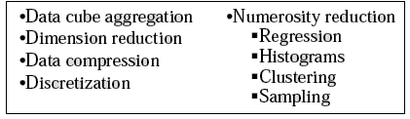
- Data cube aggregation, where aggregation operations are applied to the data in the construction of a data cube.
- Attribute subset selection, where irrelevant, weakly relevant or redundant attributes or dimensions may be detected and removed.
- Dimensionality reduction, where encoding mechanisms are used to reduce the data set size. Examples: Wavelet Transforms Principal Components Analysis
- Numerosity reduction, where the data are replaced or estimated by alternative, smaller data representations such as parametric models (which need store only the model parameters instead of the actual data) or nonparametric methods such as clustering, sampling, and the use of histograms.
- Discretization and concept hierarchy generation, where raw data values for attributes are replaced by ranges or higher conceptual levels. Data discretization is a form of numerosity reduction that is very useful for the automatic generation of concept hierarchies.
Data cube aggregation: Reduce the data to the concept level needed in the analysis. Queries regarding aggregated information should be answered using data cube when possible. Data cubes store multidimensional aggregated information. The following figure shows a data cube for multidimensional analysis of sales data with respect to annual sales per item type for each branch.
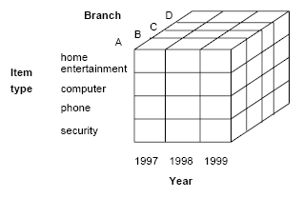
Each cells holds an aggregate data value, corresponding to the data point in multidimensional space.
Data cubes provide fast access to precomputed, summarized data, thereby benefiting on-line analytical processing as well as data mining.

The cube created at the lowest level of abstraction is referred to as the base cuboid. A cube for the highest level of abstraction is the apex cuboid. The lowest level of a data cube (base cuboid). Data cubes created for varying levels of abstraction are sometimes referred to as cuboids, so that a “data cube" may instead refer to a lattice of cuboids. Each higher level of abstraction further reduces the resulting data size.

The following database consists of sales per quarter for the years 1997-1999.
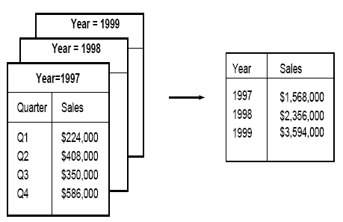
Suppose, the annalyser interested in the annual sales rather than sales per quarter, the above data can be aggregated so that the resulting data summarizes the total sales per year instead of per quarter. The resulting data in smaller in volume, without loss of information necessary for the analysis task

Dimensionality Reduction

It reduces the data set size by removing irrelevant attributes. This is a method of attribute subset selection are applied. A heuristic method of attribute of sub set selection is explained here:
Attribute sub selection / Feature selection
Feature selection is a must for any data mining product. That is because, when you build a data mining model, the dataset frequently contains more information than is needed to build the model. For example, a dataset may contain 500 columns that describe characteristics of customers, but perhaps only 50 of those columns are used to build a particular model. If you keep the unneeded columns while building the model, more CPU and memory are required during the training process, and more storage space is required for the completed model.
In which select a minimum set of features such that the probability distribution of different classes given the values for those features is as close as possible to the original distribution given the values of all features
Basic heuristic methods of attribute subset selection include the following techniques, some of which are illustrated below:
1. Step-wise forward selection: The procedure starts with an empty set of attributes. The best of the original attributes is determined and added to the set. At each subsequent iteration or step, the best of the remaining original attributes is added to the set.
2. Step-wise backward elimination: The procedure starts with the full set of attributes. At each step, it removes the worst attribute remaining in the set.
3. Combination forward selection and backward elimination: The step-wise forward selection and backward elimination methods can be combined, where at each step one selects the best attribute and removes the worst from among the remaining attributes.
4. Decision tree induction: Decision tree induction constructs a flow-chart-like structure where each internal (non-leaf) node denotes a test on an attribute, each branch corresponds to an outcome of the test, and each external (leaf) node denotes a class prediction. At each node, the algorithm chooses the “best" attribute to partition the data into individual classes. When decision tree induction is used for attribute subset selection, a tree is constructed from the given data. All attributes that do not appear in the tree are assumed to be irrelevant. The set of attributes appearing in the tree form the reduced subset of attributes.
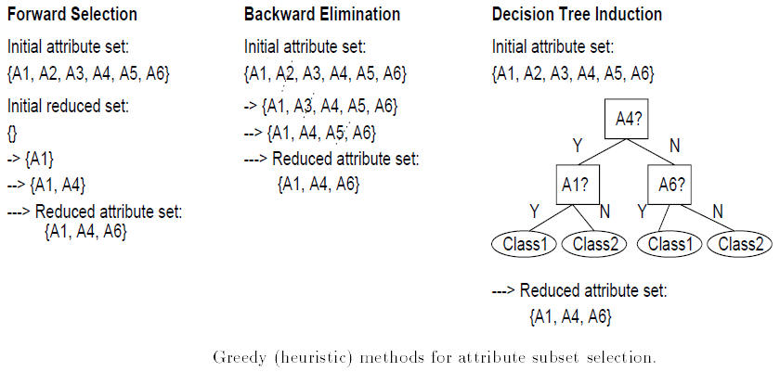
Wrapper approach/Filter approach:

The mining algorithm itself is used to determine the attribute sub set, then it is called wrapper approach or filter approach. Wrapper approach leads to greater accuracy since it optimizes the evaluation measure of the algorithm while removing attributes.
Data compression
In data compression, data encoding or transformations are applied so as to obtain a reduced or “compressed" representation of the original data. If the original data can be reconstructed from the compressed data without any loss of information, the data compression technique used is called lossless. If, instead, we can reconstruct only an approximation of the original data, then the data compression technique is called lossy. Effective methods of lossy data compression:
- Wavelet transforms
- Principal components analysis.
Wavelet compression is a form of data compression well suited for image compression. The discrete wavelet transform (DWT) is a linear signal processing technique that, when applied to a data vector D, transforms it to a numerically different vector, D0, of wavelet coefficients.
The general algorithm for a discrete wavelet transform is as follows.
1. The length, L, of the input data vector must be an integer power of two. This condition can be met by padding the data vector with zeros, as necessary.
2. Each transform involves applying two functions:
- data smoothing
- calculating weighted difference
3. The two functions are applied to pairs of the input data, resulting in two sets of data of length L/2.
4. The two functions are recursively applied to the sets of data obtained in the previous loop, until the resulting data sets obtained are of desired length.
5. A selection of values from the data sets obtained in the above iterations are designated the wavelet coefficients of the transformed data.
If wavelet coefficients are larger than some user-specified threshold then it can be retained. The remaining coefficients are set to 0.
Haar2 and Daubechie4 are two popular wavelet transforms.
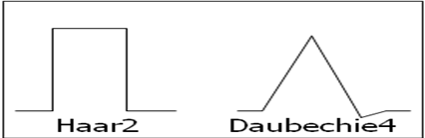

Principal Component Analysis (PCA)
-also called as Karhunen-Loeve (K-L) method
Procedure
- Given N data vectors from k-dimensions, find c <= k orthogonal vectors that can be best used to represent data
  - The original data set is reduced (projected) to one consisting of N data vectors on c principal components (reduced dimensions)
- Each data vector is a linear combination of the c principal component vectors
- Works for ordered and unordered attributes
- Used when the number of dimensions is large

The principal components (new set of axes) give important information about variance. Using the strongest components one can reconstruct a good approximation of the original signal.
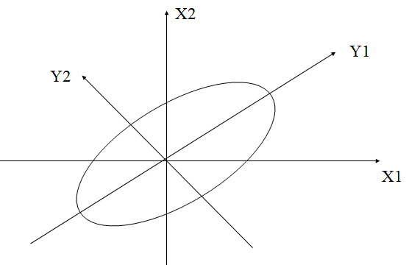

Numerosity Reduction
Data volume can be reduced by choosing alternative smaller forms of data. This tech. can be
- Parametric method
- Non parametric method
Parametric: Assume the data fits some model, then estimate model parameters, and store only the parameters, instead of actual data.
Non parametric: In which histogram, clustering and sampling is used to store reduced form of data.

Numerosity reduction techniques:

1 Regression and log linear models:
- Can be used to approximate the given data
- In linear regression, the data are modeled to fit a straight line using
Y = α + β X, where α, β are coefficients
- Multiple regression: Y = b0 + b1 X1 + b2 X2.
  - Many nonlinear functions can be transformed into the above.
Log-linear model: The multi-way table of joint probabilities is approximated by a product of lower-order tables.
Probability: p(a, b, c, d) = αab βacχad δbcd
2 Histogram

- Divide data into buckets and store average (sum) for each bucket
- A bucket represents an attribute-value/frequency pair
- It can be constructed optimally in one dimension using dynamic programming
- It divides up the range of possible values in a data set into classes or groups. For each group, a rectangle (bucket) is constructed with a base length equal to the range of values in that specific group, and an area proportional to the number of observations falling into that group.
- The buckets are displayed in a horizontal axis while height of a bucket represents the average frequency of the values.
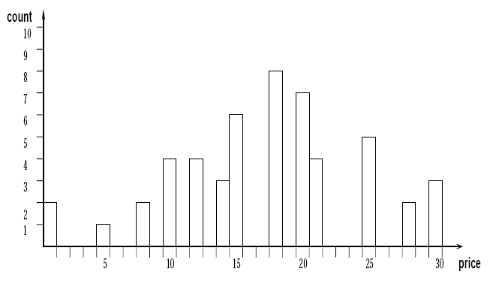

Example:
The following data are a list of prices of commonly sold items. The numbers have been sorted.
1, 1, 5, 5, 5, 5, 5, 8, 8, 10, 10, 10, 10, 12, 14, 14, 14, 15, 15, 15, 15, 15, 15, 18, 18, 18, 18, 18, 18, 18, 18, 20, 20, 20, 20, 20, 20, 20, 21, 21, 21, 21, 25, 25, 25, 25, 25, 28, 28, 30, 30, 30.
Draw histogram plot for price where each bucket should have equi width of 10

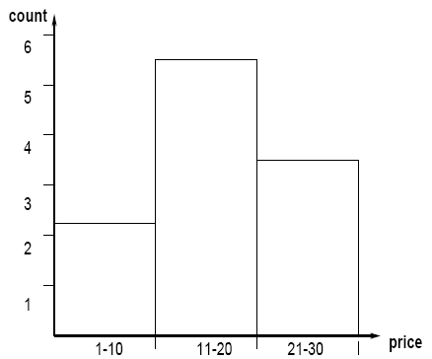

The buckets can be determined based on the following partitioning rules, including the following.

- Equi-width: histogram with bars having the same width
- Equi-depth: histogram with bars having the same height
- V-Optimal: histogram with least variance  (count_{b}*value_{b})
- MaxDiff: bucket boundaries defined by user specified threshold

V-Optimal and MaxDiff histograms tend to be the most accurate and practical. Histograms are highly effective at approximating both sparse and dense data, as well as highly skewed, and uniform data.

- Describe Data Discretization and concept Hierarchy Generation. State why concept hierarchies are useful in data mining

Discretization and Concept Hierarchy Generation for Numeric Data: It is difficult and laborious for to specify concept hierarchies for numeric attributes due to the wide diversity of possible data ranges and the frequent updates if data values.
Manual specification also could be arbitrary. Concept hierarchies for numeric attributes can be constructed automatically based on data distribution analysis.
Five methods for concept hierarchy generation are defined below- binning histogram analysis entropy-based discretization and data segmentation by “natural partitioning”.
Binning: Attribute values can be discretized by distributing the values into bin and replacing each bin by the mean bin value or bin median value. These technique can be applied recursively to the resulting partitions in order to generate concept hierarchies.
Histogram Analysis: Histograms can also be used for discretization. Partitioning rules can be applied to define range of values. The histogram analyses algorithm can be applied recursively to each partition in order to automatically generate a multilevel concept hierarchy, with the procedure terminating once a pre specified number of concept levels have been reached. A minimum interval size can be used per level to control the recursive procedure. This specifies the minimum width of the partition, or the minimum member of partitions at each level.
Cluster Analysis: A clustering algorithm can be applied to partition data into clusters or groups. Each cluster forms a node of a concept hierarchy, where all noses are at the same conceptual level. Each cluster may be further decomposed into sub-clusters, forming a lower kevel in the hierarchy.
Clusters may also be grouped together to form a higher-level concept hierarchy.
Segmentation by natural partitioning: Breaking up annual salaries in the range of into ranges like ($50,000-$100,000) are often more desirable than ranges like ($51, 263, 89-$60,765.3) arrived at by cluster analysis. The 3-4-5 rule can be used to segment numeric data into relatively uniform “natural” intervals. In general the rule partitions a give range of data into 3,4,or 5 equinity intervals, recursively level by level based on value range at the most significant digit. The rule can be recursively applied to each interval creating a concept hierarchy for the given numeric attribute.

Discretization and Concept Hierarchy Generation for Categorical Data: Categorical data are discrete data. Categorical attributes have finite number of distinct values, with no ordering among the values, examples include geographic location, item type and job category. There are several methods for generation of concept hierarchies for categorical data.
Specification of a partial ordering of attributes explicitly at the schema level by experts: Concept hierarchies for categorical attributes or dimensions typically involve a group of attributes. A user or an expert can easily define concept hierarchy by specifying a partial or total ordering of the attributes at a schema level. A hierarchy can be defined at the schema level such as street < city < province < country.
Specification of a portion of a hierarchy by explicit data grouping: This is identically a manual definition of a portion of a concept hierarchy. In a large database, is unrealistic to define an entire concept hierarchy by explicit value enumeration. However, it is realistic to specify explicit groupings for a small portion of the intermediate-level data.
Specification of a set of attributes but not their partial ordering: A user may specify a set of attributes forming a concept hierarchy, but omit to specify their partial ordering. The system can then try to automatically generate the attribute ordering so as to construct a meaningful concept hierarchy.
Specification of only of partial set of attributes: Sometimes a user can be sloppy when defining a hierarchy, or may have only a vague idea about what should be included in a hierarchy. Consequently the user may have included only a small subset of the relevant attributes for the location, the user may have only specified street and city. To handle such partially specified hierarchies, it is important to embed data semantics in the database schema so that attributes with tight semantic connections can be pinned together.
3.Discuss the various issues that have to be addressed during data integration. [May 2012]
Schema Integration
Redundancy
Detection and Resolution of data value conflict

4.What is attribute –oriented induction?Describe how this is implemented.[May 2012]

The Attribute-Oriented Induction (AOI) approach to data generalization and summarization-based characterization was first proposed in 1989, a few years prior to the introduction of the data cube approach. The data cube approach can be considered as a data warehouse-based, precomputation-oriented, materialized view approach. It performs online aggregation before an OLAP or data mining query is submitted for processing. On the other hand, the attribute-oriented induction approach, at least in its initial proposal, is a relational database query-oriented, generalization- based, on-line data analysis technique. However, there is no inherent barrier distinguishing the two approaches based on on-line aggregation versus online precomputation. Some aggregations in the data cube can be computed on-line, while online precomputation of multidimensional space can speed up attribute-oriented induction as well. In fact, data mining systems based on attribute-oriented induction, such as DBMiner, have been optimized to include such online precomputation.

The general idea of attribute-oriented induction is to first collect the task-relevant data using a relational database query and then perform generalization based on the examination of the number of distinct values of each attribute in the relevant set of data. The generalization is performed by either attribute removal or attribute generalization (also known as concept hierarchy ascension). Aggregation is performed by merging identical, generalized tuples, and accumulating their respective counts. This reduces the size of the generalized data set. The resulting generalized relation can be mapped into di_erent forms for presentation to the user, such as charts or rules.

5. Define data mining. Describe the steps involved in data mining when viewed as a process of knowledge discovery. Explain the architecture of the data mining system? [May 2010] [May 2013]or What is the use of data mining task?What are the basic types of data mining tasks?Explain with example.[June 2014].

In contrast with traditional data analysis, the KDD process is interactive and iterative. One has to make several decisions in the process of KDD.
Selection: selecting a data set, or focusing on a subset of variables, or data samples
Preprocessing: strategies for handling missing value and noise
Transformation: dimensionality reduction or transformation
Data Mining: searching for patterns
Interpretation: interpreting rules and consolidating discovered knowledge

6.Explain with diagrammatic illustration the primitives for specifying a data mining task.[June 2013] or Explain the data mining task primitives. [Dec 2013]

The set of task-relevant data to be mined: This specifies the portions of the database or the set of data in which the user is interested. This includes the database attributes or data warehouse dimensions of interest (referred to as the relevant attributes or dimensions).

The kind of knowledge to be mined: This specifies the data mining functions to be performed, such as characterization, discrimination, association or correlation analysis,classification, prediction, clustering, outlier analysis, or evolution analysis.

The background knowledge to be used in the discovery process: This knowledge about the domain to be mined is useful for guiding the knowledge discovery process and for evaluating the patterns found. Concept hierarchies are a popular form of background knowledge, which allow data to be mined at multiple levels of abstraction.

7.Describe the different types of data repositories on which data mining can be performed?

As a general technology, data mining can be applied to any kind of data as long as the data are meaningful for a target application. The most basic forms of data for mining applications are database data, data warehouse data, and transactional data. The concepts and techniques presented in this book focus on such data. Data mining can also be applied to other forms of data (e.g., data streams, ordered/sequence data, graph or networked data, spatial data, text data, multimedia data, and the WWW).Relational databases,Datawarehouses,Transactionaldatabases,Object oriented databases,Spatialdatabase,Time series databases,Textdatabase,Multi mediadatabase,WWW.

8.Briefly explain the kinds of patterns that can be mined? What kind of data can be mined? (Or)Explain the data mining functionalities. [Dec 2012][Dec 2014]

Data mining functionalities, and the kinds of patterns are, Generalize, summarize, and contrast data characteristics, e.g., dry vs. wet regions,Presentation: decision-tree, classification rule, neural network,Prediction: Predict some unknown or missing numerical values,Outlier analysis

- Concept/class description

- Association analysis
- Classication and prediction

- Clustering analysis

- Evolution and deviation analysis

9. How data mining systems are classified? Discuss each classification with an example. (Or) Give the classification of data mining system. Describe the issues related to data mining. [May 2011] [Dec 2011] [Dec 2013] [May 2012][Dec 2014]

a. Classification according to the kinds of databases mined.

A data mining system can be classied according to the kinds of databases mined. Database systems themselves can be classified according to different criteria (such as data models, or the types of data or applications involved), each of which may require its own data mining technique. Data mining systems can therefore be classified accordingly.For instance, if classifying according to data models, we may have a relational, transactional, object-oriented, object-relational, or data warehouse mining system. If classifying according to the special types of data handled, we may have a spatial, time-series, text, or multimedia data mining system, or a World-Wide Web mining system. Other system types include heterogeneous data mining systems, and legacy data mining systems.

b. Classification according to the kinds of knowledge mined.

Data mining systems can be categorized according to the kinds of knowledge they mine, i.e., based on data mining functionalities, such as characterization, discrimination, association, classification, clustering, trend and evolution analysis, deviation analysis, similarity analysis, etc. A comprehensive data mining system usually provides multiple and/or integrated data mining functionalities.

Moreover, data mining systems can also be distinguished based on the granularity or levels of abstraction of the knowledge mined, including generalized knowledge (at a high level of abstraction), primitive-level knowledge(at a raw data level), or knowledge at multiple levels (considering several levels of abstraction). An advanced data mining system should facilitate the discovery of knowledge at multiple levels of abstraction.

c. Classification according to the kinds of techniques utilized.

Data mining systems can also be categorized according to the underlying data mining techniques employed. These techniques can be described according to the degree of user interaction involved (e.g., autonomous systems, interactive exploratory systems, query-driven systems), or the methods of data analysis employed (e.g., database-oriented or data warehouse-oriented techniques, machine learning, statistics, visualization, pattern recognition, neural networks, and so on). A sophisticated data mining system will often adopt multiple data mining techniques or work out aneffective, integrated technique which combines the merits of a few individual approaches.

10. Explain in detail data cleaning and data integration process in detail. [Dec 2012][June 2014]

Data integration is the process of standardising the data definitions and data structures of multiple data sources by using a common schema thereby providing a unified view of the data for enterprise-level planning and decision making.

Design:The data integration initiative within a company must be an initiative of business, not IT. There should be a champion who understands the data assets of the enterprise and will be able to lead the discussion about the long-term data integration initiative in order to make it consistent, successful and benefitial.

Implementation: The larger enterprise or the enterprises which already have started other projects of data integration are in an easier position as they already have experience and can extend the existing system and exploit the existing knowledge to implement the system more effectively.Datacleansing is the process of detecting, correcting or removing incomplete, incorrect, inaccurate, irrelevant, out-of-date, corrupt, redundant, incorrectly formatted, duplicate, inconsistent, etc. records from a record set, table or database.

Validity: The degree to which the measures conform to defined business rules or constraints. Data-Type Constraints – e.g., values in a particular column must be of a particular datatype, e.g., Boolean, numeric (integer or real), date, etc. Range Constraints: typically, numbers or dates should fall within a certain range. That is, they have minimum and/or maximum permissible values. Mandatory Constraints: Certain columns cannot be empty.Decleansingis detecting errors and syntactically removing them for better programming.

11. How a data mining system can be integrated with a data warehouse? Discuss with an example[May 2011]or List and discuss the steps for integrating a data mining system with data warehouse.[Dec 2011]

- Integration on the front end level combining On-Line Analytical Processing (OLAP) and data mining tools into a homogeneous Graphic User Interface;

- Integration on the database level adding of data mining components directly in DBMS.

- Interaction on back end level – the usage of data mining techniques during the data warehouse

design process.

Most data mining tools need to work o n integrated, consistent, and cleaned data, which requires costly data cleaning, data transformation, and data integration as preprocessing steps. A data warehouse constructed by such preprocessing serves as a valuable source of high quality of data for OLAP as well as for data mining. Effective data mining needs exploratory data analysis.

12i)List the challenges and issues in implementation of data mining systems.
Dec 2011]

One of the key issues raised by data mining technology is not a business or technological one, but a social one. It is the issue of individual privacy. Data mining makes it possible to analyze routine business transactions and glean a significant amount of information about individuals buying habits and preferences. Another issue is that of data integrity. Clearly, data analysis can only be as good as the data that is being analyzed. A key implementation challenge is integrating conflicting or redundant data from different sources. For example, a bank may maintain credit cards accounts on several different databases. A hotly debated technical issue is whether it is better to set up a relational database structure or a multidimensional one. In a relational structure, data is stored in tables, permitting ad hoc queries. In a multidimensional structure, on the other hand, sets of cubes are arranged in arrays, with subsets created according to category. Finally, there is the issue of cost. While system hardware costs have dropped dramatically within the past five years, data mining and data warehousing tend to be self-reinforcing.

Challenges:

- improving the scalability of data mining algorithms, B) mining non-vector data, C) mining distributed data, D) improving the ease of use of data mining systems and environments, and E) privacy and security issues for data mining.

13. What is the significance of interestingness measures in data mining system? Give examples.[Dec 2011]
A pattern is interesting if,

  - It is easily understood by humans,
- Valid on new or test data with some degree of certainty,
- Potentially useful, and
- Novel.

A pattern is also interesting if it validates a hypothesis that the user sought to confirm. An interesting pattern represents knowledge.

14.What is evolution analysis? Give example. [May 2013]

Evolution Analysis: Data evolution analysis describes and models regularities or trends for objects whose behavior changes over time.

Example: Time-series data. If the stock market data (time-series) of the last several years available from the New York Stock exchange and one would like to invest in shares of high tech industrial companies. A data mining study of stock exchange data may identify stock evolution regularities for overall stocks and for the stocks of particular companies. Such regularities may help predict future trends in stock market prices, contributing to one’s decision making regarding stock investments.

15 Explain the issues in integration of data mining with data warehouse. [Dec 2009]

Large volumes of data from multiple sources are involved; there is a high probability of errors and anomalies in the data. Real-world data tend to be incomplete, noisy and inconsistence. Data cleansing is a non-trivial task in data warehouse environments. The main focus is the identification of missing or incorrect data (noise) and conflicts between data of different sources and the correction of these problems.data analysis can only be as good as the data that is being analyzed. A key implementation challenge is integrating conflicting or redundant data from different sources. For example, a bank may maintain credit cards accounts on several different databases. The addresses (or even the names) of a single cardholder may be different in each. Software must translate data from one system to another and select the address most recently entered.

- Explain the various data preprocessing tasks in data mining. [Dec 2013] [May 2012]

Data Cleaning: Missing values,Noisydata,Inconsistent data

Data Integration

Data transformation

Data Reduction: Data cube aggregation,Dimensionreduction,Data compression, Numerosity reduction,

Discretization and concept hierarchy

17.Discuss the following schemes used for integration of a data mining system with a database or data warehouse system:
Integration of a Data mining system with database or data warehouse system.

i)No coupling ii)Loose Coupling iii)semitight coupling iv)Tight coupling

i)No coupling—flat file processing, not recommended
ii) Loose coupling
Fetching data from DB/DW

iii)Semi-tight coupling—enhanced DM performance
Provide efficient implement a few data mining primitives in a DB/DW system, e.g., sorting,

indexing, aggregation, histogram analysis, multiway join, precomputation of some stat functions iv)Tight coupling—A uniform information processing environment

DM is smoothly integrated into a DB/DW system, mining query is optimized based on mining query, indexing, etc.

Many other terms carry a similar or slightly different meaning to data mining, such as knowledge mining from data, knowledge extraction, data/pattern analysis, another popularly used term, Knowledge Discovery from Data, or KDD.
18.Explain in detail about knowledge discovery in databases.
Essential step in the Process of knowledge discovery. Knowledge discovery as a process is depicted in Figure consists of an iterative sequence of the following steps:
1. Data cleaning: to remove noise and inconsistent data
2. Data integration: where multiple data sources may be combined
3. Data selection: where data relevant to the analysis task are retrieved from the database
4. Data transformation: where data are transformed or consolidated into forms appropriate for mining by performing summary or aggregation operations, for instance
5. Data mining: an essential process where intelligent methods are applied in order to extract data patterns
6. Pattern evaluation to identify the truly interesting patterns representing knowledge based on some interestingness measures;
7. Knowledge presentation where visualization and knowledge representation techniques are used to present the mined knowledge to the user
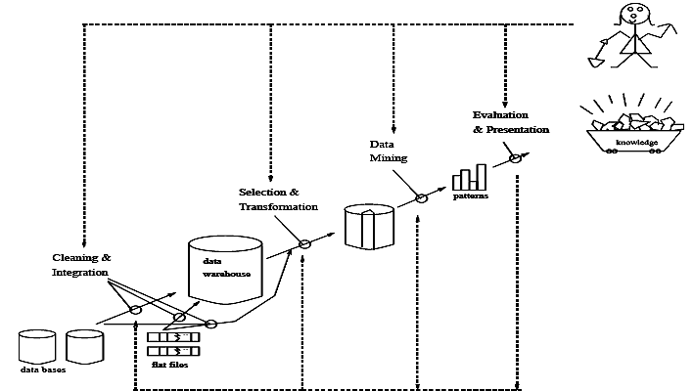

. Data mining as a process of knowledge discovery.
13.Explain data mining architecture in detail.
The architecture of a typical data mining system may have the following major components Database, data warehouse, Worldwide Web, or other information repository: This is one or a set of databases, data warehouses, spreadsheets, or other kinds of information repositories. Data cleaning and data integration techniques may be performed on the data.
Database or data warehouse server: The database or data warehouse server is responsible for fetching the relevant data, based on the user's data mining request.
Knowledge base: This is the domain knowledge that is used to guide the search or evaluate the interestingness of resulting patterns. Such knowledge can include concept hierarchies, used to organize attributes or attribute values into different levels of abstraction. Other examples of domain knowledge are additional interestingness constraints or thresholds, and metadata (e.g., describing data from multiple heterogeneous sources).
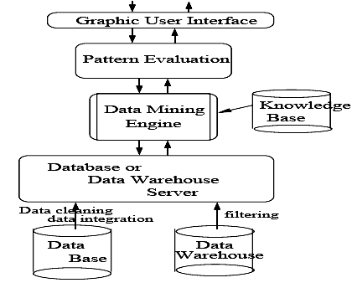

Architecture of a typical data mining system
Data mining engine: This is essential to the data mining system and ideally consists of a set of functional modules for tasks such as characterization, association and correlation analysis, classification, prediction, cluster analysis, outlier analysis, and evolution analysis.
Pattern evaluation module: This component typically employs interestingness measures (and interacts with the data mining modules so as to focus the search toward interesting patterns. It may use interestingness thresholds to filter out discovered patterns. Alternatively, the pattern evaluation module may be integrated with the mining module, depending on the implementation of the data mining method used..
User interface: This module communicates between users and the data mining system, allowing the user to interact with the system by specifying a data mining query or task, providing information to help focus the search, and performing exploratory data mining based on the intermediate data mining results. In addition, this component allows the user to browse database and data warehouse schemas or data structures, evaluate mined patterns, and visualize the patterns in different forms.

19.Explain major issues in data mining.
1. Mining methodology and user-interaction issues. These reect the kinds of knowledge mined, the ability to mine knowledge at multiple granularities, the use of domain knowledge, ad-hoc mining, and knowledge visualization.
Mining different kinds of knowledge in databases.
Since different users can be interested in different kinds of knowledge, data mining should cover a wide spectrum of data analysis and knowledge discovery tasks, including data characterization, discrimination, association, classification, clustering, trend and deviation analysis, and similarity analysis. These tasks may use the same database in different ways and require the development of numerous data mining techniques.
Interactive mining of knowledge at multiple levels of abstraction.
Since it is difficult to know exactly what can be discovered within a database, the data mining process should be interactive. For databases containing a huge amount of data, appropriate sampling technique can first be applied to facilitate interactive data exploration. Interactive mining allows users to focus the search for patterns, providing and refining data mining requests based on returned results. Specifically, knowledge should be mined by drilling-down, rolling-up, and pivoting through the data space and knowledge space interactively, similar to what OLAP can do on data cubes. In this way, the user can interact with the data mining system to view data and discovered patterns at multiple granularities and from different angles.
Incorporation of background knowledge.
Background knowledge, or information regarding the domain under study, may be used to guide the discovery process and allow discovered patterns to be expressed in concise terms and at different levels of abstraction. Domain knowledge related to databases, such as integrity constraints and deduction rules, can help focus and speed up a data mining process, or judge the interestingness of discovered patterns.

Data mining query languages and ad-hoc data mining.
Relational query languages (such as SQL) allow users to pose ad-hoc queries for data retrieval. In a similar vein, high-level data mining query languages need to be developed to allow users to describe ad-hoc data mining tasks by facilitating the speci_cation of the relevant sets of data for analysis, the domain knowledge, the kinds of knowledge to be mined, and the conditions and interestingness constraints to be enforced on the discovered patterns. Such a language should be integrated with a database or data warehouse query language, and optimized for e_cient and exible data mining.
Presentation and visualization of data mining results.
Discovered knowledge should be expressed in high-level languages, visual representations,or other expressive forms so that the knowledge can be easily understood and directly usable by humans. This is especially crucial if the data mining system is to be interactive. This requires the system to adopt expressive knowledge representation techniques, such as trees, tables, rules, graphs, charts, crosstabs, matrices, or curves.
Handling outlier or incomplete data.
The data stored in a database may reect outliers | noise, exceptional cases, or incomplete data objects. These objects may confuse the analysis process, causing over_tting of the data to the knowledge modelconstructed. As a result, the accuracy of the discovered patterns can be poor. Data cleaning methods and data analysis methods which can handle outliers are required. While most methods discard outlier data, such data may be of interest in itself such as in fraud detection for Finding unusual usage of tele-communication services or credit cards. This form of data analysis is known as outlier mining.
Pattern evaluation: the interestingness problem.
A data mining system can uncover thousands of patterns. Many of the patterns discovered may be uninteresting to the given user, representing common knowledge or lacking novelty. Several challenges remain regarding the development of techniques to assess the interestingness of discovered patterns, particularly with regard to subjective measures which estimate the value of patterns with respect to a given user class, based on user beliefs or expectations. The use of interestingness measures to guide the discovery process and reduce the search space is another active area of research.
2. Performance issues. These include efficiency, scalability, and parallelization of data mining algorithms.
Efficiency and scalability of data mining algorithms.
To effectively extract information from a huge amount of data in databases, data mining algorithms must be efficient and scalable. That is, the running time of a data mining algorithm must be predictable and acceptable in large databases. Algorithms with exponential or even medium- order polynomial complexity will not be of practical use. From a database perspective on knowledge discovery, efficiency and scalability are key issues in the implementation of data mining systems. Many of the issues discussed above under mining methodology and user-interaction must also consider efficiency and scalability.
Parallel, distributed, and incremental updating algorithms.
The huge size of many databases, the wide distribution of data, and the computational complexity of some data mining methods are factors motivating the development of parallel and distributed data mining algorithms. Such algorithms divide the data into partitions, which are processed in parallel. The results from the partitions are then merged. Moreover, the high cost of some data mining processes promotes the need for incremental data mining algorithms which incorporate database updates without having to mine the entire data again \from scratch". Such algorithms perform knowledge modification incrementally to amend and strengthen what was previously discovered.

3. Issues relating to the diversity of database types. Handling of relational and complex types of data.
There are many kinds of data stored in databases and data warehouses. Since relational databases and data warehouses are widely used, the development of efficient and effective data mining systems for such data is important. However, other databases may contain complex data objects, hypertext and multimedia data, spatial data, temporal data, or transaction data. It is unrealistic to expect one system to mine all kinds of data due to the diversity of data types and different goals of data mining. Specific data mining systems should be constructed for mining specific kinds of data. Therefore, one may expect to have different data mining systems for different kinds of data.
Mining information from heterogeneous databases and global information systems.
Local and wide-area computer networks (such as the Internet) connect many sources of data,forming huge, distributed, and heterogeneous databases. The discovery of knowledge from di_erent sources of structured, semi-structured, or unstructured data with diverse data semantics poses great challenges to data mining. Data mining may help disclose high-level data regularities in multiple heterogeneous databases that are unlikely to be discovered by simple query systems and may improve information exchange and interoperability in heterogeneous databases.

20.Explain data cleaning in data preprocessing.
Data cleaning routines attempt to fill in missing values, smooth out noise while identifying outliers, and correct inconsistencies in the data.
(i). Missing values
1. Ignore the tuple: This is usually done when the class label is missing (assuming the mining task
involves classification or description). This method is not very effective, unless the tuple contains several attributes with missing values. It is especially poor when the percentage of missing values per attribute varies considerably.
2. Fill in the missing value manually:
In general, this approach is time-consuming and may not be feasible given a large data set with many missing values.
3. Use a global constant to fill in the missing value: Replace all missing attribute values by the same constant, such as a label like ―Unknown". If missing values are replaced by, say, ―Unknown", then the mining program may mistakenly think that they form an interesting concept, since they all have a value in common - that of ―Unknown". Hence, although this method is simple, it is not recommended.
4. Use the attribute mean to fill in the missing value: For example, suppose that the average income of All Electronics customers is $28,000. Use this value to replace the missing value for income.
5. Use the attribute mean for all samples belonging to the same class as the given tuple: For example, if classifying customers according to credit risk, replace the missing value with the average income value for customers in the same credit risk category as that of the given tuple.
6. Use the most probable value to fill in the missing value: This may be determined with inference-based tools using a Bayesian formalism or decision tree induction. For example, using the other customer attributes in your data set, you may construct a decision tree to predict the missing values for income.
(ii).Noisy data
Noise is a random error or variance in a measured variable.
1. Binning methods:
Binning methods smooth a sorted data value by consulting the ‖neighborhood", or values
around it. The sorted values are distributed into a number of 'buckets', or bins. Because binning methods consult the neighborhood of values, they perform local smoothing. Figure illustrates some binning techniques.

In this example, the data for price are first sorted and partitioned into equi-depth bins (of depth 3). In smoothing by bin means, each value in a bin is replaced by the mean value of the bin. For example, the mean of the values 4, 8, and 15 in Bin 1 is 9. Therefore, each original value in this bin is replaced by the value 9. Similarly, smoothing by bin medians can be employed, in which each bin value is replaced by the bin median. In smoothing by bin boundaries, the minimum and maximum values in a given bin are identified as the bin boundaries. Each bin value is then replaced by the closest boundary value.
(i).Sorted data for price (in dollars): 4, 8, 15, 21, 21, 24, 25, 28, 34 (ii).Partition into (equi-width) bins:
• Bin 1: 4, 8, 15
• Bin 2: 21, 21, 24
• Bin 3: 25, 28, 34 (iii).Smoothing by bin means:
- Bin 1: 9, 9, 9,
- Bin 2: 22, 22, 22
- Bin 3: 29, 29, 29 (iv).Smoothing by bin boundaries:
• Bin 1: 4, 4, 15
• Bin 2: 21, 21, 24
• Bin 3: 25, 25, 34
2. Clustering:
Outliers may be detected by clustering, where similar values are organized into groups or
―clusters‖. Intuitively, values which fall outside of the set of clusters may be considered outliers.
Figure: Outliers may be detected by clustering analysis.

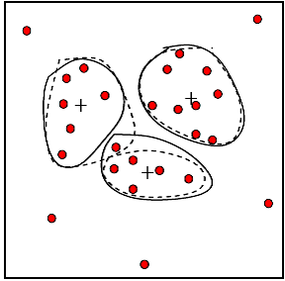

3. Combined computer and human inspection: Outliers may be identified through a combination of computer and human inspection. In one application, for example, an information-theoretic measure was used to help identify outlier patterns in a handwritten character database for classification. The measure's value reflected the ―surprise" content of the predicted character label with respect to the known label. Outlier patterns may be informative or ―garbage". Patterns whose surprise content is above a threshold are output to a list. A human can then sort through the patterns in the list to identify the actual garbage ones
4. Regression: Data can be smoothed by fitting the data to a function, such as with regression. Linear regression involves finding the ―best" line to fit two variables, so that one variable can be used to predict the other. Multiple linear regression is an extension of linear regression, where more than two variables are involved and the data are fit to a multidimensional surface.
(iii). Inconsistent data
There may be inconsistencies in the data recorded for some transactions. Some data inconsistencies may be corrected manually using external references. For example, errors made at data entry may be corrected by performing a paper trace. This may be coupled with routines designed to help correct the inconsistent use of codes. Knowledge engineering tools may also be used to detect the violation of known data constraints. For example, known functional dependencies between attributes can be used to find values contradicting the functional constraints.
21.Explain Data Transformation In detail.
In data transformation, the data are transformed or consolidated into forms appropriate for mining. Data transformation can involve the following:
1. Normalization, where the attribute data are scaled so as to fall within a small specified range, such as -1.0 to 1.0, or 0 to 1.0.
There are three main methods for data normalization : min-max normalization, z-score normalization, and normalization by decimal scaling.
(i).Min-max normalization performs a linear transformation on the original maxA and minA are maximum and minimum values of an attribute A. Min-max normalization maps a value v of A to v0 in the range [new minA; new maxA] by computing
(ii).z-score normalization (or zero-mean normalization), the values for an attribute A are normalized based on the mean and standard deviation of A. A value v of A is normalized to v0 by computing where mean A and stand dev A are the mean and standard deviation, respectively, of attribute A. This method of normalization is useful when the actual minimum and maximum of attribute A are unknown, or when there are outliers which dominate the min-max normalization.
(iii). Normalization by decimal scaling normalizes by moving the decimal point of values of attribute A. The number of decimal points moved depends on the maximum absolute value of A. A value v of A is normalized to v0by computing where j is the smallest integer such that

2. Smoothing, which works to remove the noise from data? Such techniques include binning, clustering, and regression.
(i). Binning methods:
Binning methods smooth a sorted data value by consulting the ‖neighborhood", or values around it. The sorted values are distributed into a number of 'buckets', or bins. Because binning methods consult the neighborhood of values, they perform local smoothing. Figure illustrates some binning techniques.
In this example, the data for price are first sorted and partitioned into equi-depth bins (of depth 3). In smoothing by bin means, each value in a bin is replaced by the mean value of the bin. For example, the mean of the values 4, 8, and 15 in Bin 1 is 9. Therefore, each original value in this bin is replaced by the value 9. Similarly, smoothing by bin medians can be employed, in which each bin value is replaced by the bin median. In smoothing by bin boundaries, the minimum and maximum values in a given bin are identified as the bin boundaries. Each bin value is then replaced by the closest boundary value.
(i).Sorted data for price (in dollars): 4, 8, 15, 21, 21, 24, 25, 28, 34 (ii).Partition into (equi-width) bins:
• Bin 1: 4, 8, 15
• Bin 2: 21, 21, 24
• Bin 3: 25, 28, 34 (iii).Smoothing by bin means:
- Bin 1: 9, 9, 9,
- Bin 2: 22, 22, 22
- Bin 3: 29, 29, 29 (iv).Smoothing by bin boundaries:
• Bin 1: 4, 4, 15
• Bin 2: 21, 21, 24
• Bin 3: 25, 25, 34

3. Aggregation, where summary or aggregation operations are applied to the data. For example, the daily sales data may be aggregated so as to compute monthly and annual total amounts.
4. Generalization of the data, where low level or 'primitive' (raw) data are replaced by higher level concepts through the use of concept hierarchies. For example, categorical attributes, like street, can be generalized to higher level concepts, like city or county.

UNIT IV
PART A
- Elucidate two phase involved in decision tree induction [Nov/Dec 2016]
Decision tree generation consists of two phases
Tree construction
• At start, all the training examples are at the root
• Partition examples recursively based on selected attributes
Tree pruning
• Identify and remove branches that reflect noise or outliers
• Use of decision tree: Classifying an unknown sample
Test the attribute values of the sample against the decision tree.

- List the methods to improve Apriori’s efficiency [Nov/Dec 2016]

To improve the efficiency of the level-wise generation of frequent item sets, an important property called the Apriori property, is used to reduce the search space.
Apriori property: All nonempty subsets of a frequent itemset must also be frequent. A two-step process is followed, consisting of join and prune actions
- Join Step
- Prune step

3. Define classification. [May 2012]

Data classification is a two step process. In the first step a model is built describing a predetermined set of data classes are concepts. The model is constructed by analyzing database tuples described b attributes. Each tuple is assumed to belong to the predefined class as determined by one of the attributes called class label attribute. In the second step the modal is used for classification.

4. Define training data set.

The data tuples analyzed to build the model collectively form the training data set. Individual tuples making up the training set are referred to as training samples and a randomly selected from the sample population.

5. State the need for pruning phase in decision tree construction.[May 2013]

Pruning methods can improve the generalization performance of a decision tree, especially in noisy domains. Another key motivation of pruning is “trading accuracy for simplicity”. When the goal is to produce a sufficiently accurate compact concept description, pruning is highly useful. Within this process, the initial decision tree is seen as a completely accurate one. Thus the accuracy of a pruned decision tree indicates how close it is to the initial tree.

6. Define prediction.

Prediction can be viewed as the construction and use of a model to assess the class of an unlabeled sample or to assess the value or value ranges of an attribute that a given sample is likely to have. Classification and regression are the two major types of prediction.

7. Differentiate classification and prediction.[June 2014]

Classification is used to predict discrete or nominal values whereas prediction is used to predict continuous values. Classification is also known as supervised learning whereas prediction is also known as unsupervised learning.

8. List the applications of classification and prediction.

Applications include credit approval, medical diagnosis, performance prediction, and selective marketing.

9. How do you choose best split while constructing a decision tree?[June 2014]

The choice of best split test condition is determined by comparing the impurity of child nodes and also depends on which impurity measurement is used. After building the decision tree, a tree-pruning step can be performed to reduce the size of decision tree. Decision trees that are too large are susceptible to a phenomenon known as overfitting. Pruning helps by trimming the branches of the initial tree in a way that improves the generalization capability of the decision tree.

10. What is market basket analysis?[June 2013]

Market Basket Analysis is a modelling technique based upon the theory that if a customer buys a certain group of items, they are more (or less) likely to buy another group of items. For example, if a customer buys bread, they are more likely to buy butter.

11. Define tree pruning. [May 2013]

When decision trees are built many of the branches may reflect noise or outliers in training data. Tree pruning attempts to identify and remove such branches with the goal of improving classification accuracy on unseen data.

12. Define information gain.

The information gain measure is used to select the test attribute at each node in the tree. Such a measure is referred to as an attribute selection measure or a measure of the goodness of split. The attribute with the highest information gain is chosen as the test attribute for the current node. This attribute minimizes the information needed to classify the samples in the resulting partitions and reflects the least randomness is “impurity” in the partitions.

13. List the two common approaches for tree pruning.[Dec 2014]

Prepruning approach – a tree is “Pruned” by halting its construction early. Upon halting the node becomes a leaf. The leaf may hold the most frequent class among the subsets samples or the probability distribution of the samples.

Post pruning approach – removes branches from a “fully grown” tree. A tree node is pruned by removing its branches the lowest unpruned node becomes the leaf and is labeled by the most frequent class among its former branches.

14. List the problems in decision tree induction and how it can be prevented.

Fragmentation, repetition, and replication. Attribute construction is an approach for preventing these problems, where the limited representation of the given attributes is improved by creating new attributes based on the existing ones.

15. What are Bayesian classifiers? [May 2012]

Bayesian classifiers are statistical classifiers. They can predict class membership probabilities, such as the probability that a given sample belongs to a particular class. Bayesian classification is based on bayes theorem. Bayesian classifiers exhibit high accuracy and speed when applied to large databases. Bayesian classifier also known as naïve Bayesian classifiers is comparable in performance with decision tree and neural network classifiers.

16. Define Bayesian belief networks.

Bayesian belief networks are graphical models which allow the representation of dependencies among subsets of attributes. It can also be used for classification.

17. Define rule based classification. Give Example [Dec 2011]

Rules are a good way of representing information or bits of knowledge. A rule-based classifier uses a set of IF-THEN rules for classification. An IF-THEN rule is an expression of the form

IF condition THEN conclusion Examples of classification rules:
  - (Blood Type=Warm)  (Lay Eggs=Yes)  Birds

  - (Taxable Income < 50K)  (Refund=Yes)  Evade=No

18.Define support vector machine. [May 2011]

A support vector machine is an algorithm for the classification of both linear and nonlinear data. It transforms the original data into a higher dimension, from where it can find a hyperplane for data separation using essential training tuples called support vectors.

19. Define back propagation.

Backpropagation is a neural algorithm fro classification that employs a method of gradient descent. It searches for a set of weights that can model the data so as to minimize the mean-squared distance between the network’s class prediction and the actual class lable of data tuples.

20. List the methods used for classification based on concepts from association rule mining.

ARCS (Association Rule Clustering System), Associative classification, CAEP (Classification by Aggregating Emerging Patterns).

21. Define single dimensional association rule. [Dec 2013]
Buys(X, “IBM desktop computer”) => buys(X, “Sony b/w printer”)

The above rule is said to be single dimensional rule since it contains a single distinct predicate (eg buys) with multiple occurrences (i.e., the predicate occurs more than once within the rule. It is also known as intra dimension association rule.

22. Define multi dimensional association rules.

Association rules that involve two or more dimensions or predicates can be referred to as multi dimensional associational rules.

Age(X, “20…29”) ^ occupation (X, “Student”) => buys (X,”Laptop”)

The above rule contains three predicates (age, occupation, buys) each of which occurs only once in the rule. There are no repeated predicates in the above rule. Multi dimensional association rules with no repeated predicates are called interdimension association rules.

23. List some of the other classification methods.

Other classification methods are K – nearest neighbor classification, case based reasoning, genetic algorithms, rough set and fuzzy set approaches.

24. What is K - nearest neighbor classifiers?

Nearest Neighbor classifiers are based on learning by analogy. The training samples are described by n - dimensional numeric attributes. Each Sample represents a point in an n – dimensional space. In this way all of the training samples are stored in an n - dimensional pattern space. When given an unknown sample a K – nearest neighbor classifier searches the pattern space for the K – training samples that are closes to the unknown sample. These K training samples are the K – nearest neighbors of the unknown sample.

25. Define support in association rule mining

The rule A => B holds in the transaction set D with support s where s is the percentage of transactions in D that contain A U B i.e., both A & B. This is taken to be the probability, P (A U B).

25. What is decision tree induction?[Dec 2012]

The decision tree induction algorithm works by recursively selecting the best attribute to split the data and expanding the leaf nodes of the tree until the stopping criterion is met. Decision Tree learning is one of the most widely used and practical methods for inductive inference over supervised data. A decision tree is a structure that includes a root node, branches, and leaf nodes. Each internal node denotes a test on an attribute, each branch denotes the outcome of a test, and each leaf node holds a class label. The topmost node in the tree is the root node.

26.List the two step process involved in Apriori algorithm.

Join Step

Prune Step

27.Define correlation analysis with an example. [May 2011] [Dec 2011] [May 2012]

Inconsistencies in attribute or dimension naming can cause redundancies in the resulting data set. Redundancies can be detected by correlation analysis. Given two attributes, such analysis can measure how strongly one attribute implies the other, based on available data. For nominal data chi-Square test can be used.

28. Define frequent itemset. [Dec 2013]

The number of transactions required for the item set to satisfy minimum support is therefore referred to as minimum support count. If an item set satisfies minimum support then it is a frequent itemset

29.What is support Vector machine.[May 2011]

A Support Vector Machine (SVM) is a discriminative classifier formally defined by a separating hyperplane. In other words, given labeled training data (supervised learning), the algorithm outputs an optimal hyperplane which categorizes new examples.

30.What is naïve Bayesian classification? How is it differ from Bayesian classification?[June 2012]

Bayesian classifiers use Bayes theorem, which says p(cj | d ) = p(d | cj ) p(cj)/p(d)

p(cj | d) = probability of instance d being in class cj, p(d | cj) = probability of generating instance d given class cj, p(cj) = probability of occurrence of class cj, p(d) = probability of instance d occurring.

Naïve Bayesian classifiers assume attributes have independent distributions, and thereby estimate p(d|cj) = p(d1|cj) * p(d2|cj) * ….* p(dn|cj)
p(d|cj) =The probability of class cj generating instance d, equals…
p(d1|cj )=The probability of class cj generating the observed value for feature 1, multiplied by..

31.List the two interesting measures of an association rule.[Dec 2012]
Support,Confidence

32.Define Lazy learners. Or Differentiate lazy learners.[Dec 2014]

Lazy learning (e.g., instance-based learning): Simply stores training data (or only minor processing) and waits until it is given a test tuple

Eager learning (the above discussed methods): Given a set of training set, constructs a classification model before receiving new (e.g., test) data to classify.

Lazy: less time in training but more time in predicting

UNIT IV
PART-B

- Find all the frequent sets for the training set using Aproiri and FP- growth respectively [Nov/Dec 2016]

The Apriori Algorithm:

Finding Frequent Itemsets Using Candidate Generation Apriori is a seminal algorithm proposed by R. Agrawal and R. Srikant in 1994 for mining frequent itemsets for Boolean association rules.
The name of the algorithm is based on the fact that the algorithm uses prior knowledge of frequent itemset properties, as we shall see following.
Apriori employs an iterative approach known as a levelwise search, where k-itemsets are used to explore (k+1)-itemsets.
First, the set of frequent 1-itemsets is found by scanning the database to accumulate the count for each item, and collecting those items that satisfy minimum support.
The resulting set is denoted L1.Next, L1 is used to find L2, the set of frequent 2-itemsets, which is used to find L3, and so on, until no more frequent k-itemsets can be found.
The finding of each Lk requires one full scan of the database.
To improve the efficiency of the level-wise generation of frequent itemsets, an important property called the Apriori property, presented below, is used to reduce the search space.
We will first describe this property, and then show an example illustrating its use.
Apriori property: All nonempty subsets of a frequent itemset must also be frequent.
A two-step process is followed, consisting of join and prune actions
Association rule generation is usually split up into two separate steps:
1. First, minimum support is applied to find all frequent itemsets in a database.
2. Second, these frequent itemsets and the minimum confidence constraint are used to form rules.
While the second step is straight forward, the first step needs more attention.
Finding all frequent itemsets in a database is difficult since it involves searching all possible itemsets (item combinations).
The set of possible itemsets is the power set over I and has size 2n − 1 (excluding the empty set which is not a valid itemset). Although the size of the powerset grows exponentially in the number of items n in I, efficient search is possible using the downward-closure property of support (also called anti-monotonicity) which guarantees that for a frequent itemset, all its subsets are also frequent and thus for an infrequent itemset, all its supersets must also be infrequent.
Exploiting this property, efficient algorithms (e.g., Apriori and Eclat) can find all frequent itemsets.
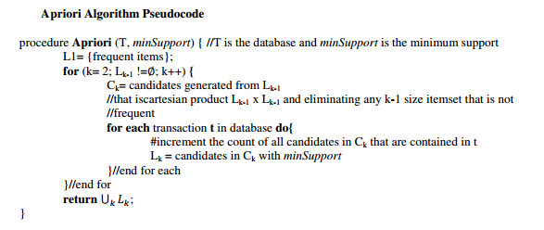

As is common in association rule mining, given a set of itemsets (for instance, sets of retail transactions, each listing individual items purchased), the algorithm attempts to find subsets which are common to at least a minimum number C of the itemsets.
Apriori uses a "bottom up" approach, where frequent subsets are extended one item at a time (a step known as candidate generation), and groups of candidates are tested against the data. The algorithm terminates when no further successful extensions are found.
Apriori uses breadth-first search and a tree structure to count candidate item sets efficiently. It generates candidate item sets of length k from item sets of length k − 1.
Then it prunes the candidates which have an infrequent sub pattern. According to the downward closure lemma, the candidate set contains all frequent k-length item sets. After that, it scans the transaction database to determine frequent item sets among the candidates.
Apriori, while historically significant, suffers from a number of inefficiencies or trade-offs, which have spawned other algorithms. Candidate generation generates large numbers of subsets (the algorithm attempts to load up the candidate set with as many as possible before each scan).
Bottom-up subset exploration (essentially a breadth-first traversal of the subset lattice) finds any maximal subset S only after all 2 | S | − 1 of its proper subsets.
Sample usage of Apriori algorithm

A large supermarket tracks sales data by Stock-keeping unit (SKU) for each item, and thus is able to know what items are typically purchased together. Apriori is a moderately efficient way to build a list of frequent purchased item pairs from this data. Let the database of transactions consist of the sets {1,2,3,4}, {1,2,3,4,5}, {2,3,4}, {2,3,5}, {1,2,4}, {1,3,4}, {2,3,4,5}, {1,3,4,5}, {3,4,5}, {1,2,3,5}. Each number corresponds to a product such as "butter" or "water". The first step of Apriori is to count up the frequencies, called the supports, of each member item separately:

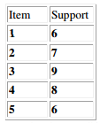
We can define a minimum support level to qualify as "frequent," which depends on the context. For this case, let min support = 4. Therefore, all are frequent. The next step is to generate a list of all 2-pairs of the frequent items. Had any of the above items not been frequent, they wouldn't have been included as a possible member of possible 2-item pairs. In this way, Apriori prunes the tree of all possible sets. In next step we again select only these items (now 2-pairs are items) which are frequent (the pairs written in bold text):

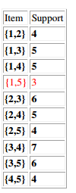
We generate the list of all 3-triples of the frequent items (by connecting frequent pair with frequent single item).

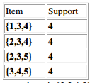
The algorithm will end here because the pair {2,3,4,5} generated at the next step does not have the desired support. We will now apply the same algorithm on the same set of data considering that the min support is 5. We get the following results: Step 1&2:

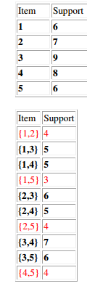
The algorithm ends here because none of the 3-triples generated at Step 3 have de desired support.

2. Explain Bayesian classification in detail. [May 2008][May 2012] (Or) Develop an algorithm for classification using Bayesian classification. Illustrate the algorithm with a relevant example. [May 2011] [May 2013][Nov/Dec 2016]

Bayesian approaches are a fundamentally important DM technique. Given the probability distribution, Bayes classifier can provably achieve the optimal result. Bayesian method is based on the probability theory. Bayes Rule is applied here to calculate the posterior from the prior and the likelihood, because the later two is generally easier to be calculated from a probability model. One limitation that the Bayesian approaches can not cross is the need of the probability estimation from the training dataset. Bayesian classification provides practical learning algorithms and prior knowledge andobserved data can be combined. Bayesian Classification provides a useful perspective forunderstanding and evaluating many learning algrithms. It calculates explicit probabilities forhypothesis and it is robust to noise in input data. the probability model for a classifier is a conditional model
over a dependent class variable with a small number of outcomes or classes, conditional on several

feature variables through . The problem is that if the number of features is large or when a feature can take on a large number of values, then basing such a model on probability tables is infeasible. We therefore reformulate the model can be written as
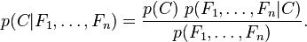

the above equation can be written as
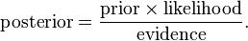

3. Explain constraint based association mining. [May 2008] [May 2012]

A good heuristic is to have the users specify such intuition or expectations as constraints to confine the search space. The constraint can include the following:
Key type constraints
Data constraints
Dimensional constraints
Interestingness constraints
Rule constraints

4.What is classification? With an example explain how support vector machine can be used for classification. [Dec 2011]
Support Vector Machines are based on the concept of decision planes that define decision boundaries. A decision plane is one that separates between a set of objects having different class memberships. A schematic example is shown in the illustration below. In this example, the objects belong either to class GREEN or RED. The separating line defines a boundary on the right side of which all objects are GREEN and to the left of which all objects are RED. Any new object (white circle) falling to the right is labeled, i.e., classified, as GREEN (or classified as RED should it fall to the left of the separating line).
The above is a classic example of a linear classifier, i.e., a classifier that separates a set of objects into their respective groups (GREEN and RED in this case) with a line. Most classification tasks, however, are not that simple, and often more complex structures are needed in order to make an optimal separation, i.e., correctly classify new objects (test cases) on the basis of the examples that are available (train cases). This situation is depicted in the illustration below. Compared to the previous schematic, it is clear that a full separation of the GREEN and RED objects would require a curve (which is more complex than a line). Classification tasks based on drawing separating lines to distinguish between objects of different class memberships are known as hyperplane classifiers. Support Vector Machines are particularly suited to handle such tasks.
The illustration below shows the basic idea behind Support Vector Machines. Here we see the original objects (left side of the schematic) mapped, i.e., rearranged, using a set of mathematical functions, known as kernels. The process of rearranging the objects is known as mapping (transformation). Note that in this new setting, the mapped objects (right side of the schematic) is linearly separable and, thus, instead of constructing the complex curve (left schematic), all we have to do is to find an optimal line that can separate the GREEN and the RED objects.

5.Discuss about mining association rules using the apriori algorithm in detail.[Dec 2013] [May 2012][May 2011][Dec 2011][Dec 2013][Dec 2014]
Find the frequent itemsets: the sets of items that have minimum support
A subset of a frequent itemset must also be a frequent itemset

i.e., if {AB} is a frequent itemset, both {A} and {B} should be a frequent itemset Iteratively find frequent itemsets with cardinality from 1 to k (k-itemset)

Use the frequent itemsets to generate association rules
The Apriori Algorithm : Pseudocode
Join Step: Ck is generated by joining Lk-1 with itself
Prune Step: Any (k-1)-itemset that is not frequent cannot be a subset of a frequent k-itemset

6.Explain classification by decision tree induction in detail. [May 2012] or what is decision tree? Explain how classification is done using decision tree induction.[June 2012]or Develop an algorithm for classification using decision trees. Illustrate the algorithm with a relevant example.[Dec 2012]

A decision tree is a structure that includes a root node, branches, and leaf nodes. Each internal node denotes a test on an attribute, each branch denotes the outcome of a test, and each leaf node holds a class label. The topmost node in the tree is the root node.
The following decision tree is for the concept buy_computer that indicates whether a customer at a company is likely to buy a computer or not. Each internal node represents a test on an attribute. Each leaf node represents a class.
The benefits of having a decision tree are as follows −
- It does not require any domain knowledge.
- It is easy to comprehend.
- The learning and classification steps of a decision tree are simple and fast.

Decision Tree Induction Algorithm
A machine researcher named J. Ross Quinlan in 1980 developed a decision tree algorithm known as ID3 (Iterative Dichotomiser). Later, he presented C4.5, which was the successor of ID3. ID3 and C4.5 adopt a greedy approach. In this algorithm, there is no backtracking; the trees are constructed in a top-down recursive divide-and-conquer manner.
Generating a decision tree form training tuples of data partition D
Algorithm : Generate_decision_tree

Input:
Data partition, D, which is a set of training tuples
and their associated class labels.
attribute_list, the set of candidate attributes.
Attribute selection method, a procedure to determine the
splitting criterion that best partitions that the data
tuples into individual classes. This criterion includes a
splitting_attribute and either a splitting point or splitting subset.

Output:
A Decision Tree

Method
create a node N;

if tuples in D are all of the same class, C then
return N as leaf node labeled with class C;

if attribute_list is empty then
return N as leaf node with labeled
with majority class in D;|| majority voting

apply attribute_selection_method(D, attribute_list)
to find the best splitting_criterion;
label node N with splitting_criterion;

if splitting_attribute is discrete-valued and
multiway splits allowed then // no restricted to binary trees

attribute_list = splitting attribute; // remove splitting attribute
for each outcome j of splitting criterion

// partition the tuples and grow subtrees for each partition
let Dj be the set of data tuples in D satisfying outcome j; // a partition

if Dj is empty then
attach a leaf labeled with the majority
class in D to node N;
else
attach the node returned by Generate
decision tree(Dj, attribute list) to node N;
end for
return N;

7.With an example explain various attribution selection measures in classification. [May 2014] Attribute selection measures

1.Information gain
2.Gain Ratio.
a.Comparison of Classification and Prediction Methods:Here is the criteria for comparing methods of Classification and Prediction:
Accuracy - Accuracy of classifier refers to ability of classifier predict the class label correctly and the accuracy of predictor refers to how well a given predictor can guess the value of predicted attribute for a new data.
Speed - This refers to the computational cost in generating and using the classifier or predictor.
Robustness - It refers to the ability of classifier or predictor to make correct predictions from given noisy data.

Scalability - Scalability refers to ability to construct the classifier or predictor efficiently given large amount of data.
Interpretability - This refers to the to what extent the classifier or predictor understand.

b.The major issue is preparing the data for Classification and Prediction. preparing the data involves the following activities:

Data Cleaning - Data cleaning involves removing the noise and treatment of missing values. The noise is removed by applying smoothing techniques and the problem of missing values is solved by replacing a missing value with most commonly occurring value for that attribute.

Relevance Analysis - Database may also have the irrelevant attributes. Correlation analysis is used to know whether any two given attributes are related.

Data Transformation and reduction - The data can be transformed by any of the following methods. Normalization - The data is transformed using normalization. Normalization involves scaling all values for given attribute in order to make them fall within a small specified range. Normalization is used when in the learning step, the neural networks or the methods involving measurements are used. Generalization -The data can also be transformed by generalizing it to the higher concept. For this purpose we can use the concept hierarchies.

8. Explain Bayesian classification and rule based classification. Give example for any one classification and explain in detail.[Dec 2014]

Classfication rules:
“if…then…” rules

(Blood Type=Warm) ∧(Lay Eggs=Yes) → Birds (Taxable_Income< 50K) ∧(Refund=Yes) → Evade=No Rule: (Condition) → y

where Condition is a conjunction of attribute tests(A1 = v1) and (A2 = v2) and … and (An = vn) and y is the class label

– LHS: rule antecedent or condition

– RHS: rule consequent

Ex:A rule r covers an instance x if the attributes of the instance satisfy the condition (LHS) of the rule
R1: (Give Birth = no) ∧ (Can Fly = yes) → Birds
R2: (Give Birth = no) ∧ (Live in Water = yes) → Fishes

9.Explain about classification and prediction techniques. [Dec 2012][Dec 2011]
Major method for prediction: regression
Many variants of regression analysis in statistics

The Data Classification process includes the two steps:Building the Classifier or Model,Using Classifier for Classification

a. Building the Classifier or Model:This step is the learning step or the learning phase. In this step the classification algorithms build the classifier. The classifier is built from the training set made up of database tuples and their associated class labels. Each tuple that constitutes the training set is referred to as a category or class. These tuples can also be referred to as sample, object or data points.

b.Using Classifier for Classification

In this step the classifier is used for classification.Here the test data is used to estimate the accuracy of classification rules. The classification rules can be applied to the new data tuples if the accuracy is considered acceptable.

10. Discuss the apriori algorithm for discovering frequent itemsets. Apply apriori algorithm to the following data set. Use 0.3 for the minimum support value. [May 2011] [Dec 2011] [May 2013][Dec 2012][June 2013][June 2014]

Trans ID | Item purchased
101 | strawberry, litchi, oranges
102 | strawberry, butterfruit
103 | butterfruit, vanilla
104 | strawberry, litchi, oranges
105 | banana, oranges
106 | Banana
107 | banana, butterfruit
108 | strawberry, litchi, apple, oranges
109 | apple, vanilla
110 | strawberry, litchi,

The set of item is {strawberry, litchi, oranges, butterfruit, vanilla, Banana, apple}. Use 0.3 for the minimum support value.
Algorithm:

The pseudo code for the algorithm is given below for a transaction database , and a support threshold of

. Usual set theoretic notation is employed, though note that is a multiset. is the candidate set for level . Generate() algorithm is assumed to generate the candidate sets from the large item sets of the
preceding level, heeding the downward closure lemma. accesses a field of the data structure that represents candidate set , which is initially assumed to be zero. Many details are omitted below, usually the most important part of the implementation is the data structure used for storing the candidate sets, and counting their frequencies
11.Explain how the Bayesian belief networks are trained to perform classification.[June 2012]
A belief network is defined by two components:
A directed acyclic graph

Conditional probability table
Training Bayesian belief network

12. Explain as to how neural networks are used for classification of data.[Dec 2013].

Backpropagation is a neural network learning algorithm. The neural networks field was originally kindled by psychologists and neurobiologists who sought to develop and test computational analogs of neurons. Roughly speaking, a neural network is a set of connected input/output units in which each connection has a weight associated with it. During the learning phase, the network learns by adjusting the weights so as to be able to predict the correct class label of the input tuples. Neural network learning is also referred to as connectionist learning due to the connections between units.
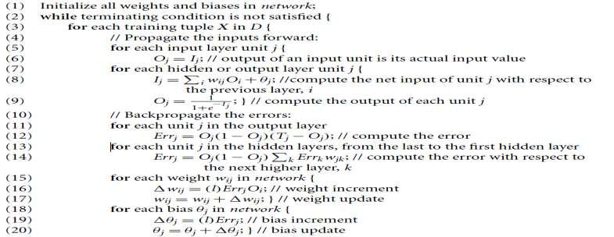

UNIT V
PART A

- State the role of cluster analysis? [Nov/Dec 2016]

Clustering analyses data objects without consulting a known class label. Class labels are not present in the training data simply because they are not known to begin with. Clustering can be used to generate such labels. The objects are clustered or grouped based on the principle of maximizing the intraclass similarity and minimizing the interclass similarity.

2. Give the reason on why clustering is need in data mining [Nov/Dec 2016]

Scalability

Ability to deal with different types of attributes

Discover of clusters with arbitrary shape

Requirements for domain knowledge to determine input parameters

Ability to deal with noisy data

Interpretability and usability

3. How is the quality of a cluster represented?

Quality of a cluster mat is represented by its diameter, the maximum distance between any two objects in the cluster. Centroid distance is another alternative measure of cluster quality and is defined by the average distance of each distance object from the cluster centroid.

4. Give the categorization of major clustering methods. [May 2012] [May 2013]

The major clustering methods are partitioning methods, hierarchical methods, density based methods, grid based methods and model based methods.

- Define Clustering. [Dec 2011] [May 2013]
A cluster is a collection of data objects that are similar to one another within the same cluster and are dissimilar to objects in other clusters. The process of grouping a set of physical or abstract objects into classes of similar objects is called clustering.

- List the commonly used partitioning methods.

K- Means and K-Medoids

- What are the characteristics of partitioning methods?
Find mutually exclusive clusters of spherical shape
Distance-based

May use mean-medoid to represent cluster center

Effective for small to medium-size data sets

8.What are the characteristics of Hierarchical methods?
Clustering is a hierarchical decomposition

Cannot correct erroneous merges or splits
May incorporate other technique like micro clustering

9.What are the characteristics of Density based methods?
Can find arbitrary shaped clusters

Clusters are dense regions of objects in space that are separated by low-density regions

Custer density-Each point must have a minimum number of points within its “neighborhood”.

May filter out outliers

10.What are the characteristics of Grid based methods?
Use a multiresolution grid data structure

Fast processing time
^{11.}What are the applications of cluster analysis?

Applications are Business Intelligence, Image pattern recognition, web search, biology and security. Cluster analysis can be used as a standalone data mining tool to gain insight into the data distribution, or as a preprocessing step for other data mining algorithms operating on the detected clusters.

12. What is the concept of partitioning methods?

It creates an initial set of k partitions, where parameter k is the number of partitions to construct. It then uses an iterative relocation technique that attempts to improve that partitioning by moving objects from one group to another.

13. Define hierarchical method in clustering.

It creates a hierarchical decomposition of the given set of data objects. The method is classified as being either agglomerative (bottom-up) or divisive (top-down), based on how the hierarchical decomposition is firmed.

14. Define density-based method in clustering.

A density-based method clusters objects based on the notion of density. It grows clusters either according to the density of neighborhood objects or according to a density function.

15. What is an outlier? Give example[May 2011] [Dec 2011][May 2013][June 2013]

Some data objects do not comply with the general behavior or model of the data. Such data objects which are grossly different from or inconsistent with the remaining set of data are called outliers. Outliers can be caused by measurement or execution error. Outlier detection and analysis is referred to as outlier mining.

Identify the outlier of the data set. 216, 403, 203, 210, 227, 220, 190, 194 Correct answer is 403

Solution:

Step 1: An outlier is an element of a data set that distinctly stands out from the rest of the data. Step 2: In the given data set, 403 is far apart from the remaining data values. Step 3: So, the outlier of the data set is 403.

16. Define grid-based method in clustering.

A grid-based method first quantizes the object space into a finite number of cells that form a grid structure, and then performs clustering on the grid structure. Ex: STING

- What are the types of clustering methods for high-dimensional data?

  - Subspace clustering methods - search for clusters in subspaces of the original space

  - Dimensionality reduction – creates a new space of lower dimensionality and search for clusters there.

- What is STING?[June 2014]

STING ( STatistical INformation Grid approach). The spatial area area is divided into rectangular cells.There are several levels of cells corresponding to different levels of resolution.Each cell at a high level is partitioned into a number of smaller cells in the next lower level.Statistical info of each cell is calculated and stored beforehand and is used to answer queries.Parameters of higher level cells can be easily calculated from parameters of lower level cell.Use a top-down approach to answer spatial data queries

- What are the types of constraints with clustering?

  - Constraints on instances
  - Constraints on clusters
  - Constraints on similarity measurement

- What are types of outliers?
Global outliers, contextual (or conditional) outliers and collective outliers.

21. List the methods for outlier detection.
Statistical approach, proximity-based methods, and clustering-based methods

22. What is distance based outlier?

An object o in a data set S is a distance based outlier with parameters p and d i.e., DB (p, d) if at least a fraction p of the objects in S lie at a distance greater than d from o.

23. List the algorithms for mining distance based outliers.
Index based algorithm, Nested Loop Algorithm, Cell based Algorithm.

- Give the two techniques used for deviation based outlier detection.

Sequential exception technique, OLAP data cube technique.

- What are the data mining applications? [May 2013] [May 2011]

Financial data analysis

Retail and telecommunication industries
Science and Engineering
Intrusion detection and prevention

Data mining and Recommender systems

Applications are business intelligence, web search, bioinformatics, health informatics, finance, digital libraries, and digital governments.

26.Mention the applications of outlier.[Dec 2011][Dec 2013]

Fraud Detection ,Intrusion Detection mFault/ Damage Detection ,Crime Investigation,Medical Informatics.

27.Distinguish between classification and clustering.[June 2012][Dec 2012]

Classification is supervised learning technique used to assign per-defined tag to instance on the basis of features. So classification algorithm requires training data. Classification model is created from training data, then classification model is used to classify new instances.

Clustering is unsupervised technique used to group similar instances on the basis of features. Clustering does not require training data. Clustering does not assign per-defined label to each and every group.

28.What is outlier analysis?[Dec 2012]

Data objects which are grossly different from or inconsistent with the remaining set of data are called as outliers. The outliers may be of particular interest, such as in the case of fraud detection, where outliers may indicate fraudulent activity. Thus outlier detection and analysis is an interesting data mining tasks referred to as outlier mining or outlier analysis.

29.Classify hierarchical clustering methods.[June 2013][Dec 2014]

Hierarchical clustering (also called hierarchical cluster analysis or HCA) is a method of cluster analysis which seeks to build a hierarchy of clusters. Strategies for hierarchical clustering generally fall into two types:

Agglomerative: This is a "bottom up" approach: each observation starts in its own cluster, and pairs of clusters are merged as one moves up the hierarchy.

Divisive: This is a "top down" approach: all observations start in one cluster, and splits are performed recursively as one moves down the hierarchy

30.How is the goodness of clusters is measured.[Dec 2013]

Numerical measures that are applied to judge various aspects of cluster validity, are classified into the following three types.

- External Index: Used to measure the extent to which cluster labels match externally supplied class labels.
  - Entropy

- Internal Index: Used to measure the goodness of a clustering structure without respect to external information.
  - Sum of Squared Error (SSE)

- Relative Index: Used to compare two different clusterings or clusters.
a.Often an external or internal index is used for this function, e.g., SSE or entropy

UNIT V
PART B

1.Explain K-Means partitioning algorithm in detail. [May 2011] [Dec 2011]
[Dec 2012] [May 2013] [Nov/Dec 2016]
k-means clustering
k-means is one of the simplest unsupervised learning algorithms that solve the well known clustering problem. The procedure follows a simple and easy way to classify a given data set through a certain number of clusters (assume k clusters) fixed apriori. The main idea is to define k centers, one for each cluster. These centers should be placed in a cunning way because of different location causes different result. So, the better choice is to place them as much as possible far away from each other. The next step is to take each point belonging to a given data set and associate it to the nearest center. When no point is pending, the first step is completed and an early group age is done. At this point we need to re-calculate k new centroids as barycenter of the clusters resulting from the previous step. After we have these k new centroids, a new binding has to be done between the same data set points and the nearest new center. A loop has been generated. As a result of this loop we may notice that the k centers change teir location step by step until no more changes are done or in other words centers do not move any more. Finally, this algorithm aims at minimizing an objective function know as squared error function given by:

where,
‘||x_{i} - v_{j}||’ is the Euclidean distance between x_{i} and v_{j.}
‘c_{i}’ is the number of data points in i^{th} cluster.
‘c’ is the number of cluster centers.

Algorithmic steps for k-means clustering
Let X = {x₁,x₂,x₃,……..,x_{n}} be the set of data points and V = {v₁,v₂,…….,v_{c}} be the set of centers.
1) Randomly select ‘c’ cluster centers.
2) Calculate the distance between each data point and cluster centers.
3) Assign the data point to the cluster center whose distance from the cluster center is minimum of all the cluster centers..
4) Recalculate the new cluster center using:
where, ‘c_{i}’ represents the number of data points in i^{th} cluster.
5) Recalculate the distance between each data point and new obtained cluster centers.
6) If no data point was reassigned then stop, otherwise repeat from step 3).

2.Explain about data mining applications.or. Expalin how data mining is used for retail industry.[June 2014] [Nov/Dec 2016]

Here is the list of areas where data mining is widely used:
- Financial Data Analysis,
- RetailIndustry,
- TelecommunicationIndustry,
- Biological DataAnalysis,
- OtherScientific Applications,
- Intrusion Detection.
- Data Mining in Telecommunication industry helps in identifying the telecommunication patterns, catch fraudulent activities,
- make better use of resource,
- improve quality of service.
- Here is the list examples for which data mining improve telecommunication services:
- Multidimensional Analysis of Telecommunication data,
- Fraudulent pattern analysis,
- Identification of unusual patterns,
- Multidimensional association and sequential patterns analysis,
- Mobile Telecommunication services,
- Use of visualization tools in telecommunication data analysis.
3.Explain outlier analysis in detail with an example. Discuss the use of outlier analysis.[June 2014] [Dec 2013][May 2012] [Dec 2014]

“An outlier is an observation which deviates so much from the other observations as to arouse suspicions that it was generated by a different mechanism.” Outliers are also referred to as abnormalities, discordants, deviants, or anomalies in the data mining and statistics literature. The recognition of such unusual characteristics provides useful application-specific insights. Some examples are as follows:Intrusion Detection Systems: In many host-based or networked computer systems, different kinds of data are collected about the operating system calls, network traffic, or other activity in the systemCredit Card Fraud: Credit card fraud is quite prevalent, because of the ease with which sensitive information such as a credit card number may be compromisedInteresting Sensor Events: The sudden changes in the underlying patterns may represent events of interest. Event detection is one of the primary motivating applications in the field of sensor networks.Medical Diagnosis: In many medical applications the data is collected from a variety of devices such as MRI scans, PET scans or ECG time-series. Unusual patterns in such data typically reflect disease conditions.Law Enforcement: Outlier detection finds numerous applications to law enforcement, especially in cases, where unusual patterns can only be discovered over time through multiple actions of an entity. Earth Science: A significant amount of spatiotemporal data about weather patterns, climate changes, or land cover patterns is collected through a variety of mechanisms such as satellites or remote sensing.

ii)DBSCAN[Dec 2013]

- Explain model based clustering.
Observe characteristics of some objects{x1, …,xN}N objects

•An object belongs to one of M clusters, but you don’t know which{z1, …, zN}cluster memberships, numbers from 1..M

•Some clusters are more likely than othersP(zk=m) = πm(πm= frequency cluster m occurs)

•Within a cluster, objects’ characteristics are generated by the same distribution, which has free parametersP(xk|zk=m) = f(xk,λm)(λm= parameters of cluster m),f doesn’t have to be Gaussian

Now you have a model connecting the observations to the cluster memberships and parametersP(xk) = Σm=1..MP(xk|zk=m) P(zk=m)

= Σm=1..Mf(xk,λm)πm, P(x1… xN) = Πk=1..NP(xk)(assuming x’sare independent)

1.Find the values of the parameters by maximizing the likelihood (usually the log of the likelihood) of the observationsmax log P(x1… xN) over λ1… λMand π1… πM

5. Explain with an example density based clustering methods.[Dec 2014]

Is a set of density-connected objects that is maximal with respect to density-reachability. Every object not contained in any cluster is considered to be noise. That is, for each data point within a given cluster, the neighborhood of a given radius has to contain at least a minimum number of points. Such an algorithm can be used to filter out noise (outliers) and discover clusters of arbitrary shape. Clustering Based on density (local cluster criterion), such as density-connected points or based on an explicitly constructed density function
Major features:Discover clusters of arbitrary shape,Handlenoise,Onescan,Need density parameters
6.With relevant example discuss constraint based cluster analysis. [May 2011]

Both a must-link and a cannot-link constraint define a relationship between two data instances. A must-link constraint is used to specify that the two instances in the must-link relation should be associated with the same cluster. A cannot-link constraint is used to specify that the two instances in the cannot-link relation should not be associated with the same cluster. These sets of constraints acts as a guide for which a constrained clustering algorithm will attempt to find clusters in a data set which satisfy the specified must-link and cannot-link constraints. Some constrained clustering algorithms will abort if no such clustering exists which satisfies the specified constraints. Others will try to minimize the amount of constraint violation should it be impossible to find a clustering which satisfies the constraints.Examples of constrained clustering algorithms include:COP K-means, PCKmeans,CMWK-Means

7.Describe cluster analysis in detail.
Clustering is the process of making a group of abstract objects into classes of similar objects
- A cluster of data objects can be treated as one group.
- While doing cluster analysis, we first partition the set of data into groups based on data similarity and then assign the labels to the groups.
- The main advantage of clustering over classification is that, it is adaptable to changes and helps single out useful features that distinguish different groups.

Applications of Cluster Analysis
- Clustering analysis is broadly used in many applications such as market research, pattern recognition, data analysis, and image processing.
- Clustering can also help marketers discover distinct groups in their customer base. And they can characterize their customer groups based on the purchasing patterns.
- In the field of biology, it can be used to derive plant and animal taxonomies, categorize genes with similar functionalities and gain insight into structures inherent to populations.
- Clustering also helps in identification of areas of similar land use in an earth observation database. It also helps in the identification of groups of houses in a city according to house type, value, and geographic location.
- Clustering also helps in classifying documents on the web for information discovery.
- Clustering is also used in outlier detection applications such as detection of credit card fraud.
- As a data mining function, cluster analysis serves as a tool to gain insight into the distribution of data to observe characteristics of each cluster.

Requirements of Clustering in Data Mining
The following points throw light on why clustering is required in data mining −
- Scalability − We need highly scalable clustering algorithms to deal with large databases.
- Ability to deal with different kinds of attributes − Algorithms should be capable to be applied on any kind of data such as interval-based (numerical) data, categorical, and binary data.
- Discovery of clusters with attribute shape − The clustering algorithm should be capable of detecting clusters of arbitrary shape. They should not be bounded to only distance measures that tend to find spherical cluster of small sizes.
- High dimensionality − The clustering algorithm should not only be able to handle low-dimensional data but also the high dimensional space.
- Ability to deal with noisy data − Databases contain noisy, missing or erroneous data. Some algorithms are sensitive to such data and may lead to poor quality clusters.
- Interpretability − The clustering results should be interpretable, comprehensible, and usable.

8. What is grid based clustering? With an example explain an algorithm for grid based clustering. [Dec 2011]
- Define a set of grid-cells
- Assign ojects to the appropriate grid cell and compute the density of each cell.
- Eliminate cells, whose density is below a certain threshold t.

- Form clusters from contiguous (adjacent) groups of dense cells (usually minimizing a given objective function)

Advantages:fast:No distance computations, Clustering is performed on summaries and not individual objects; complexity is usually O(#-populated-grid-cells) and not O(#objects), Easy to determine which clusters are neighboring
Shapes are limited to union of grid-cells

Using multi-resolution grid data structure

Clustering complexity depends on the number of populated grid cells and not on the number of objects in the dataset

Several interesting methods (in addition to the basic grid-based algorithm):STINGand CLIQUE
^{9.}Explain hierarchical clustering techniques stating their pros and cons. [Dec 2013]or what is hierarchical clustering? With an example discuss dendegram representation for hierarchical clustering of data objects.[Dec 2012][Dec 2014]

Strategies for hierarchical clustering generally fall into two types: Agglomerative: This is a "bottom up" approach: each observation starts in its own cluster, and pairs of clusters are merged as one moves up the hierarchy.Divisive: This is a "top down" approach: all observations start in one cluster, and splits are performed recursively as one moves down the hierarchy.In order to decide which clusters should be combined (for agglomerative), or where a cluster should be split (for divisive), a measure of dissimilarity between sets of observations is required. In most methods of hierarchical clustering, this is achieved by use of an appropriate between pairs of observations), and a linkage criterion which specifies the dissimilarity of sets as a function of the pairwise distances of observations in the sets.

10. What is K-Means algorithm? Cluster the following eight points (with (x, y)
Representing locations) into three clusters A1(2, 10) A2(2, 5) A3(8, 4) A4(5, 8) A5(7, 5) A6(6, 4) A7(1, 2) A8(4, 9). Initial cluster centers are: A1(2, 10), A4(5, 8) and A7(1, 2). The distance function between two points a=(x1, y1) and b=(x2, y2) is defined as: ρ(a, b) = |x2 – x1| + |y2 – y1| . Use k-means algorithm to find the three cluster centers after the first iteration and the final three clusters.[June 2012]

11.i)Explain the different types of data used in cluster analysis.[June 2014][Dec 2014]
Interval Scaled Variables
Binary Variables
Ratio-Scaled Variable
Variables of mixed types

ii)Write the difference between CLARA and CLARANS
CLARA (Kaufmann and Rousseeuw in 1990)

Built in statistical analysis packages, such as S+

It draws multiple samples of the data set, applies PAM on each sample, and gives the best clustering as the output

Strength: deals with larger data sets than PAM

Weakness:

Efficiency depends on the sample size

A good clustering based on samples will not necessarily represent a good clustering of the whole data set if the sample is biased

CLARANS (A Clustering Algorithm based on Randomized Search) (Ng and Han’94)

CLARANS draws sample of neighbors dynamically
The clustering process can be presented as searching a graph where every node is a potential solution, that is, a set of k medoids

If the local optimum is found, CLARANS starts with new randomly selected node in search for a new local optimum

It is more efficient and scalable than both PAM and CLARA

12.Explain about Cluster analysis.

Cluster is a group of objects that belong to the same class.
In other words the similar object are grouped in one cluster and dissimilar are grouped in other cluster.
Points to Remember
A cluster of data objects can be treated as a one group.
While doing the cluster analysis, the set of data into groups based on data similarity and then assign the label to the groups.
The main advantage of Clustering over classification.
Applications of Cluster Analysis
Market research, pattern recognition, data analysis, and image processing.
Characterize their customer groups based on purchasing patterns.
In field of biology it can be used to derive plant and animal taxonomies, categorize genes with similar functionality and gain insight into structures inherent in populations.
Clustering also helps in identification of areas of similar land use in an earth observation database. It also helps in the identification of groups of houses in a city according house type, value, and geographic location.
Clustering also helps in classifying documents on the web for information discovery.
Clustering is also used in outlier detection applications such as detection of credit card fraud.
As a data mining function Cluster Analysis serve as a tool to gain insight into the distribution of data to observe characteristics of each cluster.
Requirements of Clustering in Data Mining
Here are the typical requirements of clustering in data mining:
Scalability - We need highly scalable clustering algorithms to deal with large databases.
Ability to deal with different kind of attributes - Algorithms should be capable to be applied on any kind of data such as interval based (numerical) data, categorical, binary data.
Discovery of clusters with attribute shape - The clustering algorithm should be capable of detect cluster of arbitrary shape. The should not be bounded to only distance measures that tend to find spherical cluster of small size.
High dimensionality - The clustering algorithm should not only be able to handle low- dimensional data but also the high dimensional space.
Ability to deal with noisy data - Databases contain noisy, missing or erroneous data. Some algorithms are sensitive to such data and may lead to poor quality clusters.
Interpretability - The clustering results should be interpretable, comprehensible and usable.
13.Explain about density based clustering methods.

Clustering based on density (local cluster criterion), such as density-connected points
· Major features:
Discover clusters of arbitrary shape
Handle noise
One scan
Need density parameters as termination condition
· Two parameters:
Eps: Maximum radius of the neighbourhood
MinPts: Minimum number of points in an Eps-neighbourhood of that point
· Typical methods: DBSACN, OPTICS, DenClue
· DBSCAN: Density Based Spatial Clustering of Applications with Noise
· Relies on a density-based notion of cluster: A cluster is defined as a maximal set of density- connected points
· Discovers clusters of arbitrary shape in spatial databases with noise
· DBSCAN: The Algorithm
· Arbitrary select a point p
· Retrieve all points density-reachable from p w.r.t. Eps and MinPts.
· If p is a core point, a cluster is formed.
· If p is a border point, no points are density-reachable from p and DBSCAN visits the next point of the database.
· Continue the process until all of the points have been processed.
· 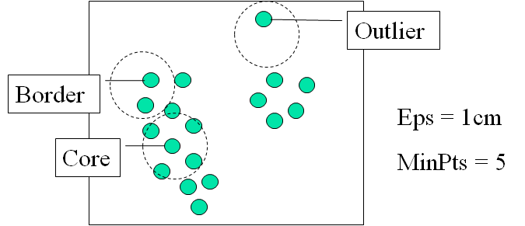
149 OPTICS: Ordering Points To Identify the Clustering Structure
Produces a special order of the database with its density-based clustering structure
This cluster-ordering contains info equiv to the density-based clustering’s corresponding to a broad range of parameter settings
Good for both automatic and interactive cluster analysis, including finding intrinsic clustering structure
Can be represented graphically or using visualization techniques
· DENCLUE: DENsity-based CLUstEring
· Major features
Solid mathematical foundation
Good for data sets with large amounts of noise
Allows a compact mathematical description of arbitrarily shaped clusters in high-dimensional data sets
Significant faster than existing algorithm (e.g., DBSCAN)
But needs a large number of parameters

14.Explain grid based clustering method.
Using multi-resolution grid data structure
· Advantage
· The major advantage of this method is fast processing time.
· It is dependent only on the number of cells in each dimension in the quantized space.
· Typical methods: STING, WaveCluster, CLIQUE
· STING: a STatistical INformation Grid approach
· The spatial area area is divided into rectangular cells
· There are several levels of cells corresponding to different levels of resolution
· 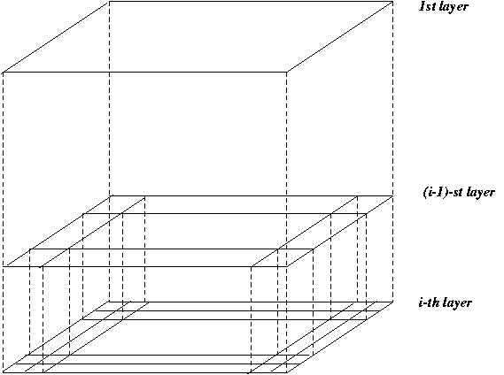

Each cell at a high level is partitioned into a number of smaller cells in the next lower level
Statistical info of each cell is calculated and stored beforehand and is used to answer queries
Parameters of higher level cells can be easily calculated from parameters of lower level cell
§ count, mean, s, min, max
§ type of distribution—normal, uniform, etc.
Use a top-down approach to answer spatial data queries
Start from a pre-selected layer—typically with a small number of cells
For each cell in the current level compute the confidence interval
· WaveCluster: Clustering by Wavelet Analysis
· A multi-resolution clustering approach which applies wavelet transform to the feature space
· How to apply wavelet transform to find clusters
Summarizes the data by imposing a multidimensional grid structure onto data space
These multidimensional spatial data objects are represented in a n-dimensional feature space
Apply wavelet transform on feature space to find the dense regions in the feature space
Apply wavelet transform multiple times which result in clusters at different scales from fine to coarse
· Wavelet transform: A signal processing technique that decomposes a signal into different frequency sub-band (can be applied to n-dimensional signals)
· Data are transformed to preserve relative distance between objects at different levels of resolution
· Allows natural clusters to become more distinguishable

15.Explain Model-based clustering methods.
Attempt to optimize the fit between the given data and some mathematical model
Based on the assumption: Data are generated by a mixture of underlying probability distribution
· In this method a model is hypothesize for each cluster and find the best fit of data to the given model.
· This method also serve a way of automatically determining number of clusters based on standard statistics, taking outlier or noise into account. It therefore yields robust clustering methods.
· Typical methods: EM, SOM, COBWEB
· EM — A popular iterative refinement algorithm
· An extension to k-means
Assign each object to a cluster according to a weight (prob. distribution)
New means are computed based on weighted measures
· General idea
Starts with an initial estimate of the parameter vector
Iteratively rescores the patterns against the mixture density produced by the parameter vector
o The rescored patterns are used to update the parameter updates
o Patterns belonging to the same cluster, if they are placed by their scores in a particular component
· Algorithm converges fast but may not be in global optima
· COBWEB (Fisher’87)
A popular a simple method of incremental conceptual learning
Creates a hierarchical clustering in the form of a classification tree
Each node refers to a concept and contains a probabilistic description of that concept

SOM (Soft-Organizing feature Map)
Competitive learning
Involves a hierarchical architecture of several units (neurons)
Neurons compete in a ―winner-takes-all‖ fashion for the object currently being presented
· SOMs, also called topological ordered maps, or Kohonen Self-Organizing Feature Map (KSOMs)
· It maps all the points in a high-dimensional source space into a 2 to 3-d target space, s.t., the distance and proximity relationship (i.e., topology) are preserved as much as possible
· Similar to k-means: cluster centers tend to lie in a low-dimensional manifold in the feature space
· Clustering is performed by having several units competing for the current object
The unit whose weight vector is closest to the current object wins
The winner and its neighbors learn by having their weights adjusted
· SOMs are believed to resemble processing that can occur in the brain
· Useful for visualizing high-dimensional data in 2- or 3-D space

16.Explain Constraint-based clustering Method
· Clustering by considering user-specified or application-specific constraints
· Typical methods: COD (obstacles), constrained clustering
· Need user feedback: Users know their applications the best
· Less parameters but more user-desired constraints, e.g., an ATM allocation problem:
obstacle & desired Clusters
· Clustering in applications: desirable to have user-guided (i.e., constrained) cluster analysis
· Different constraints in cluster analysis:
Constraints on individual objects (do selection first)
Cluster on houses worth over $300K
Constraints on distance or similarity functions
Weighted functions, obstacles (e.g., rivers, lakes)
Constraints on the selection of clustering parameters
# of clusters, MinPts, etc.
User-specified constraints
Contain at least 500 valued customers and 5000 ordinary ones
Semi-supervised: giving small training sets as ―constraints‖ or hints
· Example: Locating k delivery centers, each serving at least m valued customers and n ordinary ones
· Proposed approach
Find an initial ―solution‖ by partitioning the data set into k groups and satisfying user-constraints
Iteratively refine the solution by micro-clustering relocation (e.g., moving δ μ- clusters from cluster Ci to Cj) and ―deadlock‖ handling (break the microclusters when necessary)
Efficiency is improved by micro-clustering
· How to handle more complicated constraints?
o E.g., having approximately same number of valued customers in each cluster?! —Can you solve it?
17.Explain about outlier analysis .
The set of objects are considerably dissimilar from the remainder of the data
Example: Sports: Michael Jordon, Wayne Gretzky, ...
Problem: Define and find outliers in large data sets
Applications:
· Credit card fraud detection
· Telecom fraud detection
· Customer segmentation

· Medical analysis

Statistical Distribution-based outlier detection-Indentify the outlier with respect to the model using discordancy test
How discordancy test work

Data is assumed to be part of a working hypothesis (working hypothesis)-H
Each data object in the dataset is compared to the working hypothesis and is either accepted in the working hypothesis or rejected as discordant into an alternative hypothesis (outliers).
Distance-Based outlier detection

Imposed by statistical methods
We need multi-dimensional analysis without knowing data distribution
Algorithms for mining distance-based outliers

Index-based algorithm
Indexing Structures such as R-tree (R+-tree), K-D (K-D-B) tree are built for the multi- dimensional database
The index is used to search for neighbors of each object O within radius D around that object.
Once K (K = N(1-p)) neighbors of object O are found, O is not an outlier.
Worst-case computation complexity is O(K*n2), K is the dimensionality and n is the number of objects in the dataset.
Pros: scale well with K

Cons: the index construction process may cost much time

Nested-loop algorithm

Divides the buffer space into two halves (first and second arrays)

Break data into blocks and then feed two blocks into the arrays.

Directly computes the distance between each pair of objects, inside the array or between arrays
Decide the outlier.Here comes an example:…

Same computational complexity as the index-based algorithm

Pros: Avoid index structure construction

Try to minimize the I/Os cell based algorithm
Divide the dataset into cells with length

K is the dimensionality, D is the distance

Define Layer-1 neighbors – all the intermediate neighbor cells. The maximum distance between a cell and its neighbor cells is D
Define Layer-2 neighbors – the cells within 3 cell of a certain cell. The minimum distance between a cell and the cells outside of Layer-2 neighbors is D Criteria
Search a cell internally. If there are M objects inside, all the objects in this cell are not outlier
Search its layer-1 neighbors. If there are M objects inside a cell and its layer- neighbors, all the objects in this cell are not outlier

Search its layer-2 neighbors. If there are less than M objects inside a cell, its layer-1 neighbor cells, and its layer-2 neighbor cells, all the objects in this cell are outlier
Otherwise, the objects in this cell could be outlier, and then need to calculate the distance between the objects in this cell and the objects in the cells in the layer-2 neighbor cells to see whether the total points within D distance is more than M or not.
Density-Based Local Outlier Detection

Distance-based outlier detection is based on global distance distribution
It encounters difficulties to identify outliers if data is not uniformly distributed
Ex. C1 contains 400 loosely distributed points, C2 has 100 tightly condensed points, 2 outlier points o1, o2
Some outliers can be defined as global outliers, some can be defined as local outliers to a given cluster
O2 would not normally be considered an outlier with regular distance-based outlier detection, since it looks at the global picture
Each data object is assigned a local outlier factor (LOF)
Objects which are closer to dense clusters receive a higher LOF
LOF varies according to the parameter MinPts

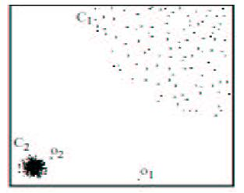

Deviation-Based Outlier detection
Identifies outliers by examining the main characteristics of objects in a group
Objects that ―deviate‖ from this description are considered outliers

Sequential exception technique
simulates the way in which humans can distinguish unusual objects from among a series of supposedly like objects
Dissimilarities are assed between subsets in the sequence the techniques introduce the following key terms
Exception set, dissimilarity function, cardinality function, smoothing factor

OLAP data cube technique
Deviation detection process is overlapped with cube computation
Recomputed measures indicating data exceptions are needed
A cell value is considered an exception if it is significantly different from the expected value, based on a statistical model
Use visual cues such as background color to reflect the degree of exception

Data Mining is widely used in diverse areas. There are number of commercial data mining system available today yet there are many challenges in this field. In this tutorial we will applications and trend of Data Mining.
Data Mining Applications

Here is the list of areas where data mining is widely used:

· Financial Data Analysis
· Retail Industry
· Telecommunication Industry
· Biological Data Analysis
· Other Scientific Applications
· Intrusion Detection

Financial Data Analysis

The financial data in banking and financial industry is generally reliable and of high quality which facilitates the systematic data analysis and data mining. Here are the few typical cases:
· Design and construction of data warehouses for multidimensional data analysis and data mining.
· Loan payment prediction and customer credit policy analysis.

· Classification and clustering of customers for targeted marketing.

· Detection of money laundering and other financial crimes.

Retail Industry

Data Mining has its great application in Retail Industry because it collects large amount data from on sales, customer purchasing history, goods transportation, consumption and services. It is natural that the quantity of data collected will continue to expand rapidly because of increasing ease, availability and popularity of web.
The Data Mining in Retail Industry helps in identifying customer buying patterns and trends. That leads to improved quality of customer service and good customer retention and satisfaction. Here is the list of examples of data mining in retail industry:
· Design and Construction of data warehouses based on benefits of data mining.

· Multidimensional analysis of sales, customers, products, time and region.

· Analysis of effectiveness of sales campaigns.

· Customer Retention.

· Product recommendation and cross-referencing of items.

Telecommunication Industry

Today the Telecommunication industry is one of the most emerging industries providing various services such as fax, pager, cellular phone, Internet messenger, images, e-mail, web data transmission etc.Due to the development of new computer and communication technologies, the telecommunication industry is rapidly expanding. This is the reason why data mining is become very important to help and understand the business.
Data Mining in Telecommunication industry helps in identifying the telecommunication patterns, catch fraudulent activities, make better use of resource, and improve quality of service. Here is the list examples for which data mining improve telecommunication services:
· Multidimensional Analysis of Telecommunication data.

· Fraudulent pattern analysis.

· Identification of unusual patterns.

· Multidimensional association and sequential patterns analysis.

· Mobile Telecommunication services.

· Use of visualization tools in telecommunication data analysis.

Biological Data Analysis

Now a days we see that there is vast growth in field of biology such as genomics, proteomics, functional Genomics and biomedical research.Biological data mining is very important part of Bioinformatics. Following are the aspects in which Data mining contribute for biological data analysis:
· Semantic integration of heterogeneous , distributed genomic and proteomic databases.

· Alignment, indexing , similarity search and comparative analysis multiple nucleotide sequences.
· Discovery of structural patterns and analysis of genetic networks and protein pathways.

· Association and path analysis.

· Visualization tools in genetic data analysis.

Other Scientific Applications

The applications discussed above tend to handle relatively small and homogeneous data sets for which the statistical techniques are appropriate. Huge amount of data have been collected from scientific domains such as geosciences, astronomy etc. There is large amount of data sets being generated because of the fast numerical simulations in various fields such as climate, and ecosystem modeling, chemical engineering, fluid dynamics etc. Following are the applications of data mining in field of Scientific Applications:
· Data Warehouses and data preprocessing.
· Graph-based mining.
· Visualization and domain specific knowledge.

Intrusion Detection
Intrusion refers to any kind of action that threatens integrity, confidentiality, or availability of network resources. In this world of connectivity security has become the major issue. With increased usage of internet and availability of tools and tricks for intruding and attacking network prompted intrusion detection to become a critical component of network administration. Here is the list of areas in which data mining technology may be applied for intrusion detection:
· Development of data mining algorithm for intrusion detection.

· Association and correlation analysis, aggregation to help select and build discriminating attributes.
· Analysis of Stream data.

· Distributed data mining.

· Visualization and query tools

