Unit-II

Part-A

1. **What is the significance of PSM and TSM? (Nov/Dec 2016)**

In induction disc relay there is a facility for selecting the plug setting and the time setting such that the same relay can be used for a wide range of current, and time characteristics. Selection of the required current setting is done by means of a plug setting multiplier plug. The operating time of the relay depends upon the distance between the moving contact and the fixed contact of the relay. The distance between the contacts is adjusted by the movement of the disc backstop which is controlled by rotating a knurled moulded wheel at the base of a graduated time multiplier scale. This is known as *time setting multiplier*.

1. **A relay is connected to 400/5 ratio current transformer with current setting of 150%. Calculate the plug setting multiplier when circuit carries a fault current of 400A. (Nov/Dec 2016)**



1. **Write the effects of arc resistance. (May/June 2016)**

Most common faults on overhead lines, such as insulator failures and lightning strikes, will include some kind of flashover. These arc have non-linearity in the network which had some influence on most impedance type distance to fault locator algorithms

1. **List out the benefits of static relays. (May/June 2016)**

* The power consumption of the static relay is much lower and thereby decrease the burden on the instrument transformer and increased its accuracy.
* The static relay has the quick response, long life, shockproof, fewer problems of maintenance, high reliability and a high degree of accuracy.
* Quick reset action, a high reset value and the absence of overshoot can be easily achieved because of the absence of thermal storage.
* Ease of providing  amplification enables greater sensitivity to be obtained.
* The risk of unwanted tripping is less with static relays.

1. **In what way a distance relay is superior to over current protection for protection of transmission lines? (Nov/Dec 2015)**

Distance relay is also called impedance relay. It compares the ratio of Voltage to current in the circuit. In overcurrent relay; the current is increased from its predetermined value and may cause short circuit which is liable to damage the equipment

1. **Where is negative phase sequence relay employed.(Nov/Dec 2015)**

The negative relays are also called phase unbalance relays because these relays provide protection against negative sequence component of unbalanced currents existing due to unbalanced loads or phase-phase faults. The unbalanced currents are dangerous from generators and motors point of view as these currents can cause overheating. Negative sequence relays are generally used to give protection to generators and motors against unbalanced currents.

1. **What is an under frequency relay? (Nov/Dec 2014)**

The under frequency relay is a device that functions to protect the load in the event generator frequency decreases below preset limits. It actuates when the frequency decreases to 55 hertz for 60-hertz operation and 46 hertz for 50-hertz operation. Upon actuation, contacts within the relay close to and open to de-energize the generator breaker (contactor), resulting in a display of the fault condition and removal of the load from the generator.

1. **Mention any two advantages of a static relay (April/May 2017,Nov/Dec 2014, May/June 2014,)**

The power consumption of the static relay is much lower and thereby decrease the burden on the instrument transformer and increased its accuracy.

The static relay has the quick response, long life, shockproof, fewer problems of maintenance, high reliability and a high degree of accuracy.

Quick reset action, a high reset value and the absence of overshoot can be easily achieved because of the absence of thermal storage.

Ease of providing  amplification enables greater sensitivity to be obtained.

The risk of unwanted tripping is less with static relays.

1. **List out the different types of distance relay (Nov/Dec 2014)**

* Impedance Relay
* Reactance Relay
* Mho Relay

1. **Give the applications of Electromagnetic relays.(Nov/Dec 2010)**

* The Over/Under Voltage and Over/Under Current protection for various equipments.
* Differential protection
* Definite time lag overcurrent and earth fault protection.

1. **Mention any two applications of differential relay(May/June 2011)**

* Protection of generator and generator transformer unit
* Protection of large motors and busbars

1. **What is meant by directional relay? (May/Jun 2012)**

The directional relay means the relay operates for the specific direction of the actuating quantity in the circuit. A directional relay is one that functions when input current is in a predetermined phase position when compared to a reference (or) polarizing quantity. The polarizing quantity may be reference voltage (or) current.

1. **State the advantages of mho relay.(May/June 2012)**

* Faster operation
* Simpler Coordination
* Reduced effects of fault current magnitudes
* Inherent Directional Characteristics

1. **In what way a distance relay is superior to over current protection for protection of transmission lines ?(Nov/Dec 2015)**

The distance relays are superior to over current relays for protection of transmission lines as the distance relays are not much affected by the changes in the short circuit current magnitude as compared to over current relays and also less affected by the changes in the generating capacity and system configuration.

1. **Where is negative phase sequence relay employed (Nov/Dec 2015)**

The negative phase sequence relays are used to provide protection against negative sequence components of unbalanced currents existing due to unbalanced loads (or) phase to phase faults. These relays are generally employed to give protection to generators and motors against unbalanced currents.

1. **Show the characteristics of an impedance relay on R-X Diagram.**

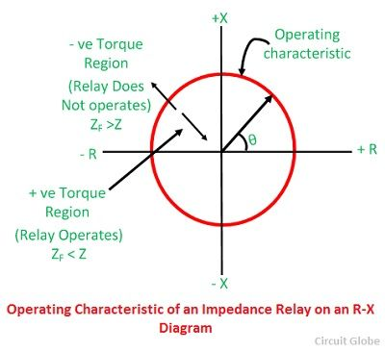

1. **A relay is connected to 200/1 ratio current transformer with current setting of 150%. Calculate the plug setting multiplier when circuit carries a fault current of 1000A.**



1. **Define Current setting of the relay.**

The **current setting of relay** is expressed in percentage ratio of relay pick up current to rated secondary current of CT.



1. **List the parameters needed to calculate relay operating time.**

For calculating actual relay operating time, we need to know these following parameters.

* Current setting.
* Fault current level.
* Ratio of current transformer.
* Time / PSM curve.
* Time setting.

1. **List out the benefits of Universal relays.**

* Modular construction via common hardware, reduced spare parts, and plug & play modules for cost savings and simplification
* Cyber Sentry UR provides robust network security aligned to industry standards and services
* Application flexibility with multiple I/O options, programmable logic, modularity, and specific customization
* Large HMI and annunciator for local monitoring and control
* Three Ethernet ports enable purpose specific LAN support, reducing latency from heavy traffic on critical communications

1. **Why a shading ring is provided in an Induction disc relay?**

The shading ring is provided to produce flux in the shaded portion of the magnet which is displaced in phase and space from flux in the remaining portion of the same magnet.

1. **Define power swing.**

During switching of lines or under wrong synchronization surges of real and reactive power flowing in the transmission lines cause severe oscillations in the voltage and current vectors. it is represented by a curve originating in load region and travelling towards relay characteristics.

1. **Mention the applications of D.C Relays.**

D.C relays are used in D.C trolley-bus systems, motor control, electroplating works , chemical and metallurgical process , auxiliary and control circuits.

1. **What is meant by polarized relay?**

Operation of the relay based on the direction of current or voltage then it is said to be polarized and the relay is polarized relay.

1. **What are the various types of electromagnetic relays?**
   1. Attracted armature type
   2. Balanced beam type
   3. Induction disc type
   4. Induction cup type
   5. Moving coil type
   6. Moving iron type

**Part-B**

1. **With a neat diagram explain the working principle of a directional overcurrent relay. Derive the torque equation and also explain about directional relay connection (Nov/Dec 2016-May/June 2016)**

Overcurrent relay is a sensing relay, which operates when the current increases beyond the operating value of the relay. Depending upon the time of operation, overcurrent relays may be categorized as instantaneous over current relay, inverse time overcurrent relay, definite time overcurrent relay, inverse definite time overcurrent relay, very inverse overcurrent relay and extremely inverse overcurrent relay. These relays are explained below in details.

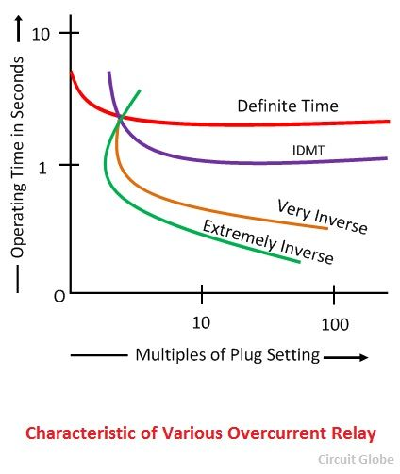

Directional overcurrent relaying refers to relaying that can use the phase relationship of voltage and current to determine direction to a fault.

Thus , if we measure the bus voltage phasor Vp and compute the phase angle of relay current with respect to bus voltage , then we can use the following logic to provide selectivity. If the relay detects fault and current lags Vr(=Vp), then permit relay tripping. If the relay detects fault and current leads Vr(=Vp) , then inhibits relay tripping. The discrimination principle based on phase angle comparison between a set of phasors , one of which is used as reference is called directional discrimination principle . Relays with this principle are called directional relays.

Directional over Current Relays. When fault current can flow in both the directions through the relay, at its location. Therefore, it is necessary to make the relay respond for a particular defined direction, so that proper discrimination is possible. This can be achieved by introduction of directional control elements. These are basically power measuring devices in which the system voltage is used as a reference for establishing the relative phase of the fault current. Basically, an AC directional relay can recognize certain difference in phase angle between two quantities, just as a D.C. directional relay recognize difference in polarity The polarizing quantity of a directional relay It is the reference against which the phase angle of the other quantity is compared. Consequently the phase angle of the polarizing quantity must remain fixed when other quantity suffers wide change in phase angle. The voltage is chosen as the “polarizing” quantity in the current-voltage induction type directional relay. Four pole induction cup constructions are normally used.

The Universal Torque Equation is a equation which governs the application of all types of relays.  The equation has variables and constants which can be ignored for specific functions.

[http://4.bp.blogspot.com/-O3FIOmGOG3E/UvzzS12fs9I/AAAAAAAAHDw/FllgtudO4ko/s1600/Universal+Torque+Equation.png](http://4.bp.blogspot.com/-O3FIOmGOG3E/UvzzS12fs9I/AAAAAAAAHDw/FllgtudO4ko/s1600/Universal+Torque+Equation.png)

This equation can be used to describe the operation of any Electrical Relay by changing the signs of some of the terms or ignoring them entirely.

For example, to describe the overcurrent relay, K2 and K3 can be considered zero while K will be negative as it is used to describe the restraining torque.

The Equation will then become

T=K1I2-K

In the case of a directional power relay, K1 and K2 can be considered to be zero while K can be considered to be negative.

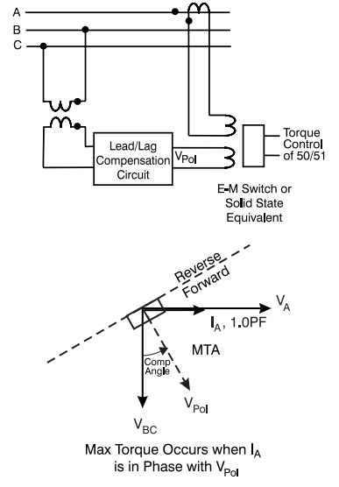

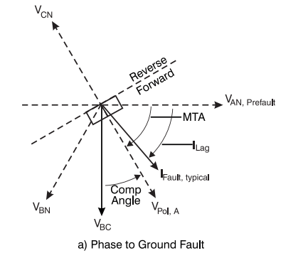

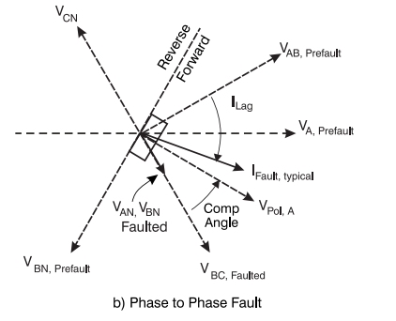

1. **From the universal torque equation determine the condition of operation for impedance relay, reactance relay and admittance relay.(Nov/Dec 2016-Nov/Dec 2015)**

# Reactance Relay

The reactance relay is a high-speed relay. This relay consists of two elements an overcurrent element and a current-voltage directional element. The current element developed positive torque and a current-voltage developed directional element which opposes the current element depending on the phase angle between current and voltage.

Reactance relay is an overcurrent relay with directional limitation. The directional element is arranged to develop maximum negative torque when its current lag behinds its voltage by 90°. The induction cup or double induction loop structures are best suited for actuating reactance type distance relays.

# Construction of Reactance Relay

A typical reactance relay using the induction cup structure is shown in the figure below. It has a four-pole structure carrying operating, polarizing, and restraining coils, as shown in the figure below. The operating torque is developed by the interaction of fluxes due to current carrying coils, i.e., the interaction of fluxes of 2, 3 and 4 and the restraining torque is produced by the interaction of fluxes due to poles 1, 2 and 4.

[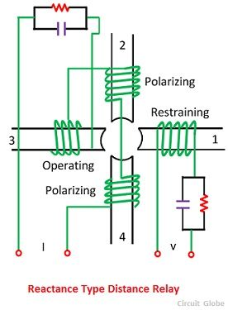](http://circuitglobe.com/wp-content/uploads/2016/07/reactance-type-distance-relay-schematic-diagram-compressor.jpg)

The operating torque will be proportional to the square of the current while the restraining torque will be proportional to VI cos (Θ – 90°). The desired maximum torque angle is obtained with the help of resistance-capacitance circuits, as illustrated in the figure. If the control effect is indicated by –k3, the torque equation becomes

[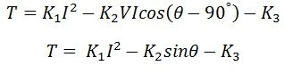](http://circuitglobe.com/wp-content/uploads/2016/07/reactance-type-distance-relay-equation-1-compressor.jpg)

where Θ, is defined as positive when I lag behind V. At the balance point net torque is zero, and hence

[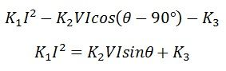](http://circuitglobe.com/wp-content/uploads/2016/07/reactance-type-distance-relay-equation-2-compressor.jpg)

[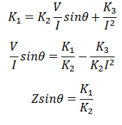](http://circuitglobe.com/wp-content/uploads/2016/07/reactance-type-distance-relay-equation-4-compressor.png)

the spring control effect is neglected in the above equation, i.e., K3 = 0.

### Operating Characteristic of Reactance Relay

The operating characteristic of a reactance relay is shown in the figure below. X is the reactance of the protected line between the relay location and the fault point, and R is the resistance component of the impedance. The characteristic shows that the resistance component of the impedance has no consequence on the working of the relay, the relay reacts solely to the reactance component. The point below the operating characteristic is called the positive torque region.

[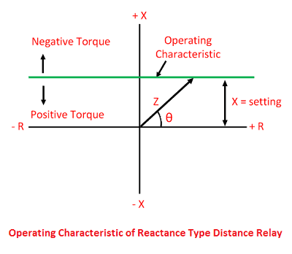](http://circuitglobe.com/wp-content/uploads/2016/07/operating-characteristic-of-distance-relay-2-compressor.png)

If the value of τ, in the general torque equation, expressed below is made any other 90º, a straight line characteristic will still be obtained, but it will not be parallel to R-axis. Such a relay is called an angle impedance relay.

[reactance-type-distance-relay-equation-3](http://circuitglobe.com/wp-content/uploads/2016/07/reactance-type-distance-relay-equation-3-compressor.jpg)

This type of relay is not capable of selecting whether the fault has taken place in the section where the relay is located, or it has taken place in the adjoining section when used on the transmission line. The directional unit used with the reactance relay will not be same as used with the impedance type relay because the restraining reactive volt-ampere, in that case, will be nearly equal to zero.

Therefore the reactance type distance relay needs a directional unit that is inoperative under load conditions. Reactance type relay is very suitable as a ground relay for ground fault because its reach is not affected by fault impedance.

# Admittance Relay

A mho Relay is a high-speed relay and is also known as the admittance relay. In this relay operating torque is obtained by the volt-amperes element and the controlling element is developed due to the voltage element. It means a mho relay is a voltage controlled directional relay.

A mho relay using the induction cup structure is shown in the figure below. The operating torque is developed by the interaction of fluxes due to pole 2, 3, and 4 and the controlling torque is developed due to poles 1, 2 and 4.

[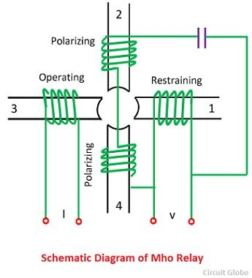](http://circuitglobe.com/wp-content/uploads/2016/07/mho-type-distace-relay-compressor.jpg)

If the spring controlling effect is indicated by –K3, the torque equation becomes,

[mho-relay-equation-1](http://circuitglobe.com/wp-content/uploads/2016/07/mho-relay-equation-1-compressor.png)

Where Θ and τ are defined as positive when I lag behind V. At balance point, the net torque is zero, and hence the equation becomes

[mho-relay-equation-2](http://circuitglobe.com/wp-content/uploads/2016/07/mho-relay-equation-2-compressor.png)[mho-relay-equation-4](http://circuitglobe.com/wp-content/uploads/2016/07/mho-relay-equation-4-compressor.jpg)

[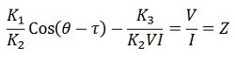](http://circuitglobe.com/wp-content/uploads/2016/07/mho-relay-equation-3-compressor.jpg)

If the spring controlled effect is neglected i.e., k3 = 0.

### Operating Characteristic of Mho Relay

The operating characteristic of the mho relay is shown in the figure below. The diameter of the circle is practically independent of V and I, except at a very low magnitude of the voltage and current when the spring effect is considered, which causes the diameter to decrease. The diameter of the circle is expressed by the equation as ZR=  K1 / K2 = ohmic setting of the relay

[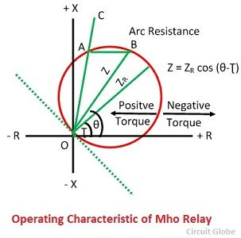](http://circuitglobe.com/wp-content/uploads/2016/07/operating-characteristic-of-mho-relay-compressor.jpg)

The relay operates when the impedance seen by the relay within the circle. The operating characteristic showed that circle passes through the origin, which makes the relay naturally directional. The relay because of its naturally directional characteristic requires only one pair of contacts which makes it fast tripping for fault clearance and reduces the VA burdens on the current transformer.

The impedance angle of the protected line is normally 60º and 70º which is shown by line OC in the figure. The arc resistance R is represented by the length AB, which is horizontal to OC from the extremity of the chord Z. By making the τ equal to, or little less lagging than Θ, the circle is made to fit around the faulty area so that the relay is insensitive to power swings and therefore particularly applicable to the protection of long or heavily loaded lines.

For a given relay the τ is constant, and the admittance phasor Y will lie on the straight line. The characteristic of mho relays on the admittance diagram is, therefore, a straight line and is shown in the figure below.

[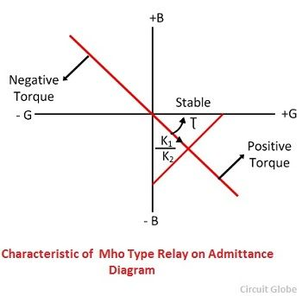](http://circuitglobe.com/wp-content/uploads/2016/07/characteristic-of-mho-type-relay-on-admittance-diagram-compressor.jpg)

Mho relay is suitable for EHV/UHV heavily loaded transmission lines as its threshold characteristic in Z-plane is a circle passing through the origin, and its diameter is ZR. Because of this, the threshold characteristic is quite compact enclosing faulty area compactly and hence, there is lesser chance to operate during power swing and also it is directional.

1. **Explain MHO relay characteristics on the R-X Diagram. Discuss the range setting of various distance relays placed on a particular location (May/June 2016)**

A mho Relay is a high-speed relay and is also known as the admittance relay. In this relay operating torque is obtained by the volt-amperes element and the controlling element is developed due to the voltage element. It means a mho relay is a voltage controlled directional relay.

A mho relay using the induction cup structure is shown in the figure below. The operating torque is developed by the interaction of fluxes due to pole 2, 3, and 4 and the controlling torque is developed due to poles 1, 2 and 4.

[](http://circuitglobe.com/wp-content/uploads/2016/07/mho-type-distace-relay-compressor.jpg)

If the spring controlling effect is indicated by –K3, the torque equation becomes,

[mho-relay-equation-1](http://circuitglobe.com/wp-content/uploads/2016/07/mho-relay-equation-1-compressor.png)

Where Θ and τ are defined as positive when I lag behind V. At balance point, the net torque is zero, and hence the equation becomes

[mho-relay-equation-2](http://circuitglobe.com/wp-content/uploads/2016/07/mho-relay-equation-2-compressor.png)[mho-relay-equation-4](http://circuitglobe.com/wp-content/uploads/2016/07/mho-relay-equation-4-compressor.jpg)

[](http://circuitglobe.com/wp-content/uploads/2016/07/mho-relay-equation-3-compressor.jpg)

If the spring controlled effect is neglected i.e., k3 = 0.

### Operating Characteristic of Mho Relay

The operating characteristic of the mho relay is shown in the figure below. The diameter of the circle is practically independent of V and I, except at a very low magnitude of the voltage and current when the spring effect is considered, which causes the diameter to decrease. The diameter of the circle is expressed by the equation as ZR=  K1 / K2 = ohmic setting of the relay

[](http://circuitglobe.com/wp-content/uploads/2016/07/operating-characteristic-of-mho-relay-compressor.jpg)

The relay operates when the impedance seen by the relay within the circle. The operating characteristic showed that circle passes through the origin, which makes the relay naturally directional. The relay because of its naturally directional characteristic requires only one pair of contacts which makes it fast tripping for fault clearance and reduces the VA burdens on the current transformer.

The impedance angle of the protected line is normally 60º and 70º which is shown by line OC in the figure. The arc resistance R is represented by the length AB, which is horizontal to OC from the extremity of the chord Z. By making the τ equal to, or little less lagging than Θ, the circle is made to fit around the faulty area so that the relay is insensitive to power swings and therefore particularly applicable to the protection of long or heavily loaded lines.

For a given relay the τ is constant, and the admittance phasor Y will lie on the straight line. The characteristic of mho relays on the admittance diagram is, therefore, a straight line and is shown in the figure below.

[](http://circuitglobe.com/wp-content/uploads/2016/07/characteristic-of-mho-type-relay-on-admittance-diagram-compressor.jpg)

Mho relay is suitable for EHV/UHV heavily loaded transmission lines as its threshold characteristic in Z-plane is a circle passing through the origin, and its diameter is ZR. Because of this, the threshold characteristic is quite compact enclosing faulty area compactly and hence, there is lesser chance to operate during power swing and also it is directional.

 a three-zone step distance relaying scheme that provides instantaneous protection over 80–90% of the protected line section (Zone 1) and time-delayed protection over the remainder of the line (Zone 2) plus backup protection over the adjacent line section. Zone 3 also provides backup protection for adjacent lines sections.

It is essential that the relays provided have the same setting regardless of the type of fault. This is possible if the relays are connected to respond to delta voltages and currents. The delta quantities are defined as the difference between any two phase quantities, for example, **Ea – Eb** is the delta quantity between phases a and b. In general, for a multiphase fault between phases x and y,

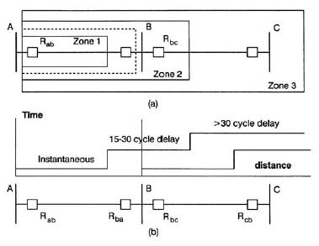

Three-zone step distance relaying to protect 100% of a line and backup the neighboring line.

FORMULA

where x and y can be a, b, or c and Z1 is the positive sequence impedance between the relay location and the fault. For ground distance relays, the faulted phase voltage, and a compensated faulted phase current must be used.

FORMULA

where m is a constant depending on the line impedances, and I0 is the zero sequence current in the transmission line. A full complement of relays consists of three phase distance relays and three ground distance relays. This is the preferred protective scheme for high voltage and extra high voltage systems.

1. **With neat diagram explain the construction and operation of induction type directional overcurrent relay.(Nov/Dec 2015)**

The directional power relay is not suitable under short circuit conditions because as short circuit occurs the system voltage falls to a low value resulting in insufficient torque to cause relay operations. This difficulty is overcome in the directional over current relay, which is independent of system voltage and power factor.

**Constructional details:** Figure shows the constructional details of a typical induction type directional over current relay. It consists of two relay elements mounted on a common case viz.(i) directional element and (ii) non-directional element.(i)

**Directional element:**

It is essentially a directional power relay, which operates when power flows in a specific direction. The potential of this element is connected through a potential transformer (PT.) to the system voltage. The current coil of the element is energized through a CT by the circuit current. This winding is carried over the upper magnet of the non-directional element. The trip contacts (1 and 2) of the directional element are connected in series with secondary circuit of the over current element. The latter element cannot start to operate until its secondary circuit is completed. In other words, the directional element must first operate (ie.contacts 1 and 2 should close) in order to operate the over current element.

**Non-directional element:**

It is an over current element similar in all respects to a non-directional over current relay. The spindle of the disc of this element carries a moving contact which closes the fixed contact after the operation of directional element. Plug setting bridge is provided for current setting. The tappings are provided on the upper magnet of over current element and are connected to the bridge.

**Operation:-**

Under normal operating conditions, power flows in the normal direction in the circuit operated by the relay. Therefore, directional power relay does not operate, thereby keeping the (lower element) un-energized. However, when a short circuit occurs, there is a tendency for the current or power to flow in the reverse direction. The disc of the upper element rotates to bridge the fixed contacts 1 and 2. This completes the circuit for over current element

The disc of this element rotates and the moving contact attached to closes the trip circuit. This operates the circuit breaker which isolates the faulty section

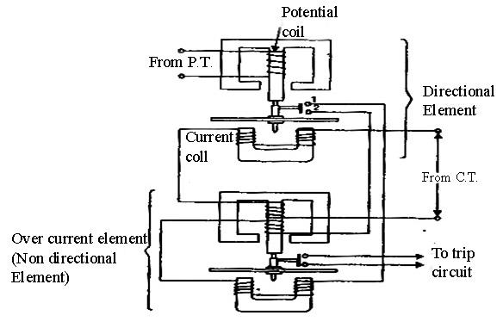

1. **Describe the techniques used to realize various time current characteristics using electromechanical relays. Also compare the time current characteristics of inverse, very inverse and extremely inverse over current relays. Discuss their applications.(Nov/Dec 2014).**

In an **over current Electromagnetic relay**, there would be essentially a current coil. When normal current flows through this coil, the magnetic effect generated by the coil is not sufficient to move the moving element of the relay, as in this condition the restraining force is greater than deflecting force. But when the current through the coil increased, the magnetic effect increases, and after certain level of current, the deflecting force generated by the magnetic effect of the coil, crosses the restraining force, as a result, the moving element starts moving to change the contact position in the relay.

Depending upon time of operation, there are various **types of Over Current relays**, such as,

* 1. **Instantaneous over current relay**.
  2. **Definite time over current relay**.
  3. **Inverse time over current relay**.

**Inverse time over current relay** or simply **inverse OC relay** is again subdivided as **inverse definite minimum time** (IDMT), **very inverse time**, **extremely inverse time over current relay** or **OC relay**.

**Instantaneous Over Current Relay**

Construction and working principle of **instantaneous over current relay** quite simple.

Here generally a magnetic core is wound by current coil. A piece of iron is so fitted by hinge support and restraining spring in the relay, that when there is not sufficient current in the coil, the NO contacts remain open. When current in the coil crosses a present value, the attractive force becomes sufficient to pull the iron piece towards the magnetic core and consequently the no contacts are closed.

The preset value of current in the relay coil is referred as pick up setting current. This relay is referred as instantaneous **over current relay**, as ideally, the relay operates as soon as the current in the coil gets higher than pick up setting current. There is no intentional time delay applied. But there is always an inherent time delay which cannot be avoided practically. In practice the operating time of an instantaneous relay is of the order of a few milliseconds. Fig

**Definite Time Over Current Relay**

This relay is created by applying intentional time delay after crossing pick up value of the current. A **definite time over current relay** can be adjusted to issue a trip output at definite amount of time after it picks up. Thus, it has a time setting adjustment and pick up adjustment.

**Inverse Time Over Current Relay**

Inverse time is a natural character of any induction type rotating device. This means the speed of rotation of rotating art of the device is faster if input current is increased. In other words, time of operation inversely varies with input current. This natural characteristic of electromechanical induction disc relay in very suitable for over current protection. This is because, in this relay, if fault is more severe, it would be cleared more faster. Although time inverse characteristic is inherent to electromechanical induction disc relay, but the same characteristic can be achieved in microprocessor based relay also by proper programming.

**Inverse Definite Minimum Time over Current Relay or IDMT O/C Relay**

Ideal inverse time characteristics cannot be achieved, in an over current relay. As the current in the system increases, the secondary current of the current transformer is increased proportionally. The secondary current is fed to the relay current coil. But when the CT becomes saturated, there would not be further proportional increase of CT secondary current with increased system current. From this phenomenon it is clear that from trick value to certain range of faulty level, an inverse time relay shows exact inverse characteristic. But after this level of fault, the [CT](https://www.electrical4u.com/current-transformer-ct-class-ratio-error-phase-angle-error-in-current-transformer/) becomes saturated and relay current does not increase further with increasing faulty level of the system. As the relay current is not increased further, there would not be any further reduction in time of operation in the relay. This time is referred as minimum time of operation. Hence, the characteristic is inverse in the initial part, which tends to a definite minimum operating time as the current becomes very high. That is why the relay is referred as **inverse definite minimum time over current relay** or simply **IDMT relay**.



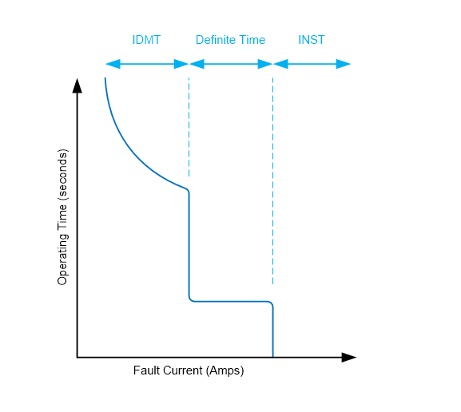

1. **Write Short notes on** 
   1. **Under Frequency relays**
   2. **Static Relays**

**Under Frequency relays**

Rate of Change of Frequency (ROCOF or df/dt) relay is used for fast load shedding, to speed up operation time in under-frequency situations and to detect loss of grid. For better understanding of role and operation of df/dt relay, let us first study the variation of frequency with load for a Grid. Graphical relationship between power and frequency of a Grid is shown in figure below.

[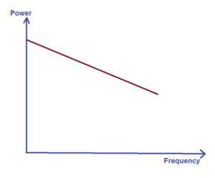](http://electricalbaba.com/wp-content/uploads/2016/12/Power-frequency-curve.jpg)

We can have two things to be noted from the above graph:

 a)    If the power available in the Grid increases i.e. in other words generation is more than the load, frequency will go up.

 b)    If the generation is less than load i.e. power deficient in the Grid then frequency will decreases.

 Large power grids (here large power grid means having large installed capacity in MW) are characterized by a very high stiffness constant which means that a large perturbation (load generation mismatch) is required to cause the grid frequency to change by 1 Hz. Thus we can say that, for the same magnitude of perturbation, the rate of change of frequency (df/dt) will be much smaller for a very large power grid as compared to a medium sized grid. Therefore, large sized grids are inherently resilient to rapid frequency fluctuations.

 If it happens that due to increase in load, frequency dips below a certain threshold the Generators connected to the Grid will trip which will result into further dip in frequency and such a cumulative dip in frequency result into complete failure of Grid.  Thus there is a need of Rate of Change of Frequency or df/dt relay which can detect the dip in frequency earlier and initiate load shedding to resume the normal frequency of the Grid.

 ROCOF or df/dt relays are particularly effective in arresting the frequency collapse of a grid in the event of sudden loss of major generation. This is because by measuring the frequency decay rate, the corrective action can be initiated much ahead of the time when frequency of the synchronous interconnection would have actually dipped to a point at which generator under-frequency relays or unit auxiliaries would trip / operate leading to a complete system shutdown. The df/dt is used for load shedding in situations where sudden loss of generating capacity on a system will be accompanied by a decrease in system frequency. In such a situation of load Generation mismatch, the system frequency tends to fall. The df/dt relay can control the circuit breakers and allow feeders to be disconnected from the network, one by one. Figure below shows a typical df/dt Relay.

**Operating principle and Setting of df/dt Relay:**

The Rate of Change of Frequency (ROCOF) Relay operation is based on the measurement of two successive frequency and the time difference between the frequency measurements. The setting of the df/dt relay is in Frequency/Time e.g. 0.3Hz/second or 0.4 Hz/.5 seconds. The minimum df/dt relay setting available is 0.1 Hz/sec. However, some df/dt relays have a minimum setting of 0.2 Hz/sec only.

**Static Relay**

The static relay is the combination of both the static and the electromagnetic relay. In this relay, there is no armature and moving contacts and response is developed by the components without mechanical motion. The solid state components used are transistors, diodes, resistors, capacitor and so on. In the static relay, the measurement is performed by electronic, magnetic, optical or another component without mechanical motion.

The static components of a static relay are shown in the figure below. Here the relaying quantity, i.e., the output of a CT or PT of a transducer is rectified by the rectifier. The rectified output is given to a measuring unit constitute of comparators, level detectors, and logic circuits. The output is actuated when the dynamic input, i.e. the relaying quantity attains the threshold value.

[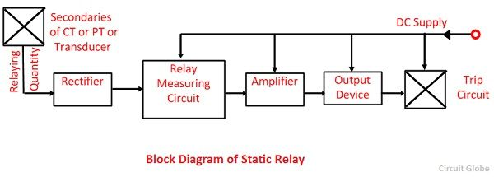](http://circuitglobe.com/wp-content/uploads/2016/06/static-relay-compressor.jpg)The output of the measuring unit is fed to the output unit devices after it is amplified by the amplifiers. The output unit activates the trip coil only when the relay operates. The relaying quantity such as the voltage and current is rectified and measured. When the quantity under measurement attains certain well-defined value, the output device is energized and hence, the circuit breaker trip is triggered.

The static relay can be arranged to respond to electrical inputs. The other types of input such as heat, light, magnetic field, traveling waves, etc., can be suitably converted into equivalent analog and digital signal and then supplied to the static relay

**Advantages of Static Relay**

* The power consumption of the static relay is much lower and thereby decrease the burden on the instrument transformer and increased its accuracy.
* The static relay has the quick response, long life, shockproof, fewer problems of maintenance, high reliability and a high degree of accuracy.
* Quick reset action, a high reset value and the absence of overshoot can be easily achieved because of the absence of thermal storage.
* Ease of providing amplification enables greater sensitivity to be obtained.
* The risk of unwanted tripping is less with static relays.
* Static relays are quite suitable for earthquakes prone areas, ships, vehicles, airplanes, etc., This is because of high resistance to shock variation.
* A static protection control and monitoring system can perform several functions such as protection, monitoring, data acquisition measurement, memory, indication, etc.,

**Limitations of Static Relay**

* Some components are sensitive to electrostatic discharges. Even small charges can damage the components, and therefore precautions are necessary for the manufacturing of static relays to avoid components failures due to electrostatic discharges.
* Static relays are sensitive to voltage spikes or voltage transients. Special measures are taken to avoid such problems.
* The reliability of the system depends on a large number of small components and their electrical components.
* The static relay has low short-time overload capacity as compared to electromagnetic relays.
* Static relays are costlier, for simple and single function than their equivalent electromechanical counterparts. But for multi-functional protection, static relay proves economical.
* Highly trained personnel are required for their servicing.
* Static relays are not very robust in construction and easily affected by surrounding interference.

1. **Describe the sequence of negative sequence relay.**

A relay which protects the electrical system from negative sequence component is called a negative sequence relay or unbalance phase relay. A negative phase sequence or unbalance relay is essentially provided for the protection of generators and motors against unbalanced loading that may arise due to phase-to-phase faults.

Negative phase sequence relay has a filter circuit which is responsible only for the negative sequence components. Since small magnitude over current can cause a dangerous condition, it becomes necessary to have low settings of such relays. Negative sequence relays are mainly required for the phase to phase fault protection.

The figure shown below illustrates the scheme used for negative phase sequence relay. A network consists of four impedance Z1, Z2, Z3 and Z4 of equal magnitude connected in a bridge formation is energized from three CTs. A single pole relay having an inverse-time characteristic is connected to the circuit

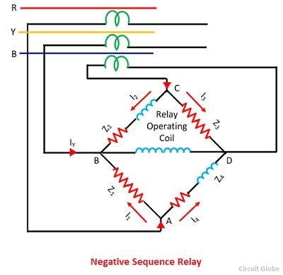

Z1 and Z2are non-inductive resistors while Z2 and Z4 are composed of both resistance and inductance. The value of Z2 and Z1 are so adjusted that the current flows through them lag behind those in impedance Z3 and Z1 by 60º. The relay is assumed to have negative impedance. The current from phase R at junction A is equally divided into two branches as I1 and I4, but, I4 will lag behind I1 by 60º.

[negative-sequential-relay-equation-1](http://circuitglobe.com/wp-content/uploads/2016/07/negative-sequential-relay-equation-1-compressor-1.png)[negative-sequence-equation-2](http://circuitglobe.com/wp-content/uploads/2016/07/negative-sequence-equation-2-compressor.jpg)

Similarly, current from phase B split at junction C into two equal components I3 and I2, I2 lagging behind I3 by 60º.

[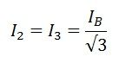](http://circuitglobe.com/wp-content/uploads/2016/07/negative-sequence-relay-equation-3-compressor.jpg)

I1 leads IR by 30º while I4 lags behind IR by 30º.  Similarly, I2 lags behind IB by 30º, whereas I3 leads IB by 30º. The current through the relay operating coil at junction B will be equal to phasor sum of I1, I2 and IY.

[negative-sequence-relay-4](http://circuitglobe.com/wp-content/uploads/2016/07/negative-sequence-relay-4-compressor.jpg)[negative-sequence-equation-5](http://circuitglobe.com/wp-content/uploads/2016/07/negative-sequence-equation-5-compressor.jpg)

**The flow of Positive Sequence Current** – The phasor diagram of positive sequence components is shown in the figure below. When the load is in balanced conditions, then there is no negative sequence current. The current flow through the relay is given by the equation

[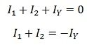](http://circuitglobe.com/wp-content/uploads/2016/07/negative-sequence-relay-equation-6-compressor.jpg)

So the relay remains operative for a balanced system.

The flow of Negative Sequence Current – In the bridge circuit it is shown that the current I1 and I2 are equal but opposite to each other, so they cancel each other and IY current flow through the relay operating coil. Thus the relay operates due to the flow of the IY.  A low setting value well below the normal full load rating of the machine is provided with comparatively small values of unbalanced current produces a great danger.

The flow of Zero Sequence Current  – The current at junction B of the relay is represented by the phasor diagram from which it is observed that the current I1 and I2 are displaced from each other by 60º, so the resultant of these current is in phase with current IY. Thus the relay would operate by the twice of the total current flow through it. For making the current inoperative, the CTs are connected in delta as shown in the figure and then no zero sequence current can flow in the network circuit.

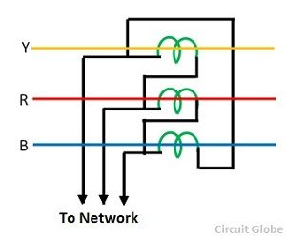

### Induction type Negative Sequence Relay

The construction of induction type negative phase sequence relay is similar as that of an induction type over current relay. This relay consists of a metallic disc usually made up of an aluminum coil, and this is rotating between two electromagnets the upper and the lower electromagnets.

The upper electromagnet has two winding; the primary winding of the upper electromagnet is connected to the secondary of the CT connected in the line to be protected. The secondary winding of the upper electromagnet is connected in series with the windings on the lower electromagnet

The primary windings provided on the central limb of the upper electromagnet which is provided by the central tap resulting into three terminals 1, 2, and 3 of these windings. The upper half is energized from phase R through CT and an auxiliary transformer while the lower half is energized from phase Y through CT. The auxiliary transformer has a special construction such that the outputs of this transformer lag by 120º instead of 180º.

**The operation for Positive Sequence Currents** – The current IR and IY flowing through the primary of the relay are in oppositions, the auxiliary transformer is so arranged that I’R and I’Y are of equal magnitude. Thus the relays remain inoperative for a balanced system.

**The operation for Negative Sequence currents** – When there is a fault on the system, resulting in phase sequence currents, there is a flow of current I through the primary windings of the relay.

[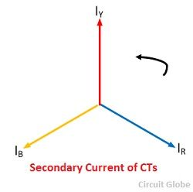](http://circuitglobe.com/wp-content/uploads/2016/07/secondary-current-cts-compressor.jpg)

[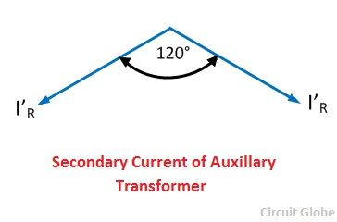](http://circuitglobe.com/wp-content/uploads/2016/07/secondary-current-of-auxiliary-transformers-compressor.jpg)

When the current flowing through the relay exceeds the relay setting, the relay operates and trips the circuit.

1. **Describe the operating principles and characteristics of impedance relay.(Apr/May 2017)**

### Induction Type Impedance Relay

Induction type impedance relay consists of a combination of an overcurrent element with a voltage restraint element. Their circuit diagram is shown in the figure below.

[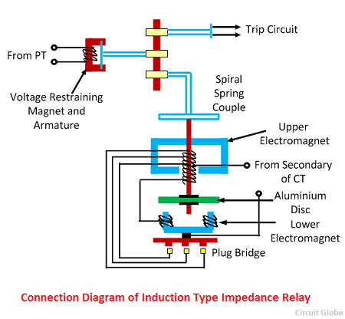](http://circuitglobe.com/wp-content/uploads/2016/07/induction-type-impedance-relay-compressor.png)

It consists of two metallic disc, usually made up of copper or aluminum which is capable of rotating between two electromagnets. The upper electromagnet has two two separate windings similar to that of overcurrent relay. The primary winding is connected to the secondary of the CT connected in the line to be protected. The winding has some tappings so as to vary the current settings; the tapping is connected to the plug bridge.

The secondary windings on the upper electromagnet are connected in series with windings on the lower electromagnet. By this arrangement leakage fluxes of upper and lower electromagnets are sufficiently displaced in space and phase to set up a rotational torque on the induction disc, as in the shaded pole induction disc motor. The controlling or braking torque caused by the permanent magnet varies directly as the driving torque.

In normal operating conditions the pull exerted by armature is more than that of the induction element and thus the trip circuit contacts remain open. When the fault occurs, the induction disc starts to rotate with a  speed approximately proportional to the operating currents. Hence the time taken by the disc to turn through a given angle varies inversely as the current.

Also, as the disc rotates the spring is wound. The disc continuously rotating till the tension of the spring is sufficient.to overcome the pull of the voltage restraint the voltage restrained electromagnet over its armature and as soon as this armature is released the trips contacts are closed.

[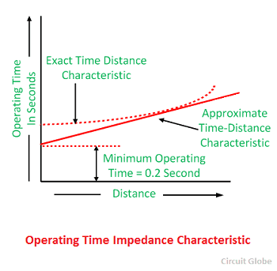](http://circuitglobe.com/wp-content/uploads/2016/07/Operating-time-impedance-characteristic-compressor.png)

Thus the angle through which the induction disc is to rotate for the operation of the relay depends on the value of the pull on the restraint armature. The greater this pull, the more significant would be the travel of the disc. This pull is also approximately proportional to the voltage, therefore, the angle through which the disc is to rotate for the operation of the relay is direct to voltage **V**.

Thus, in this type of the relay, the time required is directly proportional to the line voltage V and inversely proportional to current **I** i.e., the time of operation is proportional to V/I or the impedance of the line or section.

### Time-Characteristic of High-Speed Type Impedance Relay

The operating time characteristic of a high-speed type impedance relays is shown in the figure below. The curve shown in the figure is a particular value of current magnitude. For other current values, a similar characteristic is obtained. The curve for higher currents will lie above it. It is observed that for impedance values above 100 % pick-up impedance the relay does not operate. The curve represents the actual characteristic while curve II is a simplified representation of the same curve.

### [operating-time-impedance-characteristic-of-a-high-impedance-relay](http://circuitglobe.com/wp-content/uploads/2016/07/operating-time-impedance-characteristic-of-a-high-impedance-relay-compressor.jpg)

### Drawbacks of Plan Impedance Relay

It can respond on both side of CT, PT location so that it can discriminate between externals and internal fault. It is also affected by arc resistance of line fault and result under reach. Such type of relay is sensible to power swing as a large area is covered by the circle on each on R-X plane. During power swing which is caused by severe faults, the relays see fictitious impedance, and if this impedance is less than the relay setting, the relay may operate.

1. **Describe the operating principles and characteristics of percentage differential relay**

The percentage differential relay is defined as the relay that operates on the phase difference of two or more similar electrical quantities. It is the advanced form of differential protection relay. The only difference between them is the restraining coil. The percentage differential relay consists restraining coil for overcoming the trouble arising out of differences in the current ratio for the high value of an external [short circuit current.](http://circuitglobe.com/short-circuit-current.html)

The percentage differential system consists of a restraining coil connected in the pilot wire as shown in the figure below and the current induced in both the CTs flows through it. The operating coil places between the midpoint of the restraining coil.

[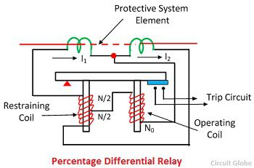](http://circuitglobe.com/wp-content/uploads/2017/01/percentage-differntial-relay.jpg)

The restraining coil controls the sensitive characteristic of the relay. It restricts the unwanted tripping of the transformer due to the imbalance current. The restraining coil also restrains the harmonics in the inrush current.

## Working of Percentage Differential Relay

The torque due to the restraining coil prevents the closing of the trip circuit while the torque due to the operating coil tends to close the trip circuit contacts. Under normal operating conditions and through load condition the torque developed by the restraining coil is greater than the operating coil torque. Thus the relay remains inoperative.

When an internal fault occurs, the operating torque exceeds the restraining torque then the trip circuit contacts are closed to open the[circuit breaker](http://circuitglobe.com/circuit-breaker.html). The restraining torque may adjust by varying the number of turns of the restraining coil.

[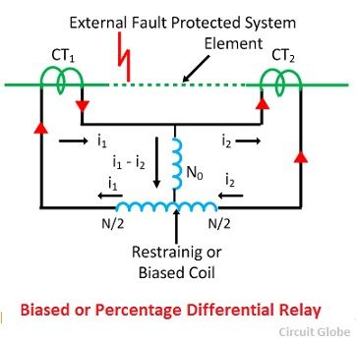](http://circuitglobe.com/wp-content/uploads/2017/01/biased-or-percentage-differential-relay-compressor.jpg)

The differential current required to utilise this relay is a variable quantity, due to the effect of the restraining coil. The differential current in the operating coil is proportional to (I1-I2), and the restraining coil is proportional to (I1-I2)/2  as the operating current is connected to the midpoint of the restraining coil. For external faults both I1 and I2 increase and thereby the restraining torque increase, which prevents the maloperation.

## Operating characteristic of the Percentage Differential Relay

The operating characteristic of the relay is shown in the figure below. The above graph shows that the ratio of their operating current and restraining current is fixed percentage. This relay is also called the biased differential relay because the restraining coil is also called a bias coil as it provides additional flux.

## [operating-charateristic-of-percentage-Differential-Relay](http://circuitglobe.com/wp-content/uploads/2017/01/operating-charateristic-of-percentage-Differential-Relay.jpg)

## Types of Percentage Differential Relay

The percentage differential relay is mainly classified into two types. They are the

* Three terminal system application of the percentage differential relay.
* Induction Type biased Differential Relay.

Such types of relays use for the protection of generators, transformer, feeders, transmission line, etc.

1. **Explain the construction and working of Electromagnetic relay.**

Electromagnetic relays are those relays which are operated by electromagnetic action. Modern electrical protection relays are mainly micro processor based, but still electromagnetic relay holds its place. It will take much longer time to be replaced the all electromagnetic relays by micro processor based static relays. So before going through detail of protection relay system we should review the various types of electromagnetic relays.

Practically all the relaying device are based on either one or more of the following types of electromagnetic relays.

* 1. Magnitude measurement,
  2. Comparison,
  3. Ratio measurement.

Principle of electromagnetic relay working is on some basic principles. Depending upon working principle the these can be divided into following types of electromagnetic relays.

1. Attracted Armature type relay,
2. Induction Disc type relay,
3. Induction Cup type relay,
4. Balanced Beam type relay,
5. Moving coil type relay,
6. Polarized Moving Iron type relay.

## Attraction Armature Type Relay

Attraction armature type relay is the most simple in construction as well as its working principle. These types of electromagnetic relays can be utilized as either magnitude relay or ratio relay. These relays are employed as auxiliary relay, control relay, over current, under current, over voltage, under voltage and impedance measuring relays.

Hinged armature and plunger type constructions are most commonly used for these types of electromagnetic relays. Among these two constructional design, hinged armature type is more commonly used.

We know that force exerted on an armature is directly proportional to the square of the magnetic flux in the air gap. If we ignore the effect of saturation, the equation for the force experienced by

https://www.electrical4u.com/equations/er-05-06-14-01.gif

the armature can be expressed as, Where, F is the net force, K' is constant, I is rms current of armature coil, and K' is the restraining force.The threshold condition for relay operation would therefore be reached when KI2 = K'.If we observe the above equation carefully, it would be realized that the relay operation is dependent on the constants K' and K for a particular value of the coil current.From the above explanation and equation it can be summarized that, the operation of relay is influenced by

1. Ampere – turns developed by the relay operating coil,
2. The size of air gap between the relay core and the armature,
3. Restraining force on the armature.

### Construction of Attracted Type Relay

This relay is essentially a simple electromagnetic coil, and a hinged plunger. Whenever the coil becomes energized the plunger being attracted towards core of the coil. Some NO-NC (Normally Open and Normally Closed) contacts are so arranged mechanically with this plunger, that, NO contacts become closed and NC contacts become open at the end of the plunger movement. Normally attraction armature type relay is DC operated relay. The contacts are so arranged, that, after relay is operated, the contacts cannot return their original positions even after the armature is de energized. After relay operation, this types of electromagnetic relays are reset manually.  
Attraction armature relay by virtue of their construction and working principle is instantaneous in operation.

## Induction Disc type Relay Working

Induction disc type relay mainly consists of one rotating disc. Every induction disc type relay works on the same well known Ferraries principle. This principle says, a torque is produced by two phase displaced fluxes, which is proportional to the product of their magnitude and phase displacement between them. Mathematically it can be expressed as

-https://www.electrical4u.com/equations/er-05-06-14-02.gif

The induction disc type relay is based on the same principle as that of an [ammeter](https://www.electrical4u.com/ammeter/) or a volt meter, or a [wattmeter](https://www.electrical4u.com/electrodynamometer-type-wattmeter/) or a watt hour mater. In induction relay the deflecting torque is produced by the [eddy currents](https://www.electrical4u.com/hysteresis-eddy-current-iron-or-core-losses-and-copper-loss-in-transformer/) in an aluminium or copper disc by the [flux](https://www.electrical4u.com/what-is-flux-types-of-flux/) of an AC electromagnet. Here, an aluminium (or copper) disc is placed between the poles of an AC magnet which produces an alternating flux φ lagging from I by a small angle. As this flux links with the disc, there must be an induced emf E2 in the disc, lagging behind the flux φ by 90o. As the disc is purely resistive, the induced current in the disc I2 will be in phase with E2. As the angle between φ and I2 is 90o, the net torque produced in that case is zero. As,https://www.electrical4u.com/equations/er-05-06-14-03.gifIn order to obtain torque in induction disc type relay, it is necessary to produce a rotating field.

## Pole Shading Method of Producing Torque in Induction Disc Relay

In this method half of the pole is surrounded with copper ring as shown. Let φ1 is the flux of unshaded portion of the pole. Actually total flux divided into two equal portions when the pole is divided into two parts by a slot.

https://www.electrical4u.com/equations/er-05-06-14-04.gif

As the one portion of the pole is shaded by copper ring. There will be induced current in the shade ring which will produce another flux φ2' in the shaded pole. So, resultant flux of shaded pole will be vector sum of φ1 and φ2. Say it is φ2, and angle between φ1 and φ2 is θ. These two fluxes will produce a resultant torque,

https://www.electrical4u.com/equations/er-05-06-14-05.gif

There are mainly three types of shape of rotating disc are available for induction disc type relay. They are spiral shaped, round and vase shaped, as shown. The spiral shape is done to compensate against varying restraining torque of the control spring which winds up as the disc rotates to close its contacts. For most designs, the disc may rotate by as much as 280o. Further, the moving contact on the disc shift is so positioned that it meets the stationary contacts on the relay frame when the largest radius section of the disc is under the electromagnet. This is done to ensure satisfactory contact pressure in induction disc type relay.Where high speed operation is required, such as in differential protection, the angular travel of the disc is considerably limited and hence circular or even vane types may be used in induction disc type electromagnetic relay.

Some time it is required that operation of an induction disc type relay should be done after successful operation of another relay. Such as inter locked over current relays are generally used for generator and bus bar protection. In that case, the shading band is replaced by a shading coil. Two ends of that shading coil are brought out across a normally open contact of other control device or relay. Whenever the latter is operated the normally open contact is closed and makes the shading coil short circuited. Only after that the over current relay disc starts rotating.  
One can also change the time / current characteristics of an induction disc type relay, by deploying variable [resistance](https://www.electrical4u.com/electrical-resistance-and-laws-of-resistance/) arrangement to the shading coil.Induction disc relay fed off a negative sequence filter can also be used as Negative-sequence protection device for [alternators](https://www.electrical4u.com/alternator-or-synchronous-generator/).

## Induction Cup Type Relay

Induction cup type relay can be considered as a different version of induction disc type relay. The working principle of both type of relays are more or less some. [Induction cup type relay](https://www.electrical4u.com/working-principle-construction-and-types-of-induction-cup-relay/) are used where, very high speed operation along with polarizing and/or differential winding is requested. Generally four pole and eight pole design are available. The number of poles depends upon the number of winding to be accommodated. The inertia of cup type design is much lower than that of disc type design. Hence very high speed operation is possible in induction cup type relay. Further, the pole system is designed to give maximum torque per KVA input. In a four pole unit almost all the eddy currents induced in the cup by one pair of poles appear directly under the other pair of poles – so that torque / VA is about three times that of an induction disc with a c-shaped electromagnet. Induction cup type relay is practically suited as directional or phase comparison units. This is because, besides their sensitivity, induction cup relay have steady non vibrating torque and their parasitic torque due to current or voltage alone are small.