Unit-III
Part-A
- What is over fluxing? How it affect transformer? (Nov/Dec 2016)
  - Over fluxing is a dangerous situation in which the magnetic flux density increases to extremely high levels. The high flux density can induce excessive eddy currents in the windings and in other conductive parts inside the transformers.
  - At saturation flux density the core steel will over heat.
  - Under conditions of excessive over fluxing the heating of the inner portion of the windings may be sufficiently extreme as the exciting current is rich in harmonies.
- Write two protection schemes used for protection of bus-bar. (Nov/Dec 2016-Nov/Dec 2014)
  - Differential Busbar Protection
  - Current Differential Protection
- Can current transformers secondary winding be open circuited? Justify your answer.(May/June 2016-Nov/Dec 2014)
A current transformer should never be open-circuited while main current is passing through the primary winding. Because the main circuit is now mostly magnetizing current; the flux in the core shoots up to a high level and a very high voltage appears across the secondary.
- What are various faults that would affect an alternator? (May/June 2016)
  - Over frequency & under frequency fault .
  - Loss of synchronism or pulling out of step fault
  - Stator inter-turn protection
  - Unbalanced loading
- What are the short comings of differential protection scheme as applied to power transformer(Nov/Dec 2015)
The problems encountered in power transformer due to differential protection scheme are
  - Unmatched characteristics of C.T.s
  - Ratio change due to tap change
  - Difference in lengths of pilot wires
  - Magnetizing current inrush
- Give the examples for unit and non unit systems of protection. (Nov/Dec 2015)
Unit protection usually involves comparison of quantities at the boundaries of the protected zone as defined by the locations of the current transformers.
  - Restricted Earth Fault
  - Differential Protection
The non unit type protection system includes following schemes:
- Time graded over-current protection
- Current graded over-current protection
- Distance or Impedance Protection

- Enumerate the concept of ring feeder (May/June 2014)
Ring main electrical power distribution system. Here one ring network of distributors is fed by more than one feeder. In this case if one feeder is under fault or maintenance, the ring distributor is still energized by other feeders connected to it. In this way the supply to the consumers is not affected even when any feeder becomes out of service. In addition to that the ring main system is also provided with different section isolates at different suitable points. If any fault occurs on any section, of the ring, this section can easily be isolated by opening the associated section isolators on both sides of the faulty zone transformer directly.
- List out the applications of current transformer (May/June 2014)
Current transformers reduce high voltage currents to a much lower value and provide a convenient way of safely monitoring the actual electrical current flowing in an AC transmission line using a standard ammeter.
There are a variety of metering applications and uses for current transformers such as with Wattmeter’s, power factor meters, watt-hour meters, protective relays, or as trip coils in magnetic circuit breakers, or MCB’s.
- What are the possible faults in transformers? (Nov/Dec 2008)
A transformer generally suffers from following types of Transformer fault
- Over current due to overloads and external short circuits,
- Terminal faults,
- Winding faults,
- Incipient faults.
- What are the main safety devices available with transformer? (May/June 2012)
  - Buchholz relay
  - Differential protection scheme
  - Oil level gauge
  - Temperature indicator (oil, winding)
- What is phase angle error for instrument transformers?
In the power measurements , it must that the phase of secondary current is to be displaced by exactly 180 degree from that of primary current for C.T While the phase of secondary voltage is to be displaced by exactly 180 from that of primary voltage , for P.T but actually it is not so. The error introduced due to this fact is called phase angle
error. It denoted by angle theta by which the phase difference between primary and secondary is different from 180.
- What are the limitations of Merz-price protection?(May/June 2011)
Since neutral earthing resistances are often used to protect circuit from earth-fault currents, it becomes impossible to protect the whole of a star-connected alternator. If an earth-fault occurs near the neutral point, the voltage may be insufficient to operate the relay. Also it is extremely difficult to find two identical CT’s. In addition to this, there always an inherent phase difference between the primary and the secondary quantities and a possibility of current through the relay even when there is no fault.
- What is the need for negative sequence relay in alternators? (Nov/Dec 2005)
A relay which protects the electrical system from negative sequence component is called a negative sequence relay or unbalance phase relay. A negative phase sequence or unbalance relay is essentially provided for the protection of Alternators against unbalanced loading that may arise due to phase-to-phase faults. During fault it produce rotating magnetic field in opposite direction to the original rotating magnetic field. this produces the double frequency currents in the rotor , this will lead to overheating of rotor.
- Why bus bar protection is needed (May/June 2013)
The bus bar protection is essential because
- The stability of the system is affected by the faults in the bus zone.
- A fault in the bus bar causes interruption of supply to a large portion of the system network.
- Which are the common methods used for the transmission line protection?(May/June 2007)
  - Time graded over current protection
  - Differential Protection
  - Distance protection

- What is the use of line traps in carrier current relaying?(Nov/Dec 2004)
The line trap unit is between the busbar and the connection of coupling capacitor to the line. it consists of parallel combination of inductance and capacitance acting as tuned circuit . the circuit offers low impedance to power frequency currents while offers very high impedance to carrier frequency currents which prevents the high frequency carrier to enter in the neighboring line and carrier currents flow only in the protected line.
- What is current grading protection?
The short circuit current along the length of the protected transmission line decreases as the distance of the fault location increases from the power station. Thus the relays near the power station are set to trip at progressively higher currents. This is called current grading protection.
- List the advantages of distance protection of transmission lines.
- The distance protection is very fast without time lag. The over current protection is slow with time lag.
- For long transmission lines , high speed fault clearing is necessary, which is provide3d by distance protection. It is not possible with over current protection.
- The operation of distance protection is not very much affected by the generation capacity.

- What is meant by loss of excitation protection in a generator?
Loss of field or excitation can be caused in the generated due to excitation failure. In larger sized generator, energy for excitation is often taken from a separate auxiliary source or from a separately driven DC generator. The failure of auxiliary supply or failure of driving motor can also cause the loss of excitation in a generator. Failure of excitation that is failure of field system in the generator makes the generator run at a speed above the synchronous speed. In that situation the generator or alternator becomes an induction generator which draws magnetizing current from the system. undercurrent relay and directional distance type relay is used.
- What are the applications of C.T.s and P.T.s in a power system?
- To sense the current in circulating current differential protection
- In over current phase fault protection.
- In various types of distance protection.
- Intermediate C.T.s for feeding protective devices, measuring systems , relays etc.
- What are the protection schemes for rotor?
  - Earth fault alarm and trip
  - Negative sequence relay for overheating due to unbalance current in stator
- What is field suppression?
When a fault occurs in an alternator winding even though the generator circuit breaker is tripped, the fault continues to fed because EMF is induced in the generator itself. Hence the field circuit breaker is opened and stored energy in the field winding is discharged through another resistor. This method is known as field suppression.
- What are the causes of bus zone faults?
  - Failure of support insulator resulting in earth fault
  - Flashover across support insulator during over voltage
  - Heavily polluted insulator causing flash over
  - Earthquake, mechanical damage etc.
- What are the disadvantages of time graded protection?
- Time lag not desirable on short circuits
- Not suitable for ring mains
- Difficult to coordinate & needs changes with new connection
- Not suitable for long distance relaying
- List the operating techniques in carrier current protection.
  - Phase Comparison technique
  - Directional comparison technique

PART-B

- Draw and explain protection scheme of an A.C Induction Motor (Nov/Dec 2016)
Generally motors up to 30 hp are considered in small category. The small motor protection in this case is arranged by HRC fuse, bimetallic relay and under voltage relay - all assembled into the motor contractor - starter itself. Most common cause of motor burn outs on LV fuse protected system is due to single phasing. This single phasing may remain undetected even if the motors are protected by conventional bimetallic relay. It cannot be detected by a set of voltage relays connected across the lines. Since, even when one phase is dead, the motor maintains substantial back emf on its faulty phase terminal and hence voltage across the voltage relay is prevented from dropping - off. The difficulties of detecting single phasing can be overcome by employing a set of three current operated relays as shown in the small motor protection circuit given below. The current operated relays are very simple instantaneous relays. There are mainly two parts in this relay one is a current coil and other is one or more normally open contacts (NO Contacts). The NO contacts are operated by the mmf of the current coil. This relay is connected in series with each phase of the supply and backup by HRC fuse. When the electrical motor starts and runs the supply current passes through the current coil of the protective relay. The mmf of the current coil makes the NO contacts closed. If suddenly a single phasing occurs the corresponding current through the current coil will falls and the contacts of the corresponding relay will become to its normal open position. The NO contacts of the all three relays are connected in series to hold - in the motor contractor. So if any one relay contact opens, results to release of motor contractor and hence motor will stop running.

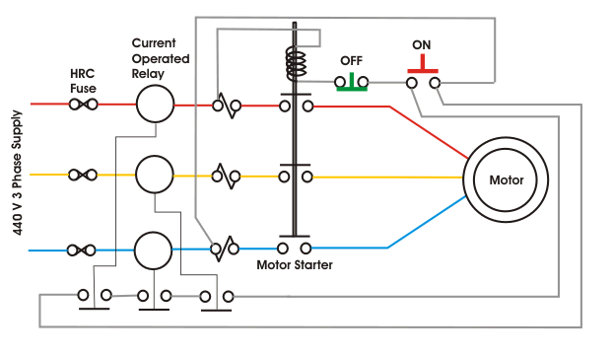

Large motor especially induction motors require protection against-
- Motor bearing failure,
- Motor overheating,
- Motor winding failure,
- Reverse motor rotation.

Motor Bearing Failure
Ball and roller bearings are used for the motor up to 500 hp and beyond this size sleeve bearings are used. Failure of ball or roller bearing usually causes the motor to a standstill very quickly. Due to sudden mechanical jamming in motor bearing, the input current of the motor becomes very high. Current operated protection, attached to the input of the motor cannot serve satisfactorily. Since this motor protection system has to be set to override the high motor starting current. The difficulty can be overcome by providing thermal over load relay. As the starting current of the motor is high but exists only during starting so for that current the there will be no overheating effect. But over current due mechanical jamming exists for longer time hence there will be a overheating effect. So stalling motor protection can be offered by the thermal overload relay. Stalling protection can also be provided by separate definite time over current relay which is operated only after a certain predefined time if over current persists beyond that period. In the case of sleeve bearing, a temperature sensing device embedded in the bearing itself. This scheme of motor protection is more reliable and sensitive to motor bearing failure since the thermal withstand limit of the motor is quite higher than that of bearing. If we allow the bearing overheating and wait for motor thermal relay to trip, the bearing may be permanently damaged. The temperature sensing device embedded in the bearing stops the motor if the bearing temperature rises beyond its predefined limit.

Motor over Heating
The main reason of motor over heating that means over heating of motor winding is due to either of mechanical over loading, reduced supply voltage, unbalanced supply voltage and single phasing. The overheating may cause deterioration of insulation life of motor hence it must be avoided by providing proper motor protection scheme. To avoid overheating, the motor should be isolated in 40 to 50 minutes even in the event of small overloads of the order of 10 %. The protective relay should take into account the detrimental heating effects on the motor rotor due to negative sequence currents in the stator arising out of unbalance in supply voltage. The motor should also be protected by instantaneous motor protection relay against single phasing such as a stall on loss of one phase when running at full load or attempting to start with only two of three phases alive.

Motor Winding Failure
The motor protection relay should have instantaneous trip elements to detect motor winding failure such as phase to phase and phase to earth faults. Preferably phase to phase fault unit should be energized from positive phase sequence component of the motor current and another instantaneous unit connected in the residual circuit of the current transformers be used for earth faults protection.

Reverse Motor Rotation
Especially in the case of conveyor belt, the reverse motor rotation must be avoided. The reverse rotation during starting can be caused due to inadvertent reversing of supply phases. A comprehensive motor protection relay with an instantaneous negative sequence unit will satisfy this requirement. If such relay has not been provided, a watt-meter type relay can be employed.

- Explain a protection scheme for protection of transformer against incipient fault (Nov/Dec 2016)

Power transformers are important and expensive components in the electric power system. The knowledge of the actual status of the transformer insulation behavior, load tap changer performance, temperature, and load condition is necessary in order to evaluate the service performance concerning reliability, availability and safety. Systems abnormalities, loading, switching and ambient condition normally contribute towards accelerated aging and sudden failure.

The faults that occur within the transformer protection zone are internal faults. Transformer internal faults can be divided into two classifications: internal short circuit faults and internal incipient faults. Internal short circuit faults are generally turn-to-turn short circuits or turn to earth short circuits in transformer windings. Internal incipient transformer faults usually develop slowly, often in the form of a gradual deterioration of the insulation due to some causes. Statistics show that winding failures most frequently cause transformer faults (ANSI/IEEE 1985). Insulation deterioration, often the result of moisture, overheating, vibration, voltage surges, mechanical stress created during transformer through faults, are the major reason for winding failure

Protection scheme is required for incipient transformer faults also. The earth fault, very nearer to neutral point of transformer star winding may also be considered as an incipient fault. Influence of winding connections and earthing on earth fault current magnitude. There are mainly two conditions for earth fault current to flow during winding to earth faults,
- A current exists for the current to flow into and out of the winding.
- Ampere-turns balance is maintained between the windings.
The value of winding earth fault current depends upon position of the fault on the winding, method of winding connection and method of earthing. The star point of the windings may be earthed either solidly or via a resistor. On delta side of the transformer the system is earthed through an earthing transformer. Grounding or earthing transformer provides low impedance path to the zero sequence current and high impedance to the positive and negative sequence currents.
An external fault in the star side will result in current flowing in the line current transformer of the affected phase and at the same time a balancing current flows in the neutral current transformer, hence the resultant current in the relay is therefore zero. So this REF relay will not be actuated for external earth fault. But during internal fault the neutral current transformer only carries the unbalance fault current and operation of Restricted Earth Fault Relay takes place. This scheme of restricted earth fault protection is very sensitive for internal earth fault of electrical power transformer. The protection scheme is comparatively cheaper than differential protection scheme. Restricted earth fault protection is provided in electrical power transformer for sensing internal earth fault of the transformer. In this scheme the CT secondary of each phase of electrical power transformer are connected together as shown in the figure. Then common terminals are connected to the secondary of a Neutral Current Transformer or NCT.
The CT or Current Transformer connected to the neutral of power transformer is called Neutral Current Transformer or Neutral CT or simply NCT. Whenever there is an unbalancing in between three phases of the power transformer, a resultant unbalance current flow through the close path connected to the common terminals of the CT secondaries. An unbalance current will also flow through the neutral of power transformer and hence there will be a secondary current in Neutral CT because of this unbalance neutral current. In Restricted Earth Fault scheme the common terminals of phase CTs are connected to the secondary of Neutral CT in such a manner that secondary unbalance current of phase CTs and the secondary current of Neutral CT will oppose each other. If these both currents are equal in amplitude there will not be any resultant current circulate through the said close path. The Restricted Earth Fault Relay is connected in this close path. Hence the relay will not response even there is an unbalancing in phase current of the power transformer.
. 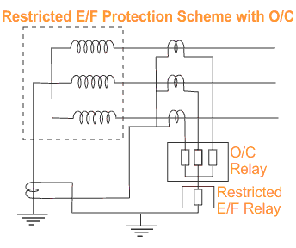
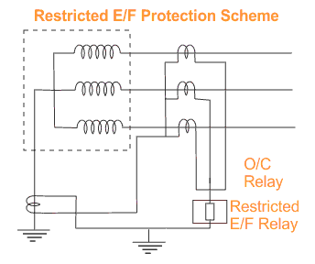 | 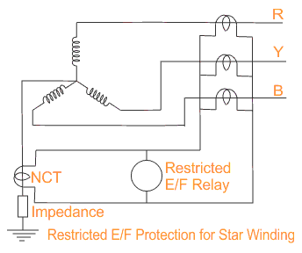

- Describe the differential protective scheme of a transformer (May/June 2016)
Generally Differential protection is provided in the electrical power transformer rated more than 5MVA. The Differential Protection of Transformer has many advantages over other schemes of protection.
  - The faults occur in the transformer inside the insulating oil can be detected by Buchholz relay. But if any fault occurs in the transformer but not in oil then it can not be detected by Buchholz relay. Any flash over at the bushings are not adequately covered by Buchholz relay. Differential relays can detect such type of faults. Moreover Buchholz relay is provided in transformer for detecting any internal fault in the transformer but Differential Protection scheme detects the same in more faster way.
  - The differential relays normally response to those faults which occur in side the differential protection zone of transformer.

Principle of Differential Protection
Principle of Differential Protection scheme is one simple conceptual technique. The differential relay actually compares between primary current and secondary current of power transformer, if any unbalance found in between primary and secondary currents the relay will actuate and inter trip both the primary and secondary circuit breaker of the transformer.
Suppose you have one transformer which has primary rated current Ip and secondary current Is. If you install CT of ratio Ip/1A at the primary side and similarly, CT of ratio Is/1A at the secondary side of the transformer. The secondaries of these both CTs are connected together in such a manner that secondary currents of both CTs will oppose each other. In other words, the secondaries of both CTs should be connected to the same current coil of a differential relay in such an opposite manner that there will be no resultant current in that coil in a normal working condition of the transformer. But if any major fault occurs inside the transformer due to which the normal ratio of the transformer disturbed then the secondary current of both transformers will not remain the same and one resultant current will flow through the current coil of the differential relay, which will actuate the relay and inter trip both the primary and secondary circuit breakers. To correct phase shift of current because of star-delta connection of transformer winding in the case of three-phase transformer, the current transformer secondaries should be connected in delta and star as shown here.
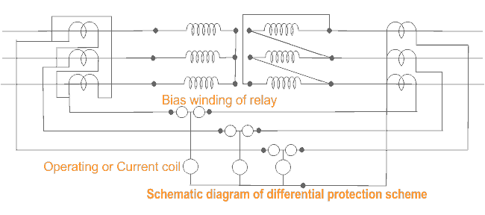At maximum through fault current, the spill output produced by the small percentage unbalance may be substantial. Therefore, differential protection of transformer should be provided with a proportional bias of an amount which exceeds in effect the maximum ratio deviation.

- Enumerate the protective scheme employed for the bus bar (May /June 2016)

Bus-Bar Protection
When the fault occurs on the bus bars whole of the supply is interrupted, and all the healthy feeders are disconnected. The majority of the faults is single phase in nature and these faults are temporary in character. The bus zone fault occurs because of various reasons likes failure of support insulators, failure of circuit breakers, foreign object accidently falling across the bus bar, etc., The clearing of a bus fault requires the opening of all the circuits branching from the faulty bus or bus section.
The most commonly used schemes for bus zone protection are:
- Backup protection
- Differential Overcurrent Protection
  - Circulating current protection
  - Voltage Overvoltage Protection
- Frame leakage protection.

Backup protection for Bus-Bars
It is the simplest of all to protect the buses with the aid of backup protections of the connected, supplying element which should respond to any fault appearing on the buses. The figure shown below the bus A is covered in the second step of distance protection B. Thus, in the event of a fault on bus A, the distance protection B will operate. The operating time of the second step can be of the order of 0.4 seconds.
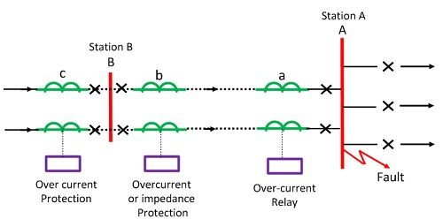
In such a system the protection is slow, and there can be an unwanted disconnection of all incoming parallel circuits. Distance protection is widely employed for the protection of transmission lines. Hence it is quite economical to use the same for bus protection. This scheme is quite satisfactory, for small switchgear installations, but for large and important installations a separate bus zone protection is provided.
Bus backup protection may also mean that in case the breaker fails to operate for a fault on the outgoing feeder, it must be regarded as a fault. It should then open all breakers on that bus. Such a backup protection can be provided with an appropriate time delay through a timer. Such types of protection have so many drawbacks like delayed in action, disconnection of more circuits in case there are two or more incoming lines, and exact discrimination is not possible in such types of protection.

Frame Leakage Or Fault-Bus Protection
This is the most simple form of protection. This method consist of insulating the bus-supporting structure and its switchgear from the ground, interconnecting all the framework, circuit breakers tanks, etc. and provided a single ground tank connection through a CT that feeds an overcurrent relay. The over current relay controls a multi-contact auxiliary relay that trips the breakers of all circuits connected to the bus.
In such type of protection only metal supporting structure or fault-bus is grounded through a CT, secondary of which is connected to an over current relay. Under normal operating condition, the relay remains inoperative, but fault involving a connection between a conductor and the ground supporting structure will result in current flow to ground through the fault bus, causing the relay to operate. The operation of the relay will trip all the breakers connecting equipment to the bus.

Differential Over Current Protection
Current Differential Protection
The protection schemes are based on the simple circulating current principle that under normal operating or external fault condition the sum of current entering into a bus-bar will be equal to the sum of current leaving the bus-bar. If the sum of current is not zero, then it is because of short circuit current. Hence this type of scheme applies to both types of faults, i.e., phase-to-phase fault as well as ground fault.
Schematic diagram of bus differential protection relay is shown in the figure below. The current transformers are inserted in each phase of the incoming and outgoing feeders of the bus bars. The secondaries of current transformers are connected in parallel with due considerations to polarity and phase.
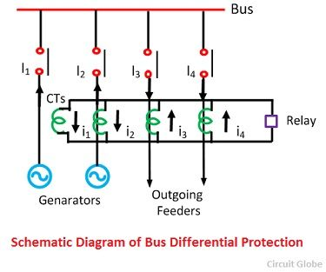
The relay operating coil is connected to the pilot wire in such a way that the summation current of secondaries flows through it. The Flow of current in the relay is an indication of a fault within the protected zone and will initiate the opening of the breakers of each generator and feeders.
The main drawback of this scheme is that there is the difference in the magnetic conditions of the iron cored current transformer, which may cause false operation of the relay time of an external fault.
Voltage Differential Protection Relay
In this schemes, CTS without iron cores, known as linear couplers is employed so that they have a much larger number of secondary turns that a core iron CT. The secondary relay of CTs is connected in series and the differential relay coil connected across them as shown in the figure.
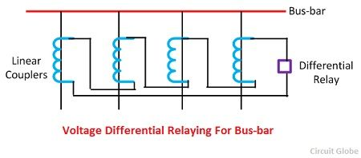
Under Normal operating condition or external fault conditions the sum of voltage induces in the secondary windings is zero in the event of an internal fault on the bus bar, the voltage of the CTs in all source circuits adds to cause the flow of current through the secondary windings and the differential relay operating coil. This scheme provides high schemes, protection for a relatively small net voltage in the differential current.
- Explain in detail the carrier current protection scheme. Describe carrier phase comparison relay with neat sketches. (Nov/Dec 2015)

Carrier Current Protection of Transmission Lines
Carrier current protection scheme is mainly used for the protection of the long transmission line. In the carrier, current protection schemes, the phase angle of the current at the two phases of the line are compared instead of the actual current. And then the phase angle of the line decides whether the fault is internal and external. The main elements of the carrier channel are a transmitter, receiver, coupling equipment, and line trap.
The carrier current receiver receives the carrier current from the transmitter at the distant end of the line. The receiver converts the received carrier current into a DC voltage that can be used in a relay or other circuit that performs any desired function. The voltage is zero when the carrier current, is not being received.
Line trap is inserted between the bus-bar and connection of coupling capacitor to the line. It is a parallel LC network tuned to resonance at the high frequency. The traps restrict the carrier current to the unprotected section so as to avoid interference from the with or the other adjacent carrier current channels. It also avoids the loss of the carrier current signal to the adjoining power circuit.
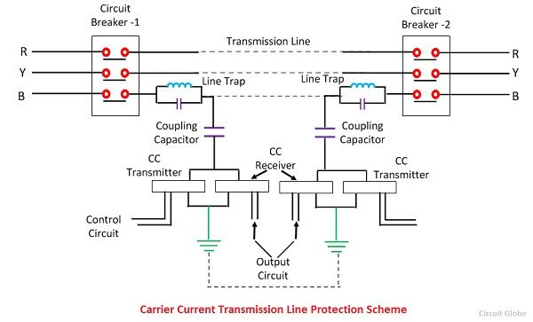 The coupling capacitor connects the high-frequency equipment to one of the line conductors and simultaneously separate the power equipment from the high power line voltage. The normal current will be able to flow only through the line conductor, while the high current carrier current will circulate over the line conductor fitted with the high-frequency traps, through the trap capacitor and the ground.

Methods of Carrier Current Protection
The different methods of current carrier protection and the basic form of the carrier current protection are
- Directional Comparison protection
- Phase Comparison Protection
These types are explained below in details

1. Directional Comparison Protection
In this protection schemes, the protection can be done by the comparison of a fault of the power flow direction at the two ends of the line. The operation takes place only when the power at both the end of the line is on the bus to a line direction. After the direction comparison, the carrier pilot relay informs the equipment how a directional relay behaves at the other end to a short circuit.
The relay at both the end removes the fault from the bus. If the fault is in protection section the power flows in the protective direction and for the external fault power will flow in the opposite direction. During the fault, a simple signal through carrier pilot is transmitted from one end to the other. The pilot protection relaying schemes used for the protection of transmission are mainly classified into two types. They are
- Carrier Blocking Protection Scheme – The carrier blocking protection scheme restricts the operation of the relay. It blocks the fault before entering into the protected section of the system. It is one of the most reliable protecting schemes because it protects the system equipment from damage.
- Carrier Permitting Blocking Scheme – The carrier, protective schemes allows the fault current to enter into the protected section of the system.

2. Phase Comparison Carrier Protection
This system compares the phase relation between the current enter into the pilot zone and the current leaving the protected zone. The current magnitudes are not compared. It provided only main or primary protection and backup protection must be provided also. The circuit diagram of the phase comparison carrier protection scheme is shown in the figure below.

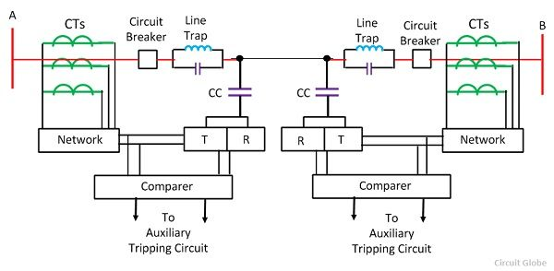 Advantage of Carrier Current Protection
The following are the advantage of the carrier current protection schemes. These advantages are
- It has a fast and simultaneous operation of circuit breakers at both the ends.
- It has a fast, clearing process and prevents shock to the system.
- No separate wires are required for signalling because the power line themselves carry the power as well as communication signalling.
- It’s simultaneously tripping of circuit breakers at both the end of the line in one to three cycles.
- This system is best suited for fast relaying also with modern fast circuit breakers.
The main operation of power line carrier has been for the purpose of supervisory control, telephone communication, telemeter and relaying.
- Briefly discuss the protective devices used for the protective devices used for the protection of a large transformer(Nov/Dec 2014)
A power transformer is a very valuable and vital link in a power transmission system. High reliability of the transformer is therefore essential to avoid disturbances in transmission of power.

When a fault occurs in a transformer, the damage is proportional to the fault time. The transformer should therefore be disconnected as fast as possible from the network. Fast reliable protective relays are therefore used for detection of faults. Monitors can also detect faults and they can sense abnormal conditions which may develop inta a fault, see section 5. The size of the transformer and the voltage level have an influence on the extent and choice of protective equipment. Monitors prevent faults and protective relays limit the damage in case of a fault. The Gast for the protective equipment is marginal compared to the total cost and the cost involved in case of a transformer fault. There are often different opinions about the extent of transformer protection. However, it is more or less normal that transformers with an ojl conservator are furnished with the following equipment: Transformers larger than 5 MVA .Gas detector relay (Buchholz relay) .Overload protection (thermal relays or temperature monitoring systems) .Overcurrent protection .Ground fault protection .Differential protection .Pressure relay for tap-changer compartment .Oil level monitor

Buchholz (Gas) Relay
The Buchholz protection is a mechanical fault detector for electrical faults in oil-immersed transformers. The Buchholz (gas) relay is placed in the piping between the transformer main tank and the oil conservator. The conservator pipe must be inclined slightly for reliable operation.
Often there is a bypass pipe that makes it possible to take the Buchholz relay out of service.
The Buchholz protection is a fast and sensitive fault detector. It works independent of the number of transformer windings, tap changer position and instrument transformers. If the tap changer is of the on-tank (container) type, having its own oil enclosure with oil conservator, there is a dedicated Buchholz relay for the tap changer.

Pressure Relay
Many power transformers with an on-tank-type tap changer have a pressure protection for the separate tap changer oil compartment. This protection detects a sudden rate-of-increase of pressure inside the tap changer oil enclosure.
When the pressure in front of the piston exceeds the counter force of the spring, the piston will move operating the switching contacts. The micro switch inside the switching unit is hermetically sealed and pressurized with nitrogen gas.
The simplest form of pressure relief device is the widely used frangible disk. The surge of oil caused by a heavy internal fault bursts the disk and allows the oil to discharge rapidly. Relieving and limiting the pressure rise prevent explosive rupture of the tank and consequent fire.
Also, if used, the separate tap changer oil enclosure can be fitted with a pressure relief device.
If the abnormal pressure is relatively high, this spring-controlled valve can operate within a few milliseconds and provide fast tripping when suitable contacts are fitted. The valve closes automatically as the internal pressure falls below a critical level.

Oil Level Monitor Device
Transformers with oil conservator(s) (expansion tank) often have an oil level monitor. Usually, the monitor has two contacts for alarm. One contact is for maximum oil level alarm and the other contact is for minimum oil level alarm.
The top-oil thermometer has a liquid thermometer bulb in a pocket at the top of the transformer. The thermometer measures the top-oil temperature of the transformer. The top-oil thermometer can have one to four contacts, which sequentially close at successively higher temperature.

Winding Thermometer
The winding thermometer, shown in the figure below, responds to both the top-oil temperature and the heating effect of the load current.
The winding thermometer creates an image of the hottest part of the winding. The top-oil temperature is measured with a similar method as introduced earlier. The measurement is further expanded with a current signal proportional to the loading current in the winding.
This current signal is taken from a current transformer located inside the bushing of that particular winding. This current is lead to a resistor element in the main unit. This resistor heats up, and as a result of the current flowing through it, it will in its turn heat up the measurement bellow, resulting in an increased indicator movement.
The temperature bias is proportional to the resistance of the electric heating (resistor) element.
The result of the heat run provides data to adjust the resistance and thereby the temperature bias. The bias should correspond to the difference between the hot-spot temperature and the top-oil temperature. The time constant of the heating of the pocket should match the time constant of the heating of the winding.
The temperature sensor then measures a temperature that is equal to the winding temperature if the bias is equal to the temperature difference and the time constants are equal.
With four contacts fitted, the two lowest levels are commonly used to start fans or pumps for forced cooling, the third level to initiate an alarm and the fourth step to trip load breakers or de-energize the transformer or both.
In case a power transformer is fitted with top-oil thermometer and winding thermometer, the latter one normally takes care of the forced cooling control.
- Describe with a neat sketch , the percentage differential protection of a modern alternator (Nov/Dec 2014)

Differential Protection of Alternator
Any internal fault inside the stator winding is cleared by mainly differential protection scheme of the generator or alternator.
The differential protection is provided in the generator by using longitudinal differential relay.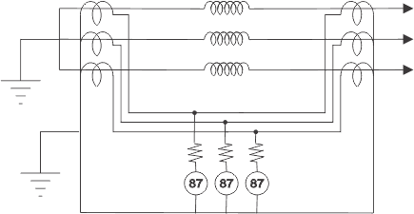
Generally instantaneous attracted armature type relays are used for this purpose because all they have high speed operation and also they are free from being affected by any AC transient of the power circuit.
There are two sets of current transformers one CT is connected to the line side of the generator and other is connected to the neutral side of the generator in each phase. It is needless to say that the characteristics of all current transformers installed against each phase must be matched. If there is any major mismatched in the current transformer’s characteristics of both sides of the generator, there may be high chance of malfunctioning of differential relay during the fault external to the stator winding and also may be during normal operating conditions of the generator.
To ensure that the relay does not operate for the faults external to the operated zone of the protection scheme, a stabilizing resistor is fitted in series with the relay operating oil. It also ensures that if one set of CT has been saturated, there will be no possibility of malfunctioning of the differential relay.
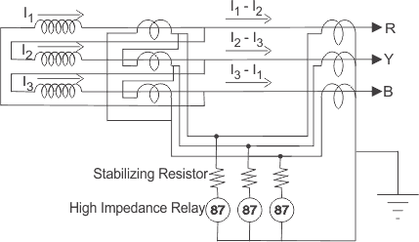

It is always preferable to use dedicated current transformers for differential protection purpose because common current transformers may cause unequal secondary loading for other functionalities imposed on them. It is also always preferable to use all current transformers for differential protection of generators or alternators should be of same characteristics. But practically there may be some difference in characteristics of the current transformers installed at line side to those installed in neutral side of the generator. These mismatches cause spill current to flow through the relay operating coil. To avoid the effect of spill current, percentage biasing is introduced in differential relay.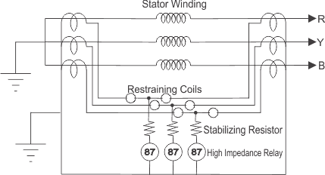
The percentage biased differential relay comprises two restraint coils and one operating coil per phase. In the relay, the torque produced by operating coil tends to close the relay contacts for instantaneous tripping of circuit breakers but at the same time the torque produced by the restraint coils prevents to close the relay contacts as restraint coils torque is directed opposite of the operating coil torque. Hence during through fault the differential relay would not be operated because the setting of the relay is increased by restraint coils and also it prevents malfunctioning of relay due to spill current. But during internal fault in the winding of the stator, the torque produced by restraint coils is ineffective and the relay closes its contact when setting current flows through the operating coil.
Differential current pickup setting/bias setting of the relay is adopted based on the maximum percentage of allowable mismatch adding some safety margin.
The spill current level for the relay is to just operate it; is experienced as a percentage of the through fault current causing it. This percentage is defined as bias setting of the relay.

- Describe the construction and working of bucholz relay (April/May 2017)

Construction of Buchholz Relay
Buchholz relay in transformer is an oil container housed the connecting pipe from main tank to conservator tank. It has mainly two elements. The upper element consists of a float. The float is attached to a hinge in such a way that it can move up and down depending upon the oil level in the Buchholz relay Container. One mercury switch is fixed on the float. The alignment of mercury switch hence depends upon the position of the float.
The lower element consists of a baffle plate and mercury switch. This plate is fitted on a hinge just in front of the inlet (main tank side) of Buchholz relay in transformer in such a way that when oil enters in the relay from that inlet in high pressure the alignment of the baffle plate along with the mercury switch attached to it, will change.
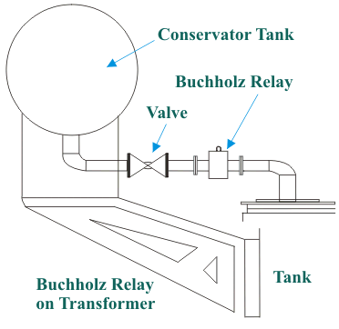
In addition to these main elements a Buchholz relay has gas release pockets on top. The electrical leads from both mercury switches are taken out through a molded terminal block.

Buchholz Relay Principle
The Buchholz relay working principle of is very simple. Buchholz relay function is based on very simple mechanical phenomenon. It is mechanically actuated. Whenever there will be a minor internal fault in the transformer such as an insulation faults between turns, break down of core of transformer, core heating, the transformer insulating oil will be decomposed in different hydrocarbon gases, CO2 and CO. The gases produced due to decomposition of transformer insulating oil will accumulate in the upper part the Buchholz container which causes fall of oil level in it.
Fall of oil level means lowering the position of float and thereby tilting the mercury switch. The contacts of this mercury switch are closed and an alarm circuit energized. Sometime due to oil leakage on the main tank air bubbles may be accumulated in the upper part the Buchholz container which may also cause fall of oil level in it and alarm circuit will be energized. By collecting the accumulated gases from the gas release pockets on the top of the relay and by analyzing them one can predict the type of fault in the transformer.
More severe types of faults, such as short circuit between phases or to earth and faults in the tap changing equipment, are accompanied by a surge of oil which strikes the baffle plate and causes the mercury switch of the lower element to close. This switch energized the trip circuit of the circuit breakers associated with the transformer and immediately isolate the faulty transformer from the rest of the electrical power system by inter tripping the circuit breakers associated with both LV and HV sides of the transformer. This is how Buchholz relay functions.

Buchholz Relay Operation Certain Precaution
The Buchholz relay operation may be actuated without any fault in the transformer. For instance, when oil is added to a transformer, air may get in together with oil, accumulated under the relay cover and thus cause a false Buchholz relay operation.
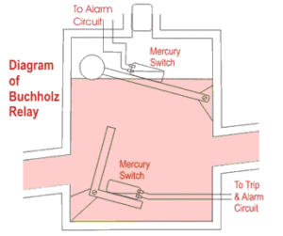
That is why mechanical lock is provided in that relay so that one can lock the movement of mercury switches when oil is topping up in the transformer. This mechanical locking also helps to prevent unnecessary movement of breakable glass bulb of mercury switches during transportation of the Buchholz relays.
The lower float may also falsely operate if the oil velocity in the connection pipe through, not due to internal fault, is sufficient to trip over the float. This can occurs in the event of external short circuit when over currents flowing through the winding cause overheated the copper and the oil and cause the oil to expand.

- With a neat schematic diagram , explain the protection of a transformer with a differential protection scheme (May/June 2014)

Generally Differential protection is provided in the electrical power transformer rated more than 5MVA. The Differential Protection of Transformer has many advantages over other schemes of protection.
The faults occur in the transformer inside the insulating oil can be detected by Buchholz relay. But if any fault occurs in the transformer but not in oil then it can not be detected by Buchholz relay. Any flash over at the bushings are not adequately covered by Buchholz relay. Differential relays can detect such type of faults. Moreover Buchholz relay is provided in transformer for detecting any internal fault in the transformer but Differential Protection scheme detects the same in more faster way.
The differential relays normally response to those faults which occur in side the differential protection zone of transformer.

Principle of Differential Protection
Principle of Differential Protection scheme is one simple conceptual technique. The differential relay actually compares between primary current and secondary current of power transformer, if any unbalance found in between primary and secondary currents the relay will actuate and inter trip both the primary and secondary circuit breaker of the transformer.
Suppose you have one transformer which has primary rated current Ip and secondary current Is. If you install CT of ratio Ip/1A at the primary side and similarly, CT of ratio Is/1A at the secondary side of the transformer. The secondaries of these both CTs are connected together in such a manner that secondary currents of both CTs will oppose each other. In other words, the secondaries of both CTs should be connected to the same current coil of a differential relay in such an opposite manner that there will be no resultant current in that coil in a normal working condition of the transformer. But if any major fault occurs inside the transformer due to which the normal ratio of the transformer disturbed then the secondary current of both transformers will not remain the same and one resultant current will flow through the current coil of the differential relay, which will actuate the relay and inter trip both the primary and secondary circuit breakers. To correct phase shift of current because of star-delta connection of transformer winding in the case of three-phase transformer, the current transformer secondaries should be connected in delta and star as shown here.
At maximum through fault current, the spill output produced by the small percentage unbalance may be substantial. Therefore, differential protection of transformer should be provided with a proportional bias of an amount which exceeds in effect the maximum ratio deviation.
- Discuss the time graded over current protection for parallel feeders (Apr/May 2017)

Time Graded Over Current Protection
This may also be referred simply as over-current protection of electrical power transmission line. Let' discuss different schemes of time graded over current protection.

Protection of Radial Feeder
In radial feeder, the power flows in one direction only, that is from source to load. This type of feeders can easily protected by using either definite time relays or inverse time relays.

Line Protection by Definite Time Relay
This protection scheme is very simple. Here total line is divided into different sections and each section is provided with definite time relay. The relay nearest to the end of the line has minimum time setting while time setting of other relays successively increased, towards the source.
For example, suppose there is a source at point A, in the figure below
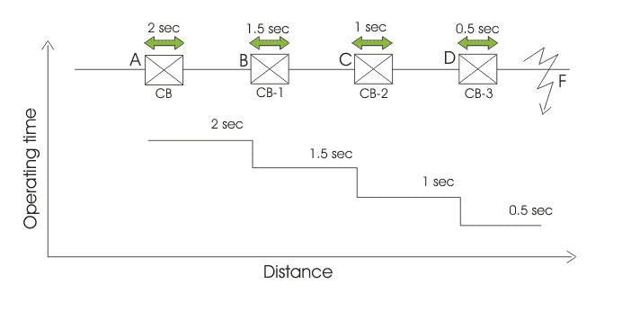At point D the circuit breaker CB-3 is installed with definite time of relay operation 0.5 sec. Successively, at point C an other circuit breaker CB-2 is installed with definite time of relay operation 1 sec. The next circuit breaker CB-1 is installed at point B which is nearest of the point A. At point B, the relay is set at time of operation 1.5 sec.
Now, assume a fault occurs at point F. Due to this fault, the faulty current flow through all the current transformers or CTs connected in the line. But as the time of operation of relay at point D is minimum the CB-3, associated with this relay will trip first to isolate the faulty zone from rest part of the line. In case due to any reason, CB-3 fails to trip, then next higher timed relay will operate the associated CB to trip. In this case, CB-2 will trip. If CB-2 also fails to trip, then next circuit breaker i.e. CB-1 will trip to isolate major portion of the line.

Advantages of Definite Time Line Protection
The main advantage of this scheme is simplicity. The second major advantage is, during fault, only nearest CB towards the source from fault point will operate to isolate the specific position of the line.

Disadvantage of Definite Time Line Protection
If the number of sections in the line is quite large, the time setting of relay nearest to the source would be very long. So during any fault nearer to the source will take much time to be isolated. This may cause severe destructive effect on the system.

- Explain with the neat diagram the application of Merz-Price circulating current principle for protection of alternator.(Apr/May 2017)
Differential protection of alternator or Merz-Price circulating current protection system is a only protection system that protects alternator stator from burning through at least 80% of it.
For alternator the most severe out come of fault is the damage of stator. If some how the stator coil is burn out, welded together then there is no solution but to replace it causing longer down time.
faults of alternator like reverse power, stator inter turn, excitation circuit protection are either rare or can be detected easily. The core concept of alternator stator protection is to save 85% of its coil from damage due to fault.
There are two types fault might occur in a alternator stator, namely phase to phase fault or phase to ground fault. In case of phase to ground fault, if one phase is grounded or shorted with alternator body/ frame, it will form a close circuit with NER or neutral earth resistance of alternator. That is fault current will flow through earthed phase – alternator frame- neutral earth resistance of alternator. For phase to phase fault a local circuit will develop in which the fault current will flow
Differential circulating current protection scheme or Mertz Price circulating current scheme is a most popular protection scheme for alternator stator protection. It function on the concept of compareing the two currents in and out of stator coil. In normal condition the two current will be same, if fault occurs there will be some difference , and Merz price circulating current scheme works by detecting this difference or differential current.
In each phase there are two identical Current transformer.This two CT is in two sides of to be protected zone. So for three phase there are six no of CT’s. The secondaries of all CT’s are connected in star and other winding of each CT’s set are connected through cable called pilot cable.Three coil are connected in pilot cable. They are connected in a equipotential point of pilot cable.

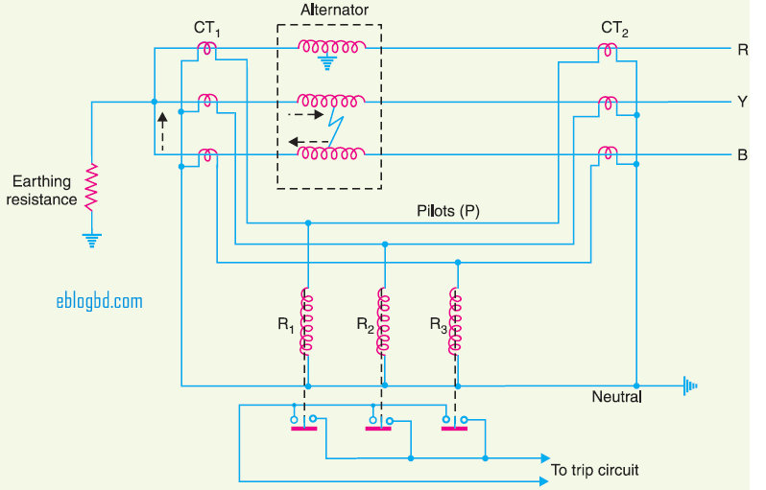

Under normal condition there will be no current difference in two sides of protected zone, hence Two ct’s in a phase will conduct same current. Thus currents from two ct’s will be balanced as current entering in same point of same value from opposite direction is vectorically summed up as zero.(From Kirchhoff current law concept)

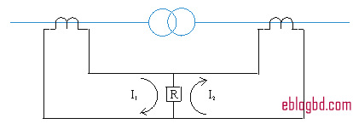

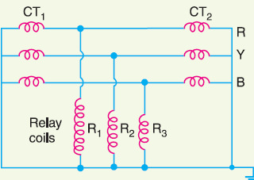

- What is the role of instrument transformers in protective schemes (April/May 2017)
Instrument Transformers are used in AC system for measurement of electrical quantities i.e. voltage, current, power, energy, power factor, frequency. Instrument transformers are also used with protective relays for protection of power system. Basic function of Instrument transformers is to step down the AC System voltage and current. The voltage and current level of power system is very high. It is very difficult and costly to design the measuring instruments for measurement of such high level voltage and current. Generally measuring instruments are designed for 5 A and 110 V.
The measurement of such very large electrical quantities, can be made possible by using the Instrument transformers with these small rating measuring instruments. Therefore these instrument transformers are very popular in modern power system.

Advantages of Instrument Transformers
- The large voltage and current of AC Power system can be measured by using small rating measuring instrument i.e. 5 A, 110 – 120 V.
- By using the instrument transformers, measuring instruments can be standardized. Which results in reduction of cost of measuring instruments. More ever the damaged measuring instruments can be replaced easy with healthy standardized measuring instruments.
- Instrument transformers provide electrical isolation between high voltage power circuit and measuring instruments. Which reduces the electrical insulation requirement for measuring instruments and protective circuits and also assures the safety of operators.
- Several measuring instruments can be connected through a single transformer to power system.
- Due to low voltage and current level in measuring and protective circuit, there is low power consumption in measuring and protective circuits.

Types of Instrument Transformers
Instrument transformers are of two types –
- Current Transformer (C.T.)
- Potential Transformer (P.T.)

Current Transformer (C.T.)
Current transformer is used to step down the current of power system to a lower level to make it feasible to be measured by small rating Ammeter (i.e. 5A ammeter). A typical connection diagram of a current transformer is shown in figure below.
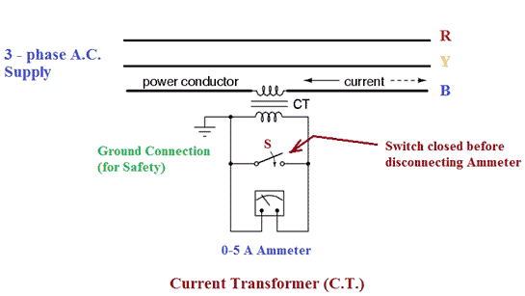
Primary of C.T. is having very few turns. Sometimes bar primary is also used. Primary is connected in series with the power circuit. Therefore, sometimes it also called series transformer. The secondary is having large no. of turns. Secondary is connected directly to an ammeter. As the ammeter is having very small resistance. Hence, the secondary of current transformer operates almost in short circuited condition. One terminal of secondary is earthed to avoid the large voltage on secondary with respect to earth. Which in turns reduce the chances of insulation breakdown and also protect the operator against high voltage. More ever before disconnecting the ammeter, secondary is short circuited through a switch ‘S’ as shown in figure above to avoid the high voltage build up across the secondary.

Potential Transformer (P.T.)
Potential transformer is used to step down the voltage of power system to a lower level to make is feasible to be measured by small rating voltmeter i.e. 110 – 120 V voltmeter. A typical connection diagram of a potential transformer is showing figure below.
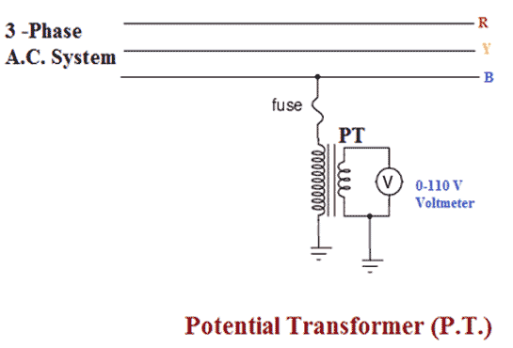
Primary of P.T. is having large no. of turns. Primary is connected across the line (generally between on line and earth). Hence, sometimes it is also called the parallel transformer. Secondary of P.T. is having few turns and connected directly to a voltmeter. As the voltmeter is having large resistance. Hence the secondary of a P.T. operates almost in open circuited condition. One terminal of secondary of P.T. is earthed to maintain the secondary voltage with respect to earth. Which assures the safety of operators.
- Explain stepped time –distance characteristics of a three distance relaying units used for 1, 2 and 3 Zone of protection. (Nov/Dec 2014).
The long transmission lines are with intermediate substations. In each substation the distance relays are provided for line protection. The settings of these relays are set with respect of impedance (radius of characteristic circle) and operating time

The distance relay in each sub-station has generally three step characteristic with respective setting of Z and t for each step. The three step characteristics of distance relay of each sub-station is achieved by providing three sets of relays in each sub-station for protection of each line. Fig (15).
- 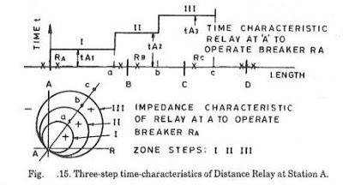
Step Characteristic
Ref Fig. 15. This figure explains a time distance characteristic of a 3-step distance scheme in substation A for one direction. These are three sets of relays for protection of each line. Each relays provides characteristic for one zone. The combined effect the distance scheme in substation A provides. Primary protection of first zone AB with minimum time setting. Normally 85% of first zone is covered to take care of errors such as fault resistance. Remote back-up for the second zone BC with time setting ... and remove Back-up for the 3rd Zonal CD with time setting.

First zone. The first zone setting is 85 to 90%of line length and with highest speed of protection so that these relays operate at the earliest and will never operate for the fault in 2nd and 3rd zones. Also the margin of 15 to 10% takes care of fault resistance seen by the relay measurement as additional time impedance.

Under reach. Suppose line impedance is ZLand arc resistance relay measures (ZL + Rf ) instead of measuring only ZL . Thereby the relay will see the fault as beyond its characteristic circle and will not operate even though it should have operated. This is called under reach Definitely.
Second Zone. The second zone relay at A provides protection for measuring 15 to 10% of line section AB. The relay is set to reach beyond the length AB and twenty to fifty per cent of the next line section BC. For achieving time co-ordination, the second zone relay at substation 1 is set with time t2 with a time delay of 0.2 to 0.5 seconds between the first zone t1 and second zone t2 . The primary protection for section BC is provided by first zone relay at substation B.

Third Zone. The third zone relay at A provides Back-up protection for section AB, BC and CD. The primary protection for line section CD is provided by first zone relay at substation C.Third zone protection at sub-station A is delayed by 0.4 to one second from first zone and 0.2 to 0.5 seconds from second zone.

- A generator is protected by restricted earth fault protection. The generator ratings are 13.2 KV, 10MVA, the percentage of winding protected against phase to ground fault is 85% . The relay setting is such that it trips for 20% out of balance. calculate the resistance to be added in the neutral to ground connection.
Relay setting=20%, winding protected = 85%
Relay setting is 20% out of balance I,e 20% of the rated current activates the relay.
Relay operating
Line neutral voltage
% of winding protected is 85% as 15% is unprotected.
- Current transformer of current ratio of 1000/5 is used for protection of a star connected 3-phase, 10MVA, and 6.6KV alternator. If the relay is set to operate for a minimum current of 0.5A. Calculate the percentage of each phase stator winding which is unprotected against earth fault when the machine operates at normal voltage. Assume that star point of alternator is earthed through a resistance of 7.5 ohm.(May/June 2007)

- A three phase transformer of 220/11000 line volts is connected in star delta. The protective transformers on 220V side have a current ratio of 600/5. What would be the current transformer ratio on 11000 V side?(Nov/Dec 2011)
For star/delta power transformers, CTs will be connected in delta on 220v side (I,e,, star side of power transformer) and in star on 11,000 V side .
Suppose the line current on 220V side is 600A.
Phase current of delta connected CTs on 220V side = 5A
Line current of delta connected CTs on 220V side =
This current will flow through the pilot wires . obviously, this will be the current which flows through the secondary of CTs on the 11000 V side
Phase current of star connected CTs on 11000 V side =
If I is the line current on 11000V side , then,
Primary apparent power = Secondary apparent power

