AALIM MUHAMMED SALEGH COLLEGE OF ENGINEERING
DEPARTMENT OF MECHANICAL ENGINEERING

QUESTION BANK
DEPARTMENT: MECH SEMESTER: VII
SUBJECT CODE / Name: ME 2402 / COMPUTER INTERGRATED MANUFACTURING

PART-A
UNIT-I

1. Explain CIM.
CIM is the integration of the total manufacturing enterprise through the use of integrated systems and data communications coupled with new managerial philosophies that improve organizational and personnel efficiency.

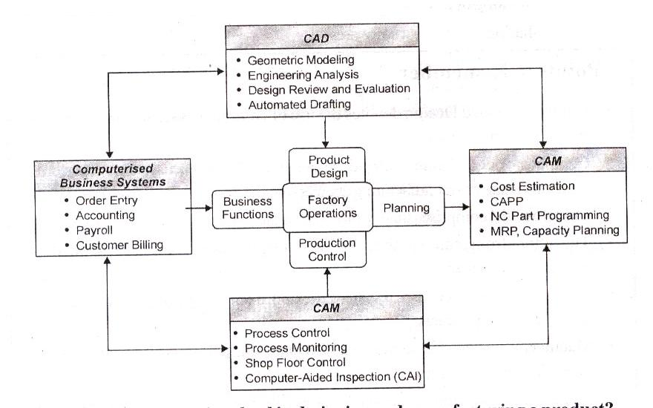
2. What are the components of CIM?

3. What are the steps involved in designing and manufacturing a product?
Steps involved in designing and manufacturing a product.
♦ Definition of product
♦ Design analysis
♦ Drifting
♦ Pilot production
♦ Inspection
♦ Packing
♦ Conceptual design
♦ Prototype
♦ Material and process selection
♦ Production, Quality assurance and Final product

4. What is the role of CIM in manufacturing?
CIM is most closely associated with functions in manufacturing engineering such a process planning and numerical control (NC) part programming.

5. What are important applications of CIM in manufacturing planning?
The applications of CIM can be divided into two broad categories.
1) Manufacturing planning 2) Manufacturing control

- What are the important applications of CIM in manufacturing control?
♦ The applications of computer process control are pervasive today in automated production systems.
♦ Quality control includes a variety of approaches to ensure the highest possible quality levels in the manufactured product.
♦ Shop floor control refers to production management techniques.

- What is management?
Management is the process of making decisions and directing the activities of personnel to achieve stated objective. The objectives are successfully met when efforts are organized by communicating appropriate information for control and readjustment.

- List out the tasks for the managers in effective management.
The following six tasks for the managers of CIM:
- Develop a business model to understand the problem environment
- Develop a functional model for the processes, functions, and activities to describe both "as is" and "to be".
- Develop an information model that identifies system interfaces, information exchange patterns, database requirements and applicable technologies.
- Develop a network model to identify communication and networking requirements
- Develop an organizational model to investigate the implications of integrating the various islands of automation on the existing organization structure and culture, and how to safeguard against detrimental effects.
- Finally, develop the implementation plan which should take into account special features of the business and operations.

- What are the major communications used in manufacturing industry?
The major communication used in manufacturing industry
  - Telephones, including cellular systems
  - Facsimile terminals (or) Fax machines
  - Satellite dish and video conferencing
  - Personal computers (PCs)

- What is videoconferencing?
The videoconferencing is a live, interactive television program delivered through satellite for a special audience. Videoconferencing can encompass several countries. In it, even two or more persons can participate. For example, in a videoconference manufacturing engineers may discuss "live" about the product with the designers who may be located at company headquarters 1000kms away. Occasionally, customers or distributors may be called in "live" to clarify a point relating to the defect.

11. Define automation.
Automation is generally defined as the process of having machines follow a predetermined sequence of operations with little or no human labour, using specialized equipment and devices that performs and control manufacturing processes.

12. What are the goals of automation in manufacturing industry?
Automation has the following primary goals.
  - Process Integration
  - Improve Productivity
  - Economize on floor space
  - Improve quality

- What are the functions of automated manufacturing system?
Automating manufacturing systems operate in the factory on the physical product. They perform operations such as processing, assembly, inspection, or material handling, in some cases accomplishing more than one of these operations in the same systems.

14. Give the classification of automation.
Automated manufacturing systems can be classified into three basic types:
  - Fixed automation
  - Programmable automation
  - Flexible automation.

- What are the benefits of automation?
    - To increase labour productivity
    - To reduce labour cost
    - To mitigate the effects of labour shortages
    - To reduce or eliminate routine and clerical takes
    - To improve worker safety.

- What are the capabilities of computer control?
The capabilities are:
1) | Polling (or) Data sampling | 2) | Interlocks
3) | Interrupt system | 4) | Exception handling
17. Explain the types of interlocks.
There are two types of interlocks:
i) Input interlocks |  | ii) Output interlocks
- Input interlocks: An input interlocks that originates from an external device. (e.g., a limit switch, sensor, or production machine) and is sent to the controller.
- Output interlocks: An output interlock is a signal from sent the controller to same external devises. It is used to control the activities of each external device and coordinate its operation with that of the other equipment in the cell.

18. What is MAP?
Manufacturing Automation Protocol (MAP) is a specialized LAN designed for a factory environment. It is hardware cum-software implement able set of rules that facilitate information transfer amount networked computers and computer-based equipment.

19. What are the approaches of physical distributions?
  - Customer service: What level of customer service should be provided?
  - Transportation: How will the products be shipped?
  - Warehousing: Where will the goods be located? How many warehouses should be utilized?
  - Order processing: How should the order be handled?
  - Inventory control: How much inventory should be maintained at each location?
  - Protective packing and materials handling: How can efficient methods be developed for handling goods in the factory, warehouse, and transport terminals?

UNIT - II

1. Define Group Technology (GT).
Group Technology (GT) is a manufacturing methodology in which indentical or similar components grouped processed together during design, process planning and manufacturing so that a wide variety of components can be manufactured, at the least expense of time, inventory, man hours and material handling.
List out the stages in Group Technology.
  - Production planners to setup the GT database.
  - Grouping the parts or components into part-families with some similar characteristics.
c) Re-design the shop-floor arrangement according to common shape, function or manufacturing process and tooling.

3. Define Part families.
Part-family is defined as" collection of parts which are similar in terms of geometric shape, size, and similar processing steps required in manufacturing, so flow of materials through the plant improves".
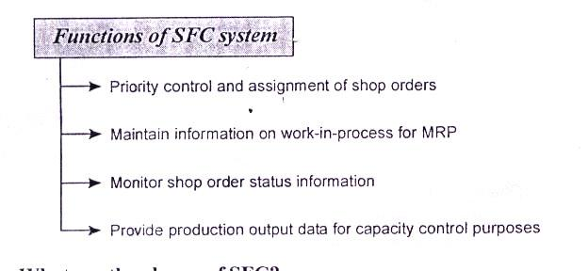
4. What are the methods available for solving problems in GT?

5. Explain the two categories of attributes of parts.
- Design attributes, which are concerned with part characteristics such as geometry, size, and material.
- Manufacturing attributes, which consider the sequence of processing steps required to make a part.

6. List out the premises for the developed of DCLASS code.
  - A part may be best characterized bytes basic shape, usually is most appartment attribute.
  - A Each basic shape may have several features, such as holes, slots, threads and grooves.
  - A part can be completely characterized by basic shape; size; precision and material type, from and condition.
  - Several short code segments can be linked to from classification code that is human recognizable and adequate for human monitoring.
  - Each of these code segments can point to more detailed information.

7. What is PFA?
Production flow analysis is a technique for pre-planning the division of the whole factory into groups or departmental groups. When the knowledge of division is available, then it is possible to plan the layout.

8. What is the weakness of PFA?
The weakness of production flow analysis (PFA) that the data used are derived from production route-sheets. But the process-sequences have been prepared by different process lanners and the difference is reflected on to these route-sheets.

- What are the applications of GT?
  - Design: In a firm many components have similar shape. They can be grouped into design families and a design can be created by simply modifying an existing component design from the same family.
  - In Manufacturing: For this purpose GT gives a great importance than simply a design philosophy. Parts that are not similar in shape may still need similar manufacturing processes. Parts of this type are called production family. (All parts may need same operation like drilling, milling thread cutting etc.)
  - Process Planning: Process planning work can be facilitated as similar processes are needed for all components of a particular family.
This helps production planning and control much easier because only similar parts are considered for each cell. Such a cell-oriented layout is called a group-technology layout or cellular layout.

- What is FMS?
FMS is a manufacturing system based on multi-operation machine tools, incorporating (automatic part handling and storage).

11. What is Process planning?
Process planning consists of preparing a set of instructions that describe how to fabricate a part or build an assembly which will satisfy engineering design specifications. Process planning is the systematic determination of the methods by which product is to be manufactured, economically and competitively.

12. What are the results of Process Planning?
Routings which specify operations, operation sequences, work centers, standards, tooling and fixtures. This routing becomes a major input to the manufacturing resource planning system to define operations for production activity control purpose and define required resources for capacity requirements planning purposes.
Process plans which typically provide more detailed, step-by-step work instructions including dimensions related to individual operations, machining parameters, set-up instructions, and quality assurance checkpoints.
Fabrication and assembly drawings to support manufacture (as opposed to engineering drawings to define the part).

13. What are the steps involved in Process planning?
Steps involved in Process Planning
- Preliminary analysis and Product design evaluation
- Selection of manufacturing process
- Selection of Machine Tool
- Selection of Tooling and Process parameters
- Final operation sequence selection

- What are the factors should be considered in selection of tooling?
- The type and amount of the material to be cut
- The surface finish required
- The rigidity and shape of the part .
- The capacity and condition of the available equipment
- The required production volume (high volume jobs usually permit optimum speeds and feeds while lot jobs may use lower speeds to achieve completion of the lot without regrinding of the cutting tool)
- The succeeding operations such as finish grinding and honing
- The recommendations given in tables should be considered only as a starting point. A detailed analysis is further required in each individual case to arrive at the most feasible solution. . .

- What are the principles should adhere while determining the efficient sequence?
- The first operation in the sequence should be one in which the largest layer of metal is removed.
- Finishing operations should be performed at the end of the operation sequence.
- Surfaces whose machining docs not greatly affect the rigidity of the work should be machined earlier in the sequence, and
- The sequence of machining operations should be coordinated with heal treating operations, it any in the processor manufacture.

16. What arc the prerequisites for process planning?
The other prerequisites for process planning are:
- Part list
- Annual demand/ batch size
- Accuracy and surface finish requirement
- Equipment details
- Data on cutting fluids, tools, jigs and fixtures, gauges.
- Standard available stock sizes.
- Machining data, data on handling and setup.

17. What are the approaches the CAPP will recognize?
Two approaches to CAPP are traditionally recognized: the variant approach and the generative approach. Many CAPP systems combine both approaches.

18. Why CAPP systems are called as variant system?
The main reasons probably are:
  - The investment is less and the development time is shorter. Especially for medium sized companies which want to establish their own research groups.
- The development costs and hardware costs are lower. Especially for some small companies where the products do not vary much and who still have process planners.
19. Give the main component of generative CAPP systems.
CAPP system contains of two main components.
      - Manufacturing data base (part description, machine tool library etc..)
      - Decision logic (to represent the process planner)

- What arc the benefits of CAPP over manual process?
    - Process rationalization: Computer-automated p r e p a r a t i o n of o p e r a t i on routings is more li k e l y to be consistent, logical, and optimal than its manual counterpart. The process plans will be consistent because the same computer software is being used by all planners.
    - increased productivity of process planners: With computer-aided process planning, there is reduced clerical effort, fewer errors arc made and the planners have immediate access to the process planning database. These benefits translate into higher productivity of the process planners.
  - Reduced turnaround time: Working with the CAPP system, the process planner is able to prepare a route sheet for a new part in less time compared to manual preparation. This leads to an overall reduction in manufacturing lead time.
  - Improved legibility: The computer-prepared document is neater and easier to read than manually written route sheets. CAPP systems employ standard text, which facilitates interpretation of the process plan in the factory.
  - Incorporation of other application programs: The process planning system can be designed to operate in conjunction with other software packages to automate many of the time-consuming manufacturing support functions.

UNIT - III

1. Gives the major objectives of a Production Management System (PMS).
The two major objectives of a production management system (PMS) are planning and controlling of the manufacturing operations. The Planning Stage deals initial Production planning, development of master schedule, capacity planning, and MRP.

2. Define SFC.
Shop Floor Control (SFC) is defined as the important manufacturing activity that will control flow of the product and materials on the factory flow involving the quantities, types of parts, schedule dates, priorities and the status of jobs and orders.

3. What are the primary functions of SFC?
→ Priority control and assignment of shop orders
→ Maintain information on work in process for MRP
→ Monitor shop order status information
→ Provide production output data for capacity control purposes

- What are the phases of SFC?
The three phases or modules are:
1. Order Release 2. Order Scheduling 3. Order Progress

5. What is the purpose of FDS?
The purpose of the Factory Data Collection (FDS) system in shop floor control is to provide basic data for monitoring order progress. In a computerized SFC system these data are submitted to the order progress module for analysis and generation of work order

6. What is an Automatic Data Capture (ADC) method?
Automatic Identification methods is also known as Automatic Data Capture
(ADC) it is refers to the technologies that provides direct entry of data into the computer or other control systems without using a keyboards. These technologies require no human involvement in the data capture and entry process.

7. | What are the technologies used in ADC?
 | 1. | Optical | 2. | Magnetic type | 3 | Electromagnetic type
 | 4. | Smart card | 5. | Touch techniques | 6 | Biometric
8. | What Bar code consists?
The bar code consists of a thick and narrow coloured bars separates thick and narrow spaces separating the bars. The pattern of bars and spaces is co to represent alphanumeric characters.

9. What are the types of Bar code?
Bar codes divide into two basic types:
- Linear, in which the encoded data are read using a linear sweep of the scan
- Two-dimensional, in which the encoded data must be read in both directions

10. What is DAS?
A data acquisitions system (DAS) is a computer system used to automatically collect the data from a process or piece of equipment. They either perform an analysis data or transmit the data to another computer for processing and analysis.

11. List out the application of ADC technology.
The following are the most common application of ADC technologies.
1) | Parts receiving | 2) | Shipping
3) | Order picking | 4) | Finished goods storage
5) | Manufacturing processing | 6) | Work-in-process storage
7) | Assembly | 8) | Sortation

12. What are the types of SFC?
The types of SFC data that would be collected the FDC system include
  - Labour time turned in against a job
  - Count on scrapped parts or needing rework.
  - Piece counts
  - Machine breakdowns.
  - Rotation of operations in the routing sequence.

- Define FMS.
A Flexible Manufacturing System (FMS) is an individual machine or group of machines served by an automated materials handling system that is computer controlled and has a tool handling capability.

  - What arc the Objectives of FMS?
    - To provide flexible manufacturing facility for pan family components.
    - To provide the benefits of grouping the operation in single location.
    - To provide the flexibility in producing small and medium parts.
    - To maximize the utilization of facilities.
    - To have a good management control.

- What are the components of FMS?
Flexible Manufacturing Systems (FMS) consists of the following four components.
  - Processing stations or workstations
- Material handling and storage
  - Computer control system
  - human labour

- What are the FMS layout configurations?
FMSs can be divided into five categories
    - In-line layout
  - Loop layout
  - Ladder layout
  - Open fie1d 1ayout
  - Robot-centered cell.

- What arc the functions of computers in FMS?
The functions of computers in FMS
1. Workstation control
  - Distribution of control instructions to workstations
  - Production control
  - Traffic control
  - Shuttle control
  - Work piece monitoring
  - Tool control
  - Performance monitoring and reporting
  - Diagnosis

- List the applications of FMSs.
Applications of FMS installations are in the following areas.
- Machining
- Assembly
- Sheet-metal press-working
- Forging
- Plastic injection molding
- Welding
- Textile machinery manufacture
  - Semiconductor component manufacture

- Give the benefits of FMSs.
The benefits that can be expected from an FMS include
    - Increased machine utilization
    - Fewer machines required
    - Reduction in factory floor space required
    - Greater responsiveness to change
  - Reduced inventory requirements
  - 1ower manufacturing lead times
  - Reduced direct labour requirements and higher labor productivity
  - Opportunity for unattended production

- List any two advantages and disadvantages of FMS implementation.
Advantages
  - Faster, lower-cost changes from one part to another which will improve capital utilization.
- 1ower direct labor cost, due to the reduction in number of workers.

Disadvantages
  - Substantial pre-planning activity.
  - Expensive, costing millions of dollars.

- How does FMS classified based on level of flexibility?
FMS classified based on level of flexibility as,
  - Production flexibility
  - Machine flexibility
  - Mix flexibility
  - Product flexibility

- How FMS classified does based on number of machines?
  - Single Machine Cell (SMC)
  - Flexible Manufacturing Cell (FMC)
  - Flexible Manufacturing System (FMS)

UNIT IV

1. Which is ideal state in computer based manufacturing applications?
Computer Integrated Manufacturing (CIM) is an ideal state in which computer based manufacturing applications communicate information to coordinate design, planning and manufacturing processes.

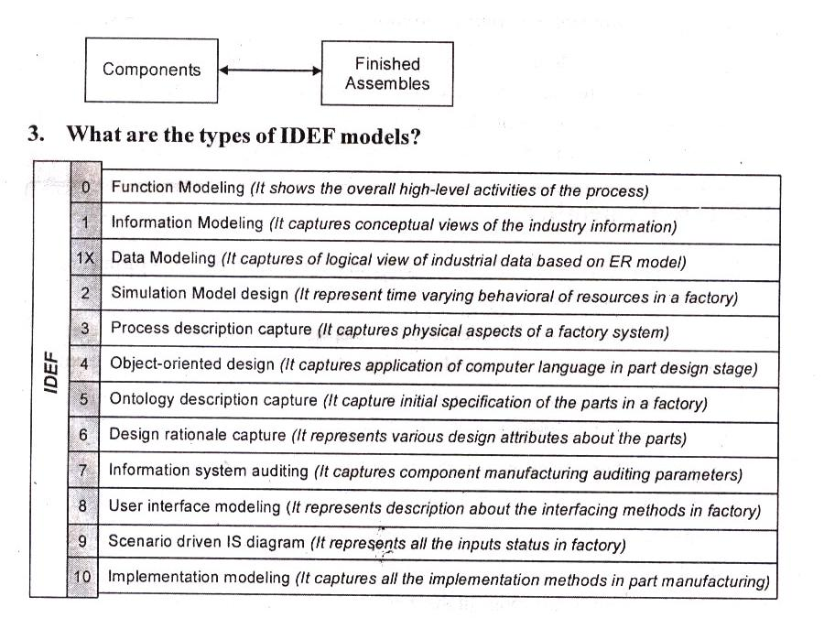
2. Draw simple E-R diagram.

4. Write about CIMOSA.
CIMOS A defines a model-based enterprise engineering method which categorizes manufacturing operations into Generic and Specific (Partial and Particular) functions.

- How CIMOSA separates functions?
- The CIMOSA Modeling Framework in which specific and generic functions are-clearly separated.
- The CIMOSA Integrating Infrastructure supporting execution of Generic functions and linking specific functions. It is effectively the communication system which interconnects all of the functions in the CIM system.

6. Explain about MRR
The material requirements planning (MRP) function takes current inventory levels for all components needed for the final products (a plant might have 20000 part numbers and perhaps 100 final products for which master schedules have been determined) as well as the components bills of materials and lead time information (obtained from design and process planning] and evolves component master schedules for all components needed by the demand requirements agreed upon. MRP does not take into account whether manufacturing has sufficient capacity to handle the job releases, and so capacity planning evaluates shop loading in terms of the requirements and feeds back to the master schedule for corrective action if problems occur. A further function of MRP based on such analysis is determining whether components should be produced in-house or subcontracted to outside vendors.

7. What is the role of process planning in CIM architecture?
The process planning function can ensure the profitability or non profitability of a part being manufactured because of the myriad ways in which a part can be produced.

8. What is dispatching?
Dispatching is the function of releasing all required items needed to perform an operation on a part so that part production may be accomplished at the time planned by the scheduling function.

9. What about shop-floor information?
Shop-floor information system is responsible for getting the required information down to the processing equipment local controllers and sequencing controllers as well as capturing real-time status data from the equipment and parts so that the feedback loops can effect corrections or normal continuation of operation as required.

10. Explain PDM.
Product | Data | Management |  | (PDM) | or Product | Information | Management | (PIM)
systems | provide | the | tools to | control access to and |  | manage all product definition date.
It does this by maintaining |  |  |  | information (meta-data) about product information. Product
Data Management |  |  | (PDM) | systems, | when tightly integrated |  | with other | product
development tools does this transparently and with minimal additional effort on the part of the user.

UNIT V

- What are the two types of channel?
Two basic channel types are used in data communications. They are
i) Analog type ii) Digital type

- List the characteristics of channel.
The channel characteristics are
i) Electronic noise ii) Signal attenuation
iii) Analog channel capacity iv) Digital channel capacity

3. What is channel bandwidth?
An analog signal can vary from a minimum to maximum frequency. The difference between the lowest and the highest frequency of a single analog is the bandwidth of that signal. The mathematical formula for frequency is,
Frequency = Velocity / Wavelength

4. What are two types of transmission mode?
There are three transmission modes available. They arc
i) Simplex ii) Half-duplex iii) Duplex.
They can be applied to both analog and digital channels.

- What is modulation?
The process of varying amplitude or frequency or phase of the carrier signal in accordance with the instantaneous value of the information signal is known as modulation.

- What is demodulation?
The process of separating the original information signal from the modulated carrier signal is known as demodulation. It is the inverse process of modulation.

- What are the reasons for using LAN?
    - LAN allows for decentralization of various data processing functions.
2 LAN allows departments to share hardware.
- LAN allows for the electronic transfer of text.
- LAN allows for communication between organizations.
- LAN allows information to be shared.

- What are the features of LAN?
i) Compatibility ii) Protected Mode Operation
iii) Internetworking iv) Growth Path and Modularity
v) System Reliability

- Define topology and explain its classification.
The pattern of interconnection of nodes in a network is called topology. Topology can also be defined as the geometric arrangement of workstations and the links among them.
The types of LAN topology are
i) Bus topology ii) Ring topology iii) Star topology iv) Mesh topology

- What are the Advantages of LAN?
  - LAN is suited to any type of application.
  - It provides data integrity.
  - Any number of users can be accommodated.
  - A LAN can fit any site requirements.
  - It is flexible and growth-oriented.
  - LAN provides a cost-effective multi user computer environment.
  - Data transfer rates are above 10 Mbps.
  - It allows sharing of mass central storage and printers.
  - It allows file/record locking.

- Define OSI.
Open systems interconnection (OSI) reference model is an international standards organization (ISO) standard that specifies the conceptual structure of systems that are to communicate with each other.

- List out the layers of OSI model.
Seven layers in OSI model
- Physical layer
- Data link layer
- Network layer
- Transport layer
- Session layer
- Presentation layer
- Application layer

- What are the functions of physical layers?
The physical layer consists of the hardware that drives the network and circuits.

- What is the function of data link layer?
The data link layer handles the task of transferring information across the physical link by sending blocks of data.

- What is the function transport layer?
The transport layer provides transparent transfer of packets (data) to and from the session layer without disruption.

16. What is the role of application in OSI model?
The application layer provides the user interface to the networking system.

- What is gateway?
A gateway device is a special-purpose computer, a workstation with associated software, or a software module that runs as a task in a mainframe. It is essentially a protocol converter that facilitates the connection of two dissimilar network architectures. Gateways are integration tools to permit end-to-end communications.

- List the application protocols of TCP/IP.
A number of application protocols and user applications have been developed based on TCP/IP. These include Telnet, FTP, Network File System (NFS), Simple Mail Transfer Protocol (SMTP), and Simplified Network Management Protocol (SNMP).

  - How data’s are classified in engineering/manufacturing environment?
Data encountered in an manufacturing environment can be classified into 4 basic types
  - Resource data, which describes the resources involved in production, such as machines and tools.
  - Product data, which consists of graphic, text and numeric data.
  - Operational data, which describes the events of production, such as schedules and lot sizes.
  - Production data, which describes how the parts are to be manufactured.

- What is database?
A database is a collection of files as an organized assembly of information that users can access for various purposes; that is, adding, deleting, or modifying data.

21. What is data model?
A data model is a logical representation of a collection of data elements. Data models are the basic building blocks for designing all databases.

22 What is DBMS?
DBMS stands for Database management system. A program which lets you manage information in databases. The program we use to organize our data and the actual data structure we create with that program.

23. What is Primary key?
A key is used to represent unique value in a table. For example, in student table every student has unique identification such as ID.

24. What is foreign key?
A key used in one table to represent the value of a primary key in a related table. While primary keys must contain unique values, foreign keys may have duplicates.
For instance, if we use student ID as the primary key in a Students table (each student has a unique ID), we could use student ID as a foreign key.

25. What is normalization?
The process of structuring data to minimize duplication and inconsistencies. The process usually involves breaking down a single table into two or more tables and defining relationships between those tables. Normalization is usually done in stages, with each stage applying more rigorous rules to the types of information which can be stored in a table.

27. Mention the different levels of data modeling.
The Data structures are created within a database. The extent of the relationships among them plays an important role in determining the effectiveness of DBMS. Therefore the database design becomes a crucial activity in the database environment. The task of Database design is made simpler when data models are used. Models are ''Simplified abstractions of real-world events or conditions".
For example, such abstractions will enable us to explore the characteristics of entities and the relationships that can be created among such entities. If the models are not logically sound, the database designs derived from them will not deliver the database system's promise of effective information drawn from an efficient database.
- What is Network Data Model?
A network data model is simply a graph wherein nodes represent unique records, and links between nodes represent association between the corresponding records.

29. What is Hierarchical Data Model?
The hierarchical data model is similar to the network data model except that the relationships among the records are represented in the form of tree structure.

30. What is Data Associations?
A link describes an association between two records. The following are the different types of data associations used in DBMS in manufacturing scenario.
    - One-to-one association
  - One-to-many association
  - Many-to-many association

- List out the Database operators.
To manipulate data in a relational database, three basic operations can be applied to the tables. These are:
- Selection,
- Projection
- Join.

